**Chris Doyle**

***Director of Council for Advancing Arab-British Understanding (CAABU)***

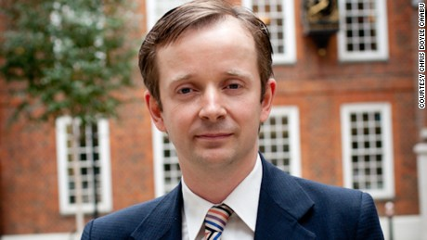Chris is the Director of CAABU. He has worked with the Council since 1993 after graduating with a first class honors degree in Arabic and Islamic Studies at Exeter University. As part of this course he spent a year in Alexandria. Since then he has travelled widely in the Middle East and North Africa. In 1996 Chris moved to work for a professional government relations firm but returned to a more senior role at CAABU in 1997. In November 2002, he was made full-time Director.

As the lead spokesperson for CAABU and as an acknowledged expert on the region, Chris is a frequent commentator on TV and Radio.  He gives numerous talks around the country on issues such as the Arab Spring, Libya, Syria, Palestine, Iraq, Islamophobia and the Arabs in Britain. In January 2013, Chris appeared as an expert witness in front of the Foreign Affairs Select Committee in Parliament discussing UK relations with the Gulf.

He has travelled to nearly every country in the Middle East. He has organized and accompanied numerous British Parliamentary delegations to Arab countries. In recent years, CAABU has been exclusively sending such delegations to the West Bank and Israel.

In 2003, he observed the elections to the Kuwait National Assembly. On 29th November 2005, Chris addressed the United Nations on the occasion of the International Day of Solidarity with the Palestinians. His statement was delivered on behalf of the International Coordinating Network on Palestine. He urged members of the UN General Assembly to increase their efforts to establish a meaningful peace process with the aim of creating a viable Palestine state on the territory occupied in 1967. Chris was the winner of the [2015](http://caabu.org/news/news/caabu-director-chris-doyle-wins-muslim-news-award)Annemarie Schimmel Award for Excellence in championing a Muslim cause.   He also won a Special Tribute award from the Arab Screen Independent Film Festival in 2001 for his work with the media.

Chris writes for a number of journals about the region and was the UK correspondent for Middle East International covering all aspects of the British relationship with the Middle East.   He was a Visiting Lecturer at St. Mary's College, University of Surrey, lecturing on religion in the Middle East. He was also Chair of Friends of Birzeit University and a former trustee of Medical Aid for Palestinians. He is also a member of the Royal Institute for International Affairs.

His articles have appeared in the Independent, CNN, the Middle East Eye, the Guardian, Al Arabiya and Arab News. He has spoken at numerous international conferences. He has also given talks at Chatham House, RUSI, the Dubai Press Club and the annual Doha Forum on Free Trade and Democratization in Qatar.