

Ministry of Foreign Affairs
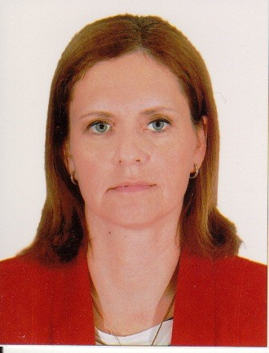
MEIRAV EILON SHAHAR
Deputy Director General for Coordination and Policy Planning

Meirav Eilon Shahar assumed the position of Deputy Director General for Coordination and Policy Planning in October 2017.
Prior to this mission, she served as Israel's Ambassador to Vietnam between 2012 and July 2017.
Joining the Ministry of Foreign Affairs in 1995, Meirav has represented Israel in a number of different capacities. Until summer 2012 Meirav Eilon Shahar directed the Department for United Nations Political Affairs in Jerusalem after returning from New York where she served as Counsellor at the Permanent Mission of Israel to the United Nations.
Previously, Ms. Eilon Shahar served as Consul for Communications and Public Affairs at the Consulate General of Israel in Los Angeles from 2000 to 2002. There, she directed public, media and academic affairs in the southwestern United States. She also served as Second Secretary and Deputy Head of Mission at the Embassy of Israel in Nairobi, Kenya between 1997 and 2000. In this capacity, she oversaw all aspects of bilateral relations between Israel and six east African countries.
Born in Ramat Gan on 12 September 1969, she served in the Israel Defense Forces for two years, after which she earned a dual degree in Political Science and Cinema and Communications from Tel Aviv University. In the following years, Ms. Eilon Shahar completed her Master's in Public Policy and Administration from Tel Aviv University.
Ms. Eilon Shahar is married with three children.

