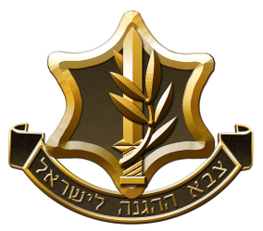
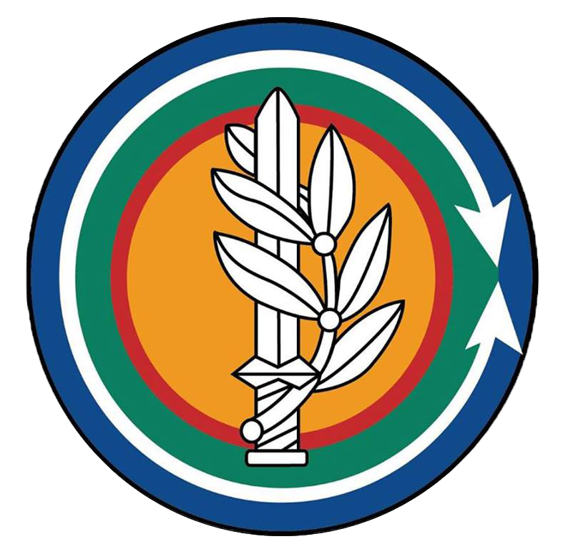
Colonel Alon Madanes
IDF Ground Forces Attaché to the US
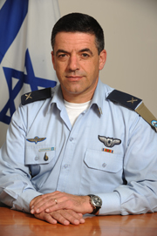

Military Career
2019 | IDF Ground Forces Attaché to the US
2018-2019 | Participant, Israel National Defense College
2016-2018 | Head of operations (G3), Central Command
2014-2016 | Commander, Baram (300) Brigade
2012-2014 | Team Commander, Tactical Command College
2010-2012 | Commander, 101 Battalion of the Paratroopers
2009-2010 | Head, Arms Support Branch, Infantry Professions Training School
1995-2009 | Various command and staff positions in the Paratroopers Brigade (from combative soldiers to deputy battalion commander)

Education
L.LB., Kyriat Ono Academic College
M.A. in National Defense, Haifa University
Graduate, Israel National Defense College
Personal Information
COL Madanes has received the Central Command Commanders Commendation for his performance during Operation Defensive Shield. During his service, COL Madanes sustained injuries to several limbs and severely damaged his hearing.
Born on September 26th 1976, COL Madanes is married to Dana a department manager at a local municipality, they have 3 kids (Tom, Romi and Noa). Hobbies include: sports, traveling in Israel and abroad, history and films.

