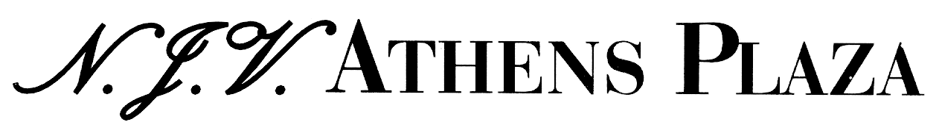
Constitution Square (Syntagma) 105 64 Athens Greece

Tel: 0030 210 3352400 / Fax: 0030 210 3235856 / Sales Dep’t Fax: 0030 210 3237185

e-mail: reservations@njvathensplaza.gr

Credit Card Payment Authorization Form

Please complete all areas below. Incomplete requests may be rejected.
Kindly sent this form by fax to 0030 210 3235856.

CARDHOLDER – Please complete the following section and sign / date below.
Guest Name:
Check in: Check out:
Cardholder Name as it appears on Credit Card:
Cardholder Address:
City: Postcode: Country:
Daytime / Business Telephone: Evening Telephone:
Credit card no: Expiration Date:
Credit card type: (circle one)

Visa / Mastercard / American Express / Diner club

Credit card Issuing Bank Name:
Bank Phone Number (from back of your credit card):

I agree that the hotel may use this credit card for below charges (Please circle)

Room & Accommodation Tax & Breakfast All charges

By signing below, you authorize the hotel to preauthorize your credit card immediately.

Cardholder Signature: Date:

