Book report

Maya sason

Date – 12/13/18

"THE FAULT IN OUR SATRS" Name of the book:

Author: John Green

What's the book about ?

It’s a story of Hazel Grace she's sixteen years old ' she lives in America and she has terminal cancer ' she knows she's terminal she's known several years but she's been lucky enough to find a drug therapy which works for her purely in terms of buying her some time' but she knows she is going to die . She joins a group called " kids with cancer " so she can meet other kids in the same boat and have someone else to talk to . There she meets Augustus waters (Gus ) who's a teenage boy who also has cancer but he is in remission.

Gus and Hazel gets on like a house on fire and very quickly they are being teenagers and fall madly in love and it's very effective story about their love and hoe they deal with the question of death and life . Hazel and Gus are both tremendously intelligent and have a huge sense of humor .

Describe an interesting character –

Hazel Grace Lancaster was born on September 29th 1996. She is age sixteen, is an only child friend of Isaac and girlfriend to Augustus Waters. Hazel finished high school early and has already begun pursuing a college education. She is diagnosed with Stage IV Thyroid cancer with metastasis forming in her lungs, but has managed to live with her disease owing to doses of an experimental drug called Phalanxifor.

Hazel is described as having a pageboy haircut with dark brown hair and green eyes. Hazel must carry an oxygen tank (which she calls Philip) and nasal canulas wherever she goes. She also usually wears converse shoes, which she quotes to wear when she dresses up as her favorite character out of 'An Imperial Affliction by Peter Van Houten

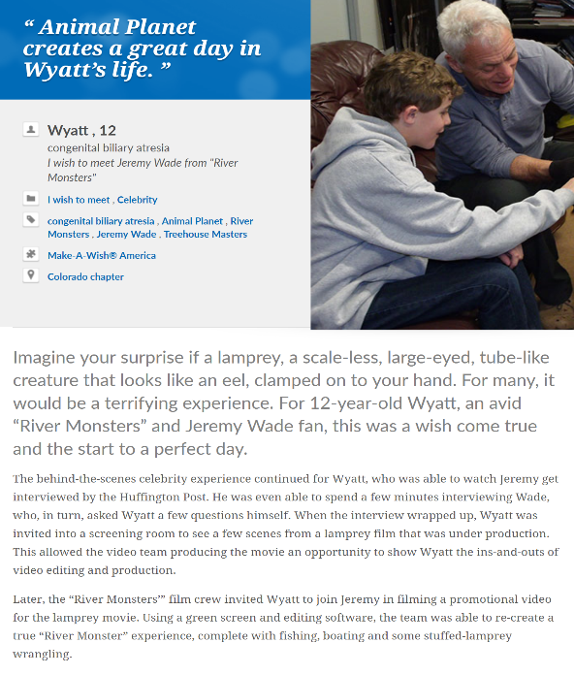

Read an excerpt -

1 why did you choose ?

A wish come true helps children feel stronger, more energetic, more willing and able to battle their critical illnesses. For many, the wish marks a turning point in the fight against their illnesses. Doctors, nurses and other health professionals say, the wish experience works in concert with medicine to make their patients feel better emotionally and even physically. That is why wishes matter.

2) how does it relate to your story ?

In the end of chapter five (88-90 p) Hazel receives a response from Van Houten. He states he cannot answer any of Hazel’s questions for fear that she might twist those answers into a sequel. However he extends an invitation: They can discuss the novel in person if Hazel ever finds herself in Amsterdam. Hazel is elated by the offer, but quickly determines a trip to Amsterdam would be financially unfeasible. She shares the news with Augustus**,** who asks if she's used her wish from ***The Genie Foundation***, an organization that grants sick kids one wish. Unfortunately Hazel spent her wish on a cliché trip to Disney World when she was first diagnosed. A few days later Augustus plans a surprise Dutch themed-date at the Funky Bones sculpture park. He shocks Hazel with the news that he never used his wish, ***and The Genie Foundation has agreed to fly them to Amsterdam.***

This is relates by the central idea of ​​the two foundations .

Do you recommend the book ?

This book’s theme to the world can make anyone go deeper into their thoughts. Hazel and Augustus don’t let cancer stop them from living their life. They go out and make the best of their situation. Hazel says, “You gave me a forever within the numbered days.” They are by each other’s side every step of the way which made their numbered days endless. I learned that out of every situation we face, we should always see the bright side in it. Because as John Green says, “Some infinities are bigger than other infinities.”

I would recommend The Fault In Our Stars to anyone, but mostly people that are attracted to love stories. This story shows you the advantages and disadvantages of being a cancer patient. This is a story you’ll never forget.

