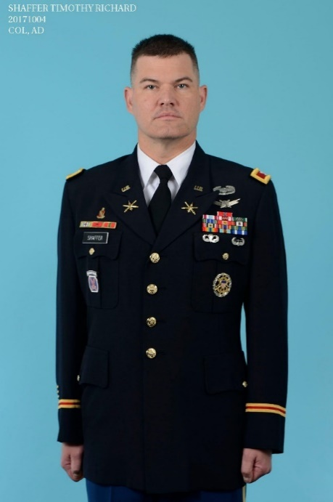

**Colonel Timothy R, Shaffer, United States Army**

COL Shaffer is a career Air Defense Artillery officer, having served in various air and missile defense assignments over the last 24 years, commanding at all levels through Battalion Command. He has served combat tours in both Afghanistan and Iraq.

_____________________________________________________________________________

He graduated and received his commission as an Air Defense Artillery (ADA) Officer from the Reserve Officer Training Corps program at Southern Illinois University - Carbondale. Following initial training at the Air Defense Officer Basic Course, COL Shaffer served in 5-5 ADA in Camp Casey, South Korea and 2-44 ADA, 101st Airborne Division at FT Campbell, Kentucky.

Following further training at the Engineer Captains Career Course at FT Leonard Wood MO, he reported to 4-5 ADA, 1st Cavalry Division at FT Hood Texas. Subsequently, COL Shaffer served as an Assistant Professor of Military Science at University of Maine Army ROTC Battalion, where he also earned a Masters of Public Administration. From there, he was the Senior Air Defense Observer/Controller/Trainer at the Army’s Joint Readiness Training Center located at FT Polk, Louisiana.

Following coursework at the Army Command and General Staff College, COL Shaffer was assigned to the 2nd Brigade Special Troops Battalion, 2nd Brigade Combat Team, 10th Mountain Division where he served as both the Operations Officer and the Executive Officer which included a 10-month deployment to Western Baghdad. Upon his return from Iraq, COL Shaffer moved to US Northern Command at Peterson Air Force base, serving as a Missile Defense watch officer and the Chief of Current Operations for Ballistic Missile Defense.

COL Shaffer next assumed command of 2-44 ADA at FT Campbell, Kentucky, conducting a short notice Battalion deployment to Afghanistan. He deployed the first Counter Rocket, Artillery, and Mortars (C-RAM) intercept capability in support of Coalition Forces in Afghanistan. Upon return to FT Campbell, the Battalion transformed to an Indirect Fire Capability Battalion and prepared for follow on missions. Following command, COL Shaffer attend the National War College at FT McNair. Prior to his current assignment, he was assigned to The Joint Staff Strategic Plans and Policy Directorate, J-5 as the Missile Defense Branch Chief. He was responsible for the development and implementation of Missile Defense strategy and plans as well as interagency and international interfaces.

Colonel Shaffer currently is the chief of the Air and Missile Defense Division at Headquarters, US Army Europe. In this position he is responsible for the US Army’s Air and Missile Defense operations, support, and planning in support of US Operations. He is married to the former Patty Hiatt of Pontiac, IL.

**EDUCATION:**

1995 Bachelor of Arts degree, Southern Illinois University Carbondale, Carbondale, IL.

2005 Masters Of Public Administration, University of Maine, Orono ME

2016 Masters of Science in National Security Studies, National War College, Fort McNair, DC

**MILITARY TRAINING / PROFESSIONAL MILTARY EDUCATION:**

1996 Air Defense Artillery Officers Basic Course, Fort Bliss, TX

1997 Airborne School; Fort Benning, Georgia

1997 Air Assault School; Fort Campbell, Kentucky

2000 Engineer Officers Advanced Course, Fort Leonard Wood, MO

2001 Combined Arms Services School; Fort Leavenworth, KS

2006 Joint Firepower Controller Course; FT Polk, LA

2008 Command and General Staff College, Fort Leavenworth, KS

2015 National War College, Ft McNair, DC

**ASSIGNMENTS:**

* January 1996 - January 1997, Platoon leader, 5th Battalion 5th Air Defense Artillery, 2nd Infantry Division, Camp Casey Korea.
* January 1997 - June 1999, Platoon Leader and Battery Executive Officer, 2nd Battalion 44th Air Defense Artillery, 101st Airborne Division, Fort Campbell, KY.
* January 2000 – July 2002, Assistant Battalion S3 then Headquarters Battery Commander, 4th Battalion 5th Air Defense Artillery, 1st Calvary Division, Fort Hood, TX.
* July 2002 - June 2005, Assistant Professor of Military Science, University of Maine, Orono
* June 2005 - June 2007, Senior Air Defense Observer/Controller, Joint Readiness Training Center, Fort Polk, LA.
* July 2008 – June of 2010, Operations Officer then Executive Officer, 2nd Brigade Special Troops Battalion 2nd Brigade Combat Team, 10th Mountain Division, Fort Drum, NY and Iraq. October 2008 to December 2009
* July 2010 – June 2013, Missile Defense Officer then Chief of Current Operations, Missile Defense, U.S. Northern Command, Peterson Air Force Base, CO
* July 2013 – June 2015, Commander, 2nd Battalion, 44th Air Defense Artillery Regiment, Fort Campbell, KY and Afghanistan.
* June 2016 – July 2018, Chief, Missile Defense Policy Branch, J-5 Global Policy and Partnerships, Joint Staff, Washington, D.C.
* July 2018- Present, Chief, Air and Missile Defense Division, G-3, U.S. Army Europe, Wiesbaden, Germany

**AWARDS AND DECORATIONS:**

Bronze Star Medal (with Oak Leaf Cluster)

Defense Meritorious Service Medal (with Oak Leaf Cluster)

Meritorious Service Medal (with three Oak Leaf Clusters)

Army Commendation Medal (with four Oak Leaf Clusters)

Army Achievement Medal

National Defense Service Medal (Second Award)

Afghanistan Campaign Medal

Iraq Campaign Medal

Global War on Terrorism Expeditionary Medal

Global War on Terrorism Service Medal

NATO Medal

Joint Superior Unit Award (with two Oak Leaf Cluster)

Army Superior Unit Award (with Oak Leaf Cluster)

Army Meritorious Unit Award

Combat Action Badge

Army Parachutist Badge

Army Air Assault Badge

Army Basic Space Badge

Joint Staff Identification Badge