NATO UNCLASSIFIED

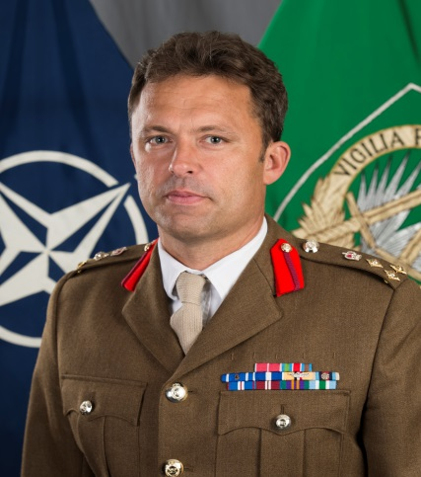 | Supreme Headquarters Allied Powers Europe  Director of the Comprehensive Crisis and Operations Managements Centre at SHAPE  Brigadier Jasper de Quincey Adams OBE

Brigadier Jasper de Quincey Adams was commissioned into 1st The Queen’s Dragoon Guards (QDG) in 1991 and spent his early years based in Germany as a Formation Reconnaissance and Challenger Main Battle Tank Troop Leader. In 1995 he deployed as a Captain to Bosnia-Herzegovina (BiH) with the United Nations Protection Force (UNPROFOR) working as a Sector Liaison Officer between the Warring Factions. He subsequently completed two additional tours in BiH with the NATO Implementation Force (IFOR) as a Squadron Second-in-Command and as a J5 staff officer in Multinational Division Headquarters South-West. He returned to the Balkans in 1999 as the QDG Battle Group Operations Officer with the Kosovo Force (KFOR).

He completed three tours in Iraq (Op TELICs 5, 8 and 11), twice as a Squadron Leader working alongside the Iraqi Security Forces in Basra, and finally as a liaison officer with the Multinational Headquarters South-East. Subsequently he was posted to the UK’s Permanent Joint Force Headquarters (PJHQ) as a J3 staff officer before deploying to Afghanistan (Op HERRICK 10 and 11) as the mentor to the Helmand Provincial Chief of Police, establishing the Police Mentoring Advisory Group. In 2010 he assumed command of his Regiment, returning to Afghanistan (Op HERRICK 15) in command of the ISTAR Battle Group.

His recent staff experience includes working at the UK Ministry of Defence in Army Resources and Plans, a short spell as the Task Force Ukraine Team Leader at SHAPE and two years as a Special Advisor to the Chairman of the NATO Military Committee. He has completed the Advanced Command and Staff Course as well as the Higher Command and Staff Course.

He was awarded the Queen’s Commendation for Valuable Service in 2007 and was appointed Officer of the Most Excellent Order of the British Empire (OBE) in 2013.

He is married to Jill and they have one daughter, Arabella, and an ever-changing collection of dogs, cats and horses. He enjoys hockey, hiking, sailing and fly-fishing.

Current as of 12 July 2017

NATO UNCLASSIFIED

