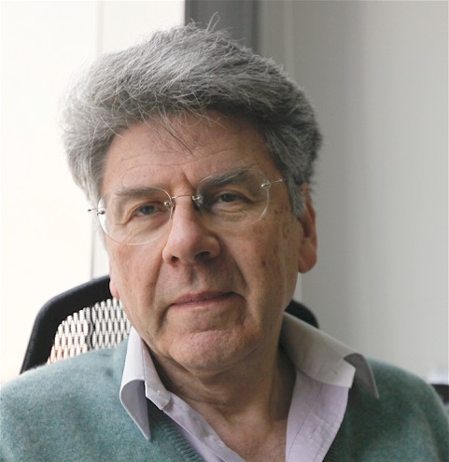

**Professor Chalom SCHIRMAN**

**Associate Professor and the Head of the International MBA Program at the Faculty of Management of the University of Haifa**

A former Israeli diplomat, he has been the Acting Director of the Economic Intelligence division in the Center of Research and Policy of the Foreign Ministry (1974-1979), the Chief of the Economic section at the Embassy of Israel in Paris (1979-1985) and Israel’s Consul General in Montreal (1986-1990).

He then created *Capitêtes International*, a consulting firm, based in Paris, to train and support corporate and institutional clients in international negotiations and industrial collaboration.

From 1997 to 2010, he was Associate Professor in the world network of the ENPC-MBA (Paris, Buenos Aires, Edinburgh, Casablanca, Tokyo, New Delhi and Shanghai) teaching *International Business Negotiation* and *Geopolitics for Business* in all these campuses.

In 2000 he co-created SIMBA (Shanghai International MBA), one of the first international MBA programmes in China, as a JV between ENPC and Tongji University. He has been the International Dean of that Program until 2010.

From 2012 to 2015 he lived in Shanghai and was Director of the International Executive Development Program (IEDP) of Tongji University’s School of Economics and Management.

He is a visiting lecturer in several Business Schools in China and very active in academic cooperation between Israel and China.