|  |
| --- |
| **Lieutenant Colonel Tim Scott**  **Student**  **Israel National Defense College** |

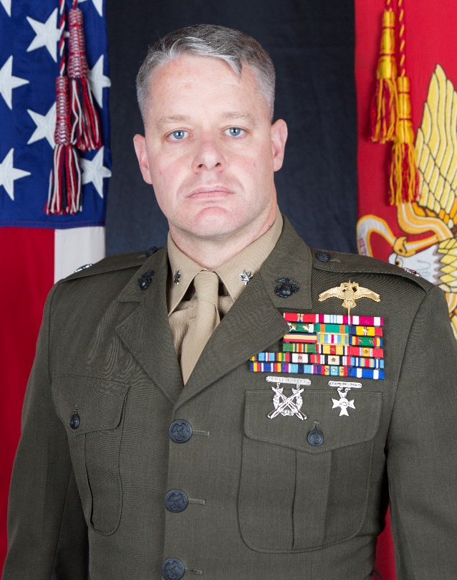Lieutenant Colonel Timothy J. Scott enlisted in the Marine Corps reserve in 1994 and completed Officer Candidates School via the Platoon Leaders Class in 1998. He was commissioned a Second Lieutenant in the summer of 2000 after graduating from Southern Illinois University at Edwardsville.

Lieutenant Colonel Scott's platoon commander assignments were with 3rd Battalion 2nd Marines (2001-2003) and 2nd Reconnaissance Battalion (2003-2004). He served as a Company Commander with Company C, 2nd Reconnaissance Battalion (2004-2005), and Weapons Company 3rd Battalion 6th Marines (2007-2009). Lieutenant Colonel Scott was assigned to Expeditionary Warfare Training Group, Atlantic (2005-2007) as the Assistant Officer-in-Charge of Amphibious Reconnaissance School.

His assignments in Special Operations include Team Leader, Marine Special Operations Team 8233, 2nd Marine Raider Battalion (2009-2011); Future Operations Officer, Marine Raider Regiment (2011-2012); Operations Officer, 3rd Marine Raider Battalion (2012-2014); North Africa engagements planner (2014-2016) and Executive Officer to the Commanding General (2016-2017) Special Operations Command Africa; MARSOC G7 Training and Education branch chief (2017-2018) and Commanding Officer, 2d Marine Raider Support Battalion (2018 – 2020). From August 2019 – January 2020 he forward deployed to Erbil, Iraq, and commanded Special Operations Task Force – North.

Lieutenant Colonel Scott is a Marine Combatant Diver, Parachutist, and graduate of the Marine Corps Basic Reconnaissance Course. He completed Marine Forces Special Operations Command assessment and selection class 002 in September 2007.

His Professional Military Education includes Infantry Officer Course, Expeditionary Warfare School, Marine Corps Command and Staff College, and Air War College (non-resident).

He holds a Master of Arts Degree in Leadership Studies from Marshall University and a Master of Arts Degree in International Relations from New England College.

Lieutenant Colonel Scott is a native of St. Louis, MO. He has been married to his wife, Dana, since 2003. They have two daughters, Kat and Maggie.