**Benny Katzover** 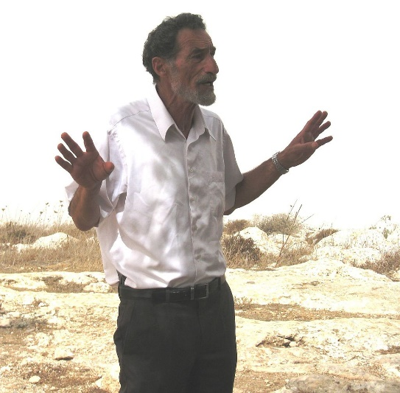

Benny Katzover was born in Petah Tikvah. He lives in Elon Moreh; married and has five daughters and two sons.

In Passover 1986, he joined a group who settled in the Hebron Park Hotel under the leadership of Rabbi Moshe Levinger. While living there, he and his girlfriend at the time were the first Jewish residents to marry in Hebron since the devastating riots of 1929.

In 1973, Katzover established the Elon Moreh Gar'in – the first settlement Gar'in in Samaria along with his friend, Rabbi Menahem Felix. Later on, he was one of the founders of the "Gush Emunim )"Bloc of the Faithful"(, a religious – national- social movement established after the Yom Kippur War in order to renew Jewish presence in Judea & Samria, the Golan, Negev and Galilee as well as in the Gaza Strip and Sinai.

Katzover served as Head of the Samaria Regional Council in 1981 – 1993 He was active in the "Techiya" and "Tkuma" movements.

In 2008-2015 he as the chairman of the Samaria Settlers Committee.

Over the last decade, Benny Katzover has been an active advocate for the settlements in Samaria.