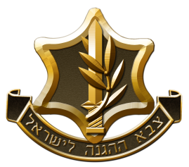[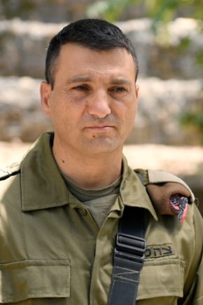](https://www.google.co.il/url?sa=i&source=imgres&cd=&ved=2ahUKEwjXr4Thi5DpAhUwNOwKHS1nALoQjRx6BAgBEAQ&url=https://www.lebanonwar2.idf.il/%D7%9E%D7%A4%D7%A7%D7%93%D7%99%D7%9D-%D7%9E%D7%A1%D7%A4%D7%A8%D7%99%D7%9D/&psig=AOvVaw3zKP8Tu468rC53nCNwQP2F&ust=1588334101636582)

**BRIGADIER GENERAL Yaniv Asor**

HEAD OF OPERATIONS DIVISION

**MILITARY CAREER**

2018-Current Head of operations division

2015-2018 Deputy Commander of 210th Division

2011-2014 Commander of “Golani” Brigade

2011-2012 Deputy Commander of 36th Division

2009-2011 Commander of 769th Brigade

2006-2008 "Egoz" Unit Commander

2004-2006 Battalion Commander, "Shaldag" Unit

2003-2004 Operations Officer, "Golani" Brigade

2001-2002 Deputy Battalion Commander, "Shaldag" Unit

1997-1999 Company Commander, "Golani" Brigade

**EDUCATION**

Academic: B.A in logistics from "Bar - Ilan" University

M.A in Business Administration from "Bar - Ilan" University

Military: Marines College Graduate, US

**INFORMATION**

Brigadier General Asor is married to Dikla, they have 4 children together.