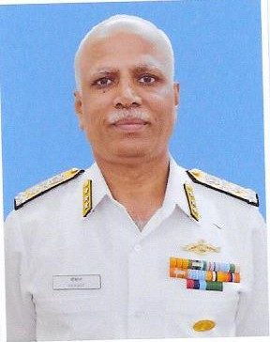

**BIO-DATA – VADM SRIKANT, AVSM**

**COMMANDANT, NATIONAL DEFENCE COLLEGE, NEW DELHI**

1. Vice Admiral Srikant, AVSM is a native of Bangalore, Karnataka. He did his early education in Bangalore and Bijapur, Karnataka and graduated as a Bachelor of Science from the National Defence Academy, Khadakvasla, Pune in December 1980.

2. The Admiral was Commissioned in the Navy in January 1982 and joined the Submarine Arm in 1983. He has held various operational appointments on three classes of conventional submarines of the Navy and commanded the first indigenously built submarine INS Shaliki. He is a Navigation and Direction Specialist and a Graduate of the United States Staff College, Newport, Rhode Island. His large surface combatant commands have been of destroyer Ranvijay and larger destroyer Delhi. He served as the Naval Adviser at the High Commission of India in Islamabad, Pakistan from 1998-2002 when Op Vijay and Op Parakram were conducted by India.

3. His Staff appointments have been at the Naval Headquarters, New Delhi and the Western Naval Command. Being elevated to Flag Rank in July 2011, he has been the Submarines Class Authority, Flag Officer Submarines and served in the nation’s Strategic Programme. He was the Inspector General Nuclear Safety prior to assuming the mantle as the Commandant NDC. The Admiral is a keen sportsman and earlier represented the Navy Cricket Team. He is also a keen golfer. The Admiral is a recipient of the Ati Vishisht Seva Medal for distinguished service.

3. Mrs. Sudha Srikant is a home maker and is a Graduate in Sociology and Public Administration and takes keen interest in various Naval Wives Welfare Association activities. Their daughter Shraddha holds a Master’s degree in Development Economics from the London University and presently works for the United Nations Industrial Development Organisation at New Delhi.