Rabbi Amniel Hirsch
Reform Jewish rabbi and a bar-certified lawyer in New York
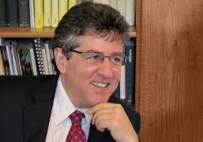
previous positions

 | Rabbi Hirsch is recognized internationally for his leadership in Jewish affairs and is frequently cited in the media
 | Hirsch is also an officer of the New York Board of Rabbis and a member of the Partnership of Faith, an interfaith body of New York religious leaders
2004 | Joined the Stephen Wise Free Synagogue as Senior Rabbi
1992-2004 | served as executive director of the Association of Reform Zionists of America (ARZA)
Education
LL.B Honors law degree from the London School of Economics and Political Science
Received rabbinical ordination from the Hebrew Union College-Jewish Institute of Religion
Personal Information
Has two brothers a sister
Served in the IDF as a tank commander

