*Economic Policy to Reduce Littering in Israel*

Lt Col Randal Allen, USAF

Economy

Paper 1

Prof. Omer Moav

31 March 2020

Introduction/Problem Definition

Israel, like many countries, is suffering from a litter problem that is linked to misapplication of economic policy. Israeli citizens and tourists alike are frustrated by the large amount of waste left behind by fellow beach-goers. Public parks and sidewalks are similarly affected. The problem is not merely one of aesthetics. For a country that relies on tourism dollars, litter can affect the economy and therefore, national security. While probably seen as a mostly innocent act by the culprits, it is disrespectful to the environment and one’s countrymen. Israel, a country that has historically relied on tight national unity to overcome overwhelming odds in the political and military battlespace, can ill afford such disharmony. Litter also creates ecological and environmental problems.

The litter problem is a manifestation of the litterers having poor or no motivation to remove their own waste. Certainly, there is a market failure problem that does not adequately distribute the costs of removing waste to the litterers. In fact, there is presently no cost passed on to the litterers for leaving their waste behind, yet there are perceptible costs for cleaning up after oneself. Certainly, it can be burdensome to carry waste away from the beach, especially when also carrying towels, an umbrella, toys, and other items that are brought on a normal visit to the beach. If waste receptacles are not readily available, the costs are even steeper for the individual, who may have to carry the waste to his or her car and take it home. There is almost no moral cost to the visitor, who likely feels as if his or her contribution to cleaner public spaces would not be noticed amongst the existing litter already present and the other litter that will no doubt continue by others. A correction must be made to the market failure in order to reduce the amount of litter left behind.

Evidence

One need only visit a nearby public park to observe that Israel has a litter problem. The issue is perhaps most apparent on Israeli beaches, where the site of waste stands in contrast to the sandy beach underneath. *Haaretz* quantified the problem in a 2018 article, in which it mentions that 400 tons of litter were picked up during Passover 2015 around Lake Kinneret alone. Also in 2015, two thirds of Israeli beaches were ranked between moderately and very dirty. 100,000 volunteers collected 800 tons of litter in one day. (<https://www.haaretz.com/israel-news/MAGAZINE-total-rubbish-why-is-israel-so-filthy-1.6006920>).

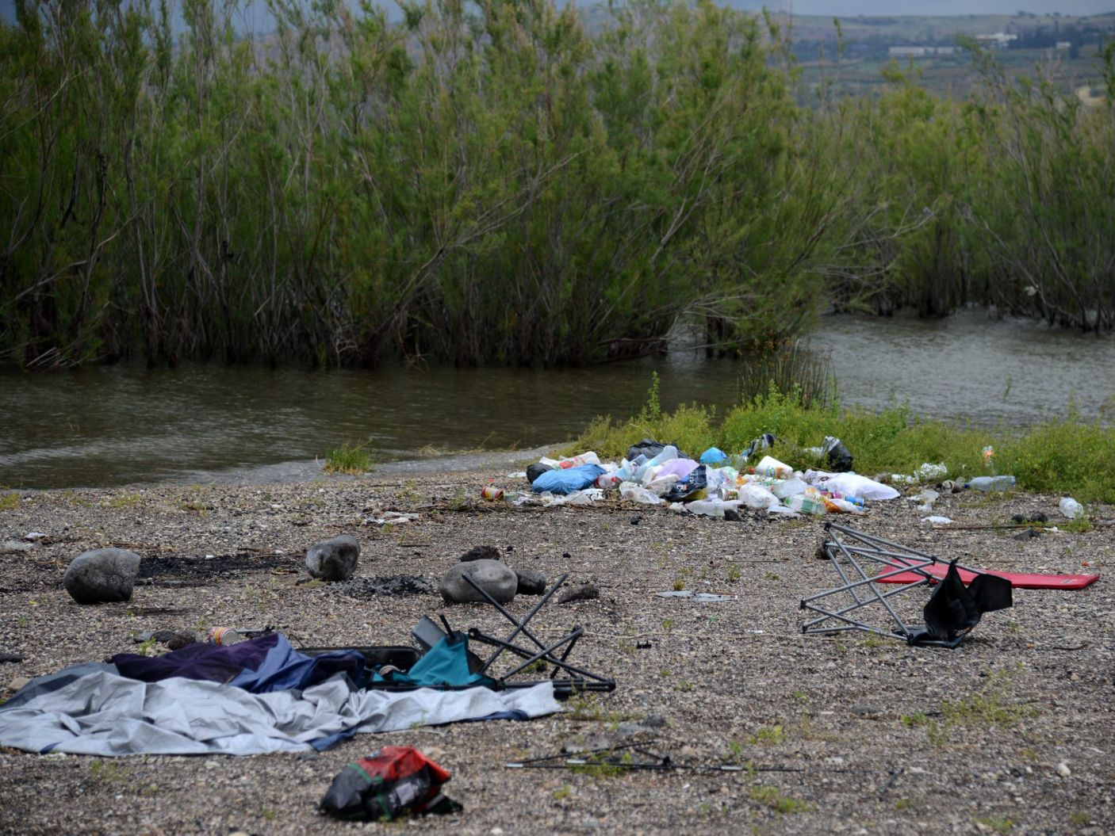

Source: Haaretz

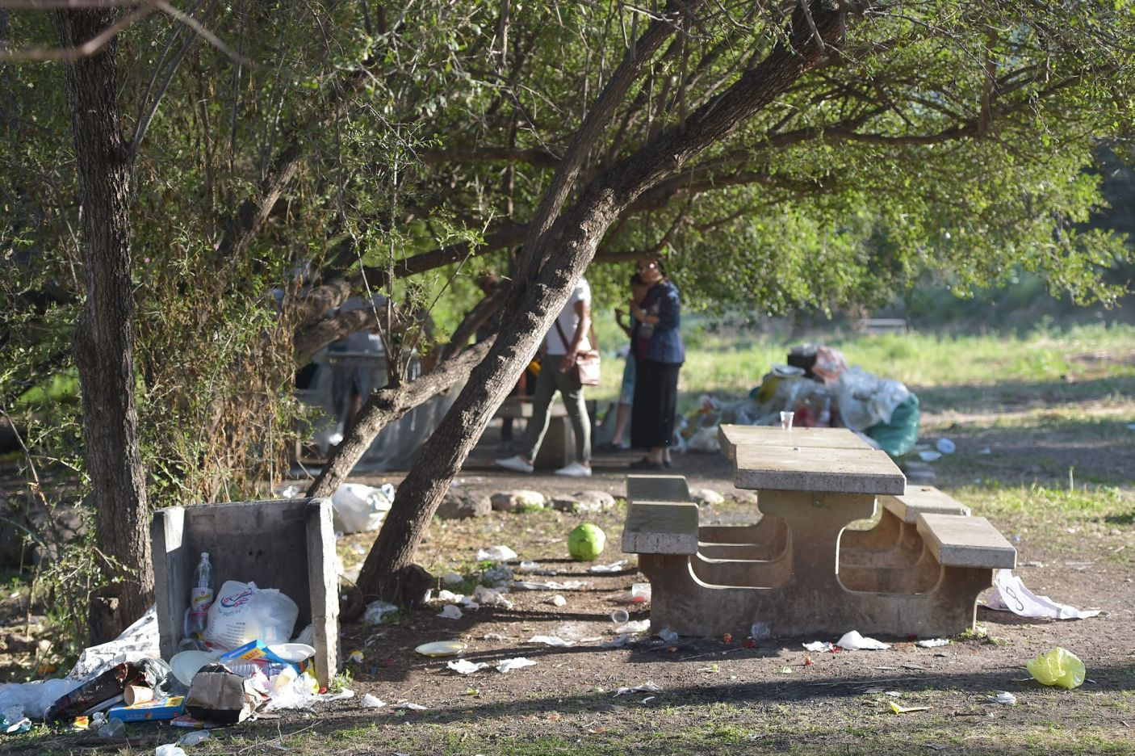

Source: Haaretz

Alternatives

What can be done? There are many options available, yet none would be effective on its own. Rather, a long-term effort of creating and maintaining awareness much be launched and programs developed to remove existing litter. Israel can learn from other countries and localities that have taken on a litter problem. Awareness is perhaps the most important. Litter is a choice and efforts must be undertaken to instill in Israelis a desire to contribute to the cleanliness of their public spaces, which can be effective in creating moral costs. An awareness campaign should target all age groups. Children could be particularly valuable partners in a litter reduction campaign, as their attitudes are likely more malleable and they might help convince their parents of the importance of not littering. At the same time, the government needs to lower costs for complying by installing and regularly servicing waste receptacles in places where litter most often originates. Existing litter laws and enforcement regimes should be reviewed and updated as necessary to complement these programs. Imposing or enforcing fines for littering is another way to create costs for littering. And workers must be hired to pick up existing trash and the littering that will no doubt persist in spite of efforts to reduce it.

These programs will not be free. Even awareness campaigns, launched on social media, will need full-time public relations professionals to develop and run them. Like all other public spending priorities, such a litter reduction campaign will have to compete for taxpayer dollars (shekels) and may have to displace other important initiatives in order to win funding. Depending on the budget for such a program, fines imposed on litterers may provide enough funding to sustain the program.

Any strategy to invest resources into a litter reduction campaign should take into account the interests of three powerful groups: politicians, bureaucrats, and special interest groups. Politicians are usually primarily interested in getting reelected. A successful litter policy would ensure that there would be tangible results that politicians can highlight to voters and special interest groups in order to boost their chances of reelection. Bureaucrats are interested in increasing their budgets. If resources are diverted from other programs to fund a litter reduction campaign, some bureaucrats stand to lose portions of their budget while bureaucrats that oversee such a campaign have an opportunity to increase the size of their budgets. Certainly, the latter should be informed of any attempt to gain approval for a litter reduction campaign. They might have access to information that can be used to further convince politicians of the need to approve such a campaign.

Special interest groups arguably hold the most power in the process for gaining approval of a litter reduction campaign. Lobbying groups for promotion of tourism in Israel should be brought in early. Environmental and ecological lobbying groups also have interests at stake and should also be consulted. Unions for waste collection workers and law enforcement stand to benefit from the increased jobs in their sectors that such a campaign would create. They likely have influence with the politicians that should be leveraged. The relationships and interaction between the politicians, special interest groups, and bureaucrats can be seen in *Figure 1*, below.

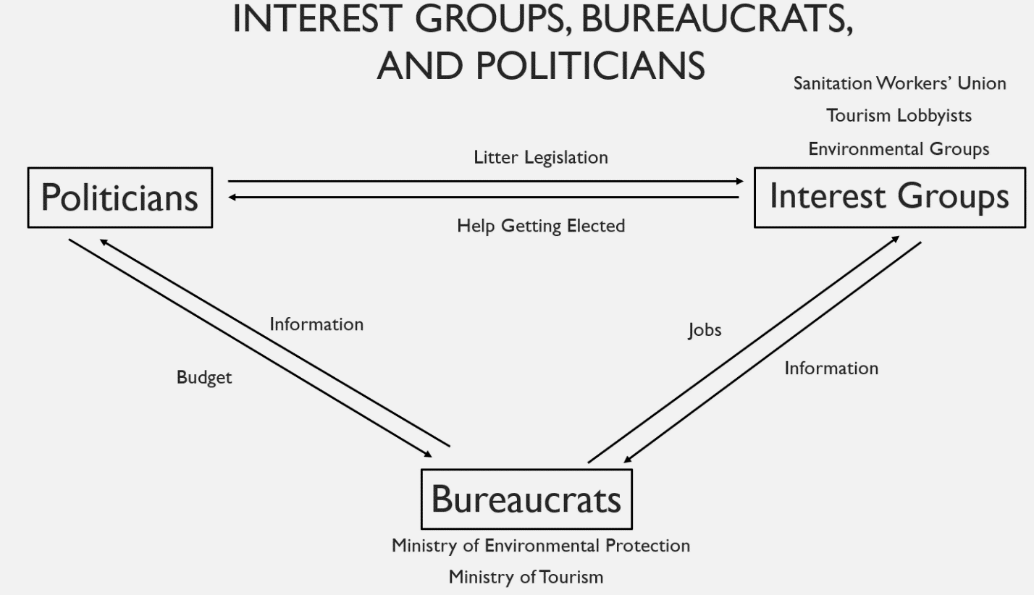

Figure : Interaction Between Interest Groups, Bureaucrats, and Politicians

Prisoner’s Dilemma Analysis

A prisoner’s dilemma analysis can be a helpful tool in understanding the difficulty in getting individuals to avoid littering. *Figure 2*, below, presents the deliberations of an individual and a critical mass of the public space users. The variable *b* represents the benefit of collective cooperation, which is assigned a value of 100. If enough people cooperate and do not litter enough that a public space is almost completely free of litter, each individual will enjoy a utility of 100 units. The variable *E* represents the value of the cleanliness that results from one person refraining from littering, and it is approximately .01. The individual cost of cooperating is represented by the variable *c*. *c* can also be seen as the burden for each individual to clean up after himself or herself. Relative to *b* and *E*, *c* is 10 in the analysis below.

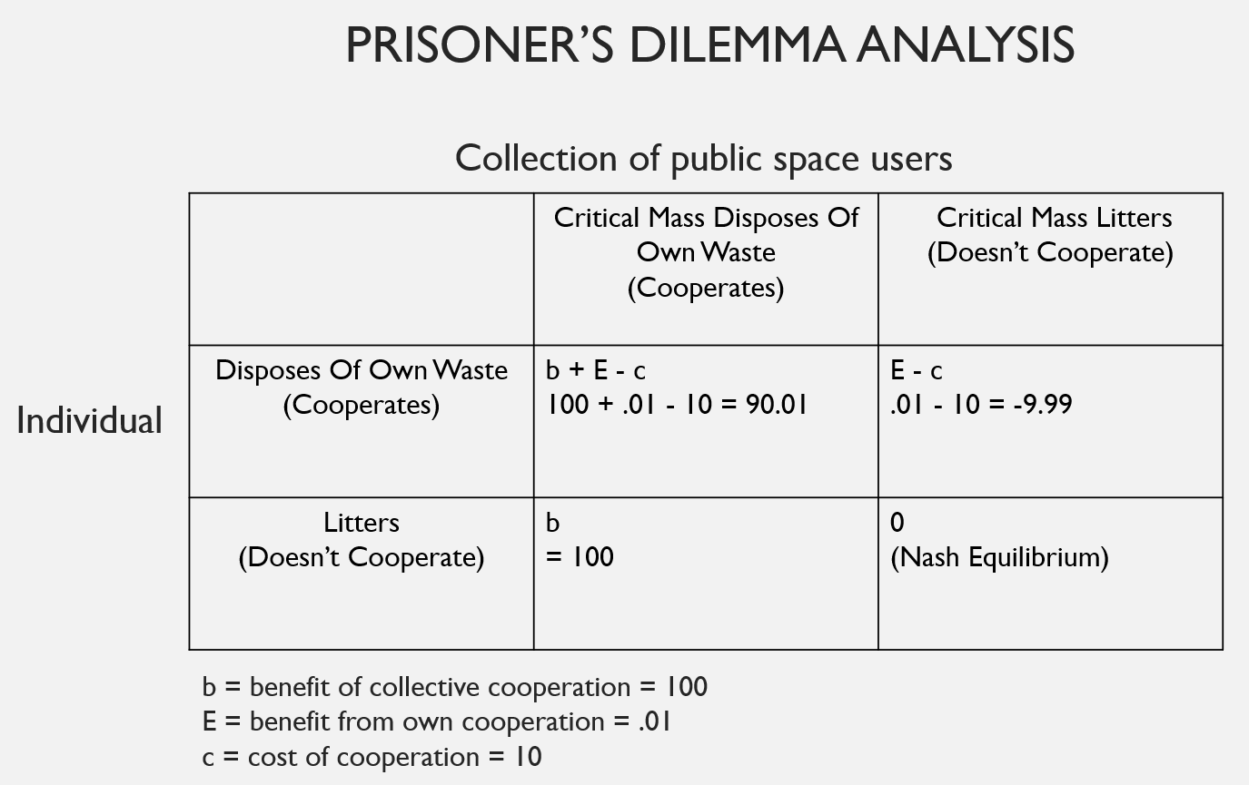

Figure 2: Prisoner's Dilemma Analysis

The best utility an individual can hope for is that everyone else cleans up after themselves and the individual can leave his litter without further cost. For example, he could enjoy a day at a clean beach and then leave his waste at the beach without having to be burdened by carrying these items off the beach or to his home. This scenario is represented on the prisoner’s dilemma chart by the lower-left quadrant, and has a utility value of 100. Because most visitors to the beach also try to maximize their utility by leaving their waste on the beach, the scenario described above is highly unlikely to occur. More probable is that a critical mass of beach visitors will leave their waste behind and, consequently, no one will gain the benefit of collective cooperation. This scenario is represented in the lower-right quadrant and has a utility value of 0. Individuals understand that if they arrive at such a beach and they carry their own litter away, they will enjoy a utility valued at even less. Their beach experience will be marred by litter and they lose utility by enduring the burden of having remove their own waste. They gain only a very small utility of about .01 by preventing some litter from negatively affecting their next visit to that same beach. This scenario is represented by the upper-right quadrant.

Ideally, a rewards and penalties structure would be established such that a critical mass of beach visitors would remove their own waste. They would all gain the utility of a clean beach and only endure the burden of having to remove their own waste. This scenario would be represented by the upper-left quadrant, but until a litter-reduction campaign is launched, the lower-right quadrant will be the Nash Equilibrium. Policy strategies must be pursued that reduce the cost of cooperation, and increase the individual benefit to cooperation.

Criteria Selection

Criteria selection is a key determinant in ensuring the right alternatives are chosen. The criteria should be outcome focused. Below, I have outlined the best criteria to use in evaluating the various alternatives.

* Litter left behind in selected public spaces should be monitored and amounts tracked over time to measure effectiveness—this will mostly measure success of awareness campaign.
* Litter placed in new waste receptacles should be measured and tracked over time to evaluate effectiveness of placement of these receptacles.
* Number of fines imposed should be tracked over time. Success of this alternative would be represented by a downward slope following a sharp initial climb as enforcement measures are put in place. However, a downward slope may also indicate dwindling enforcement as the initial energy and motivation to enforce wears off.
* Amount of litter picked up by workers hired for this purpose should also be tracked and monitored. A successful litter reduction program will be indicated by high levels of littered removed initially as existing litter build-up is removed, followed by a plateau as litter reduction alternatives are instituted, followed then by a downward slope as the litter reduction campaign becomes effective. It will not be possible to determine from this criterion which alternatives have had the most effect, only that one or more of the alternatives have likely been successful. There is also a chance that a decline in the amount of litter removed by these newly hired personnel will indicate that their job performance is declining over time.

Analysis of Alternatives

Naturally, we would expect that the combined result of all alternatives employed would be that the amount of litter in Israeli public spaces would decline. However, much of the success of a litter reduction campaign hinges on the success of heightening awareness of the problem among the public and subsequent changed behavior, and these are very difficult to predict. What has worked in other awareness campaigns may not work as well or as quickly in Israeli society. Or Israel’s results might come faster. Ultimately, no predications can be made at this stage as to the speed or degree of success of this litter reduction campaign. A program must first be launched, even a pilot program on a smaller geographic scale, and data collected and analyzed.

Certainly, undesirable outcomes are possible. A poorly designed awareness campaign is likely to be mocked, rejected, and even resisted, which could result in Israelis leaving more waste behind. Increased enforcement of existing litter laws and new litter legislation could similarly result in protest and resistance, ultimately creating a problem of even more litter. New waste receptacles placed in areas prone to littering could be vandalized or stolen, which is also likely to create a mockery of this litter reduction campaign, leading to additional litter. Hiring personnel to clean up litter could also backfire. If not supervised properly, these employees might purposely perform poorly in order to preserve their jobs. Even worse, they might add waste to their assigned areas for the same reason.

Trade-Offs/Decision

These possible negative outcomes should be considered and measures put in place to reduce their likelihood, but the risk of their occurrence should not serve as a deterrence to implementing a comprehensive litter reduction campaign. These possible outcomes certainly should not be considered trade-offs.

The only trade-offs to be considered for each of the alternatives presented are their associated costs, which are described above. However, it is impossible to predict effectiveness by cost, nor should this campaign be only partially funded, lest some of the undesirable possible outcomes become realities. This program needs all alternatives to be implemented simultaneously, as they are complementary in nature. Therefore, there are no trade-offs to be had amongst alternatives. The decision should be made to implement all of the alternatives.

Telling the Story

In order to gain approval, this policy proposal needs to be convincing to all stakeholders. The project will have to compete for funding against other important priorities, such as education, transportation, security, and defense. Naturally, some stakeholders will need little convincing while others, such as those championing competing priorities, will need a lot more. A full presentation that includes imagery and hard facts, along with an explanation of the root problems, proposed solutions, and their associated costs, is essential.

Conclusion

While many Israelis and visitors are justifiably disappointed with the issue of litter in Israeli public spaces, there is much that can be done and many other countries have successfully overcome their own litter problems. The government must look at the problem as one of market failure and use proven economic theory, such as raising the cost for littering and lowering the cost for keeping the public spaces clean. Naturally, tackling this problem will not be free and so will have to compete for funding against other government priorities. The analysis above should provide an effective playbook.