Ali Velshi
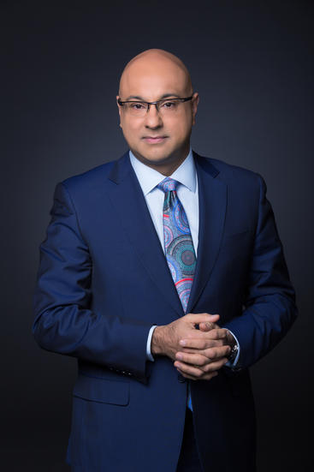
Deputy to Israel’s Ambassador to the UN
previous positions

2016-Present | MSNBC, Business Correspondent, Co Host
2013-2016 | Al Jazeera America, host of Real Money with Ali Velshi
2008 | Hosted CNN's Energy Hunt
2005-2006 | Assigned to the newly launched The Situation Room
2001-2004 | Anchored several shows including Insights, Business Unusual, Street Sweep, Your Money, and co-hosted The Money Gang with Pat Kiernan before the network closed down
1999 | Hosted The Business News
Education
2016 | Honorary Doctorate of Laws at Queens University
1988-1993 | BA, Religious Studies at Queens University
Personal Information
Born October 29, 1969 Nairobi, Kenya

