Subject: IDF Roster for in-country integration

1. The list enclosed in appendix a comprises the IDF roster for integration in Germany during TAC-1 of Exercise JUNIPER FALCON 2021.
2. Please note the following COVID mitigation measures we will be taking:
   1. All personnel will arrive in Germany after receiving **two** dosages of COVID-19 vaccines.
   2. All personnel will be abiding restriction on movement – essential work and life support activities, in accordance with Israeli law.
   3. All personnel will monitor medical vitals (i.e fever, COVID symptoms and etc).
3. Please note the requested base access, per group.
4. For lodging arrangement, we would appreciate your input for most appropriate location, with our reference for USAFE Lodging in Ramstein AFB.
5. As always, I am grateful for your ongoing cooperation and friendship. But moreover, your commitment to the assistance of the defense of Israel.

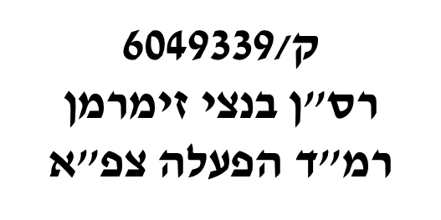

Benzi Zimmerman, Major, IDF

Head, US Operation Cooperation Desk (J53)

Copy:

* JOHN W. LECLAIR, JR., Colonel, USAF - Chief, Forces Management Division (A3F)
* Seth MacCutcheon, LtCol, USMC - Southern Flank Branch Chief and Israel Desk
* Brian R. Miletich, LTC, USA - ECJ-35 Plans, Levant Branch Chief, U.S. European Command
* Pat Vongsavanh, LtCol - ECJ7 JtrEx, JFHQ Branch Chief
* William Haag, Lt Col, USAF - ECJ7-JTrEx, Joint Training and Exercise Planner
* ALEXANDER SAYRE, GS13, DAF-C - USAFE-AFAFRICA 603 AOC / A37H
* Michael L Huff - JFHQ Exercise Branch, G37 TREX, USAREUR
* THOMAS M. HOOPER - Valiant Inte grated Services, Joint Exercise Planner, HQ EUCOM ECJ7 (JTrEx)

|  |  |  |  |  |  |
| --- | --- | --- | --- | --- | --- |
| **Security Clearance** | **DOB** | **Passport** | **Rank** | **Name** | **Location** |
| IDF TS | 30/12/1973 | 32394248 | LtCol | Tal Kaduri | WPC and JSMC-K |
| IDF TS | 26/01/1970 | 31348030 | Col | Gershon Zlotnik | WPC and JSMC-K |
| IDF TS | 17/03/1990 | 33257685 | Capt | Michael Pitchkhadze | WPC |
| IDF TS | 15/12/1974 | 31749318 | Capt | Adi Ben David | WPC |
| IDF TS | 21/10/1987 | 22194709 | Maj | Eitan Asher Cartier | WPC |
| IDF TS | 21/05/1974 | 22231319 | Maj | Sagiv Eugene Pazin | JSMC-K |
| IDF TS | 8/8/1963 | 32487262 | Maj | Daniel Citron | JSMC-K |
| IDF TS | 19/07/1990 | 32618809 | MAJ | Ben Zion Zimmerman | WPC and JSMC-K |
| IDF TS | 8/10/1970 | 34325708 | Col | Bar Zohar Aviv | JSMC-K |
| IDF TS | 19/12/1988 | 14769951 | Maj | Rami Rahamin Mazon | JSMC-K |
| IDF TS | 15/11/1964 | 22633633 | BrigGen | Doron Gavish | WPC and JSMC-K |
| IDF TS | 10/05/1970 | 23361454 | Maj | Gideon Freedman | WPC |