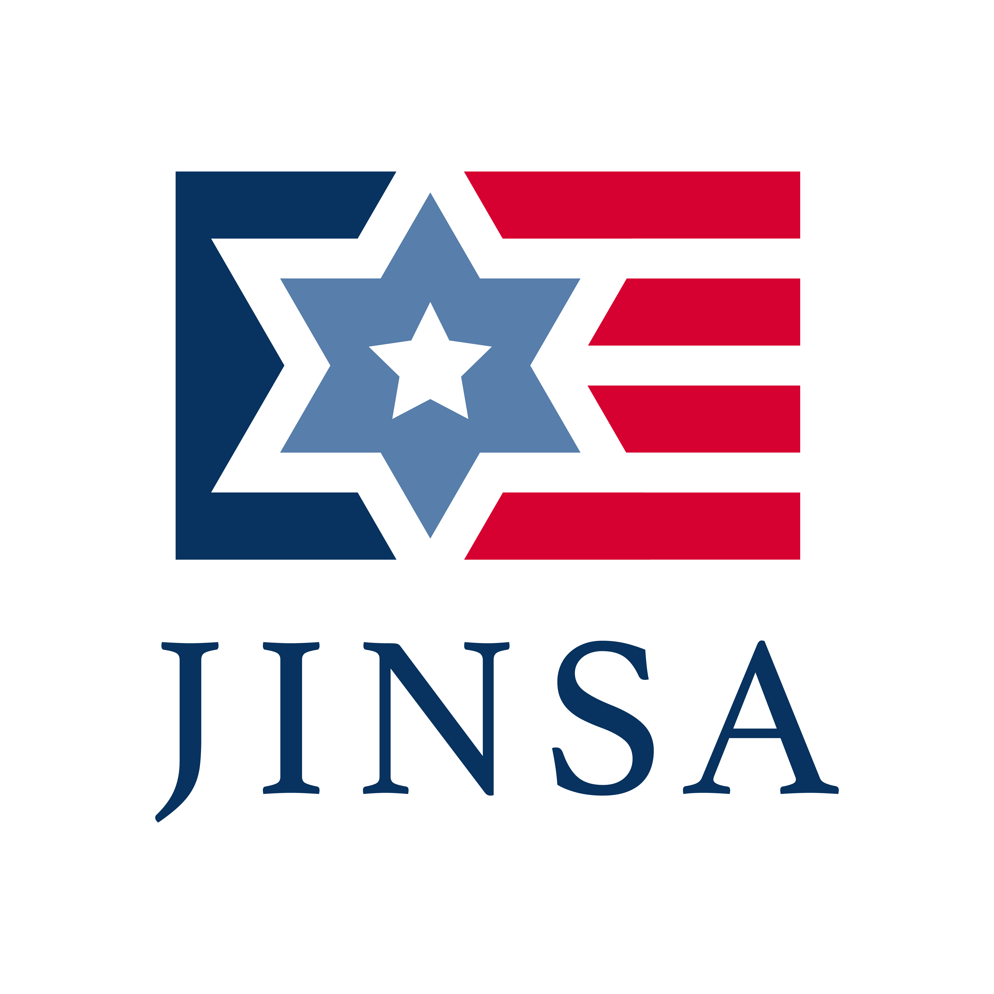

**IDF Brigadier Generals Program**

**Sunday, October 27 – Tuesday, November 5, 2019**

**About the IDF Leadership Education Program**

JINSA inaugurated the IDF Leadership Education Program in 2016 to help fill crucial knowledge gaps about the United States among current and future generation of IDF Leadership. The program will expose rising IDF officers to various American political, military, business, historical and cultural elements that inform the U.S.-Israel relationship, as well as U.S. policies towards other countries and organizations that impact Israel. It will also educate the IDF on different aspects of U.S. foreign policy and strategic thinking, and will provide them the opportunity to engage with senior American defense, political, business and other leaders that will carry forward for many years.

**About JINSA**

The Jewish Institute for National Security of America (JINSA) is dedicated to educating Congressional, military and civilian national security decision-makers on American defense and strategic interests, primarily in the Middle East, the cornerstone of which is a robust U.S.-Israeli security cooperation. JINSA believes that a strong American military and national security posture is the best guarantor of peace and the survival of our values and civilization.

**Location**

The sessions will take place at **1101 14th Street, NW, 2nd Floor\*** in Washington, D.C. unless otherwise noted.

The blue/orange/silver line at McPherson Square is two blocks away. The red line from Farragut North is approximately 10 minutes walking distance. Nearby street parking may be limited. Garage parking is available on L Street, NW between 13th and 14th streets, and on 14th Street, NW between L Street and Thomas Circle.

**Dress Code**

Dress code is uniform, except for public events.

*\* When you exit the elevators on the second floor, turn right and follow the hallway to the conference room.*

5:01 PM

Draft Schedule*

*\*All briefings will take place at 1101 14th Street, 2nd Floor unless otherwise specified.*

Sunday, October 27

*12:15 PM – 1:00 PM:* Lunch

*1:00 PM – 2:00 PM:* ***Welcoming Remarks and JINSA Intro****,* Michael Makovsky, PhD

*2:00 PM – 4:30 PM:* National Monument Tour

*5:30PM – 7:00 PM:* ***U.S. Policy in Syria,*** Vance Serchuk – Working Dinner

Monday, October 28

*9:00 AM – 10:15 AM:* ***U.S. Culture, Politics and Civil Society****,* Michael Barone

*10:15 AM – 10:30 AM:* Break

*10:30 AM – 11:45 AM:* ***American Christians and U.S. Foreign Policy****,* Robert Nicholson

*11:45 AM – 12:30 PM:* Lunch on the go/travel to Capitol Hill

*12:30 PM – 1:45 PM:* ***Role of the Executive Branch and Congress in U.S. Foreign Policy,***

Doug Feith (location: Capitol Hill)

*1:45 PM – 2:00 PM:* Break

*2:00 PM – 3:15 PM:* ***N. American Energy Trends and Impact on U.S. Foreign Policy,***

Bob McNally (location: Capitol Hill)

*3:30 PM – 4:20 PM:* ***Capitol Hill Tour***

*4:20 PM – 5:15 PM:* ***Discussion with former senior Hill staffer***

*5:15 PM – 6:00 PM:* Dinner

Tuesday, October 29

*9:00 AM – 12:00 PM:* ***Briefings at Pentagon***

*12:00 PM – 12:30 PM:* Lunch

*12:30 PM – 1:45 PM:* IDF Discussion Time

*1:45 PM – 2:00 PM:* Break

*2:00PM – 3:15 PM:* ***U.S. Policy and Strategy Towards Asia-Pacific,***VADM John Bird, USN (ret.) and Jake Sullivan

*3:15 PM – 3:30 PM:* ***U.S. Navy****,* VADM John Bird, USN (ret.)

*3:30 PM – 5:30 PM:* ***Briefings at National Security Council (White House)***

*5:30 PM – 6:30 PM:* Travel to Dinner

*6:30 PM – 8:30 PM:* ***U.S. – Israel Military Social Dinner***

Wednesday, October 30

*8:30 AM – 9:15 AM:* ***Briefing by Israeli Defense Attaché,***  MG Yehuda Fox

*9:15 AM – 9:30 AM:* Break

*9:*30 AM – 10:45 AM: ***U.S. Central Command (CENTCOM) Workshop****,* VADM Mark Fox, USN (ret.)

*10:45 AM – 11:00 AM:* Break

*11:00 AM – 12:30 PM:* ***U.S. Military Operations and Policy in Iraq/Afghanistan,***Dr. Michael O’Hanlon and LtGen John Toolan, USMC (ret.)

*12:30 PM – 12:45 PM:* ***U.S. Marine Corps****,* LtGen John Toolan, USMC (ret.)

*12:45 PM – 1:15 PM:* Lunch

*1:15 PM – 2:45 PM:* ***U.S. Perspective and Activities in Africa,***GEN David Rodriguez, USA (ret.)

*2:45 PM – 4:15 PM:* ***Historical Trends in the U.S.-Israel Relationship****,* David Makovsky and Steve Rosen

*4:15 PM – 4:30 PM:* Break

*4:30 PM – 5:30 PM:* ***Workings of the American Jewish Community,***Malcolm Hoenlein

*5:30 PM – 7:00 PM*: Break

*7:00 PM*: Movement to Capital One Arena

8:00 PM: ***Wizards vs. Rockets NBA Game***

Thursday, October 31

*9:00 AM – 10:15 AM:* ***U.S. Public Opinion on Foreign Policy,***Mark Mellman

10*:15 AM – 10:30 AM:* Break

*10:30 AM – 11:45 AM:* ***How Government and Public React to Israel in Wartime,***Mark Mellman

*11:45 AM – 12:30 PM:* Lunch

*12:30 PM – 2:30 PM:* ***Historical Themes in U.S. Foreign Policy,***Amb. Eric Edelman

*2:30 PM – 2:45 PM:* Break

*2:45 PM – 4:00 PM:* ***U.S. National Security Challenges, Policy and Policymaking,***Ambassador Eric Edelman

*4:00 PM – 4:15 PM:* Break

*4:15 PM – 5:30 PM:* ***U.S. Policy on Human Rights Case Study,***Amb. Paula Dobriansky

5:30 PM – 6:00 PM: Dinner

Friday, November 1

*8:00 AM – 11:45 AM:* ***Briefings at******National Defense University (NDU)***

*11:45 AM – 12:30 PM:* Lunch

*12:30 PM – 2:00 PM:* ***U.S.-Russia Relations,***Ambs. Stephen Rademaker and

Stephen Sestanovich

*2:00 PM – 5:00 PM:* Break prior to Shabbat

*5:43 PM:* ***Shabbat Begins***

*6:00 PM-6:30 PM:* ***Discussion with the Rabbi at Washington Hebrew Reform Congregation***

*6:30 PM-7:30 PM:* ***Shabbat Service at Washington Hebrew Reform Congregation***

*8:00 PM:* Shabbat dinner at 6th & I Historic Synagogue

Saturday, November 2

8:00 AM: Field trip to Mt. Vernon, includes stop at Tangier Outlets

Sunday, November 3

*9:15 AM – 10:30 AM:* ***Defining Political Themes in U.S. History,***Dr. Bill Kristol

*10:30 AM – 10:45 AM:* Break

*10:45 AM – 12:00 PM:* ***U.S. Budget and Foreign Aid,***Steve Bell

*12:00 PM – 12:45 PM:* Lunch

*12:45 PM – 2:00 PM:* ***U.S. European Command (EUCOM),*** *Gen Frank Gorenc, USAF (ret.)*

*2:00PM – 2:15 PM:* ***U.S. Air Force,*** *Gen Frank Gorenc, USAF (ret.)*

*2:15PM – 2:30PM:* Break

*2:30 PM – 3:45PM:* ***U.S. Policy on Iran’s Nuclear Program and Regional Aggression,*** Michael Makovsky, PhD and Jonathan Ruhe

*3:45 PM – 5:00 PM:* IDF DiscussionTime

*5:00 PM:* Dinner

Monday, November 4

*9:30 AM – 10:45 AM:* ***U.S. Policy on Turkey,***Dr. Svante Cornell and Alan Makovsky

*10:45 AM – 11:00 AM:* Break

*11:00 AM – 12:15 PM:* ***Case Study: 2007 Syria Reactor Attack,*** Amb. Elliott Abrams

*12:15 PM – 1:15 PM:* Lunch and Movement to Embassy

*1:15 PM – 2:30 PM:* ***U.S. Policy Toward the Middle East and Israel,*** Amb. Dennis Ross

*2:30 PM – 2:45 PM:* Break

*2:45 PM – 4:00 PM:* ***Politics of American Jews,***Dr. Tevi Troy and William Daroff

*4:00 PM – 4:15 PM:* Break

*4:15 PM – 4:35 PM:* ***Israeli Embassy Presentation***

*4:35 PM – 5:30 PM:* ***Internal IDF Wrap-Up Session***

*6:30 PM – 7:45 PM: Farewell Dinner at Char Bar*

Tuesday November 5

*9:00 AM – 10:15 AM****: U.S. Media Coverage of Israel and the Middle East,*** Jackson Diehl and Seth Mandel

*10:15 AM – 10:30 AM:* Break

*10:30 AM – 11:45 AM:* ***President Trump: His Policies and Decision-Making,***Dr. Ken Weinstein

*11:45 AM – 12:30 PM:* ***Wrap-up Session***

*12:30 PM – 1:30 PM:* ***Discussion with Israeli Ambassador Ron Dermer***

*2:00PM:* Depart for Airport

*\* All sessions are subject to change. This is a confidential document not meant for public consumption*

Instructors

**Ambassador Elliott Abrams** – Trump administration special envoy overseeing policy toward Venezuela; former Deputy Assistant to the President and Deputy National Security Advisor to President George W. Bush.

**Michael Barone** – Resident Fellow, American Enterprise Institute; senior political analyst, *The Washington Examiner;* author and journalist.

**Steve Bell** – Senior Advisor, Bipartisan Policy Center; former Defense and Energy Budget Analyst for Senate Budget and Senate Appropriations Committees.

**Vice Admiral John Bird, USN (ret.)** – JINSA 2014 Generals and Admirals Program participant, Iran Policy Project member and Hybrid Warfare Policy Project member; former Commander, U.S. 7th Fleet; former Director of the Navy Staff; currently Senior Vice President of Military Affairs, USAA.

**Dr. Svante Cornell –** JINSA Policy Advisor and Director of the American Foreign Policy Council's Central Asia-Caucasus Institute and Director and co-founder of the Institute for Security and Development Policy, Stockholm.

**William Daroff** – Chief Executive Officer of the Conference of Presidents of Major American Jewish Organizations starting Feb. 2020; current Senior Vice President for Public Policy and Washington Office Director, The Jewish Federations of North America.

**Ambassador Ron Dermer –** Israel’s Ambassador to the United States.

**Jackson Diehl** – Deputy Editorial Page Editor, *The Washington Post.*

**Ambassador Paula Dobriansky -** Senior Fellow in the Future of Diplomacy Project at Harvard University’s JFK Belfer Center for Science and International Affairs; former Under Secretary of State for Democracy and Global Affairs.

**Ambassador Eric Edelman** – Counselor at the Center for Strategic and Budgetary Assessments; Roger Hertog Distinguished Practitioner-in-Residence at the Philip Merrill Center for Strategic Studies, John Hopkins School of Advanced International Studies; former Undersecretary of Defense for Policy.

**Hon. Douglas Feith -** Senior Fellow at the Hudson Institute and former Under Secretary of Defense for Policy.

**VADM Mark Fox, USN (ret.) –**2018 JINSA Generals and Admirals Program participant and 2019 Gettler International Program trip participant and Eastern Mediterranean Policy Project member; former Deputy Commander, US Central Command.

**IDF Major General Yehuda Fox** – Israeli Defense Attaché to the United States and Canada.

**Gen Frank Gorenc, USAF (ret.) –** JINSA 2019 Generals and Admirals Program participant; former Commander, USAF Europe and Commander USAF Africa and Commander, NATO Allied Air Command.

**Malcolm Hoenlein –** Executive Vice Chairman of the Conference of Presidents of Major American Jewish Organizations.

**Dr. William Kristol** – Founder and former Editor-at-large, *The Weekly Standard.*

**Alan Makovsky -** Senior Fellow for National Security and International Policy at Center for American Progress.

**David Makovsky –** Ziegler distinguished fellow at The Washington Institute and director of the Project on Arab-Israel relations.

**Michael Makovsky, PhD** – JINSA President and CEO.

**Seth Mandel -**  Executive editor, *The Washington Examiner.*

**Bob McNally –** Founder & President of Rapidan Energy Group; former Special Assistant to the President on the National Economic Council and Senior Director for International Energy on the National Security Council in George Bush’s administration.

**Mark Mellman** – President & CEO of the Mellman Group; President of the American Association of Political Consultants.

**Robert Nicholson** – Executive Director, Philos Project.

**Dr. Michael O’Hanlon** – Senior Fellow, and director of research, in Foreign Policy at the Brookings Institution.

**Hon. Stephen Rademaker** – Senior Adviser, JINSA Gemunder Center for Defense and Strategy; Senior of Counsel, Covington & Burling LLP; former Assistant Secretary of State.

**GEN David Rodriguez, USA (ret.)** –JINSA 2018 Generals and Admirals Program Participant, and 2019 Gettler International Program trip participant and Eastern Mediterranean Policy Project member; former Commander, USAFRICOM.

**Steven J. Rosen** – Former Director of Foreign Policy Issues, American Israel Public Affairs Committee.

**Ambassador Dennis Ross** – Distinguished Fellow, Washington Institute for Near East Policy; former Special Assistant to President Obama and National Security Council Senior Director for the Central Region.

**Jonathan Ruhe ­–**Director of Foreign Policy at JINSA’s Gemunder Center for Defense and Strategy.

**Vance Serchuk –** adjunct senior fellow at the Center for a New American Security and former senior foreign policy advisor to Senator Joseph Lieberman (I-CT) and professional staff member on the Senate Homeland Security and Governmental Affairs Committee.

**Ambassador Stephen Sestanovich -** George F. Kennan senior fellow for Russian and Eurasian studies at the Council on Foreign Relations and the Kathryn and Shelby Cullom Davis professor of international diplomacy at Columbia University’s School of International and Public Affairs; former ambassador-at-large and special advisor to the Secretary of State on the New Independent States (NIS).

**Jake Sullivan** –nonresident senior fellow in Carnegie’s Geoeconomics and Strategy Program and also a Martin R. Flug visiting lecturer in law at Yale Law School; former National Security Advisor to Vice President Joe Biden; former Director of Policy Planning, U.S. Department of State; former Deputy Chief of Staff to Secretary of State Hillary Clinton.

**LtGen John Toolan, USMC (ret.) –**2018 JINSA Generals and Admirals Program Participant, and Hybrid Warfare Policy Project member; former Commander, Marine Forces Pacific.

**Dr. Tevi Troy –**Vice President of Public Policy at JUUL Labs; former Deputy Secretary of the U.S. Department of Health and Human Services.

**Dr. Ken Weinstein** - President and Chief Executive Officer of Hudson Institute.