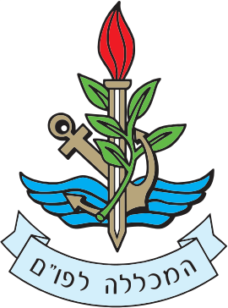

To Whom It May Concern

Re: Major Ido Soceanu – Concluding his Role as Head of the International Fellowship and
Cooperation Desk at the INDC and the Military Colleges

- Major Soceanu is concluding a chapter of his service in the IDF and is turning towards his academic endeavors.
I would like to express my appreciation and thank Major Soceanu for his diverse and rich contribution to the IDF.

- Major Soceanu has been in charge of the International participants and foreign relations at the Israel National Defense College for the past two years. Before that, he served in various roles including his position as Head of the North America Desk.

- Major Soceanu has an impressive academic background and demonstrates high personal abilities.

- Thank you Major Soceanu, all the best in the future.

- Regards,

Udi Ben Moha, Brigadier General
Commandant of the IDF
Command & Staff College

