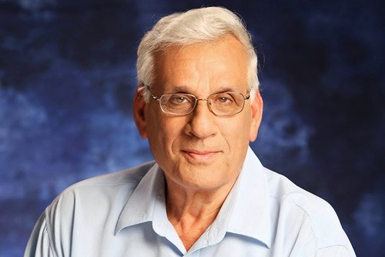**Former Minister Haim Oron (Jumes)**

**Mr. Oron** was born in Tel Aviv to polish immigrants, Haim Oron is commonly known by the nickname “Jumes” (sycamore fruit in Arabic).

Oron enlisted in 1958, and served in the IDF’s airborne [Nahal](https://en.wikipedia.org/wiki/Nahal" \o "Nahal) brigade. During his service, he and his wife Nili joined Kibbutz Lahav where they still live to this day.

In 1964, Oron was appointment secretary of the “HaShomer HaTzair” movement and in 1964 he became the youngest to serve as the secretary of the National Kibbutz Movement.

In 1994, he joined the “Histadrut” union and was named Head Treasurer.

He later served in the 12th through the 18th Knesset.

In 1999, Oron was appointed Minister of Agriculture. A year later he resigned in order to enable another party member to join in his place. He later became the Chairperson of the Meretz party and returned to the Knesset in 2003. In that same year he was one of the leaders of the Geneva Accord to put an end to the Palestinian-Israeli conflict.

In 2005 Oron was presented with the Quality in Government Award by the Movement for Quality Government in Israel.

During his many years in the Knesset, Oron led and passed many laws concerning health while voicing calls to end the conflict with the Palestinians.

Upon leaving the political arena, Haim Oron was appointed Head of the Administrative Committee of the Society for the Protection on Nature in Israel.

In February 2013, Oron was appointed by then governor of the [Bank of Israel](https://en.wikipedia.org/wiki/Bank_of_Israel), Mr. Stanley Fischer as a member of the director appointing committee.

Haim Oron is married and has four children, one of whom is Brigadier General in the Air force and another, a Squadron Commander.