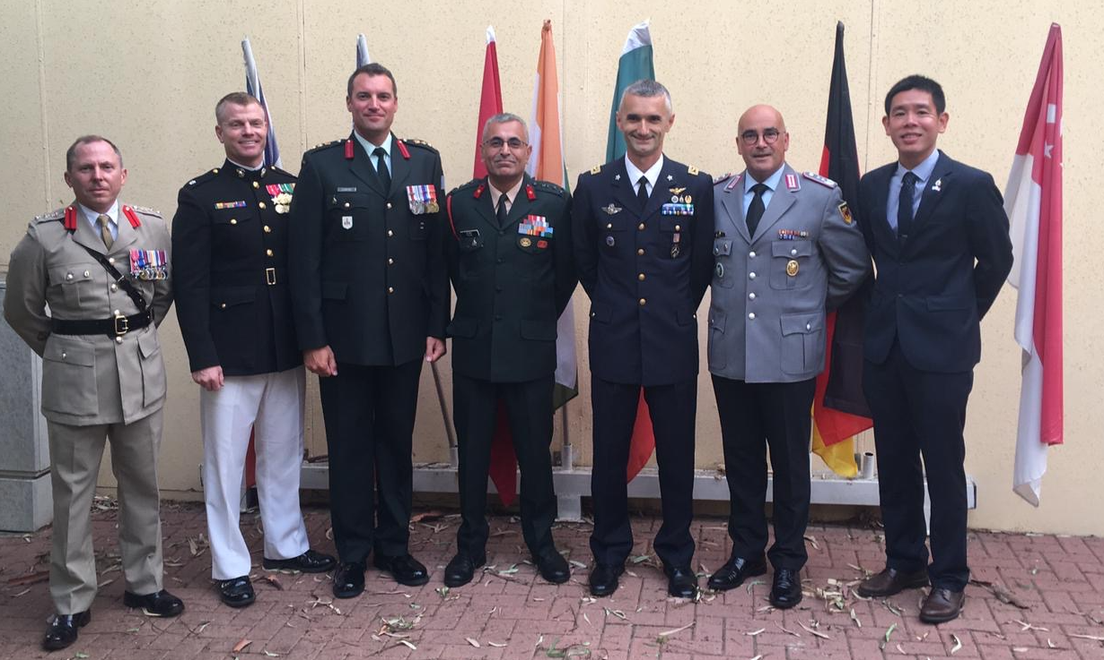

Presented to the Commander, Instructors, Staff and Soldiers of the INDC with gratitude from the International Students of the 46th Class (2018 – 2019)

L to R: Col Jim Priest (British Army), Lt Col Seth MacCutcheon (USMC), Col Patrick Lemyre (Canadian Army), Brig Raju Baijal (Indian Army), Col Eros Zaniboni (Italian Air Force),

Col Klaus Harrer (German Army), Col Teng Shin Fong (Singapore Army)