**Attachment C**

**Administrative arrangements**

**Location**

The conference venue will be in the “Fanehallen” (building 65) at the Akershus fortress area, centrally situated in Oslo. The “outer” fortress area with the main gate and the “Fanehallen” is illustrated on the picture and map below. 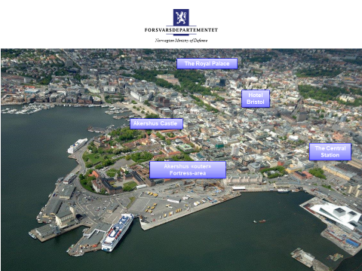

[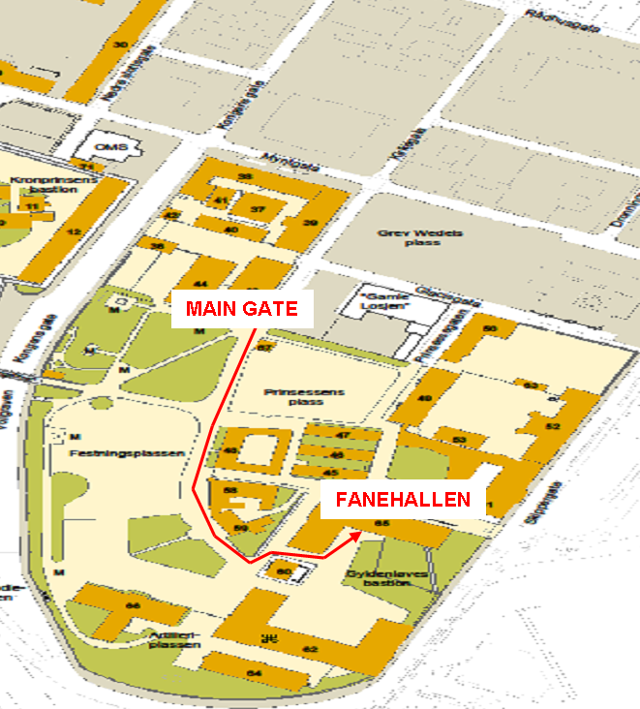](https://www.google.no/url?sa=i&rct=j&q=&esrc=s&source=images&cd=&cad=rja&uact=8&ved=2ahUKEwiZ7Jr_-9DbAhWQhqYKHWHOBigQjRx6BAgBEAU&url=http://www.artilleri.no/side20.html&psig=AOvVaw0q_PK3qX48f26LdTDhwOaA&ust=1528990594727751)

**Hotel**

It is the responsibility of individual national delegates to book accommodation. A block reservation for delegates has been made at Hotel Bristol, Kristian IVs gate 7, 0168 Oslo. The rates per night are as follows:

* Standard room - 1 person in room: NOK 1420
* Standard room - 2 persons in room: NOK 1720

The booking arrangement is valid until 24. September. For booking, please use the following link to the hotel: <https://www.thonhotels.com/event/33rd-ncg-conference/>

**Transport**

Transport to the centre of Oslo has to be arranged individually. Oslo is served by Oslo Airport Gardermoen. It is easy access by airport train to Oslo Central Station or by airport bus. The airport bus stops right outside Hotel Bristol.

During the conference, transport will be arranged between Hotel Bristol and the conference venue. On 26. October, transport from the conference venue to Gardermoen airport will be available after lunch.

**Security**

The venue takes place at a military, but unclassified area, open for the public. However, the actual location (building 65) will be guarded during the meetings and NCG-delegates will be the only group inside the building. Delegates have to fill in the Personal Administration Form (PAM), but Request for Visit is not necessary.

Delegates are requested to have their conference name cards visible during the meetings.

**Dress code**

Military delegates are requested to wear their office uniform or smart casual at the meetings, in accordance with own national regulations.

The dress code for the hosted dinner 25. October is the same as for the meetings.

**Meals**

Lunch will be served at the conference venue both days. Coffee, tea and refreshments will be provided throughout the day. On the evening of the first day of meetings, 25. October, a hosted dinner will be offered. Other meals will be the responsibility of national delegates.

**Registration**

All NCG participants are requested to complete the PAM (Attachment D) and return it to our POC no later than 10. September.

Registration for the conference will take place during the Icebreaker at Hotel Bristol 24. October, between 18.00 and 20.00.

**Briefings**

National presentations has to be confirmed via our POC no later than 25. September.

**IT**

All necessary IT will be provided for at the conference venue. Specific requests must be addressed to the POC**.**