July 2018

**INDC International Alumni Network**

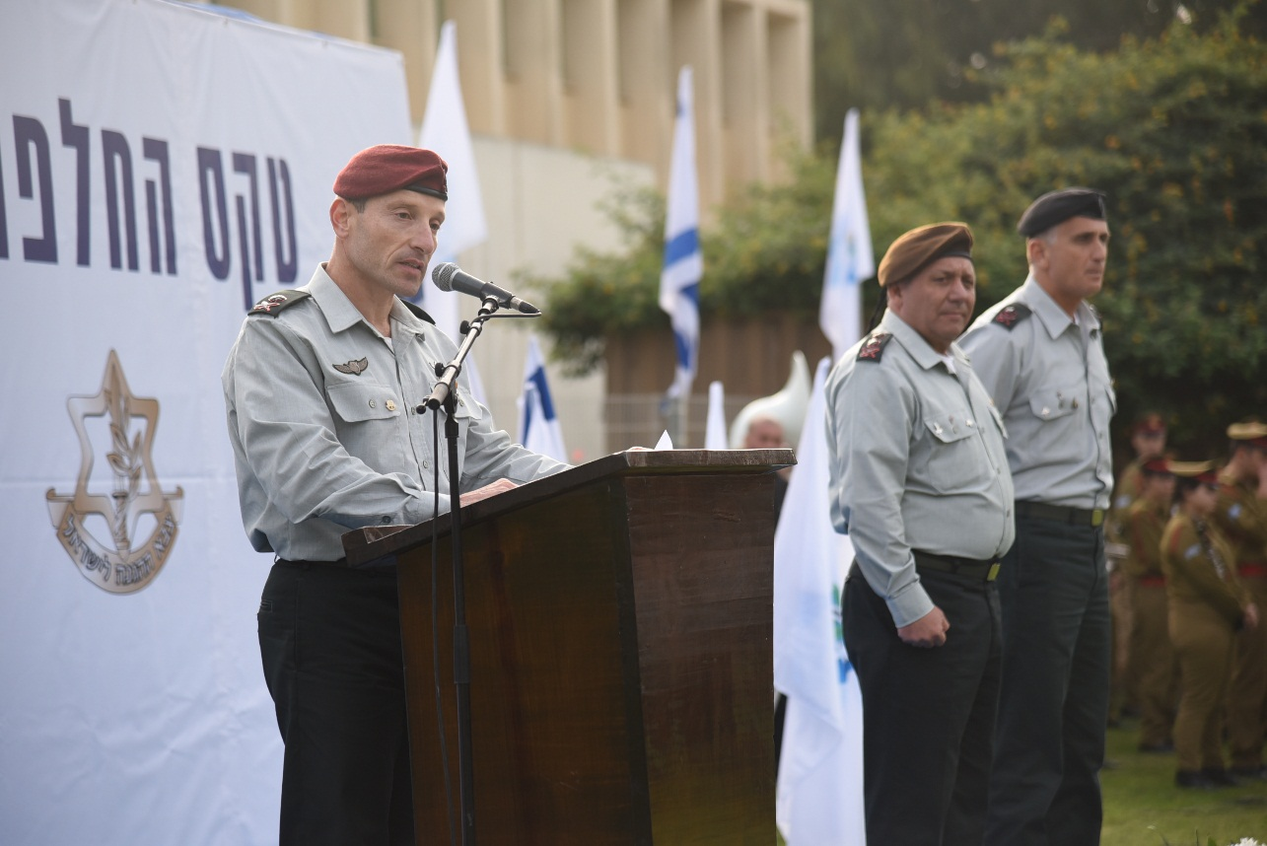

Dear Israel National Defense College alumni,

We would like to inform you of the creation of the INDC international alumni network

We hope this platform will serve you as a gateway to staying in touch with the INDC, receiving updates on the IDF colleges and fellow alumni, and act as a point of contact for any questions.

We began 2018 with the ceremony of the change of command of the INDC.

MG Tamir Hayman completed his two and a half year term in office and will be appointed Head of the Intelligence Directorate in coming days.

MG Amir Baram has received the mantel of commander of the IDF Colleges during a ceremony on January 3rd.

Please feel free to contact us with any queries or comments

We look forward to seeing you on your next visit to the area.

With the warmest regards and a happy new year,

**MAJ Ido Soceanu**Head of the International Fellowship  
& International Relations Desk  
Israel Defense Forces