**INSTRUCTIONS FOR CONNECTING TO A NATO UNCLASSIFIED VTC**

The following instructions will allow a user who is not using NATO systems to connect to a NATO UNCLAS VTC.

1. In order to connect into NATO VTC you must have a SIP or H323 capable device or VTC service. For information NATO uses POLYCOM.
   1. If you do not already have a SIP or H323 capability then it is possible to obtain the “Polycom Real Presence Desktop” software on a free 30 day trial license. This can be easily installed in a laptop which has a webcam and internet access. The software is available at the following URL: <https://www.polycom.com/forms/try-realpresence-desktop-trial-thankyou.html>
   2. Once you have installed the Polycom Real Presence Desktop software the first time it is used you must select the **"individual account"** option and NOT the "enterprise sign-in". Then select "continue" for the 30 day trial. (unless you already have purchased a licence).
   3. Once the Polycom Real Presence Desktop software is configured as an individual user you are now able to dial into NATO Virtual Meeting Rooms.
   4. Alternately, it is also possible to install the “Polycom RealPresence Mobile-Phone” app on a smartphone. There is no need to register or enter any account details in the smartphone app, simply install and dial following the instructions in Para 2.
2. In order to connect to a NATO VTC (often called a Virtual Meeting Room (VMR)) you should dial the following:
   1. <VMR>@nato.int. The VMR number will be provided to you by the VTC organiser.[1]
   2. A VMR number is in the format 95800054xxxxx where xxxxx is the specific 5 digit conference number.
3. In order for you to test the ability of your VTC system or software to connect into NATO VMRs there is an official VTC Control Centre test VMR which is available 24/7.
   1. The VMR number for the test conference is: 9580005483177
   2. To dial into the test VMR you should dial the following:

9580005483177@nato.int

1. If your connection is successful you will either see the other conference participants or get a NCIA VTC welcome slide and message telling you that you have joined the conference

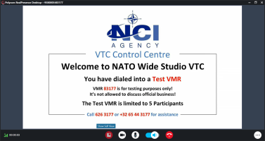

Notes:

1. It may be that your internet service provider, DNS server or firewall configuration prevents you achieving a connection. For this reason a selection of alternate dial strings are available. All of the following should be attempted as some may work while some do not.

<VMR>@81.246.126.51

<VMR>@natovideogateway1.nato.int

<VMR>@nato.int

<VMR>@natovideogateway2.nato.int

<VMR>@62.134.186.43

1. It may be that your internet provider, DNS server or firewall configuration prevents you achieving a connection. For this reason a selection of alternate dial strings are available and are listed at the end of this guide.