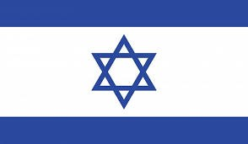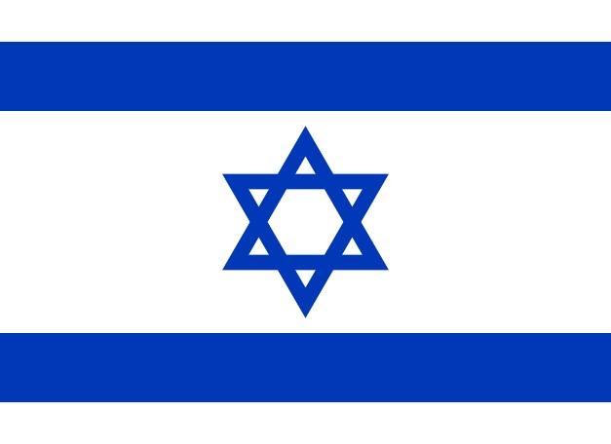

Welcome to ISRAEL

Some Facts and Figures

The Israel National Defense College

The Middle East

In Numbers

Area (km2)

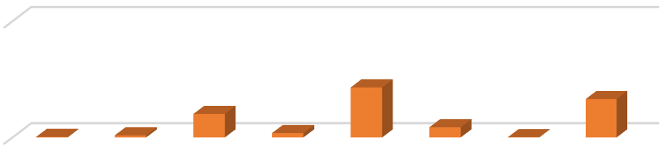

Area

0

5,000,000

22,000

89,342

1,010,407

185,180

2,149,690

437,072

10,452

1,648,195

Population (M)

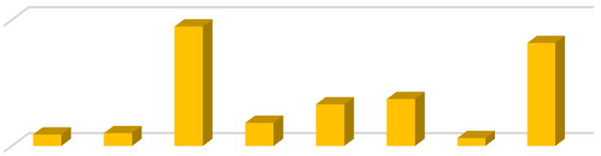

Population (M)

-

100.00

9.03

10.10

94.80

18.30

33.00

37.20

6.18

81.67

GDP/Capita ($)

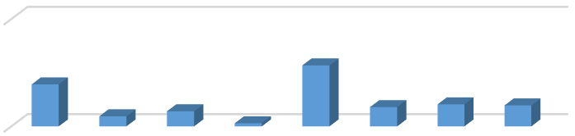

GDP/Capita ($)

0

100,000

39,106

9,406

14,080

2,900

56,817

17,957

20,543

19,541

[https://en.wikipedia.org](https://en.wikipedia.org/)

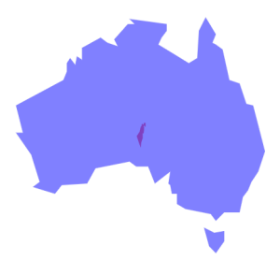

Canada

China

United

States

Australia

Sweden

Poland

Germany

France

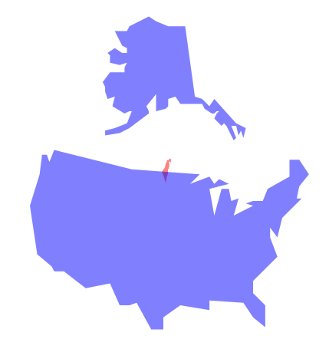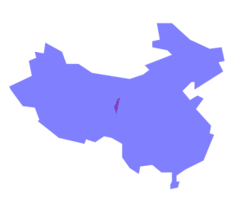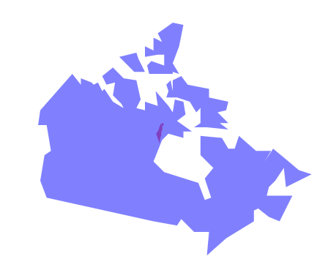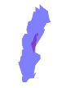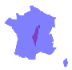

Israel

Proportions

Kingdom

Ghana

Italy

Greece

Norway

United

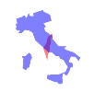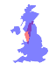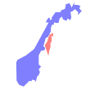

Denmark

Netherlands

Belgium

Singapore

Switzerland

Iceland



Israel

Landmarks

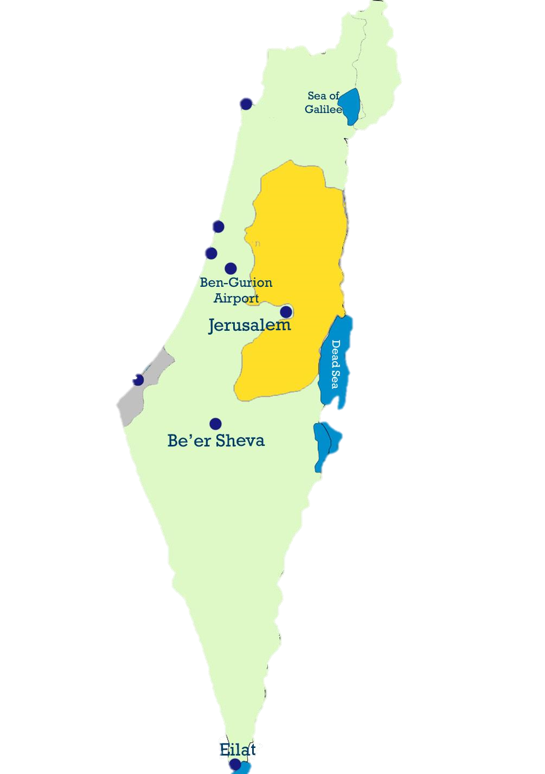

Haifa

Gaza

Herzliya

Tel Aviv

-

Jaffa

The Dead Sea

Negev



Sea of Galilee

Mount

Hermon

Mount Hermon is a mountain cluster constituting the southern end of the Anti-Lebanon Mountain Range.

Mount Hermon

Its summit straddles the border between Syria and Lebanon and, at 2,814 m (9,232 ft.) above sea level, is the highest point in the area.

Most of the mountain in Israeli territory is a nature reserve. There are four Israeli towns on the mountain, two Jewish (Neve Ative and Nimrod) and two Druze (Majdal Shamse and Ein Qiniyye).

The southern slopes of Mount Hermon extend to Israel, where the Mount Hermon ski resort is located. Mount Hermon is Israel’s only winter ski and snowboard resort. The peak in this area rises to 2,236 m (7,336 ft.), the highest in Israel.

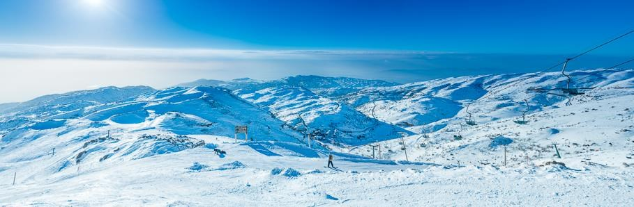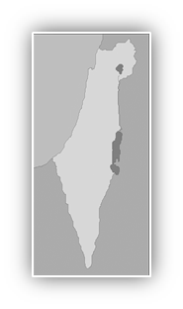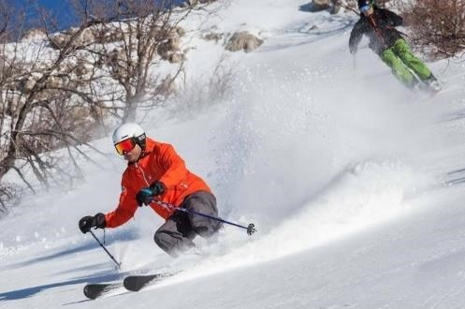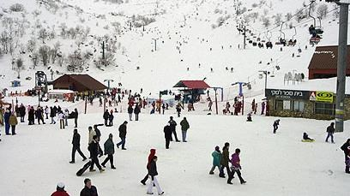

Sea of Galilee

The Sea of Galilee (Kinneret) is the largest freshwater lake in Israel. In previous years it was the source of 25% of the water consumption in Israel, but due to drought, today it is the source of only 2%.

The Sea of Galilee has significant religious significance, and is considered one of the main sites for Christian visitors to Israel. According to the New Testament, some of Jesus' miracles were held in the Sea of Galilee.

It is approximately 53 km (33 mi) in circumference, about 21 km (13 mi) long, and 13 km (8.1 mi) wide. Its maximum depth is approximately 43 m (141 feet).

At levels between 215 meters (705 ft.) and 209 meters (686 ft.) below sea level, it is the lowest freshwater lake on Earth and the second lowest lake in the world (after the Dead Sea).

The lake is fed partly by underground springs, although its main source is the Jordan River, which flows through it from north to south.

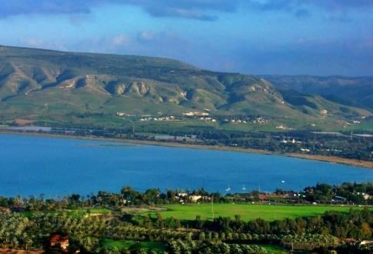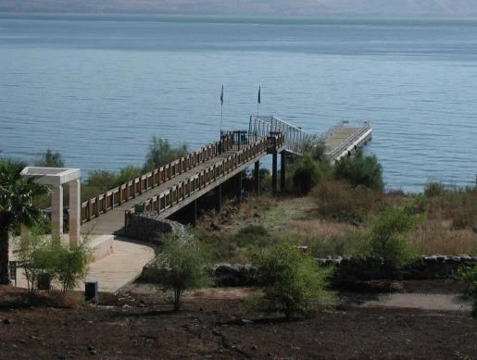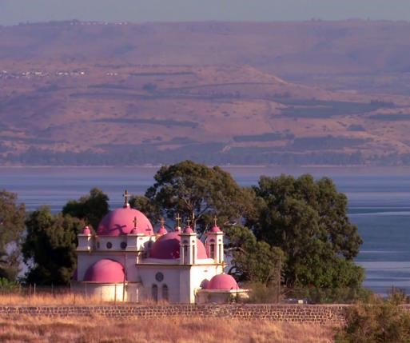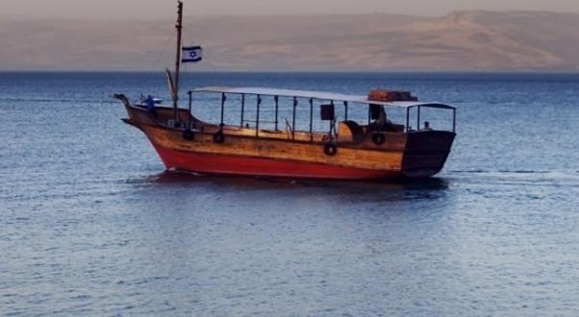

Herzliya

Herzliya is a city in the central coast of Israel, at the Northern part of the Tel Aviv District, known for its robust start-up and entrepreneurial culture.

Herzliya has a population of approximately 100,000. The city is named after Theodor Herzl, the founder of modern Zionism and is considered to be the visionary of Israel. The beautiful Herzliya Marina was built in the 1970s.

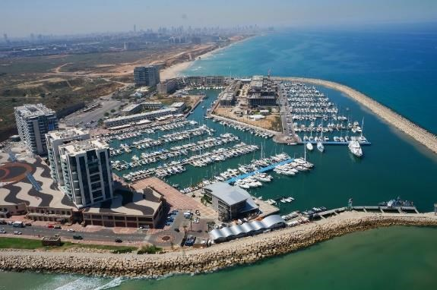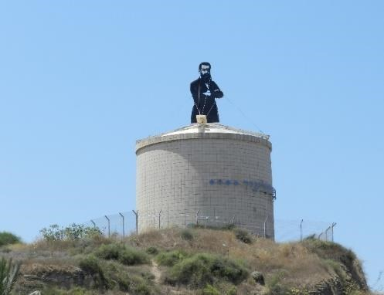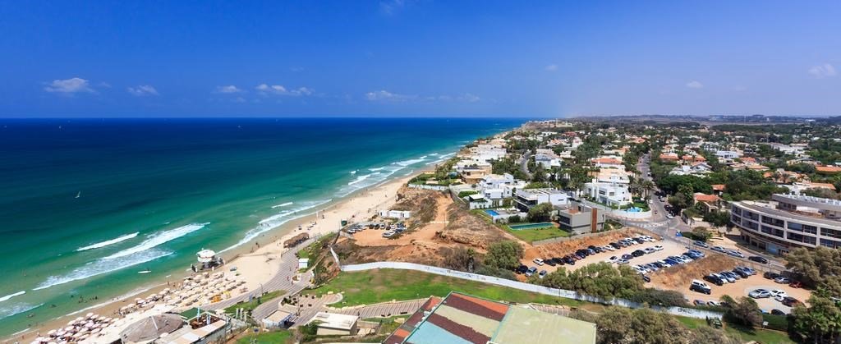

Tel Aviv - Jaffa

Tel Aviv is the second most populous city in Israel—after Jerusalem—and the most populous city in the conurbation of Gush Dan, Israel's largest metropolitan area.

Located on the country's Mediterranean coastline and with a population of 443,939, it is the economic and technological center of the country.

The city was founded in 1909 by the Yishuv (Jewish residents) as a modern housing estate on the outskirts of the old port city of Jaffa, then part of the Jerusalem province of Ottoman Syria.

It was at first called Ahuzat Bayit (lit. "Building Houses", the name of the association which established the neighborhood). The name changed the following year to Tel Aviv, which means "Ancient Hill of Spring".

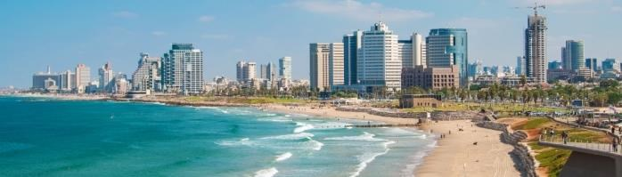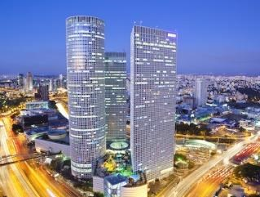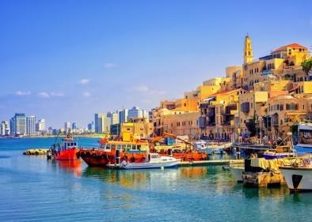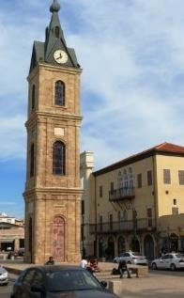

Jerusalem

Jerusalem is the capital of Israel. Jerusalem is one of the oldest cities in the world. The part of Jerusalem called the City of David shows the first signs of settlement in the 4th millennium BCE.

The city is considered holy to many religious and ethnic groups. Its a place of outmost importance to the three major Abrahamic religions - Judaism, Christianity, and Islam.

Jerusalem is situated on the southern spur of a plateau in the Judean Mountains, which include the Mount of Olives (East) and Mount Scopus (North East).

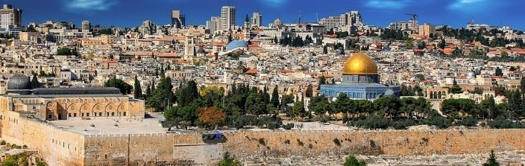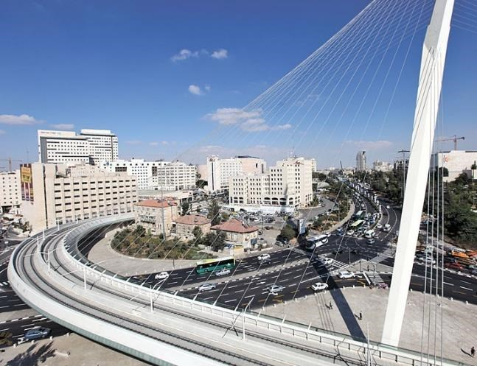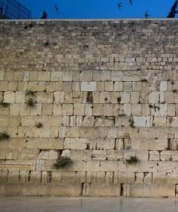

The Negev

The Negev is desert and semi desert region of southern Israel.

The region's largest city and administrative capital is Be'er Sheva, in the north. At its southern end is the Red Ses and the resort city of Eilat.

The Negev contains many towns, including the cities of Dimona, Arad and Mitzpe Ramon, as well as a number of Bedouin cities and villages, such as Rahat and Lakyah. There are also several kibbutzim.

The desert is home to the Ben-Gurion University of the Negev. One of the most impressive sites in the Negev is Masada, an ancient fortification situated on top of an isolated rock plateau.

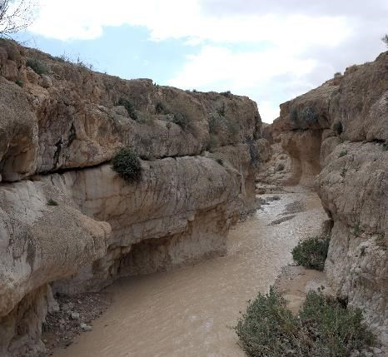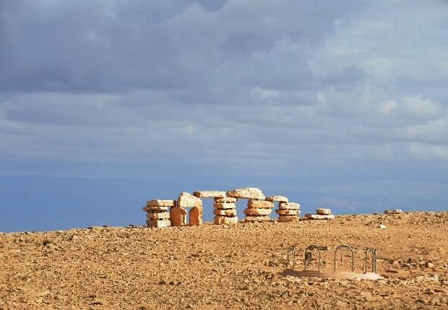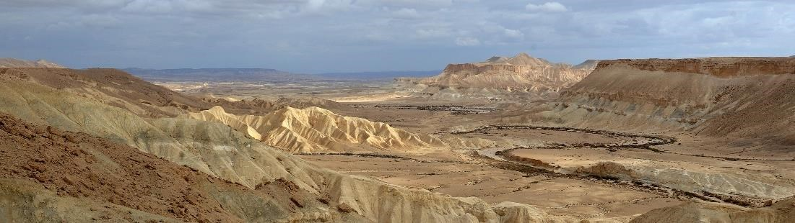

The Dead Sea

The Dead Sea is a salt lake bordered by Jordan to the east and Israel to the west.

It lies in the Jordan Rift Valley, and its main tributary is the Jordan River.

Its surface and shores are 430.5 m (1,412 ft.) below sea level, Earth's lowest elevation on land.

It is 304 m (997 ft.) deep, the deepest hypersaline lake in the world. With a salinity of 34.2% (in 2011), it is one of the world's saltiest bodies of water – 9.6 times as salty as the ocean – and has a density of 1.24 kg/liter, which makes swimming similar to floating. This salinity makes for a harsh environment in which most plants and animals cannot flourish, hence the name of the lake.

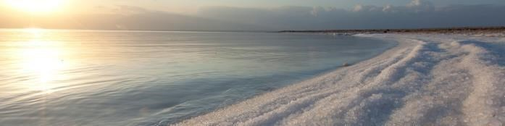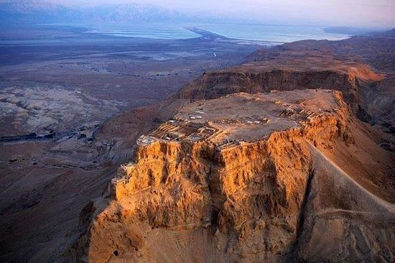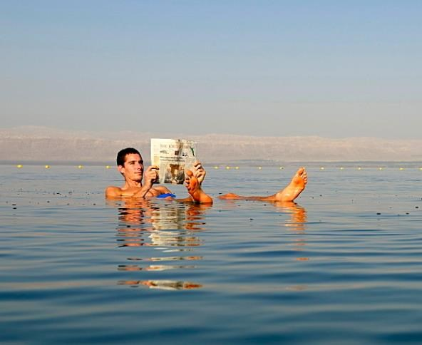

Eilat

Eilat is Israel's southernmost city, a busy port and popular resort located at the northern tip of the Red Sea, on the Gulf of Eilat.

The city's beaches, coral reef, nightlife and desert landscapes make it a popular destination for domestic and international tourism.

Eilat's arid desert climate and low humidity are moderated by proximity to a warm sea.

Temperatures often exceed 40 °C (104 °F) in summer, and 21 °C (70 °F) in winter, while water temperatures range between 20 and 26 °C (68 and 79 °F). Eilat averages 360 sunny days a year

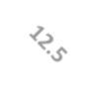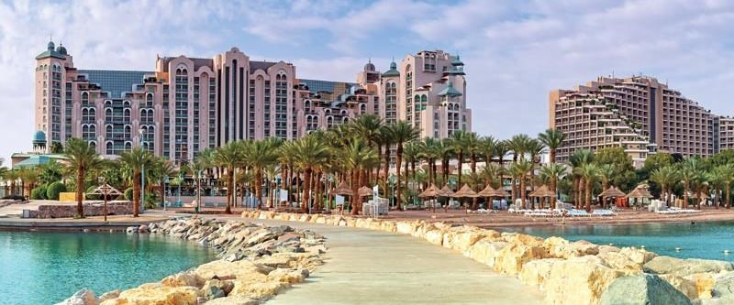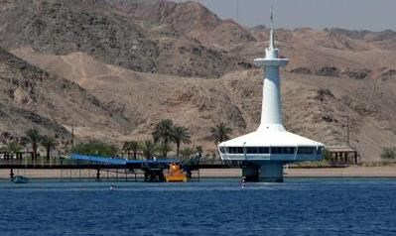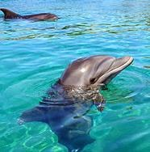

.

Some of Israel's Achievements

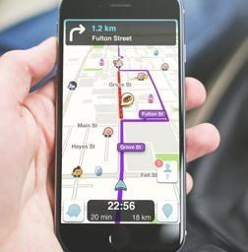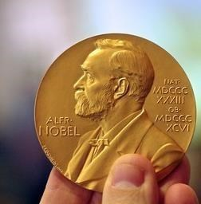

Pill Cam

Drip Irrigation

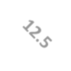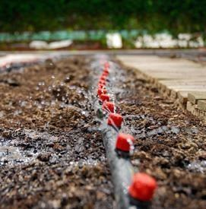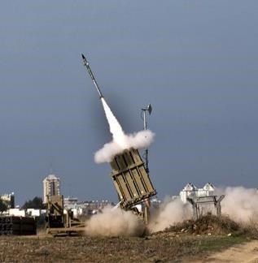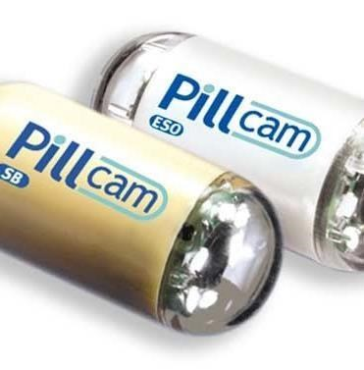

Iron Dome

Flash Drive

Waze

12 Nobel Prizes