|  |  |
| --- | --- |
| Description: DAoUK_BLK_AW | **John Hughes**  Development Faculty Coordinator  Defence Academy of the United Kingdom  Shrivenham, Swindon SN6 8LA  Telephone: ++44 (0)1793 788014 Mil: [96161] 8014  E-Mail: [DEFAC-JSCSC-DAconference@da.mod.uk](mailto:DEFAC-JSCSC-DAconference@da.mod.uk)  [www.da.mod.uk](http://www.da.mod.uk)  1 May 19 |

**DEFENCE ACADEMY ANNUAL CONFERENCE 2019: 21-23 MAY**

**‘PUTTING MODERN DETERRENCE INTO PRACTICE’**

**Conference Overview and Aim**

1. This inaugural Defence Academy Annual Conference is an opportunity for military, academic, civil service, industry and international alliances to debate the future of Modern Deterrence; determining the ‘what is’ and the ‘how to’ of Modern Deterrence such that current and future interested parties will gain maximum insight and advantage. The Conference aims to expose debate and work through scenarios based on some of the excellent current international thought and practice being carried out independently from each other and/or in closed groups. This then forms a collective view of the challenges, opportunities and solution sets for Modern Deterrence. It is centred on establishing: a better-informed, focussed and collaborative network of practitioners and strategic thinkers that can add real understanding, synergy, and a recognisable benchmark.
2. The Conference will include a key note speaker, panel discussions, papers and scenario-based workshops that seek to elicit the purpose and future of Modern Deterrence.

**Participation**

1. **Delegate Participation.** The Conference is aimed at an international audience of practitioners and theorists. A willingness to contribute shared experience and innovation is vital. Delegates are requested to bring and share their experience of Modern Deterrence which have succeeded, or failed, which all delegates can learn from.
2. **Conference Venue.** The Conference will be held at the Defence Academy of the United Kingdom’s main site at [Shrivenham](https://www.da.mod.uk/contact-us). The Conference will take place in the Cormorant Building, the home of the Joint Services Command and Staff College (JSCSC). Delegates will be accommodated within this building and only the Evening Reception on Tue May 21st will be held outside of this building.
3. **Outline Programme**. The Conference will run from 1830hrs on Tue May 21st to 1530hrs on Thu 23rd May. A detailed programme will be included in your Welcome Pack, which you will receive on your arrival at the Defence Academy. An outline the overarching of the conference can be found at this link: [Deterrence Conference Programme](https://www.da.mod.uk/Portals/0/Deterrence%20conference/20190207-Def_Ac_Deterrence_Conf_Flyer_V2.0.pdf?ver=2019-03-19-145113-563%20) .The conference will include the following activities:
   1. **Evening Reception**. The Defence Academy will host an Evening Reception from 1830-2030hrs on Tue 21st May at the Technology School. Transport will be available, or delegates may wish to walk/self-drive the distance of 800m. The dress will be casual (non-denim trousers and open-necked shirt, or equivalent).
   2. **Deterrence Conference**. The Conference will start at 0900hrs on Wed 22nd May in the Cormorant Lecture Theatre (CLT). The dress will be normal working dress for military and jacket and tie for civilians, or equivalent.
   3. **Formal Dinner**. The Defence Academy will host a Formal Dinner from 1900-2300hrs on Wed 22nd May in the Cormorant building. The dress will be lounge suit or equivalent.
   4. **Closing Address**. The Conference will close on Thu 23rd May at 1530hrs.
4. **Conference Fee**. The Conference is free to serving UK military and Civil Servants. There will be a conference fee of £75 for all other delegates. This fee covers administrative costs, conference services and catering. Please click on the URL below to pay with Credit / Debit card.

<https://www.gov.uk/payments/defence-academy-of-uk/defence-academy-deterrence-conference-21-23-may-19>

By clicking on this URL and completing the payment you are confirming acceptance of the Defence Academy’s Terms & Conditions which are available at <https://www.da.mod.uk/>.

1. **Administration**. Administrative details for the Conference and the Defence Academy are available at Annex A. Conference delegates will receive a Welcome Pack on arrival at the Defence Academy which will provide full details of the structure of the Conference.
2. **Travel**. Conference delegates are requested to organise their own transport to the Defence Academy’s main site Shrivenham. Detailed travel information for reaching the Defence Academy Shrivenham is at Annex B.
3. **Conference Contacts**. If you have any questions then please contact the conference planning team via the Group Inbox at:

[DEFAC-JSCSC-DAconference@da.mod.uk](mailto:DEFAC-JSCSC-DAconference@da.mod.uk)

Annexes:

A. Administrative instructions.

B. Location maps and travel instructions.

**Annex A to**

**Det Conf JI**

**Dated 1 May 19**

**MODERN DETERRENCE CONFERENCE 21 – 23 MAY 19**

**'Putting Modern Deterrence into Practice’**

**Administrative Instruction**

1. **Arrival**. You will need to have some form of valid photographic identification with you, e.g. your passport, to show at the Main Visitors’ Reception (MVR). Accommodation in the Cormorant Building has been booked for you to check in from 1200hrs on Tue 21st May and check out on 0900hrs Thu 23rd May.
   1. **Find us.** See Annex B. You will need to make your own arrangements for transport to the MVR at the Def Ac. You can use a hire car, train/bus or train/taxi to get to the Academy from your point of arrival in UK. Swindon is the nearest town and transport hub. There are taxis at Swindon railway station, but it is advisable to book a taxi in advance. Note that the only taxi company authorised to enter the Defence Academy campus without booking in is Brian’s Hire – Tel 01793 827100, [www.brianshire.co.uk](http://www.brianshire.co.uk): they need to be booked in advance. The walk from the MVR to the Cormorant building is approximately 700 metres.
   2. **Main Visitors Reception.** When you arrive at the MVR, give your name to the staff so they can issue you a site access pass and direct you to your accommodation reception. Parking for delegates will be signed.
   3. **Cormorant Building Reception desk.** The accommodation reception desk in Cormorant Building will give you your room keys and a Conference Welcome Pack, which will provide you with all the relevant details for your stay with us.
2. **Departure**. Accommodation is booked for you in the Defence Academy until the morning of Thu 23rd May and you need to check out and return your room key and Cormorant Building access pass to reception before 0900hrs. Luggage can be left in the RAMSLADE room. After the Conference closes you will need to make your own arrangements for travelling back to your departure hub.

**Administration**

1. **Security**. All personnel are to exercise appropriate security precautions throughout the period of the visit. In particular, personal luggage is to be clearly marked with the owner’s name and is not to be left unattended around the Defence Academy (except in your accommodation). You will be provided with luggage tags in the Welcome Pack. The following security procedures will be applied and must be adhered to at all times:
   1. **Access to the Defence Academy**. On arrival at the MVR, you will be given a photographic Defence Academy access pass which you should wear at all times when you are within the Defence Academy. It is to be returned to the MVR as you leave on Thu 23rd May. You must also carry your passport or other form of photographic identification with you at all times during your stay.
   2. **IT Security & Internet Access**. Delegates are welcome to bring their own laptops / tablets / etc should they wish. There is a site-wide free Wi-Fi network called “Defence\_Academy" which is available in all educational facilities across the campus but **is not available in the Accommodation Blocks.** For internet access within the accommodation there is Pay As You Go (PAYG) Wi-Fi connectivity provided by a private company, WIFINITY. Please note that a credit card will be required to pay for this service, there is no alternative method of payment. Please ensure you bring the correct plug and cable adaptors for UK electricity sockets for laptops, etc.
2. **Foreign Exchange**. Please note that there is no facility to exchange foreign currency on campus. You are recommended to exchange any currency prior to arrival at Shrivenham and there are ample facilities at all major airports and London train stations. The nearest Post Office within walking distance is on High Street, Shrivenham and they provide Bureau De Change facilities. The Post Office is open 0830-1730 Mon-Fri, 0900-1230 Sat, and closed Sun.
3. **UK Phone Sim Cards**. There is no facility to purchase UK Sim Cards on campus. The nearest shop selling UK Sim Cards is the Co-op at Watchfield, close to the MVR (next to McDonalds). If you need one, you are recommended to purchase a UK Sim Card prior to arrival at Shrivenham. UK Sim Cards are widely available at arrival airports and also available in any mobile provider shop in Swindon Town Centre.
4. **Accommodation**. All delegates will be accommodated in single study bedrooms with en-suite WC and shower; all necessary bedding is provided and toiletries and towels are included. There are facilities in Cormorant building to purchase a variety of basic essentials. Individual rooms do not have televisions though communal TV rooms are available. For details on Wi-Fi, please see section 4b above.
5. **Welcome Pack**. You will receive a Welcome Pack when you arrive at Cormorant Building; this will provide details on conference meal timings, locations and other useful information.
6. **Meals**.

a. **Breakfast**. (0700-0830 hrs) is provided in the Victory Dining Room in your accommodation.

b. **Lunch**. During the Conference a buffet lunch will be served in the Collingwood Room on Wed 22nd and Thu 23rd May.

c. **Dinner**. During the Conference there will be two formal evening events hosted by the Defence Academy. The evening reception on 21st; and the dinner on the 22nd May.

1. **Points of Contact**. The Point of Contact at the Defence Academy are (from overseas drop the ‘0’ after the International dialling code):

|  |  |
| --- | --- |
| **Contact Details** | **Point of Contact** |
| ++44 (0)1793 788014  [DEFAC-JSCSC-DAconference@da.mod.uk](mailto:DEFAC-JSCSC-DAconference@da.mod.uk)  [www.da.mod.uk](http://www.da.mod.uk) | Deterrence Conference Team  Group Inbox |

**Annex B to**

**Det Conf JI**

**Dated 1 May 19**

**LOCATION MAPS AND TRAVEL INFORMATION**

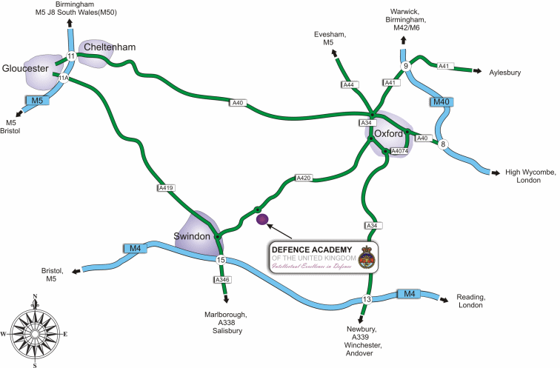

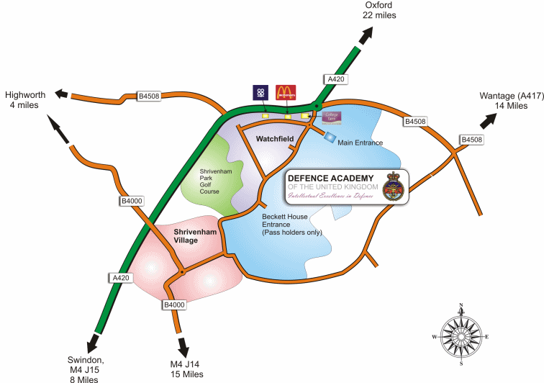

## TRAVEL INFORMATION

**By Air**

The major UK airports are easy and quick to reach. Heathrow is less than two hours by road along the M4 and the M25 has now reduced travelling time to Gatwick. There are also good rail links to the airports. Also close by are Bristol, Southampton and Cardiff airports.

### By Rail

Swindon is just 60 minutes from London Paddington and 25 minutes from Bristol. The Great Western Trains service also links Swindon with South Wales, and other services provide easy access to the Midlands and North. Information is available on the National Rail website <http://www.nationalrail.co.uk/>

### By Road (Car)

### Shrivenham is 12km from Swindon, the nearest town, which lies off the M4 at the hub of Britain's motorway network. We are well positioned for the rest of the country, with Bath, Cheltenham, Bristol and Oxford all within an hour's drive. London is less than two hours away. The postcode for Satellite Navigation is SN6 8LA.

**By Road (Taxi)**

The only taxi company authorised to enter the Defence Academy campus is:

Brian’s Hire – Office 01793 784455 or 01793 827100. Mobile 07812 162567

[www.brianshire.co.uk](http://www.brianshire.co.uk)

[brihire@aol.com](mailto:brihire@aol.com)

Other taxi companies are available but they need to book in at the Main Visitors Reception to get on camp.

### By Road (Bus)

National Express do a direct bus service to Swindon from various locations, including London and details can be found using this [link](http://coach.nationalexpress.com/nxbooking/journey-search?searchSessionKey=1380881786340) <https://beta.nationalexpress.com/>

Buses depart daily from the Defence Academy for both Swindon and Oxford and details can be found using this [link](http://www.swindonbus.info/tts/066.htm).

The Megarider Bus Ticket allows you the opportunity use the bus service all day as a ‘hop on, hop off’ service. There are also weekly tickets available. All details can be found at the Stagecoach [Website](http://www.stagecoachbus.com/tickets.aspx). <https://www.stagecoachbus.com/>

## DIRECTIONS

Defence Academy of the United Kingdom, Shrivenham, SN6 8LA

### From M4

* Leave the **M4** at **Junction** **15**, taking the exit for **Swindon**
* Take the **3rd exit** from the dual carriageway onto the **A420**, signposted **Swindon** **and** **Oxford**
* Follow the **A420**, heading for **Oxford**
* Continue past the turning for Shrivenham till you reach the **Watchfield** **roundabout** – The Defence Academy is **signposted**
* Take the **3rd exit** (Shrivenham and Defence Academy) and at the next **roundabout** take the **1st** **exit** into the Defence Academy
* The **Visitors Car Park** is just to the right as you enter the Academy.  Please **report** to the Main Visitors Reception on arrival.

### From M5

* Exit **M5** at **Junction** **11a** and follow the **A417** towards **Cirencester**.
* From **Cirencester**, follow the **A419** south towards **Swindon** (approx. 15 Miles) until the **A420** (Oxford) turn off
* Follow the **A420**, heading for **Oxford**
* At the **Watchfield** **roundabout** (the Defence Academy is signposted) take the **2nd** **exit** towards **Shrivenham**
* At the next **roundabout** take the **1st** **exit** into the Defence Academy
* The **Visitors Car Park** is just to the right as you enter the Academy.  Please **report** to the Main Visitors Reception on arrival.

### From Oxford

* From the **Botley** **Interchange** **roundabout** (just off the **A34**), follow the **A420**, heading for **Swindon**
* Continue heading for **Swindon** till you reach the **Watchfield** **roundabout** where the Defence Academy is signposted
* Take the **2nd** **exit** and at the next **roundabout** take the **1st** **exit** into the Defence Academy
* The **Visitors Car Park** is just to the right as you enter the Academy.  Please **report** to the Main Visitors Reception on arrival.

## ON ARRIVAL

Visitors arriving at the Defence Academy should first visit the Main Visitor Reception at the main entrance.

* Car parking is available in front of the Main Visitor Reception.
* **Valid Photographic Identification** will be **required**.
* The reception desk staff will issue a temporary pass and will assist with directions on camp (to Cormorant Hall if booking into accommodation).