

INDC 46th Class – Europe Tour

Itinerary

3 – 7 March 2019

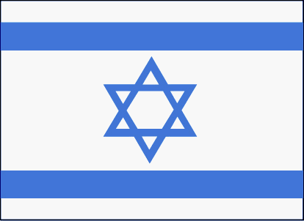

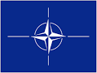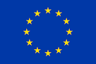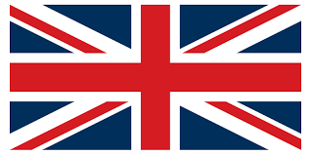

Instructor in Charge: Rafi Schutz
Table of Contents
Description | Page(s)
General  Tour Aims | 3
Schedule of the INDC Trip to Europe | 4
Brussels Information &  Biographical Notes | 5
London Information &
Biographical Notes
Things to do in London
The History of the Public House (Pub)

1. General. Over the period 3-7 March 2019, the National Defense College will conduct a study tour to Europe, which will focus on NATO organisations and the European Union (EU) in Brussels, Belgium before moving to the UK. The tour will include meetings with senior NATO and EU officials as well as those from the field of Politics, Diplomacy and National Security in London.

2. Tour Aims:

a. Recognition of NATO and the EU as major international organisations in the global system and their impact on aspects of Israeli national security.

b. Understand the relationship of the UK with wider Europe, its role within NATO, the challenges of Brexit and antisemitism and the consequences for Israel.

SCHEDULE OF THE INDC TRIP TO EUROPE
Hour/Day | Sunday | Monday  NATO | Tuesday  EU | Wednesday-Britain's security challenges regarding Israel | Thursday | Friday
Morning | Takeoff at 05:15  Landing at 09:15 (flight 3294) Brussels Airlines  En route to hotel | Visit to the new NATO HQ  Briefing – NATO's relations with the Middle East and the Mediterranean  NATO's Political Agenda – NATO-Russia Relations  Chairman of the NATO Military Committee  Ally Panel | Israel’s ambassador to the EU and NATO  Israel-EU relation  Visit to the European Parliament  Meet with an MEP  En Route to Hotel | Meeting with the ambassador  Rise of antisemitism and the British left – CST  Tour of the parliament | BREXIT briefing by a senior journalist  UK's National Security challenges  The Middle east through the UK's eyes | Landing 05:05
Afternoon | Lunch  Walking tour in Brussels | Lunch  Planning NATO's defense policies  Deputy Secretary General NATO  NATO facing security challenges | The Middle East through the EU's Eyes + EU Foreign Affairs  EU without the UK and Vice Versa  Lunch  Joint Defense Policy  EU General Secretary  Summary | Meeting with a supportive member of parliament  Meeting with a critical member of parliament | Lunch  Cultural tour  MG Summary

NORTH ATLANTIC TREATY ORGANISATION (NATO) HQ
In 1949, Allied countries established NATO's first Headquarters in London, the United Kingdom, at 13 Belgrave Square.
As NATO's structure developed and more space was needed, its Headquarters moved to central Paris in April 1952. At first it was temporarily housed at the Palais de Chaillot, but then moved to a purpose-built edifice at Porte Dauphine in 1960.
In 1966, however, France decided to withdraw from NATO's integrated military command structure, which called for another move – this time to Brussels. The new site in Belgium was constructed in a record time of six months and was inaugurated on 16 October 1967.
By 1999, NATO Heads of State and Government came to realise that, with NATO’s enlargement and transformation, the facilities no longer met the requirements of the Alliance. They agreed to construct a new Headquarters situated across the road from the existing Headquarters, Boulevard Léopold III, Brussels. The construction of the building was finalised in 2017 and the move took place in 2018.

SUPREME HEADQUARTERS ALLIED POWERS EUROPE (SHAPE)

Allied Command Operations, NATO's headquarters for all military plans and operations, is the successor to two historic strategic commands for NATO – Allied Command Europe and Allied Command Atlantic.

Two years after NATO was founded in 1949, the members of the Alliance realized that a military command structure was necessary to ensure greater integration of NATO forces and proper lines of command in the event of a crisis or war. As a result, in 1951 the first strategic command, Allied Command Europe (ACE), came into existence under the command of General Dwight D. Eisenhower, US Army, who had the title of Supreme Allied Commander Europe or SACEUR. His headquarters – the Supreme Headquarters Allied Powers Europe or SHAPE – was located in the Parisian suburb of Rocquencourt, France. One year later the second major strategic command for NATO was activated. Allied Command Atlantic (ACLANT) had its headquarters in Norfolk, Virginia, USA, and was commanded by the Supreme Allied Commander Atlantic or SACLANT. The first SACLANT was Admiral Lynde D. McCormick, US Navy.

In 1967 SHAPE moved from Rocquencourt, France, to Casteau, Belgium, as a result of French President Charles de Gaulle's decision to withdraw his country from NATO's integrated military command structure. Headquarters ACLANT remained in its original location throughout its history.

At the Prague Summit in 2002 the member nations of NATO agreed on a major reorganisation of the NATO command structure under which there would only be one strategic-level command in charge of all NATO operations, with the title of Allied Command Operations (ACO), while a second strategic- level headquarters – Allied Command Transformation (ACT) – would be established to promote and oversee the continuing transformation of Alliance forces and capabilities through training and the development of new concepts and doctrine. The headquarters for ACO and ACT were located in the sites of the two previous strategic commands, ACE and ACLANT, thus in Casteau, Belgium and Norfolk, Virginia.

For both historical and financial/legal reasons, the headquarters of ACO retained its traditional title of SHAPE and its commander the traditional designation as SACEUR. In essence, when the new organisational structure became in effective in 2004, SHAPE simply added to its existing responsibilities in Europe the ocean areas previously under ACLANT. At the same time some of SHAPE's transformational activities moved over to the new Allied Command Transformation, whose commander is known as the Supreme Allied Commander Transformation or SACT.

EU HQ

Brussels in Belgium is considered the de facto capital of the European Union, having a long history of hosting the institutions of the European Union within its European Quarter. The EU has no official capital, and no plans to declare one, but Brussels hosts the official seats of the European Commission, Council of the European Union, and European Council, as well as a seat of the European Parliament.

The European Union (EU) is a political and economic union of 28 member states that are located primarily in Europe. It has an area of 4,475,757 km (1,728,099 sq mi) and an estimated population of about 513 million. The EU has developed an internal single market through a standardized system of laws that apply in all member states in those matters, and only those matters, where members have agreed to act as one. EU policies aim to ensure the free movement of people, goods, services and capital within the internal market, enact legislation in justice and home affairs and maintain common policies on trade, agriculture, fisheries and regional development. For travel within the Schengen Area, passport controls have been abolished. A monetary union was established in 1999 and came into full force in 2002 and is composed of 19 EU member states which use the euro currency.

The EU and European citizenship were established when the Maastricht Treaty came into force in 1993. The EU traces its origins to the European Coal and Steel Community (ECSC) and the European Economic Community (EEC), established, respectively, by the 1951 Treaty of Paris and 1957 Treaty of Rome. The original members of what came to be known as the European Communities were the Inner Six: Belgium, France, Italy, Luxembourg, the Netherlands, and West Germany. The Communities and its successors have grown in size by the accession of new member states and in power by the addition of policy areas to its remit. The latest major amendment to the constitutional basis of the EU, the Treaty of Lisbon, came into force in 2009. While no member state has left the EU or its antecedent organisations, the United Kingdom signified the intention to leave after a membership referendum in June 2016 and is negotiating its withdrawal on 29 March 2019.

BIOGRAPHICAL NOTES

Deputy Chairman of the Military Council – Lieutenant General Steven Shepro (US Air Force)

Deputy Secretary General NATO

Deputy Supreme Allied Commander Europe (DSACEUR) – General Sir James Everrard KCB, CBE

Commander Comprehensive Crisis & Operational Management Centre (CCCOMC)

Israel’s Ambassador to the EU and NATO

UK Permanent Representative to the North Atlantic Council – Sarah MacIntosh CMG

Ms Sarah MacIntosh CMG was appointed Permanent Representative to the United Kingdom’s Delegation to NATO in February 2017.
Previously she served as Director General, Defence and Intelligence at the Foreign Office from May 2014 to November 2016.
Sarah joined the FCO in 1991. Previous appointments include Director for Defence and International Security (2011-2014); Director for Strategic Finance (2009-2010); Her Majesty’s High Commissioner to Sierra Leone and Her Majesty’s Ambassador to Liberia (2006-2008) and the Strategy Co-ordinator for the UN Mission in Kosovo (2004-2005).
Sarah has also been posted to the UK Mission to the United Nations at New York; the UK Mission to the IAEA at Vienna; and the British Embassy Madrid.

LONDON INFORMATION

Community Security Trust (CST)

The CST is a British charity established in 1994 to ensure the safety and security of the Jewish community in the UK. Its inception follows a history of threats to the Jewish community in Britain, in particular to attacks on British Jews and their buildings by British Fascists from the 1930s, and to further attacks by Islamists hostile to Israel and by extension to its British supporters. The attacks in the 1930s were repelled by community action and Jewish self-defence groups, persuading many within the community that organised self-defence organisations were required because police authorities could not be expected to devote disproportionate resources to synagogues, schools and other Jewish infrastructure. The CST was the product of a similar response to Islamicist hostility from the 1980s. Its chairman is the British businessman Gerald Ronson and its deputy chairman is Lloyd Dorfman CBE.

The CST provides security advice and training for Jewish schools, synagogues and communal organisations and gives assistance to those bodies that are affected by antisemitism. The CST also assists and supports individual members of the Jewish community who have been affected by antisemitism and antisemitic incidents. It advises and represents the Jewish community on matters of antisemitism, terrorism and security and works with police, government and international bodies. All this work is provided at no charge.
The CST has recorded antisemitic incidents in the UK since 1994 and publishes an annual Antisemitic Incidents Report. The CST also published Terrorist Incidents against Jewish Communities and Israeli Citizens Abroad 1968-2010, a definitive report of terrorist attacks against Jewish communities around the world.

House of Commons Foreign Affairs Committee

The Foreign Affairs Committee's remit is to examine the expenditure, administration and policy of the Foreign and Commonwealth Office (FCO), other bodies associated with the Foreign Office and thereby within the Committee's remit, include the British Council. The FCO is also responsible for UK participation in international and regional multilateral organisations such as the United Nations, the OECD (Organisation for Economic Co-operation and Development), NATO and the European Union.

The Committee is appointed by the House of Commons. It comprises 11 backbench Members of Parliament from Government and Opposition parties, and is calculated to reflect the membership of the House as a whole.

The Daily Telegraph Newspaper

The Daily Telegraph, commonly referred to simply as The Telegraph, is a national British daily broadsheet newspaper published in London by Telegraph Media Group and distributed across the United Kingdom and internationally. It was founded by Arthur B. Sleigh in 1855 as Daily Telegraph & Courier.

The Telegraph is widely regarded as a national "newspaper of record" and it maintains an international reputation for quality, having been described by the BBC as "one of the world's great titles".

The Daily Telegraph has been politically conservative in modern times. The personal links between the paper's editors and the leadership of the Conservative Party, along with the paper's generally right-wing stance and influence over Conservative activists, have resulted in the paper commonly being referred to, especially in Private Eye, as the Torygraph. Even when Conservative support was shown to have slumped in the opinion polls and Labour gained the ascendant, the newspaper remained loyal to the Conservatives. This loyalty continued after Labour ousted the Conservatives from power by an election result in 1997, and in the face of Labour election wins in 2001 and the third successive Labour election win in 2005.

BIOGRAPHICAL NOTES

Israel’s Ambassador to UK – Mark Regev

Chairman of the House of Commons Foreign Affairs Committee – Tom Tugendhat MP

Assistant Editor, The Daily Telegraph – Philip Johnston

Deputy National Security Advisor

THNGS TO DO IN LONDON

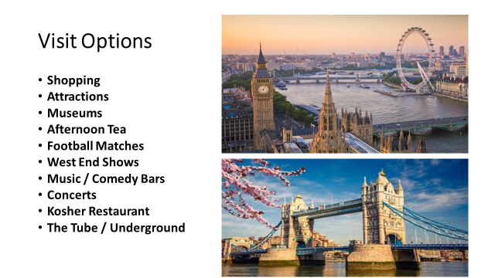

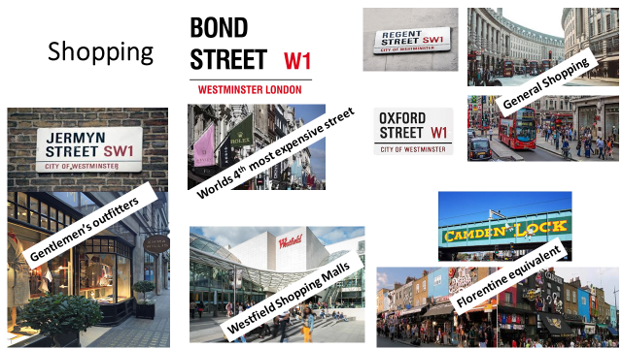

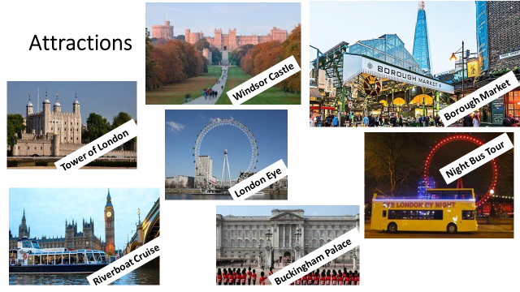

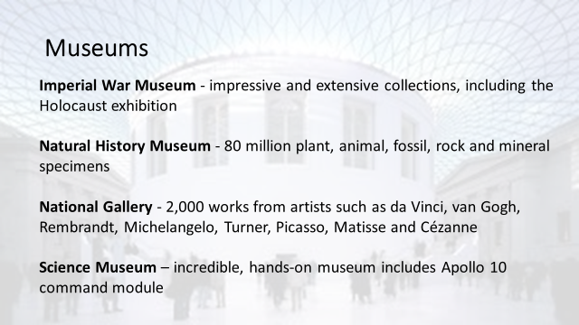
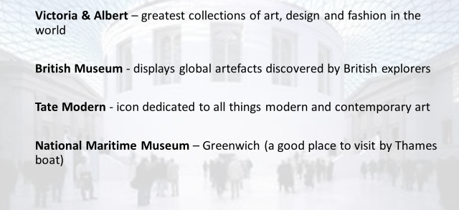

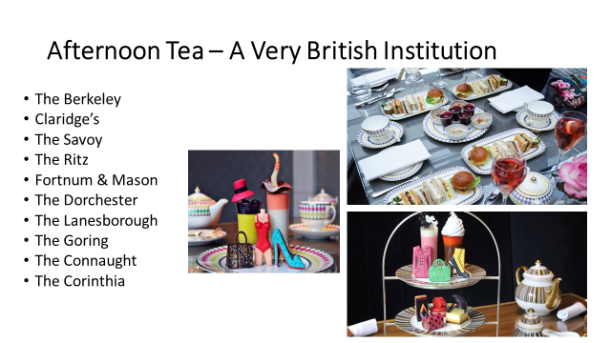

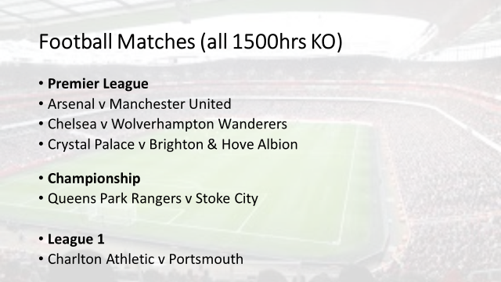



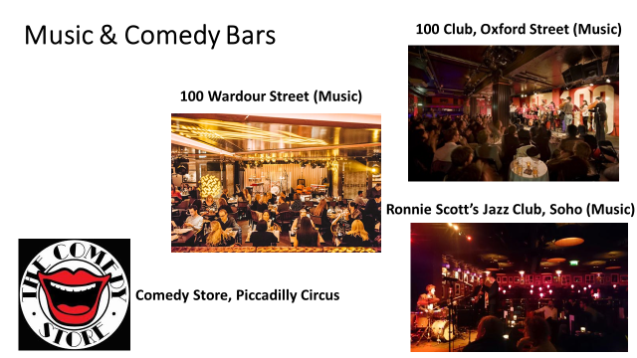


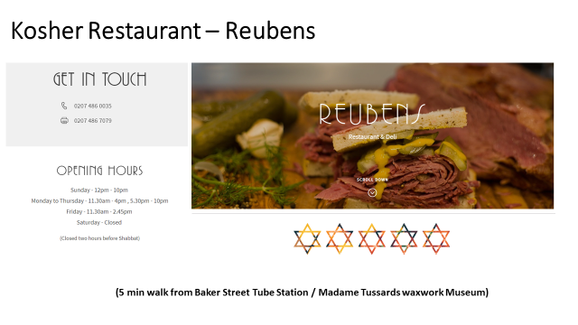

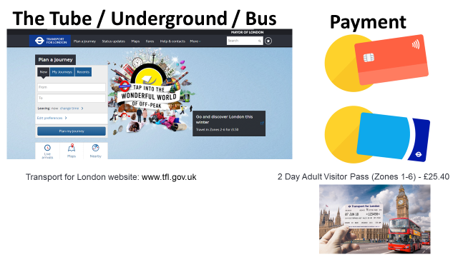

The History of the Public House (Pub)

Renowned the world over, the great British pub is not just a place to drink beer, wine, cider or even something a little bit stronger. It is also a unique social centre, very often the focus of community life in villages, towns and cities throughout the length and breadth of the country.
Yet it appears that the great British pub actually started life as a great Italian wine bar, and dates back almost 2,000 years.
It was an invading Roman army that first brought Roman roads, Roman towns and Roman pubs known as tabernae to these shores in 43 AD. Such tabernae, or shops that sold wine, were quickly built alongside Roman roads and in towns to help quench the thirst of the legionary troops.
It was ale, however, that was the native British brew, and it appears that these tabernae quickly adapted to provide the locals with their favourite tipple, with the word eventually being corrupted to tavern.
These taverns or alehouses not only survived but continued to adapt to an ever changing clientele, through invading Angles, Saxons, Jutes, and not forgetting those fearsome Scandinavian Vikings. In around 970 AD, one Anglo-Saxon king, Edgar, even attempted to limit the number of alehouses in any one village. He is also said to have been responsible for introducing a drinking measure known as ‘the peg’ as a means of controlling the amount of alcohol an individual could consume, hence the expression “to take (someone) down a peg”.
Taverns and alehouses provided food and drink to their guests, whilst inns offered accommodation for weary travellers. These could include merchants, court officials or pilgrims travelling to and from religious shrines, as immortalised by Geoffrey Chaucer in his Canterbury Tales.
Inns also served military purposes; one of the oldest dating from 1189 AD is Ye Olde Trip to Jerusalem in Nottingham, and is said to have acted as a recruitment centre for volunteers to accompany King Richard I (The Lionheart) on his crusade to the Holy Lands.

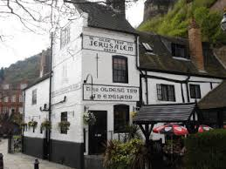

Alehouses, inns and taverns collectively became known as public houses and then simply as pubs around the reign of King Henry VII. A little later, in 1552, an Act was passed that required innkeepers to have a licence in order to run a pub.
By 1577 it is estimated that there were some 17,000 alehouses, 2,000 inns and 400 taverns throughout England and Wales. Taking into account the population of the period, that would equate to around one pub for every 200 persons. To put that into context, that same ratio today would be approximately one pub for every 1,000 persons.

The Red Lion Pub, Westminster

The Red Lion stands on the site of a medieval tavern – known in 1434 as the Hopping Hall. The tavern passed through various hands and traded under many names in its early years, before it was bought by the Crown in 1531.
Centuries later, with the inn trading as The Red Lion, a young Charles Dickens became a regular visitor. Dickens’ noted that the pub’s landlady was a kind-hearted soul, whose attitude towards him was ‘admiring as well as compassionate’.
Standing so close to Downing Street and the Houses of Parliament, The Red Lion also became a popular haunt for British Prime Ministers. Indeed, the pub served every British Prime Minister up until Edward Heath in the 1970s - welcoming the likes of Sir Winston Churchill and Clement Atlee for a drink.
Situated between 10 Downing Street and the Houses of Parliament, the Red Lion is probably the best pub in the city for lovers of political history. There's every chance you'll catch a glimpse of some of our Government's elite in the bar, too.

