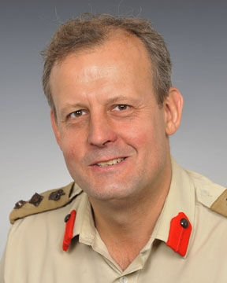

**COLONEL MARTYN FORGRAVE OBE QGM MPHIL MA**

Colonel Forgrave was commissioned into The 22nd (Cheshire) Regiment in 1986 during a Public Duties (ceremonial) tour in London. Staff appointments include postings to the Defence Intelligence Staff covering the Balkans, Directorate of Military Operations in the Ministry of Defence during the second Gulf War, Chief of Staff of the Junior Officers Tactics Advisory Course during its design and establishment, SO1 J5 Plans Combined Joint Task Force Horn of Africa (CJTF-HOA), SO1 Policy in Headquarters Northern Ireland at the end of Operation BANNER and in the Development Concepts and Doctrine Centre where he authored the Future Land Operating Concept (2030). Operational tours have included multiple deployments to Northern Ireland, the Balkans and as a planner embedded with the US-led CJTF-HOA. Between 2008-2010, he commanded the 4th Battalion, The Mercian Regiment, deploying in excess of 200 reservists to Afghanistan on Operation HERRICK.

Between 2012-2016, he was Director of the International Section within the Shrivenham Leadership Centre at the Defence Academy of the United Kingdom. During this time, he was responsible for the delivery over 100 expeditionary education courses across Europe; South America; the Middle East; Africa; the Caucuses; and South and South East Asia.

Colonel Forgrave has a Master of Arts degree in Defence Studies from Cranfield University and a Master of Philosophy Degree in International Relations at St John’s College, Cambridge University, where his dissertation addressed the UK’s approach to Security Sector Reform in the context of conflict prevention. He is currently undertaking a part-time PhD in cross-cultural leadership at Cranfield University as part of the Army’s Higher Defence Studies Programme

Colonel Forgrave was awarded the Queen’s Gallantry Medal for his service in Bosnia-Herzegovina in 1992-93. In 2015, he was awarded the Order of British Empire medal for services to Defence Engagement. .