Lieutenant colonel (GS) Christian ARIOLI
Name and first name: | ARIOLI, Christian | 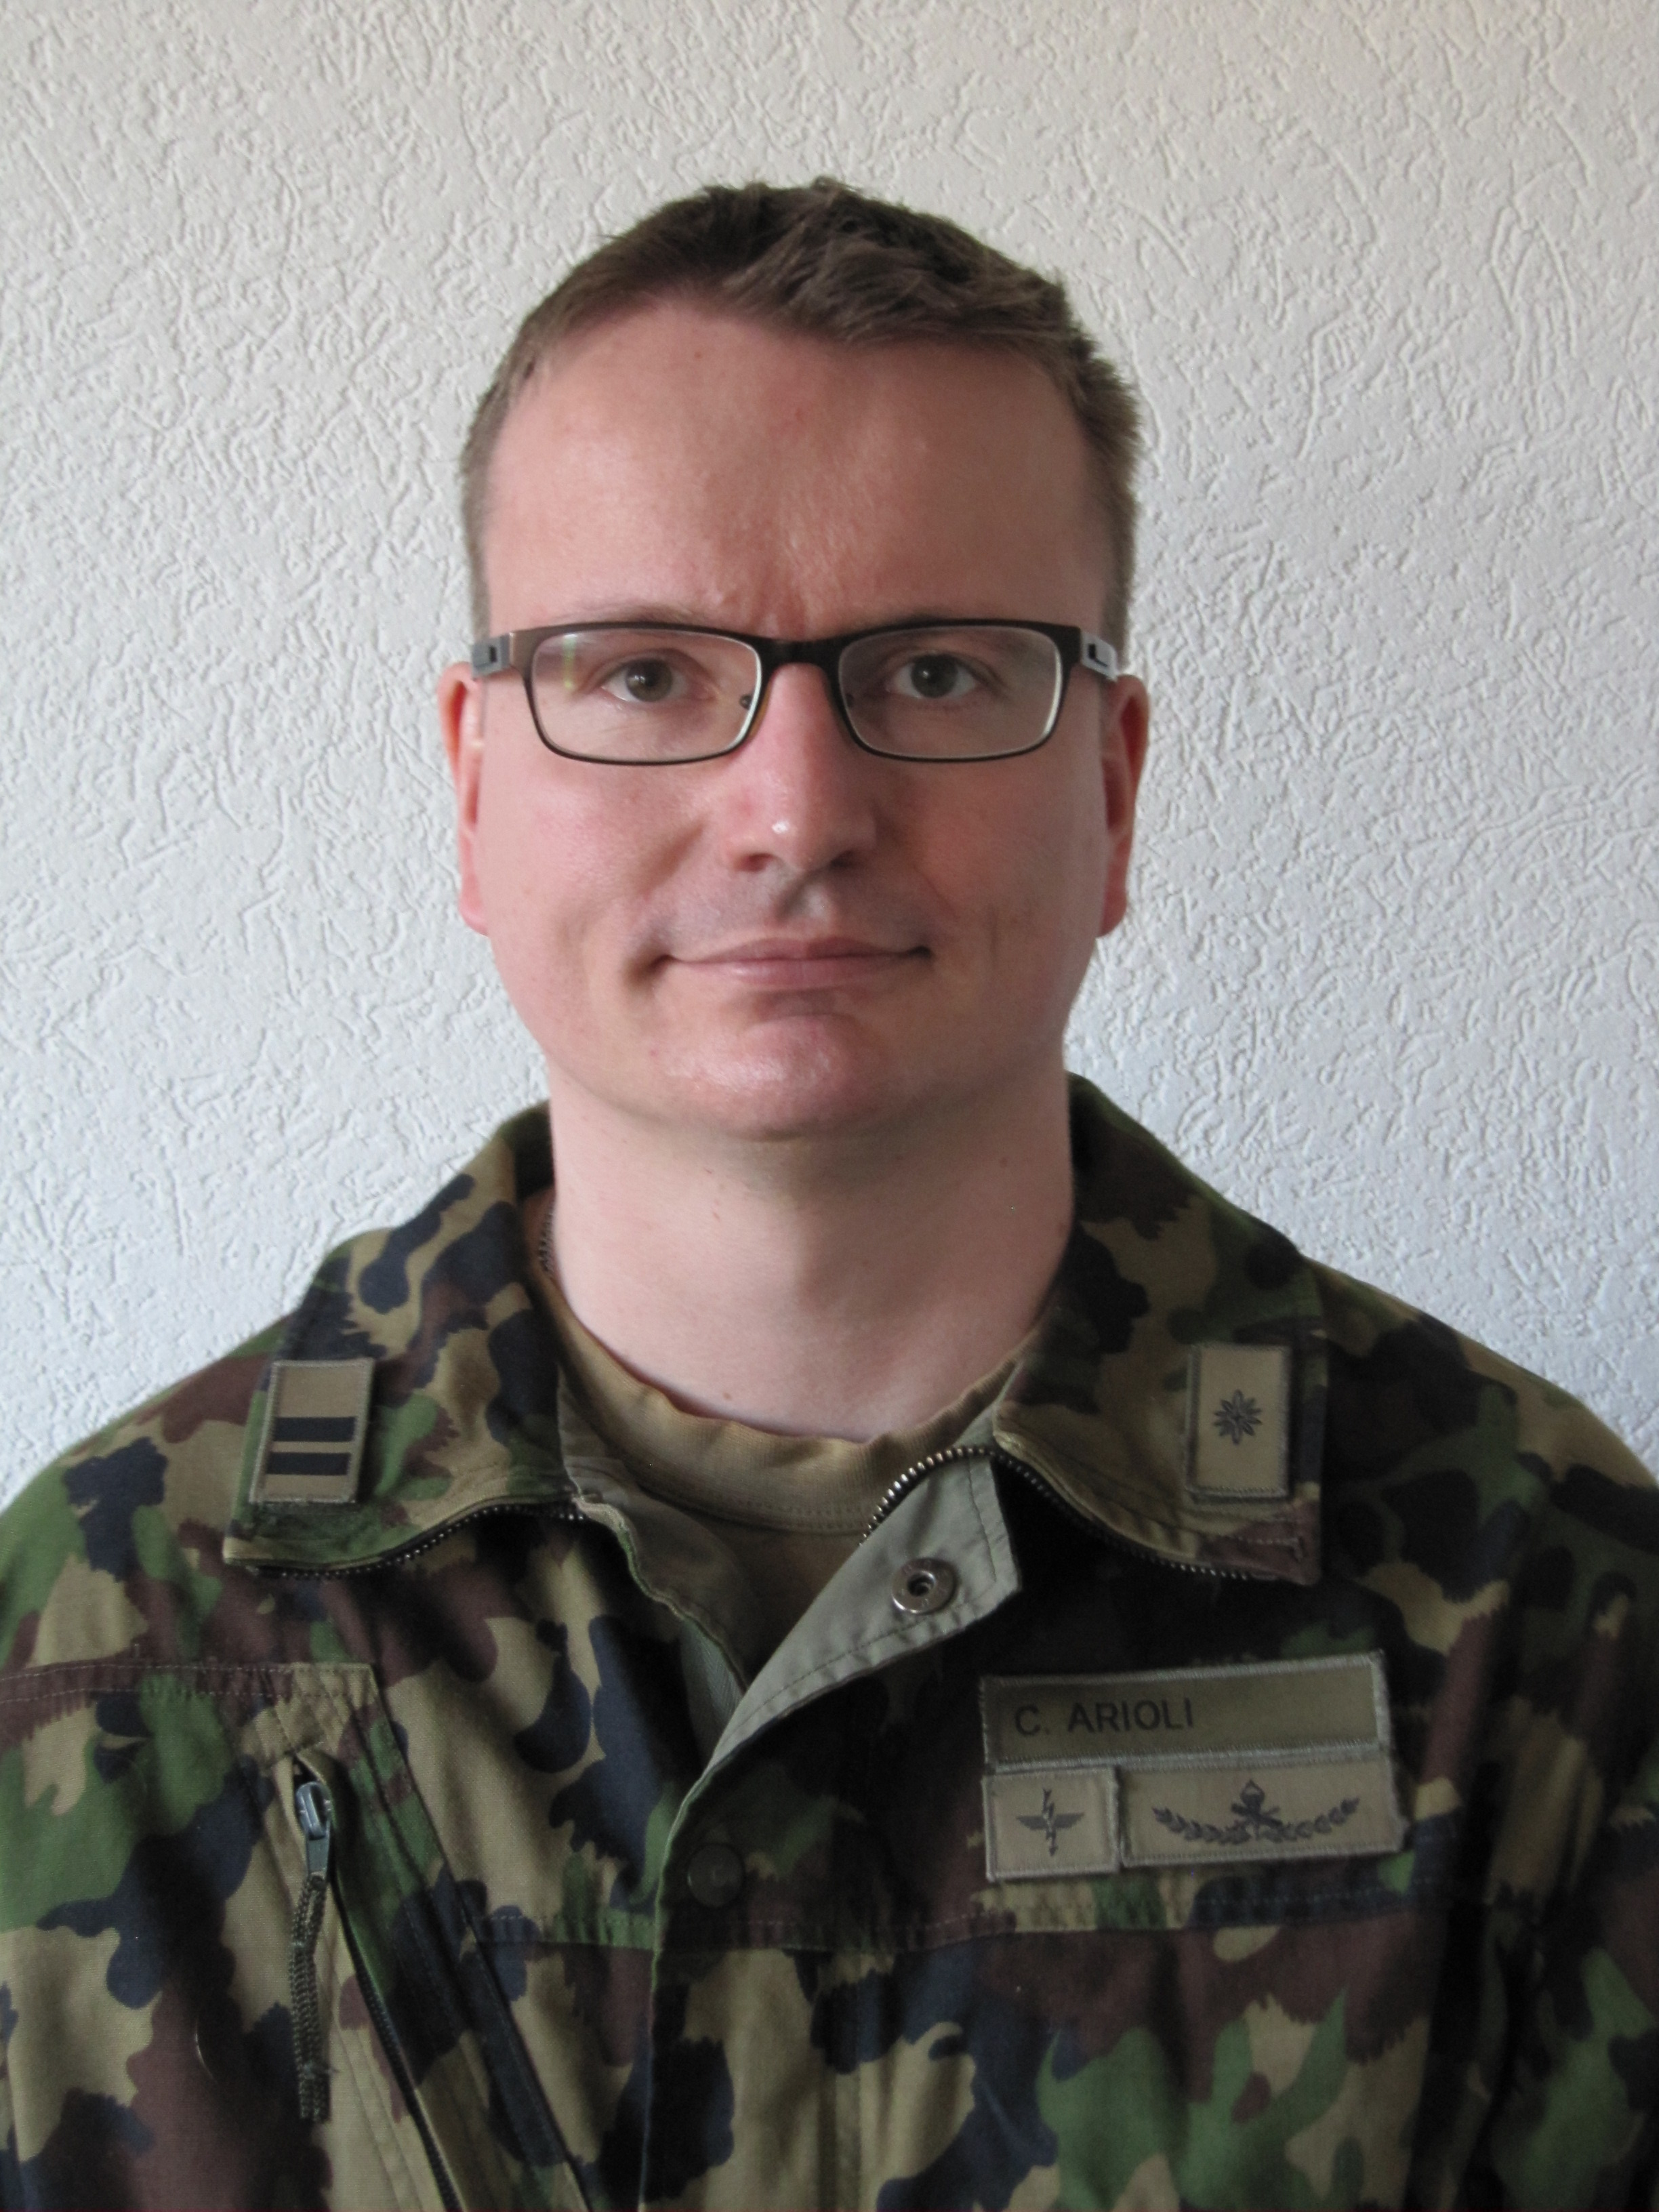
Profession: | Career Officer
Military Rank: | Lieutenant colonel
Function: | Military assistant to the Chief Joint Operations Command
Date of birth: | 28.03.1974
Place of birth: | Lucerne (Switzerland)
Native cities: | Lauperswil (Berne)
Marital status: | Married, 2 daughters
Mother tongue: | (Swiss) German
Additional languages: | (fluent in) French, English, Swedish
Leisure activities: | Nature, family, reading, IT
Location of work: | Papiermühlestrasse 20,  CH-3003 Bern

Military Assignments and Studies (excerpt)
1994 Matura graduation
2001 Master in Biology (Dipl natw ETH), Swiss Federal Institute of Technology Zurich
2007 PhD in Biology / Natural Sciences (Dr. sc. Nat.), University of Zurich
2007 Career officer diploma, military academy, Swiss Federal Institute of Technology Zurich
2011 teaching diploma for grammar schools/MAS in Secondary and Higher Education, Swiss Federal Institute of Technology Zurich
2015-2017 Batallion cdr, signals batallion (militia function)
2018 Military assistant to the Deputy Chief Joint Operations Command (militia function)
2019 Chief Targeting Joint Operations Command ai (militia function)
2010-2014 Chief Operations of the competence centre for NRBC defense
2014-2015 Participant at Austrian General Staff Course, Landesverteidigungsakademie Vienna
2015-2017 Military assistant to the Chief of Joint Forces Staff
2018 Military assistant to the Deputy Chief Joint Operations Command
2019 Military assistant to the Chief Joint Operations Command

