Brigadier General Raynald DROZ
Name and first name: | Raynald DROZ | 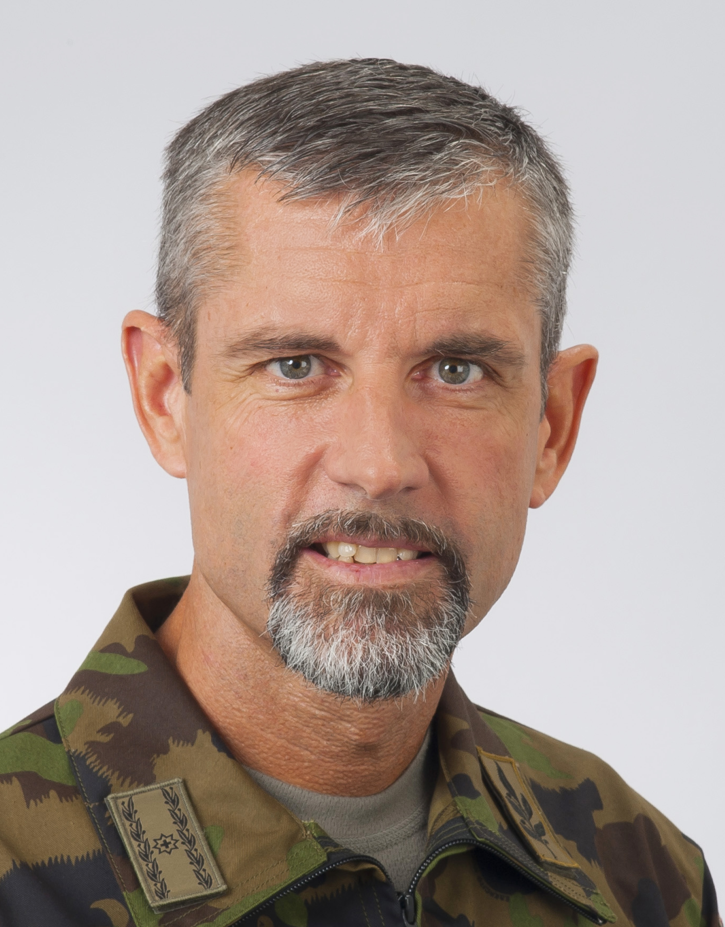
Profession: | Carrer Officer
Military Rank: | Brigadier General
Function: | Chief of Staff Joint Operations Command
Date of birth: | 08.10.1965
Place of birth: | Estavayer-le-Lac
Native cities: | Cugy (FR), Le Locle (NE), Tramelan (BE)
Marital status: | Married, 1 daughter, 1 son
Mother tongue: | French and Italian
Additional languages: | German, English
Leisure activities: | Sports (triathlon long distance - Ironman)
Location of work: | Papiermühlestrasse 20,  CH-3003 Bern

Military Assignments and Studies
1987 Matura graduation (ITALY)
1991 Matura graduation (SWITZERLAND)
1994 Career Officer degree
1995-1996 Instructor of Artillery Forces
1996-2002 Deputy Commander of the Artillery Forces Recruits School, Bière
2002-2003 Masters in Defence and Administration (MBA-D) at Defence Academy Shrivenham (UK)
2003-2007 Assigned Staff Officer to the Chief of the Armed Forces
2008-2009 Chief Planning Officer in Armed Forces Armour Planning
July 2009 Project Leader in Armed Forces Planning Division
2010 Assigned Staff Officer to the Commander of the Ground Forces
June 2010 Commander Infantry Forces long-term Schools 14
Nov 2012 Chief Operations Armed Forces Joint Staff (J3/5)
2018 Chief of Staff of the Chief of the Armed Forces (promotion to Brigadier General)
2019 Chief of Staff Joint Operations Command

