**The Democrats’ dilemma**

What Ilhan Omar and Dean Phillips tell us about the future of the Democratic Party.

By [**TIM ALBERTA**](https://www.politico.eu/author/tim-alberta/)

3/9/19, 1:30 AM CET

Updated 4/19/19, 1:13 AM CET

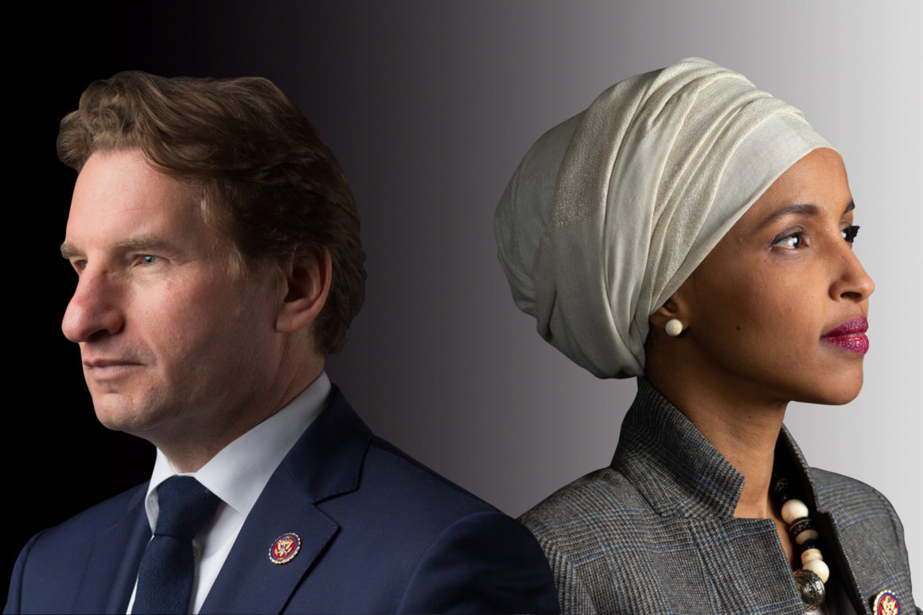

Source images by Allison Shelley for POLITICO Magazine and Jason Grow for POLITICO Magazine

MINNEAPOLIS — They have gathered in defiance of the freezing temperatures on a late February’s night, scores of them twirling Somali flags in one hand and American flags in the other, crowding around the arrivals terminal and waiting to welcome one of their own. The vast Somali community in the Twin Cities is like one sprawling extended family, explains Ali Aden, a 39-year-old engineer who came to the U.S. two decades ago, as we survey the scene. When a prominent member of the family arrives, it’s customary to greet them this way.

“Is it Congresswoman Omar they’re waiting for?” I ask, referencing the freshman Democrat whose district we’re standing in.

“Ilhan?” he smiles broadly. “No, no. If it were Ilhan, the whole city would be here.”

As it turns out, the reception is for an obscure Somali government dignitary. In normal times, his arrival would be the talk of the local expat community; some 80,000 people of Somali descent are estimated to live in Minnesota, the largest such diaspora in the United States, one that has distinctly flavored the Twin Cities’ culture and caused some occasional unease on the right, such as when then-candidate Donald Trump warned in 2016 of the “disaster” of Somali refugees moving into Minnesota and becoming radicalized by ISIS.

But these are not normal times. The voters of Minnesota’s 5th District knew they were making history last November: Omar’s victory made her both the first Somali-American to serve in Congress and, along with fellow newcomer Rashida Tlaib of Michigan, its first Muslim woman member. What they didn’t expect was that in her first seven weeks on the job she would become one of the most prominent, polarizing and recognizable politicians in America—the subject of fierce debates on the House floor and cable news, lauded on the left for standing up to Israel and vilified on the right for comments seen by many as anti-Semitic.

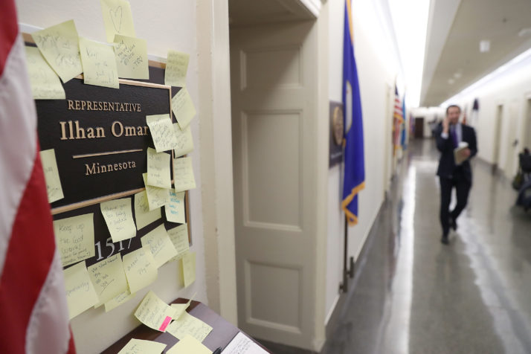

After uproar over an Omar tweet that some called anti-Semitic, supporters placed notes on Omar's nameplate in the Longworth House Office Building | Mark Wilson/Getty Images

Omar was destined to stand out: After Congress changed its 181-year-old rule prohibiting headwear to accommodate her, she became the first person to wear a hijab on the House floor. But it wasn’t her wardrobe, or her religion, or her gripping biography as the congresswoman who came of age in a refugee camp, that distinguished Omar in her early days on Capitol Hill. Rather, it was her usage of social media and the uproar that ensued.

First, Omar tweeted that Lindsey Graham had been “compromised,” suggesting that his support for Trump—whom he’d verbally mauled throughout the 2016 campaign—owed to blackmail collected on the South Carolina senator. (Conservatives accused Omar of playing on the long-running, unsubstantiated insinuation that Graham is gay; she denied this, but apologized.) Then, after being seated on the House Foreign Affairs Committee, Omar was lampooned for a 2012 tweet in which she wrote during an Israeli military campaign in the Gaza Strip, “Israel has hypnotized the world, may Allah awaken the people and help them see the evil doings of Israel.” (Omar later apologized and deleted the tweet; she claimed ignorance of the anti-Semitic trope that conceives of Jewish hypnosis.)

Finally, in early February, after just over a month on the job, Omar made the jump from occasional agitator to permanent lightning rod. Arguing that U.S. lawmakers back Israel because of campaign donations from Jewish donors, the congresswoman tweeted, “It’s all about the Benjamins baby,” a reference to $100 bills. The fallout was fierce: The entire House Democratic leadership denounced Omar, forcing yet another apology, and both the president and vice president piled on, skewering the congresswoman for her remarks, with Trump even suggesting that she should resign from Congress. (Notably, neither Trump nor Mike Pence has ever criticized Congressman Steve King despite his well-documented record of openly racist rhetoric.)

All of this proved agonizing for Omar’s constituents, particularly those in the Somali community. Her arrival in Congress was meant to bring them legitimacy and representation. Instead, almost immediately, it invited controversy and humiliation. “I was shocked. I don’t like her on Twitter,” Aden tells me. “She’s very smart, and I didn’t think she would talk that way. It was an embarrassment for me as a Somali-American, because we do not like extreme left or extreme right. But she will do better. This is new to her—she will learn how to handle it.”

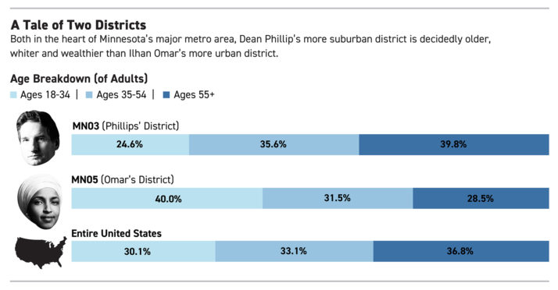

The more essential question, it seems, is whether the Democratic Party—its base bursting with energy, riding high off the House takeover of 2018—will learn to handle Omar.

The Minnesota congresswoman, along with the likes of Tlaib and Alexandria Ocasio-Cortez of New York, represent the unapologetic new guard of progressivism, pushing the party’s establishment to embrace tactics and positions that have heretofore been considered outside of the mainstream. Yet they face resistance not just from party elders but from many of their fellow freshmen, centrists who campaigned as fixers not firebrands, moderates who are watching warily as the Democrats’ brand is being hijacked by the far left. One of these members is Omar’s neighbor in Minnesota: Dean Phillips, a wealthy businessman who represents the 3rdDistrict.

To better understand these dueling visions for the Democratic Party, I sat down with both Omar and Phillips, spent several days in their communities and talked with some of their constituents. What I learned is that, despite the cautionary tale offered by years of vicious Republican infighting, Democrats are dangerously close to entering into their own fratricidal conflict. On matters of both style and substance, the fractures within this freshman class are indicative of the broader divisions in a party long overdue for an ideological reckoning.

And Omar isn’t shying away from it. “I am certainly not looking to be comfortable, and I don’t want everyone necessarily to feel comfortable around me,” she told me, a mischievous smile tugging at her lips. “I think really the most exciting things happen when people are extremely uncomfortable.”

Phillips, a friendly soul and consensus-builder by nature, is among those feeling a bit uncomfortable. Amid a discussion of Omar and Ocasio-Cortez, he complained, “Suddenly an entire party is being branded by the perspectives of two of its members who represent 1 percent of the caucus.”



Dean Phillips at the International School of Minnesota for WE DayX, a youth empowerment | Adam Bettcher/Getty Images for WE Charity

For Somali-Americans like Aden, the Democrats’ identity crisis cuts more deeply. Joyful yet jittery in this era of anti-immigrant politics, they knew that she, as a Muslim woman born in Africa, would be a magnet for scrutiny, and it’s going to take more than a few careless tweets to diminish their immense pride in her success. What worries Aden and others in the Somali community I spoke with is that Omar has walked into a trap—stumbling into these controversies not because she is motivated by anti-Semitism, but by a background in grassroots activism and a belief that the only way to defeat Trump is to play the game by his rules: accusing instead of inquiring; wielding hyperbole as an everyday weapon; tweeting first and asking questions later.

“Trump is a radical. Maybe I should say he’s a racist, because that’s what I believe. But I don’t want to see others becoming radical as the result,” Aden, a naturalized citizen and a loyal Democrat, says. Like more than a few members of Pelosi’s team, he shudders at talk of impeaching the president—not because he likes Trump, but because he thinks it will help the president paint his opponents as “extreme, just like him,” and benefit his reelection in 2020.

“I just worry Ilhan will be too much left, like the woman in New York,” Aden says. “You know—AOC.”

***

**In January,** Democrats reclaimed the House majority with a freshman class of over 60 members, the party’s biggest in nearly a half-century. It has already distinguished itself as perhaps the most consequential crop of new lawmakers ever to arrive in Washington. Even more immediately than the 2010 wave of Tea Party Republicans rebranded the GOP just two years removed from George W. Bush’s presidency, this 2018 class has demonstrated at warp speed its capacity for manipulating the trajectory of the post-Barack Obama Democratic Party, its presidential hopefuls succumbing to the gravitational pull of the freshmen agitators within weeks of their taking office.

For Omar, there is no danger in calling for Trump’s impeachment, or in advocating the abolition of Immigration and Customs Enforcement, or in pushing Medicare for All, or in supporting the Green New Deal: Hillary Clinton carried her district by 55 percentage points in 2016. The same can be said for Omar’s closest friends: Tlaib, Ocasio-Cortez and Ayanna Pressley from Massachusetts. This clique of rookie lawmakers, who call themselves “Squad,” represent four of the safest Democratic districts in America. They have come to Congress not to pursue incremental victories, but to push for wholesale change in the government and inside their own party, secure in the knowledge that their deep-blue backyards will buffer them from whatever recoil might damage other Democrats in less ideologically insulated parts of the country.

The dilemma for the party is that Democrats would not have won their majority without the influx of some 40 newcomers who flipped Republican-held battleground seats—the vast majority of them running on platforms of good government and bipartisan productivity.

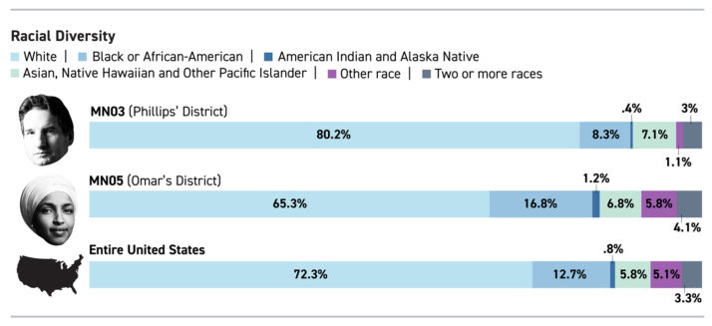

In Michigan, while Tlaib’s flamboyant liberalism suits the Detroit-anchored 13th District—“We’re going to impeach the motherfucker!” she declared hours after being sworn in—it makes life considerably harder for Haley Stevens and Elissa Slotkin, a pair of moderate freshmen who won difficult races in the suburban-heavy 11th and 8th Districts, respectively.

And in New York, while Ocasio-Cortez puts the Bronx-based 14th District on the map with her championing of Democratic socialism, her fellow freshman Max Rose, a combat veteran who won a major upset in the 11thDistrict by playing to the cultural conservatism of Staten Island, is forced to answer for his party’s lurch to the left.

But perhaps nowhere is the divergence inside today’s Democratic Party better crystallized than here in greater Minneapolis. Omar’s 5th District, which includes the airport, has not been represented by a Republican since 1962. A five-minute cab ride away is the Mall of America, located in Minnesota’s 3rd District, which had not been represented by a Democrat since 1960—until January, when Phillips took office after knocking off GOP incumbent Erik Paulsen last fall.

“The districts couldn’t be more remarkably different. They’re neighboring, but don’t have a lot of similarities,” says Ken Martin, chairman of the Minnesota state party and vice chair of the Democratic National Committee.

Omar’s district is entirely urban, a mix of the very prosperous and the very poor, with a median household income of $63,202 and a mean household income of $88,390, according to the Census Bureau. Phillips’ district is mostly suburban, enwrapping Minneapolis like a giant “C,” containing blue-collar boroughs to the north, affluent areas to the west and upper-middle-class communities to the south of the city. Its median household income is $89,442, and its mean household income is $123,574.

That Phillips is Jewish and Omar is a Muslim—the only such neighboring members of Congress in American history—makes their intersection all the more intriguing, particularly in light of recent events.

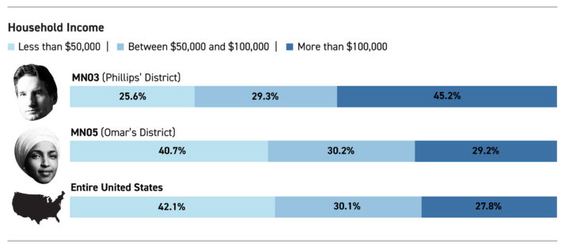

Yet to focus too narrowly on this unique dynamic is to obscure the phenomena of polarity that Omar and Phillips represent. With a new generation of Democratic leaders emerging, and the left splintered over some of the existential questions of governing in the age of Trump, two warring iterations of the modern Democratic Party can be found in one overlapping zip code. Where Omar and her fellow safe-seat Democrats prescribe a fearless liberalism and believe Trump’s scorched-earth approach calls for zero-sum political warfare, Phillips and his swing-district confederates preach cooperation and a post-ideological pragmatism, fearful that the president’s surest path to reelection is by portraying their party as even more dogmatic than his own.

The weight of these circumstances is not lost on either lawmaker. In separate interviews, both Omar and Phillips had kind words for the other, downplaying intra-party rivalries while offering bromides of shared goals for their caucus.

But once I began drilling down on specifics—of policy and strategy, ideological branding and political temperament—the tensions quickly bubbled to the surface. Their responses revealed not just disagreements within the Democratic coalition that will prove difficult to reconcile on Capitol Hill amid an acrimonious presidential election cycle, but also a hint of distrust that if unchecked could yield the sort of bloody internecine struggle that crippled the GOP for much of the past decade.

Welcome to the opening salvos of the Democrats’ Civil War.

***

**Phillips has a pedigree**that orients toward resolution, making him remarkably well-suited to the task ahead.

The grandson of renowned advice columnist Abigail Van Buren (“Dear Abby”), he traffics in relationships and common ground, viewing no problem as too big for people collaborating in good faith. The first group he joined in Congress was the Problem Solvers Caucus, a club of business-minded centrists that accomplishes little legislatively (and earns sneers on the far-left and far-right) but provides something of a spiritual oasis for moderates in both parties. The closest friendships he has made on Capitol Hill are with Republicans, though as a courtesy he checked with them before giving me their names, not wanting to inadvertently damage their standing on the right. And when Omar tweeted what was panned as an anti-Semitic trope, Phillips held off for many hours on issuing a press release, much to the irritation of Jewish friends and colleagues. The reason: He hadn’t spoken with his fellow Minnesota freshman and wanted to have a private dialogue before commenting publicly on the matter.

“That's how I wish more people would conduct themselves—let’s share it face to face,” Phillips says. “You know, a little more talking, a little less tweeting. It’s the tweeting that gets us into trouble.”



Phillips in his Washington, D.C., office | Allison Shelley for POLITICO Magazine

Even as he said that, Phillips managed to show a level of empathy worthy of his grandmother. “Our conversation was about as much about me expressing my feelings and why I was hurting, why such language and statements are destructive, as it was an invitation to work together and start a respectful understanding and talk about our differences in life experience,” he said. “I mean, Representative Omar’s life experience and mine couldn’t be more dissimilar—but that’s the beauty of the United States.”

Fifty years old and fabulously wealthy, with black-rimmed glasses and waves of toffee-colored hair swept neatly back and behind his ears, Phillips looks the part of an industry mogul. His family is corporate royalty in the Twin Cities, with a liquor distilling empire that he took over after finishing his MBA and various properties scattered across the metro area. We’re inside one of them on a Wednesday afternoon, a historic downtown building two blocks from the Mississippi River, once owned by the Pillsbury family (of biscuit fame) and now being sold off by his family, which has used the estate to house its philanthropic work. Phillips mastered every gofer’s position in the distilling company before running it, then launched several other fruitful ventures of his own. It was only after he had established his own name, his own brand, that Phillips turned to politics.

Paulsen, the GOP incumbent in the 3rd district, had cruised to a fifth term in 2016—winning by 14 points—despite Trump losing the district by nearly 10 points. Unbowed and armed with a personal fortune, Phillips persuaded party elders that he was just the sort of Chamber of Commerce-friendly, compromise-minded Democrat who could win independents and disaffected Republicans in the Minneapolis suburbs. He was right: Running as a problem-solver on issues of health coverage, gun violence and fiscal profligacy, Phillips thumped Paulsen by double digits, flipping a GOP district that had stymied Democrats for years.

Two things have stood out about Phillips, as a candidate and during his baptism by tweet-fire in Congress. The first is his tolerance of—dare I say deference toward—Trump, a man for whom reflexive loathing is a prerequisite on today’s left. Phillips labored throughout his campaign not to mention the president at all; though Trump was deeply unpopular in the district, he says, voters rarely mentioned the chaos emanating from the White House. They were more interested in his bread-and-butter issues: expanding health-care coverage, getting corporate money out of politics, balancing the budget. To the extent Phillips talked about Trump, however, he came across as reverent, even appreciative, praising the president for channeling the angst of voters who felt abandoned by the governing class. This has continued since taking office: Several times in our conversation, unsolicited, Phillips cites Trump’s ability to connect with the neglected masses, once going so far as to credit him with showing Democrats how to campaign differently in 2018.

The second thing that distinguishes Phillips is his allergy to labels. He talks frequently of “outcomes” but can prove impossible to pin down on policy details, the result of a studied effort to avoid being typecast either as a wild-eyed progressive or a weak-kneed moderate. (According to the Minneapolis *City Pages*, he told voters at an event last year, “I’m pro-life. And I’m also pro-choice. And I don’t think they’re mutually exclusive. I think it’s really important to be both. And I celebrate both.”)

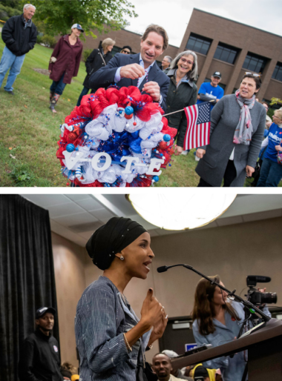

Top: Dean Phillips talks with people outside City Hall during early voting in Plymouth. Bottom: A newly elected Omar speaks to a group of supporters in Minneapolis | Tom Williams/CQ Roll Call and Karem Yucel/AFP via Getty Images

In one breath, Phillips tells me, “I can’t think of many Americans who wouldn't want better access to health care at a lower cost, wouldn’t want cleaner air, wouldn’t want to protect our environment, wouldn’t want to have better access to education a lower cost,” he says. “These are all shared outcomes. … There isn’t a lot of daylight between what I want to see done and what some of my colleagues perhaps further to the left on the political spectrum may want.”Yet in the next breath, when quizzed on some of the specific proposals in question, the daylight becomes blinding. He promptly points out that he didn’t sign onto the Green New Deal, a plan calling for tens of trillions of dollars to transform America into an Elysium of renewable energy. He scoffs at the mention of “modern monetary theory,” the fashionable notion pushed by Ocasio-Cortez and others on that left that America’s national debt is a meaningless number. He does not support a single-payer, Medicare for All health care apparatus. Nor does he subscribe to the increasingly common proposal of tuition-free college.This is not to accuse Phillips of duplicity or doublespeak. Like many rookie lawmakers—at least, those of his moderate tribe—he doesn’t want to rock the boat. Those Democrats who flipped red districts campaigned on promises not to clash emptily with Republicans; the irony, of course, is that they arrived in Washington only to realize that the greater threat to their jobs is coming from the left flank of their own party.

Phillips approaches the subject like he approaches every other political subject: gingerly. “It’s creating some interesting challenges in that some very young and new members have followings. Two people, their collective following exceeds the entire remainder of the Democratic caucus,” he says, deploying some digital hyperbole in referring to Omar and Ocasio-Cortez. “By definition, they become to the public the voice of a party, they become even de facto leaders of a party.”

As if this point isn’t explicit enough, Phillips adds, “This majority was achieved not by winning in AOC’s district or Ilhan Omar’s district, [but] by victories in districts that had not been terribly favorable to Democrats in the past. … So if there’s a tension in the party, it’s how do you maintain that majority?”

***

**Omar has a simple answer to her colleague’s question.**

“I think you endanger your majority by not doing what got you into the majority. And this is something that the Republicans often are in tune with that the Democrats are not. We seem to be afraid of our own shadow. We’ve become too afraid, I think, to actually listen to the people, and to recognize who our base is,” she says. “I’m fascinated by Republicans. They seem to have, for good or bad, a full understanding of their base and complete loyalty to them. We have a bigger base, but we seem to not understand them or have loyalty to them. When you are constantly trying to figure out how to appease everyone, you end up not appeasing anyone.”

The congresswoman is leaning forward out her chair, a sudden urgency inflecting her voice as she evaluates the departing paths before the Democratic Party. Seated inside her fifth-floor congressional suite, a brunet headscarf framing her face and a winter coat draped around her shoulders to fight the morning chill, Omar was cautious when we first began speaking. Understandably so: Between the Lindsey Graham controversy, the two early incidents of alleged anti-Semitism, and a recent viral sparring match with Trump’s special envoy to Venezuela, Elliott Abrams, she has the wary look of a battle-scarred trouper rather than a rookie lawmaker not two months into her first term.

But her guard doesn’t stay up for long. Though she is just 37, with delicate features, a puckish giggle and a strident social media voice that reflects her relative youth, Omar is a woman in a hurry.

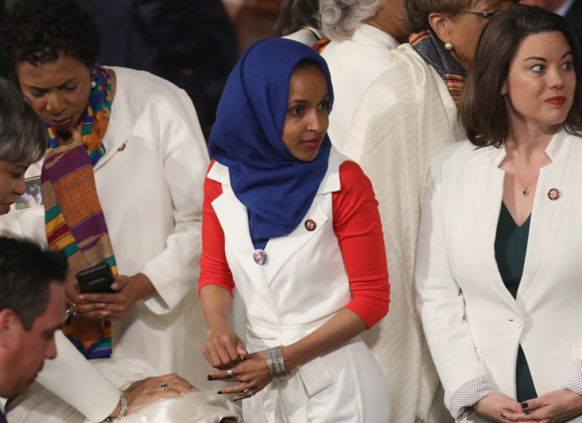

Omar wore white with a group of female Democratic lawmakers at the State of the Union address on February 5 | Win McNamee/Getty Images

Having fled the civil war in her native Somalia at age 8, spending the next four years in a Kenyan refugee camp before finding asylum in America, her adolescence was spent questioning why the land of opportunity she had read so much about—her new home, the United States—was falling short of its promise. Landing briefly in the suburbs of Washington, D.C., and then in Minneapolis, she saw dire poverty. She saw broken schools. She saw people without health care. Naturalized at age 17, she set off for college in North Dakota, studying political science and beginning her journey as a community activist focused on nutrition and education. She knocked on doors and startled many a rural, white woman with her headscarf, only to form deep bonds over their shared anxieties, such as “having affordable childcare, making it work with school, holding down a job, and making it home in enough time to make dinner.”

As the Somali population in her city continued to swell, so did the young activist’s discontent. By the time she ran for office in 2016, knocking off a 22-term incumbent to win a seat in the Minnesota statehouse, Omar was fed up—not so much with Trumpism, or with politics in general, as with the Democratic Party.

As she saw it, the party ostensibly committed to progressive values had become complicit in perpetuating the status quo. Omar says the “hope and change” offered by Barack Obama was a mirage. Recalling the “caging of kids” at the U.S.-Mexico border and the “droning of countries around the world” on Obama’s watch, she argues that the Democratic president operated within the same fundamentally broken framework as his Republican successor.

“We can’t be only upset with Trump. … His policies are bad, but many of the people who came before him also had really bad policies. They just were more polished than he was,” Omar says. “And that’s not what we should be looking for anymore. We don’t want anybody to get away with murder because they are polished. We want to recognize the actual policies that are behind the pretty face and the smile.”

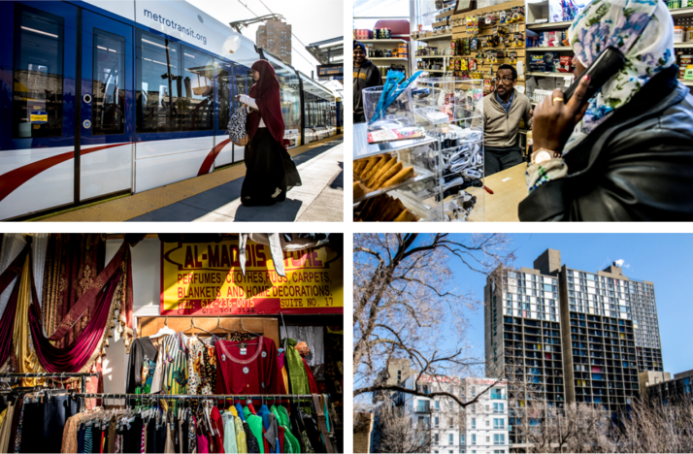

80,000 people of Somali descent live in Minnesota, a sizeable diaspora that lends a distinctive feel to the state's major cities like Minneapolis, pictured above | Mark Peterson/Redux Pictures for POLITICO Magazine

Omar embraces the comparisons between the Squad and the Tea Party. Despite the obvious philosophical differences, the models are strikingly similar: a two-term president leaves office with unfulfilled promises to the ideological core of his party’s base; that core base is galvanized by the election of the other party’s president; two years later, in that president’s first midterm election, the energy of that core base helps the out-of-power party retake control of Congress.

What remains to be seen is whether Democrats follow the comparison to its natural conclusion, with the insurgent activist wing swallowing up the party’s establishment. It’s a thought that paralyzes lawmakers like Phillips—and animates those like Omar. “We look at the negative aspects of the Tea Party and not really at the part of them that spoke to the American people, that made them feel like there were people actively fighting for them,” she says. “There’s a resemblance there. A lot of us are not that much different in our eagerness to want to come here and *fight* for our constituents, *fight* for the American ideals we believe in.”

The problem as Omar sees it—and not coincidentally, as some Tea Party conservatives saw it back in 2011—is that many of her fellow freshmen didn’t come to Washington to fight.

“I don’t believe that tiptoeing is the way to win the hearts and the minds of the people,” she says. “I get saddened by some of my freshman colleagues who can’t understand that within their districts the idea of Medicare for All is extremely popular. The Green New Deal is a very popular idea in their districts. Making sure that we have a final fix to our broken immigration system is very popular in their districts. What they pay attention to is the rhetoric that says, ‘This is a red-to-blue district, you have to be careful, you can’t talk about these policies.’ Well, in reality, these people are like everyone else: They struggle with the cost of health care, they struggle with our broken infrastructure, they struggle with having an economy that brings them into the 21st century. And we have to be willing to have those conversations.”

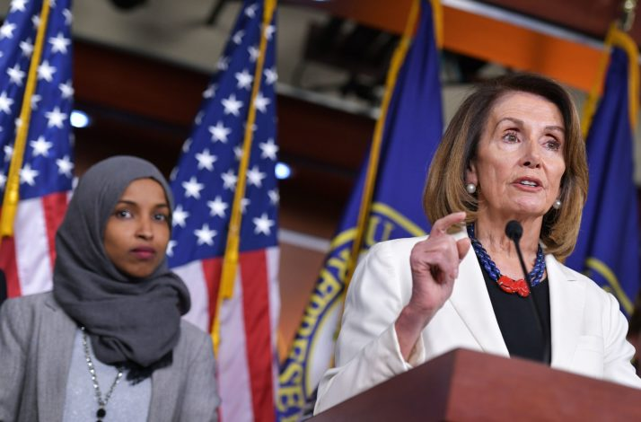

House Speaker Nancy Pelosi of California, center, holds a news conference at the U.S. Capitol. Omar is seen behind her | Mandel Ngan/AFP via Getty Images

Some of Omar’s colleagues in the Democratic caucus grumble that those difficult conversations need to be handled sensitively—and that the overzealous crop of young lawmakers are acting like bulls in a china shop. Indeed, just hours after I left her office, Omar was at the center of a fresh firestorm: This one owed to videotape that surfaced featuring comments made at an event in Washington the night before, in which she again took issue with Israeli influence over American policymaking, questioning some lawmakers’ “allegiance to a foreign country.”

Facing another round of denunciations, including from some of the most powerful members of her own party, Omar refused to back down. What ensued was a week of unmitigated chaos within House Democratic ranks: Senior Democrats pushed for a vote on a resolution condemning anti-Semitism, younger Democrats rallied behind Omar and objected to her being singled out, and the party’s leadership, desperate to defuse the situation, finally settled on a catch-all version of the resolution condemning all forms of hate speech, including against Native Americans and Pacific Islanders. It was a clear-cut victory for Omar and her allies on the left.

In a preview of her defiance, just hours before the videotaped comments thrust the congresswoman back into the national limelight, Omar told me that Washington—and especially her Democratic colleagues—should get used to her troublemaking.

“As much as other people are uncomfortable, I’m excited about the change in tone that has taken place that is extremely positive. The insightful conversations that we’re having about money and its influence in Washington. And my ability, I think, to agitate our foreign policy discussions in a way that many of my colleagues who have been anti-intervention, anti-war have been unable to do in the past,” she says. “So, I’m OK with taking the blows if it means it will ignite conversations that no one was willing to have before.”

***

**It’s easy to overlook the fact that,** as Phillips points out, Speaker Nancy Pelosi and the House Democratic leadership made their legislative priority, H.R. 1, a massive anti-corruption and voting-rights package that has near-unanimous support across the party’s internal divides.

It’s also easy to overlook the fact that, as Phillips also points out, the largest caucus within the House majority is that of the centrist, business-minded New Democrat Coalition. It boasts 101 members, many of them freshmen from swing districts. The group doesn’t get many headlines—“we’re not filled with show horses,” Phillips says—but its sizable membership reflects an ideological equilibrium in the caucus that isn’t widely appreciated.

And yet, if the divisions within the House Democratic caucus are a proxy war for the identity of the party, these insider battles are shaping up to be unfair fights. The intensity of the freshman progressives aside, leading Democrats hail primarily from areas of the country where working with Trump on virtually anything is a non-starter. For these members, even those inclined toward restraint, the realities of divided government and the zeal of their base provide an impetus for collision instead of collaboration.

“It’s not just the divide in the freshman class, it’s the divide between the Democrats who just got elected from swing districts and the Democrats who were elected to committees and committee chairmanships who come from ultra-safe districts and are now under heavy pressure from activists to investigate 10,000 different things in the executive branch,” says Dave Wasserman, the House editor at the Cook Political Report. “It was only a matter of time before these fissures in the Democratic caucus emerged, and they’re emerging with a vengeance.”

Meanwhile, in the nascent race for the right to take on Trump in 2020, the hearts and minds of Democratic voters are waiting to be won. No two elections are alike, and it’s premature to handicap the presidential field based on the cult followings enjoyed by freshmen members of Congress. But it’s increasingly difficult to envision a Democrat capturing the party’s center of gravity without replicating some model of what Trump did in 2016 and what Omar is doing in 2019: shunning the rules, turning up the volume and connecting with voters on their terms.

It’s a most discouraging thought for Phillips. “The only way to build a national brand it seems in this day and age, the only way to be listened to on a broad scale, is to throw political bombs,” he sighs. “And that’s a misalignment of incentives. There is not an incentive to conduct ourselves respectfully and decently.”

Inside the Mall of America on another snowy February night, a pair of local 25-year-old women, Duyen Lieu and Jeannie Farrell, can’t stop talking about the freshman congresswoman from Minneapolis. They praise Omar as courageous, trailblazing, a progressive visionary. Lieu says her supposedly anti-Semitic comments have been “blown out of proportion” by Democrats who fear her disruption of their clubby existence, and Farrell says “there’s a target on her back” because of her hijab, her refugee background and her Muslim faith.

They both follow Omar on social media. They also follow Ocasio-Cortez and other popular young Democrats. One person they don’t follow: Phillips, their representative in the 3rd District. In fact, they have never heard of him. (Omar has 800,000 Instagram followers and about the same on Twitter between her personal and political accounts, while Phillips has about 6,000 followers on Instagram and just over 20,000 on Twitter.)

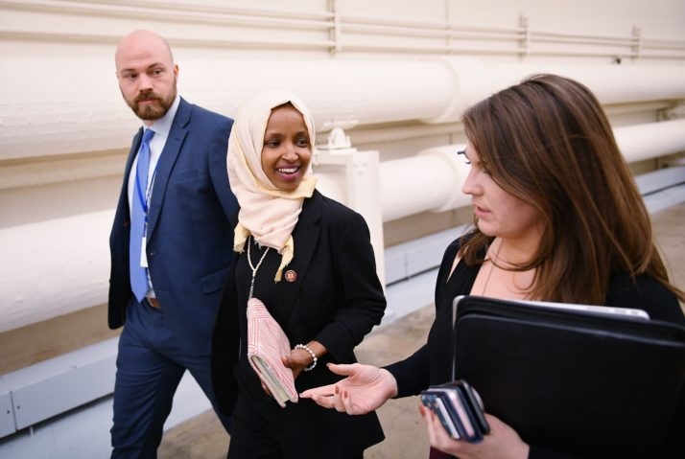

Omar at the U.S. Capitol in Washington | Mandel Ngan/AFP via Getty Images

It’s an open question whether the views of young, swing-district Democrats like Lieu and Farrell—who embrace the term “socialism” and are backing Bernie Sanders for president—portend the sort of rapid, sweeping changes Omar and her allies see in the party’s future. (Omar does not openly identify as a Democratic Socialist like Tlaib and Ocasio-Cortez; Phillips says the socialist labeling “drives me nuts,” and believes “it’s a damn big problem for the country” if his party gets branded that way because “two members out of two hundred” are so affiliated.)

What appears certain, however, is that the fault lines within this freshman class of House Democrats are the same ones shaping the contours of the party’s presidential nominating contest. Phillips, the business-oriented moderate, is backing Minnesota Senator Amy Klobuchar, someone who is “pragmatic” and will “build bridges” to win over independents and disaffected Republicans. Omar, the audacious progressive, has not endorsed, but says she is most excited by Sanders and Elizabeth Warren, candidates who are “not afraid” and have offered “bold proposals” that will turn out the party’s base.

One defining question Democrats will be expected to answer in the months ahead—both on the campaign trail and on Capitol Hill—is whether Trump should be subjected to articles of impeachment. While some progressives, including Tlaib, are actively pushing to begin impeachment proceedings, Democratic leaders have urged caution. They want members to wait for the release of special counsel Robert Mueller’s report on Russian interference in the 2016 campaign, fearful that the perception of overreaching could alienate the middle of the electorate and boost the president’s prospects for reelection.

Phillips and his fellow majority-makers from purple districts don’t need to be told twice. They’ll be dependent on ticket-splitters to keep their own jobs in 2020 and have little to gain by so much as uttering the I-word.

Omar is also reluctant, though, she professes, for a very different reason. She believes Trump is “completely insane” and has proven himself unfit for office. However, she adds, “I think the vice president is more dangerous than the man who is running the circus. So, impeachment is something that I think might become necessary—but I’m also afraid of it.”

*Tim Alberta is chief political correspondent at* POLITICO Magazine.