**Religion, Culture and Art in Haifa and Mount Carmel**

Mount Carmel has been a spiritual place for thousands of years. On our tour we will taste a variety of beliefs, streams and cultures. We will visit holy sites and museums. Haifa is the World Center of the Bahá'í Religion, where a unique Carmelite nunnery was founded, in which a 19th-century Mosaic Christian 'Templar' was established, and even housed a special Islamic stream, the Ahmadis, alongside other unique streams and institutions. We will all know and meet all of them.

**Meeting # 1: Louie Promenade in Haifa:** A Visit to the Bahai Garden, English tour

Mana Katz Museum and / or Japanese Art Tikotin Museum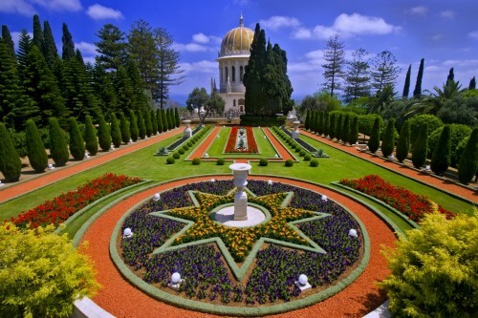

**Meeting # 2:** A visit to the Hecht Museum of the University of Haifa, the German Colony (Templars) and antique shops in the lower city.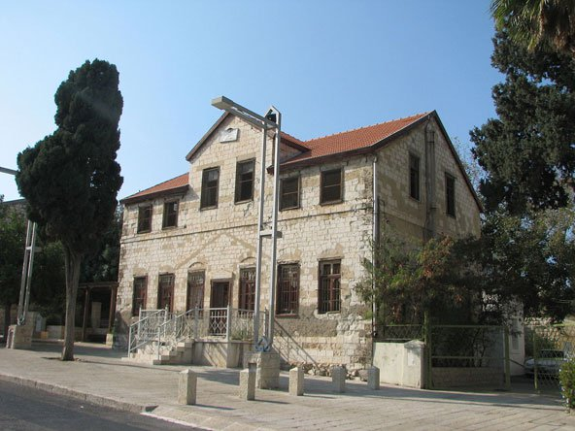

**Meeting # 3: A visit to El Carmel's Dalia and acquaintance with the Druze community**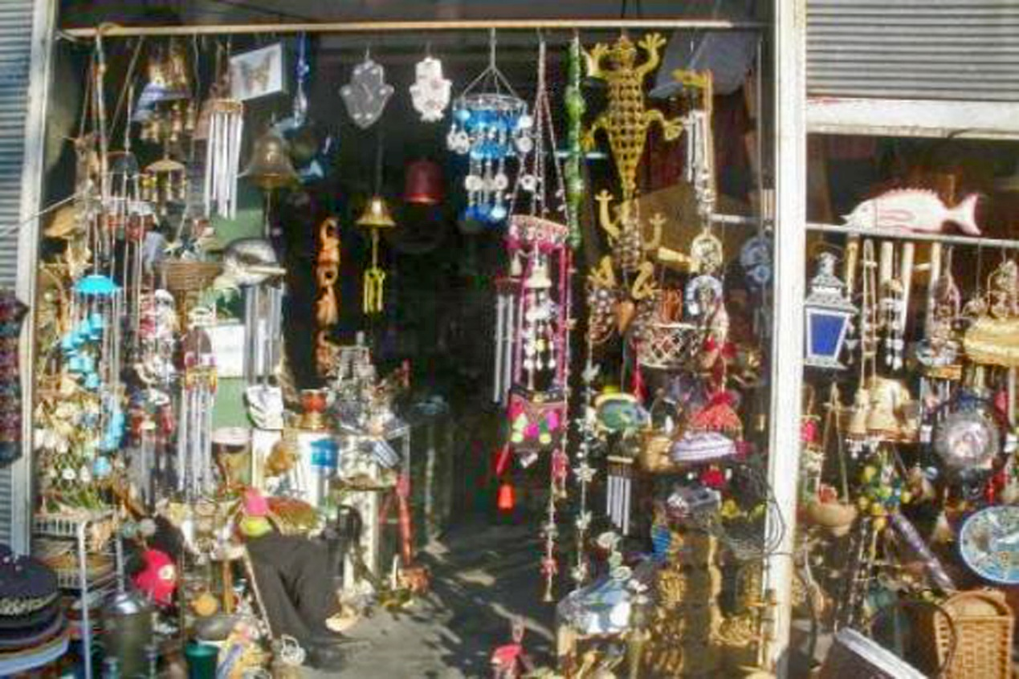

**Meeting # 4:** A visit to Acre, a tour of the Knights' Halls, the Walls of the Treasure Museum and Hammam. Cruise

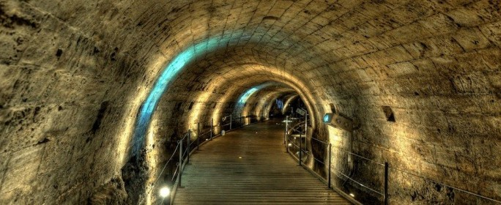

**Meeting # 5:** Monasteries and Monks on Mount Carmel, Stella Maris, Carmelite Monastery

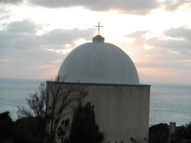

**Meeting # 6:** Visiting Caesarea: Herod's Construction Works, Kibbutz Sdot Yam, Beit Hannah Szenes and the Recanati Museum.

