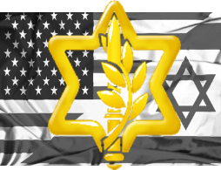Subject: IDF Roster for in-country integration

1. The list enclosed in appendix a comprises the IDF roster for integration in Germany during TAC-1 of Exercise JUNIPER FALCON 2021.
2. Please note the following:
   1. All personnel will arrive in Germany after receiving **two** dosages of COVID-19 vaccines (PFIZER).
   2. A negative COVID-19 PCR test will be presented as will (72-Hrs prior to departure).
   3. All participants will be equipped with N095 facemasks, and will abide social distancing rules.
3. Please note the requested base access, per group.
4. As always, I am grateful for your ongoing cooperation and friendship. But moreover, your commitment to the assistance of the defense of Israel.

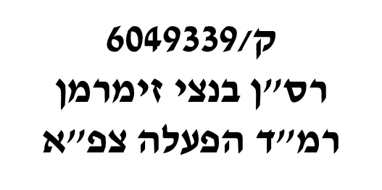

Benzi Zimmerman, Major, IDF

Head, US Operation Cooperation Desk (J53)



Copy:

* JOHN W. LECLAIR, JR., Colonel, USAF - Chief, Forces Management Division (A3F)
* Seth MacCutcheon, LtCol, USMC - Southern Flank Branch Chief and Israel Desk
* Brian R. Miletich, LTC, USA - ECJ-35 Plans, Levant Branch Chief, U.S. European Command
* Pat Vongsavanh, LtCol - ECJ7 JtrEx, JFHQ Branch Chief
* William Haag, Lt Col, USAF - ECJ7-JTrEx, Joint Training and Exercise Planner
* ALEXANDER SAYRE, GS13, DAF-C - USAFE-AFAFRICA 603 AOC / A37H
* Michael L Huff - JFHQ Exercise Branch, G37 TREX, USAREUR
* THOMAS M. HOOPER - Valiant Inte grated Services, Joint Exercise Planner, HQ EUCOM ECJ7 (JTrEx)

|  |  |  |  |  |  |  |
| --- | --- | --- | --- | --- | --- | --- |
| **Security Clearance** | **DOB** | **Passport** | **Rank** | **Name** | **Location** |  |
| IDF TS | 30/12/1973 | 32394248 | LtCol | Tal Kaduri | WPC and JSMC-K | 1 |
| IDF TS | 26/01/1970 | 31348030 | Col | Gershon Zlotnik | WPC and JSMC-K | 2 |
| IDF TS | 17/03/1990 | 33257685 | Capt | Michael Pitchkhadze | WPC | 3 |
| IDF TS | 15/12/1974 | 31749318 | Capt | Adi Ben David | WPC | 4 |
| IDF TS | 21/10/1987 | 22194709 | Maj | Eitan Asher Cartier | WPC | 5 |
| IDF TS | 21/05/1974 | 22231319 | Maj | Sagiv Eugene Pazin | WPC and JSMC-K | 6 |
| IDF TS | 8/8/1963 | 32487262 | Maj | Daniel Citron | WPC and JSMC-K | 7 |
| IDF TS | 19/09/1981 | 22699406 | LTC | Shahar Shoshana | WPC and JSMC-K | 8 |
| IDF TS | 19/07/1990 | 32618809 | MAJ | Ben Zion Zimmerman | WPC and JSMC-K | 9 |
| IDF TS | 12/1/1988 | 23586441 | MAJ | Gal Am-Shalom (Tzur) | WPC and JSMC-K | 10 |
| IDF TS | 11/5/1986 | 14992458 | Maj | Lev Kolomietz | WPC and JSMC-K | 11 |
| IDF TS | 8/10/1970 | 34325708 | Col | Bar Zohar Aviv | WPC and JSMC-K | 12 |
| IDF TS | 12/9/1968 | 3296600 | LCDR | Barry Oren Zebrak | WPC and JSMC-K | 13 |
| IDF TS | 25/09/1978 | 22871211 | MAJ | Gil Elharar | WPC and JSMC-K | 14 |
| IDF TS | 15/04/1970 | 32297150 | LtCol | Noam Shlomo Assael | WPC and JSMC-K | 15 |
| IDF TS | 11/9/1975 | 34585167 | LtCol | Richard Hecht | WPC and JSMC-K | 16 |
| IDF TS | 19/12/1988 | 14769951 | Maj | Rami Rahamin Mazon | WPC and JSMC-K | 17 |
| IDF TS | 26/01/1960 | 33818405 | COL | David Cesana | WPC and JSMC-K | 18 |
| IDF TS | 15/11/1964 | 22633633 | BrigGen | Doron Gavish | WPC and JSMC-K | 19 |
| IDF TS | 16/03/1979 | 32545598 | LTC | Oron Mincha | WPC and JSMC-K | 20 |
| IDF TS | 02/09/1983 | 22910428 | LTC | Nimrod Gross | WPC and JSMC-K | 22 |
| IDF TS | 05/03/1972 | 22310317 | BG | Avi Gil | WPC and JSMC-K | 23 |
| IDF TS | 17/01/1972 | 33842052 | BG | Efrain Defrin | WPC and JSMC-K | 24 |