The IDF is sending a group of 13 Colonels and Brigadier Generals, led by MG Itai Veruv, to a week and a half long seminar in the USA.

The purpose of the seminar is to **Enhance the understanding of the American “system”, Strategy and Interests, as an “Operational Compass” for decision making.**

**All participants are highly valued officers, hand picked by the IDF’s senior leadership and “marked” as potential senior leadership.**

**The Seminar rational is:**

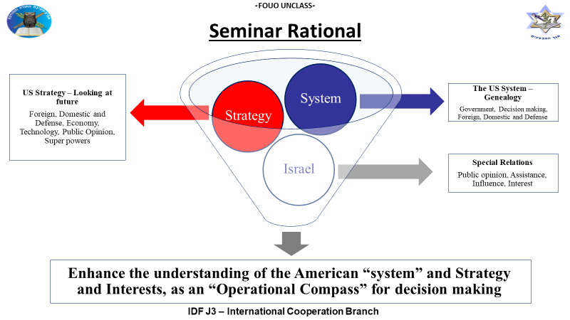

During the seminar, that is co-sponsored by JINSA, the officers will meet acting and former Government and Defense officials, tour Washington D.C and socialize with US Armed Forces colleagues.

We would wish to coordinate the following meetings and tours:

1. 29 October - Half a day in the Pentagon. Talking to acting officials (Mr. Rood /Mr. Mulroy / Mr. Jeffries/ Joint Staff CoS/J5/J3 /Vice Chairman…). The topics we would like to hear about are:
   1. Pentagon Tour and concept of operations.
   2. Role of the Joint Staff Vs. COCOMS
   3. “USA – WORLD SITREP”
   4. Mil-Gov relationship and processes of forming a defense policy.
2. 1 November - National Defense University - Digital Revolution and National Security, Big Data and Digital transformation. We can maybe do a joint PT session in the morning and a tour of the new College of Information and Cyberspace.
3. 4 November- Full day at the Israel U.S Embassy, lectures to be coordinated by JINSA and IDF.

1. MG Itai Veruv, commandant of the IDF Military colleges.

2. Colonel (promoted), Effie Defrin, designates Head is the IDF Intl. Cooperation Until

3. RDML Eyal Harel, Israel Navy

4. Brig. Gen. Amir Gat, Israel Airforce

5. BG Yaron Finkelman, CG 98TH Division

6. BG Ziv Avtalion, Designated head of the Digital Transformation working gorup

7. BG Avi Gil, CG 36th Division

8. BG Eran Niv, CG Judean and Samaria Division

9. BG Eran Ortal, Commander, DADO Center

10. COL Amit Saar, Israel Defense Intelligence

11. COL Erez Askal, Israel Defense Intelligence

12 BG Dan Newman, Head, Ground Forces Personnel Division

13. COL Gil Pinchas, Financial Advisor to the Chief of Staff

14. Colonel Hadas Minka-Brand Head of the behavioral sciences center

15. MAJ Benzi Zimmerman, Operations Directorate International Cooperation Desk

16. LT Mateo Elbaum, IDF J5