

**CoreControl Overview:**

CoreControl enhances your body’s natural cooling process using radiator structures in the palm of your hand. It does this by carefully maintaining the optimal temperature for heat exchange on the palm while placing the hand in a vacuum chamber. This combination can extract heat from the core body up to 500% faster. Many athletes experience cessation of sweating within minutes. CoreControl technology was discovered and patented at Stanford University as the result of years of research funded in part by the US Defense Dept. as a means to keep soldiers cool in desert locations. AVAcore is the exclusive worldwide licensee of these Stanford patents. Recently CoreControl has been made more accessible to the general public with the introduction of a new portable, less expensive product. CoreControl is in global use by the US Military, pro sports teams, NCAA and industry. CoreControl technology has been proven time and time again with peer reviewed published scientific studies, most recently by the prestigious Korey Stringer Institute at UConn. CoreControl is used for both heat safety as a preventative measure and as a performance enhancing modality to increase endurance and strength.

**CoreControlTechnology: How it works**

Elevated core body temperature is a problem for many, including athletes, industrial workers, miners and soldiers. Emergency medical responders and physicians are often overwhelmed by heat stress incidents. Anyone regularly subjected to exertion in sweltering conditions knows what heat can do to performance. As the temperature of the body's core organs (heart, lungs, liver, kidneys, and brain) rise, fatigue sets in and strength, endurance and cognitive functions deteriorate rapidly.

CoreControlTM was originally developed on the principles of mammalian thermoregulation. All mammals have "radiators," specific regions of the body surface designed for dissipating excess heat from the body core to the environment - think of a dog's tongue, or rabbits' ears. Blood is preferentially pumped to these surfaces when metabolism increases as it does during exercise. In humans, some of these radiator surfaces are found in the palms of the hands and soles of the feet. When an athlete gets hot, blood flow naturally increases through these skin regions to dissipate heat through specialized blood vessels called arteriovenous anastomoses (AVAs). CoreControl enhances heat extraction through the radiator surfaces in the hand by amplifying local blood flow using a proprietary and scientific combination of carefully controlled temperature settings and slight vacuum. Core body cooling is increased by 500%! One doesn't really feel CoreControl effects so much as a cooling sensation because the core body doesn’t have heat sensor nerves, but rather as the sensation of being refreshed and less fatigued.Conventional methods of cooling the body include remedies typically applied to the skin's surface (i.e., misting fans, ice packs, cold water, etc.). While such solutions often make one’s skin "feel" cooler temporarily, they are generally ineffective at cooling the body's core organs as they are insulated by tissue and fat. This is a result of two phenomena: First, these treatments are applied to the skin's surface, and thus have difficulty penetrating the body's insulating layers of tissue. Second, the cold temperatures of these remedies can result in a vasoconstriction of the peripheral blood vessels and actually cause a reverse of the desired effect by shutting down the natural heat dissipation mechanisms.

Over the last two years, studies have targeted individuals with maximized exercise workloads in hot environments. These studies show dramatic improvements in recovery from heat stress. Use of the RTX technology reduced the rate of core temperature rise during exercise and increased the rate of core temperature decline following exercise resulting in increased speed, strength and endurance and reduced risk of heat and dehydration related injuries (e.g., cramping).

For those working in extreme environments or those susceptible to heat stress, CoreControl can help keep the core body temperature within the zone for optimal performance. When overheated, it cools the body rapidly and non-invasively to reduce fatigue, increase endurance and strength, and improve cognitive function. Please check the websites below for peer reviewed scientific articles and data.

**Who Uses CoreControl Technology?**

In sports CoreControl is in use by the NFL, NBA, NHL, NCAA, FIFA World Cup Football and US Olympic Teams. Most notably CoreControl is in use by the Super Bowl Champion Seattle Seahawks, The FIFA World Champion German Team, Manchester United and Chelsea Football teams, the NIKE Oregon Project US Track and Field Team, US Winter Olympic Speed Skating Team, The Golden State Warriors, Celtics, Boston Bruins and many of the top 10 NCAA D1 football teams including Ohio State. In industry CoreControl is used by the Phoenix Fire Department, Occidental Petroleum and Exxon, and mining companies Rio Tinto, Boddington and BHP Billiton to name a few. CoreControl is also used by the US Army and Navy.

For recent videos check out the sampling of these videos available on line:

The Stanford football team among many other top NCAA D1 teams, has made CoreControl part of their everyday routine for both performance enhancement and heat safety.  The following link gives a brief explanation on the technology and then an interview with Steve Bartlinski, Head Athletic Trainer for Stanford Football.

<http://youtu.be/-wBek9CgmhU>

This past winter the US Men's Olympic Speed Skating Team used CoreControl in Sochi.  The following link is an interview with one of the skaters, Jonathan Garcia.

<http://youtu.be/gK0_1NcDXqY>

Casey Paterson, US Men's Olympic Beach Volleyball player has been a user of CoreControl for over a year and we expect great things from his team in 2016. An interview with Casey is in the following link.

<http://youtu.be/Nm9AiRfbIQE>

Last, one of the most prestigious and innovative of all fire departments, Phoenix Fire Department, is using multiple CoreControl units on a daily basis for recovery for their Hazmat Team.  The following video is from last summer.

<http://www.myfoxphoenix.com/story/22719384/2013/06/28/cooling-glove>

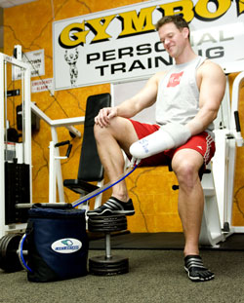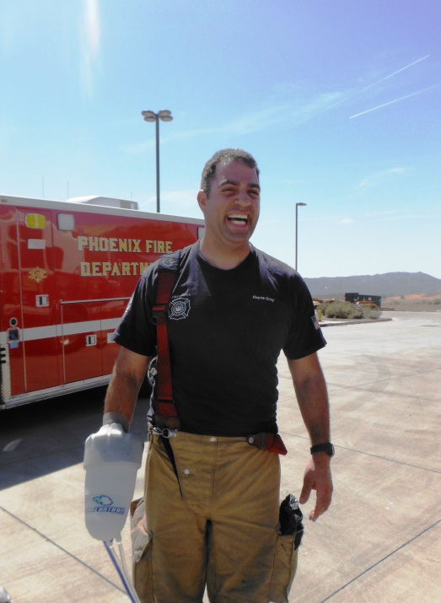

[www.avacore.com](http://www.avacore.com) or email [info@avacore.com](mailto:info@avacore.com)

call 888-ava-core