**Jamie Shea**

*Deputy Assistant Secretary General for Emerging Security Challenges, NATO*

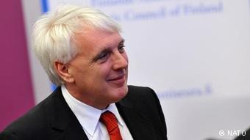

Jamie Shea is NATO Deputy Assistant Secretary General for Emerging Security Challenges. He has been working with NATO since 1980. Positions included Director of Policy Planning in the Private Office of the Secretary General, Deputy Assistant Secretary General for External Relations, Public Diplomacy Division, Director of Information and Press, Spokesman of NATO and Deputy Director of Information and Press, Deputy Head and Senior Planning Officer at the Policy Planning and Multilateral Affairs Section of the Political Directorate as well as Assistant to the Secretary General of NATO for Special Projects. Jamie Shea is involved with several prominent academic institutions and acts amongst others as professor of the Collège d’Europe, Bruges, Visiting Lecturer in the Practice of Diplomacy, University of Sussex, Associate Professor of International Relations at the American University, Washington DC, where he also holds the position of Director of the Brussels Overseas Study Programme, and lectures at the Brussels School of International Studies at the University of Kent. He also is a regular lecturer and conference speaker on NATO and European security affairs and on public diplomacy and political communication and lobbying. He holds a D.Phil. in Modern History from Oxford University (Lincoln College), 1981. Amongst his many associations and memberships, Jamie Shea is Member of the Advisory Board, Security and Defence Programmes at Chatham House, Member of the Policy Council at the World Economic Forum in Geneva and Founder and Member of the Board, Security and Defence Agenda Brussels.