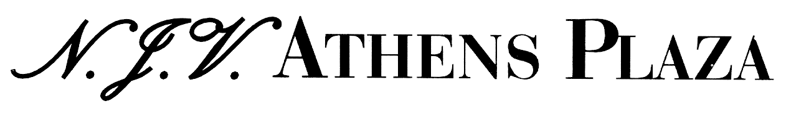
Constitution Square (Syntagma) 105 64 Athens Greece

Tel: 0030 210 3352400 / Fax: 0030 210 3235856 / Sales Dep’t Fax: 0030 210 3237185

e-mail: reservations@njvathensplaza.gr

Credit Card Payment Authorization Form

Please complete all areas below. Incomplete requests may be rejected.
Kindly sent this form by fax to 0030 210 3235856.

CARDHOLDER – Please complete the following section and sign / date below.
Guest Name: Amihai Levin
Check in: NOV 7th Check out: NOV 10th
Cardholder Name as it appears on Credit Card: Amihai Levin
Cardholder Address: Mahane Yaffe, 504
City: Mahane Yaffe Postcode: 8542500 Country: Israel
Daytime / Business Telephone: +972529256902 Evening Telephone:
Credit card no: 5326101318006378 Expiration Date: 04/12
Credit card type: (circle one)

Visa / Mastercard / American Express / Diner club

Credit card Issuing Bank Name: Otzar Hahayal
Bank Phone Number (from back of your credit card): +97235130037

I agree that the hotel may use this credit card for below charges (Please circle)

Room & Accommodation Tax & Breakfast All charges

By signing below, you authorize the hotel to preauthorize your credit card immediately.

Cardholder Signature: Amihai Levin Date: 30/10/2019

