June 7th, 2020

**FINAL GRADE FOR YEAR LONG PROJECT: Sima Spitzer, Ido Mizrachi, Michal Masti**

**l סימה שפיצר, ת.ז: 016347593**

**מיכל מסטיי, ת.ז: 027958032**

**עידו מזרחי, ת.ז: 032812406**

The topic of investigation chosen by Sima, Ido and Michal required them to plunge into a new field, cryptocurrencies, about which they knew little (as for most people) and identify key elements that can present a threat to national security, and how best to counter these threats. Together we identified the main elements that need to be further investigated, both theoretically and empirically.

There were many obstacles, first to understand how these cryptocurrencies work, why do they present a potential threat by allowing the easy finance of terrorism, and how the latter can be prevented. This required understanding the technology, the typology of criminal activity, and the legal tools available to counter the threat. They not only researched the academic and policy research available, studied what was done elsewhere around the world as this is a global problem, but also interviewed comprehensively people who work in the field – a very important step in order to ensure that they are up to date with respect to the fast moving developments in the area. They themselves designed a methodology, and suggested an ingenious risk management tools to tackle the threat. This is innovative and creative as well as led to a useful set of recommendations for policy makers.

This is an important piece of work, and I hope that it will be brought to the knowledge of policy makers in the field. It is thorough, well written and clear in its recommendations. It contains all of the elements of an academic paper, the research background, literature survey, the chosen methodology justification, discussion of empirical findings and conclusions.

I assign the grade of 98/100 for the paper.

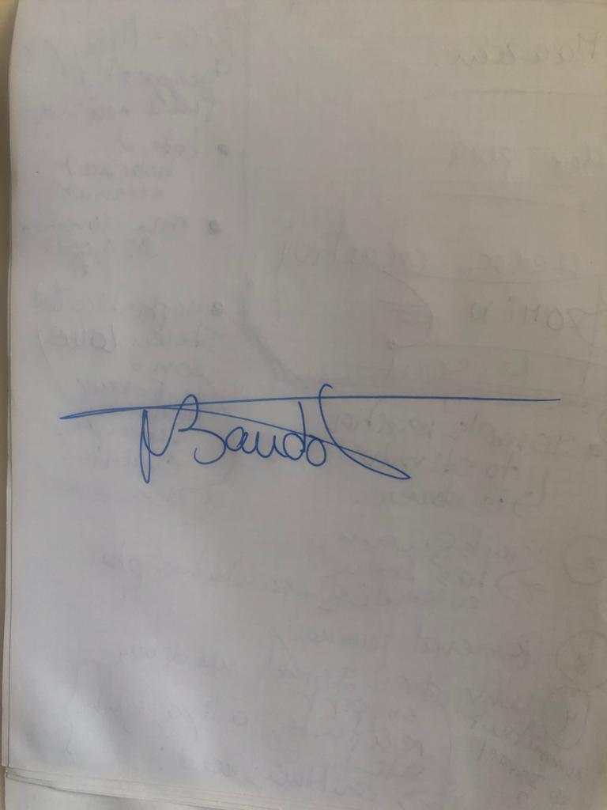Best

Nadine Baudot-Trajtenberg

Tiomkin School of Economics

IDC Herzliya