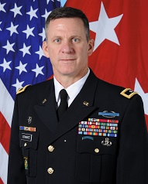

Lieutenant General Mark C. Schwartz currently serves as the United States Security Coordinator for Israel and the Palestinian Authority. Prior to arriving to the United States Embassy Jerusalem, LTG Schwartz served as the Deputy Commanding General, Joint Special Operations Command. His other general officer assignments include; Commander, Special Operations Command Europe, Deputy Commanding General for Maneuver, 1st Cavalry Division and Deputy Commander Special Operations Joint Task Force – Afghanistan.

A career Special Forces officer, prior to being promoted to brigadier general, LTG Schwartz served in Special Operations key developmental command and staff assignments including; Chief of Staff, Joint Special Operations Command; Commander, 3rd Special Forces Group; Commander, Combined Joint Special Operations Task Force – Afghanistan; Director of Operations, Combined Forces Special Operations Component Command – Afghanistan; Deputy Commander for Operations, CJSOTF-A; Executive Officer and Deputy Commander, 3rd Special Forces Group; Commander, 4th Battalion 1st Special Warfare Training Group; Special Operations Plans Officer, Joint Forces Command Brunssum the Netherlands NATO.

He is a graduate of the Navy War College, Newport, RI and the Command and General Staff College, Leavenworth, KS.

LTG Schwartz is a native of Colorado. He attended Idaho State University, Pocatello ID majoring in Finance and was commissioned an Armor second lieutenant in December 1987 through ROTC.