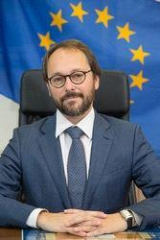

**Emanuele Giaufret**

Head of Delegation of European Union to the State of Israel

Ambassador Emanuele Giaufret arrived in Israel in 2017, following an extensive career in EU foreign policy. Most recently, he was Head of Division for Democracy and Electoral Observation at the European External Action Service (EEAS); Advisor to the Managing Director for North Africa and the Middle East; and prior to that he served in the EU Delegation to the UN in New York. This is Mr. Giaufret's second post in Israel; he headed t**he Economic and Political Section** of the EU Delegation in Tel Aviv between 2003-2007. Before joining the EU, Mr. Giaufret worked for the Organisation for Security and Cooperation in Europe. He has a PhD in History of International Relations from the University of Florence and a Master's degree in European Affairs received from the College of Europe in Belgium. He is married and has three children.