**^12^ 43**

Israel National Defense College

39th Class 2011-2012

**University of Haifa**

**Germany and the Middle East –**

**The Potential to play a Pivotal Role and to be a Leading Mediator**

Lecturer: Prof. Avraham BenZvi

Instructor in charge: Mrs. Liora Herzl

Submitted by: LTC GS Michael E. Rüb

Date: 25th April 2012

Content:

1. Introduction 4

2. Guidelines of German Intermediaries Tradition 6

3. Intermediaries Theory in Political Science 8

3.1 Central Developments of Intermediaries from 19th Century until today 8

3.2 Mediator and their Determining Factors 10

3.3 The Basis of Mediators Influence 13

3.4 Mediators and disputant Parties decision-challenges 14

3.4.1 The Mediator 15

3.4.2 Disputant Parties 17

3.5 Analytical Matrix for Mediation Potential 18

3.5.1 Interests and Capabilities + Extracted Value 18

3.5.2 Target of Intervention 19

3.5.3 Objective of Intervention 20

3.5.4 Analytical Framework for Potential Analysis of Mediators 21

4. Germany´s and Israel´s National Security Strategy 22

4.1 National Security and National Interests 22

4.2 Evaluation of the main components of Germany´s National Security Strategy 24

4.3 Evaluation of the main components of Israel´s National Security Strategy 32

4.4 Comparisons and Conclusion 39

5. Analysis of the Catalyzers “Arab Uprising” and “Euro-Crisis” 42

5.1 “Arab Uprising” and its Ramifications towards Israel and the Middle East Region 42

5.1.1 Israel loses its “Partners” in the Region 44

5.1.2 Increasing Influence of Arab Populations 46

5.1.3 Iran´s Challenged Ambition and the Turkish Role Model 47

5.1.4 Israel´s “wagon fort” perception 49

5.1.5 Palestinian Power Sharing and unilateral UN Approach 49

5.1.6 Conclusions 50

5.2 The EU and the catalyzing effects of the “Arab Uprising” 52

5.2.1 Regional Connection and Regional Interest 53

5.2.2 European Unions Toolbox 54

5.2.3 Energy and Migration 56

5.2.4 Conclusion: Chance for Europe and therefore for Germany 59

5.3 Catalyzer “Euro Crisis” and Germany 63

5.3.1 Germany´s internal Transformation Process 66

Economy 66

From “Bonn Consensus” to “Berlin Consensus” 68

Perception and Understanding of National Security and Defence 70

5.3.2 After Lisbon Treaty the “Euro Crisis” is shaping a New Power Balance 71

5.3.3 Germany´s Foreign Policy in a Transition Phase 73

5.3.4 Conclusions 75

5.4 Implications of the Catalyzers towards the potential future role of Germany in the Middle East 78

6. Mediation-Potential Analysis of Germany 83

7. Conclusions/ Summary 88

**Endnotes**………………………………………………………………………….90

**Appendix:**

Appendix 1: Third Party United States of America………………………………98

Appendix 2: Reconfiguration and Bargaining Range………………………….....99

Appendix 3: Description of the Security model systematics…………………….100

Appendix 4: Quotation Former British Prime Minister Margaret Thatcher…......101

Appendix 5: Development of EU Treaties……………………………………....102

Appendix 6: Voting weights: EU Parliament; European Council ……………....103

Bibliography……………………………………………………………………..104

# 1. Introduction

***O! it is excellent***

***To have a giant´s strength; but it is tyrannous***

***To use it like a giant.***

(William Shakespeare; in Measure for Measure: Act II. Scene II)

This quotation about power and dominance could describe the political and military policy of Germany, 20 years after the foundation of the Second Reich in Versailles 1871. Chancellor Bismarck’s policy after the foundation was to establish an alliance network to integrate Germany into the “club” of superpowers of this era.[1] The colonialism was “blooming” and Germany was perceived as the “belated nation”. The maxim of Bismarck´s Foreign Policy was after the successful war against France, that Germany is now “saturated”. Unfortunately, the young emperor Wilhelm II. disagreed with Bismarck´s approach, dismissed him 1890 and directed Germany´s fate towards the known catastrophes of the first and second world war.

In the twenty years, between 1871 and 1890 Germany developed, as the most powerful economic nation in Europe, with Bismarck´s approach of self-limitation a role of a Mediator, who balanced the interests of the other “superpowers” in a kind of a “Honest Broker”.

140 years later, also 20 years after the reunification of Germany in 1990, the history seems to offer Germany another approach. Again, Germany is arising to the dominating and biggest economy in Europe. Will Germany follow in any kind this Integration and Intermediaries “Tradition”? What will be the future role in this different political environment and in which direction will German Foreign Policy heading?

First of all, I will try to carve out, if there is in German History a kind of “guidelines of Mediation Tradition”. Then the focus will be directed to the current status of modern mediation in Political Science. I will analyze how the process of mediation can be operationalized and which factors are the determine one to become a mediator. These operationalized factors will be used within a process model as a tool later on to analyze the mediation-potential of Germany.

The Middle East Region is, because of its direct geographical connection to the European Union sphere and because of a broad spectrum of other influencing factors like migration, energy resources, political instability, Arab-Israeli Conflict, etc. of special importance for Germany. Therefore it is necessary to analyze the National Security Strategy of Germany and Israel in the current situation, to be able to identify interests, capabilities, possibilities, challenges and threat-perceptions as a starting point for a potential mediator. For Germany as well as for Israel exists no official document what cover the topic of National Security Strategy. In consequence, I will transfer the comprehensive approach of Barry Buzan for conceptualization of security into an analytical matrix and I will expand his model by a supporting aspect or positive factor in a sense of a comprehensive analysis tool. This tool will be applied on Germany and Israel and the analysis will end in a comparison of both countries. The result of the comparison will enable me to identify the current status of the specific perception to the particular National Security and will show starting points and “naturally” complementary sectors for Germany´s potential to become a Mediator in the Middle East Region.

This current status of the perception to National Security of Germany and Israel is in transition. Two catalytic processes – “Arab Uprisings” and “Euro-Crisis” -, with their development-accelerating and changing effects towards National Security, are affecting the National Interest, capabilities, shifting environments and/ or positions of actors and changes at least a long-lasting, well known security environment. I will analyze the ramifications towards the carved out status of National Security of Germany and Israel and will combine this with the potential analysis of mediation capabilities of Germany.

# 2. Guidelines of German Intermediaries Tradition

The first unification of German principalities and small kingdoms took place 1871 with the foundation of the Second German Reich in Chateau Versailles’s hall of mirror. In the following two decades the young German Nation became the strongest economic power in Europe, but Bismarck decided not to conduct a power, instead to pursue a security policy. Within this approach Bismarck conducted two mediation conferences in Berlin – 1878 Balkans Conference[2] and 1887 Mediterranean Treaty[3] – and generated German Foreign Policy and himself to a “Honest Broker”. This kind of Foreign Policy can be seen as the foundation stone of the integrative and balance of interest oriented German approach, with mediation as its integral part.

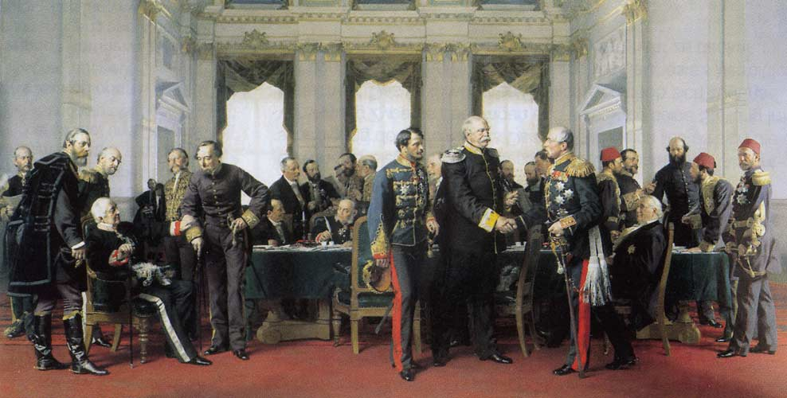

Source: closing meeting Berlin 1878; picture in cityhall Berlin

After Word War II, Germany had an unprecedented incision in its history. At the end of the Potsdam Conference on 2nd of August 1945 with it´s famous four D´s: Demilitarization, Denazification, Democratization and Dismantlement can be described as the zero hour for future German politics.[4] The first German Chancellor of the Federal Republic of Germany, Konrad Adenauer developed his concept of “Westbindung” – Integration into the Western Community – for the Foreign Policy of the young Federal Republic of Germany.

This concept based on the following foundation pillars: Member in the Euro-Atlantic security architecture, integration into the Western European economical and political organizations and structures, as well as the conciliation with France.[5] Therefore, he was willing to give up sovereignty of the Federal Republic of Germany to international organizations and structures, to regain integration, political sovereignty and acceptance in the same way.[6]

From 1969 to 1974, Chancellor Willi Brandt – leader of the Social Democratic Party of Germany - initiate a new approach of German Foreign Policy called “Ostpolitik”, aiming at "Wandel durch Annäherung" ("change through [rapprochement](http://en.wikipedia.org/wiki/Rapprochement)"), encouraging change through a policy of engagement with the (communist) Eastern Bloc, rather than trying to isolate those countries diplomatically and commercially. After Adenauer´s approach towards the “Westbindung”, Brandt pursue with his strategy now a balance of interests with the “Eastern Bloc”. In 1971 Brandt won the Nobel Peace Prize for his policy.

In the decades between 1945 to 1989 German Policy was focused on the goal of balance of interest to regain sovereignty and unification. This kind of action deepened the basic notion to conduct Foreign Policy in a sense of mediation, means balance of interests, between the different parties towards the special German position. The process of reunification between 1989 to 1990 reflects this in an excellent manner, because (West-) Germany acted in this process as a mediator on one´s own account. Germany had to balance the interests of the Allied Powers to regain its own sovereignty and succeeded with the 2 + 4 Treaty 1990.

Germany followed this guideline of Foreign Policy also after the Reunification and mediated in the gas supply dispute between Russia and Ukraine 2006 and Chancellor Angela Merkel unveiled her position in the Georgia conflict in 2008 as a trustworthy “middleman” with and unparalleled capacity to negotiate between Russia and the West.[7] Furthermore, Germany hosted two Afghanistan Conferences 2001 and 2011 in Bonn/ Petersberg to facilitate a solution for a better future of this country and was deeply involved in mediation processes in the Middle East between Israel and terror organizations like Hezbollah and Hamas.[8] This examples are providing evidence that, since the Second World War and especially after regaining sovereignty with the reunification, Mediation is an integral aspect of German Foreign Policy and that this is basing on clear guidelines in history.

Geography and history have led to the result, that German Power is always bigger and more influential, when Germany is acting and cooperating with its European Neighbours. Therefore, as more trust Germany´s neighbours have into the German responsibility and fairness, as much are the chances of Germany to gain its goals. Balance of interests and efforts towards a common denominator are in consequence not signs of weakness, but a condition for German strength.

# 3. Intermediaries Theory in Political Science

In this chapter I try to characterize the peculiarities of the position of an Intermediary – “in the middle” –and to lay out what is distinctive about intermediary intervention as a method of international conflict management. In this context I will focus on the system and process of mediation, will analyze its elements, factors, parties, interconnections and interdependencies, and will develop an Analytical Framework for the further analysis. Based on this analysis tool, I would like to assess and identify the specifica of Germany´s potential-spectrum to take a pivotal role and to be a leading mediator in conflict or crisis situations.

## 3.1 Central Developments of Intermediaries from 19th Century until today

The international system and diplomatic practice have changed dramatically since the nineteenth century. Like I elucidated in the second Chapter, in the classical European great power system, relations were managed by a “diplomatic caste” and negotiations were facilitated by the mutual expectations to be basically accommodative as well as flexible and negotiators were only accountable to an emperor or a monarch. The phenomena of mass media and the public opinion were of minor concerns. In consequence this “diplomatic caste” could operate in secret and with each other´s confidence.[9]

Modern diplomacy is much more complex. This complexity finds its expression nowadays in a diplomatic system, which contents many more actors, state and non-state and a much broader spectrum of issues to negotiate about. Official negotiations are conducted today as much by heads of states and politicians as by professional diplomats (mostly in a supporting function). Therefore, these groups are continually exposed to the pressure of public opinion and domestic politics in their own countries. The mass media plays in this concert a prominent role, so that the effects, created by pronouncements, are not only directed to the opponent, but also towards the constituencies in the home countr.y[10] Modern international negotiations are widely lacking effective communication and realistic empathy. Robert Jervis expressed it like following:

*“In almost no interactions do two adversaries understand each other´s goals, fears, means-ends beliefs and perceptions. Empathy is difficult and usually lacking… . The fine-tuning of policies and the subtle bargaining tactics that would be called for in a world of clear communication cannot work in our world.”[11]*

In modern diplomacy negotiators are much more vulnerable. If a significant constituency feels a legitimate state interest has been sacrificed or if an opportunity for gain has been foregone, the negotiators or politicians can be easily eliminated – through dismissal, election, or coup. The natural “reflex” is to turn to a third party and to transfer the responsibility for negotiations and their results to this – as a legitimate agent.

The expectation to third parties is to persuade the other side of the own rightful position and when compromise would be necessary, to persuade the own constituency about the necessity of the concession. They are expected to be “neutral” or “impartial” or, at least, to act to preserve one´s expected – and “deserved” – outcome. The leaders choose these third parties to save face at home and abroad. However, a third party in the role of a mediator has to pass a special test, it must be accepted by both sides! [12]

Another challenge of modern diplomacy is communication. The central problem to achieve an agreement lies in the relationship of strategic interaction between the parties, domestic politics and public opinion. Therefore leaders in such conflicts are open to third parties, to gain and possible to reveal information, which are necessary for a settlement. By virtue of being in the middle, intermediaries are committed to improve the communication between the negotiating parties and itself, and this may inadvertently result in a better assessment of goals and fears, beliefs and perceptions.[13]

The kind of intervention of a third party to negotiators can be based on influence (promises and threats) or to change the parties´ mode of interaction. A powerful third party can change behavior by using or threatening to use its power resources (military or economic). This would be the classical form of intervention and remains important today, but force and its threat become increasingly limited in a unilateral context and even the “powerful” actor is regularly better advised to facilitate rather than coerce settlements between disputing parties today. The core-question is, how does influence vary with the kind of intervenor, the nature of the conflict and the issues at stake? To understand the essential nature of the mediating role, one must go beyond the traditional roles and the traditional focus on power, interests and rationality. The analytic challenge is to explain facilitation as more than altruistic behavior and yet other than traditional power politics.[14]

## 3.2 Mediator and their Determining Factors

For the purpose of assessing the potential of a Mediator it is necessary to develop a conceptual framework to analyze the different parameters of third-party-intervention. I follow the idea of Thomas Princen, who criticize that in mediation-analysis almost the implicit assumption exists that mediators are apolitical, disinterested entities, which enter a dispute just to facilitate agreement.

In contrast to this kind of approach I underline the notion of Thomas Princen, that mediators have their ***own interests***, that ***fundamental differences*** among mediators exist, and that a mediator´s ***bargaining relationship*** with the disputants is critical for understanding its impact on a dispute.

Negotiation parties must assess their own interests and those of their opponents to be able to act effective. The same counts for a third party, called mediator. It is critical to distinguish the interest mediators have in the issues disputed by the conflicting parties.[15]

This distinction can be done by examine the nature of interest that a mediating party has in the disputed issue (e.g. Middle East Conflict see Appendix 1: Third Party USA).

The Principal Mediator has interests in the disputed issues and can bring considerable resources – military or economic - to bear. [16] In contrast to the Principal Mediator there could also be a neutral one who is not interested in the disputed issues themselves, but in the achievement of an agreement. This kind of Neutral Mediator can offer a low risk environment with facilitation of the negotiation-process itself.

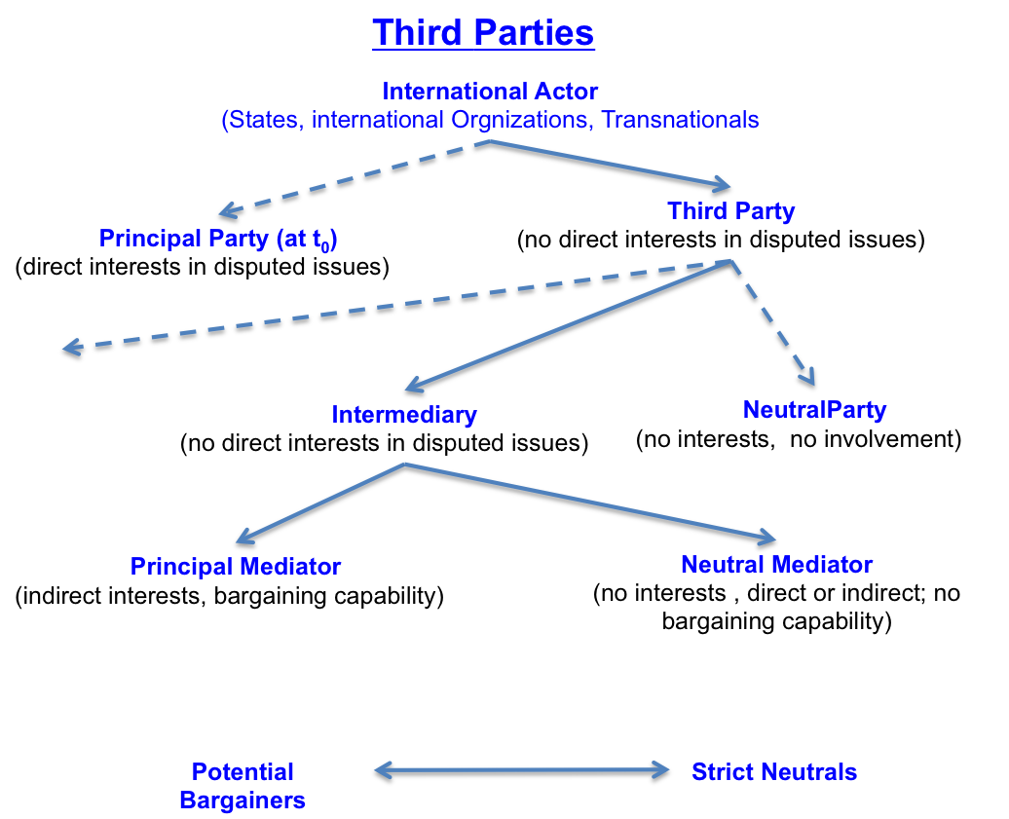

Source: Princen; Intermdiaries in Internat. Conflict, p. 21

A mediator targets its intervention either at the nature of the bargaining – that is, its structure and its pay-offs to the disputants – or at the nature of the interaction itself – that is, the modes of exchanging information, clarifying perceptions and intentions, identifying interests, recognizing fundamental concerns, exploring options, and so forth.

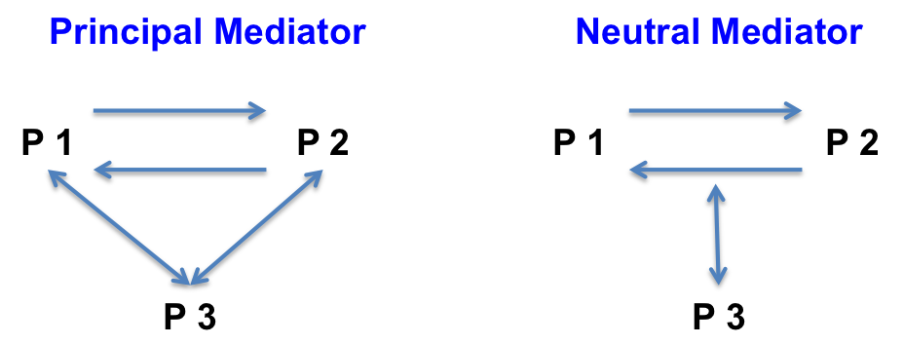

Source: Princen; Intermdiaries in Internat. Conflict, p. 24

The Principal Mediator´s intervention, consequently, changes the bargaining dynamics and fundamentally, the structure of bargain.[17] The bargain is no longer direct and bilateral, now it is a three-way bargain. In consequence, this kind of intervention detracts the disputants from the direct interactions.

What is the effect of a Principal Mediator intervention? It changes the disputants’ incentive structure. It changes the magnitude of the outcome or the consequences of not agreeing or the sequence of achieving agreement. The entire intervention game is to rearrange payoffs to overcome an impasse.[18] The three way bargaining serves to conceal concessions – a circular bargain looks good for all – or to give negotiators a face-saving way out.[19]

A Neutral Mediator cannot bargain with disputants. It has neither the interests nor the capacity. The focus of the attention in intervention is the disputant’s interactions, their relationship, their communication, their mutual perceptions and the mode of bargaining. In consequence, the Neutral Mediator has interests in the structural relationship between it and the disputants. By its “weakness” in bargaining resources, the Neutral can credibly demonstrate its lack of interest in the issues in dispute and commit itself to one object, getting an agreement.[20]

For the **Principal**, the target of intervention is the **outcome structure** and the intervention objective is to **enhance incentives** for agreement. In contrast, for the **Neutral Mediator**, the target of intervention is the **mode of interaction** and the intervention objective is to **create realistic empathy** (overcome cognitive limitations and misperceptions).

The distinction between Principal and Neutral Mediators helps differentiate the

target and the effect of an intermediary intervention:[21]

* Differences in Interest and Capabilities

(Principal vs. Neutral Mediator)

* Differences in the Target of Intervention

(Payoff Structure vs. Mode of Interaction)

* Differences in the Objective of Intervention

(Enhance Incentives vs. Create realistic Empathy)

In principle the policy-choice choice between Principal and Neutral Mediators is not an either-or proposition. Rather, what the Principal-Neutral framework suggests is that, for complex disputes that evolve over time, a combination of intermediaries carefully sequenced will be most effective.

## 3.3 The Basis of Mediators Influence

The impact of a mediator on a dispute can be traced back to three attributes of

intermediary intervention:[22]

1. Ability to change bargaining dynamics by reconfiguring the structure of the bargain process.
2. Ability to initiate movement through making proposals.
3. Ability to pool information.

The different Interests of a Principal and a Neutral Mediator in the disputed issues and as well in the bargaining capabilities determine whether the primary target of intervention is payoff-structure or the interaction of the disputants.[23]

**Ad 1:** The bargaining-structure is determined by the number and nature of issues and by the parties. A mediator reconfigures the structure of bargain on the one hand through the fact that the number of involved parties increases – with all sociological and game-theoretical effects and on the other hand by the option to rearrange the disputed issues themself. [24] A mediator can disaggregate issues and find creative ways to trade across subissues to benefit both sides (e.g. economic or military aid). This approach would change the bargaining-range of each party by increasing the value of exchange or by a specification of the reservation value.

**Ad 2:** The mere suggestion of a solution can affect negotiations merely through its immediate effect on the bargaining dynamics. It becomes effective, due to the fact that it comes from outside of the realm of strategic moves by the disputing parties. The intermediary´s proposal can “anchor” perceptions.[25] This helps to the disputant´s constituencies, help parties to save face by avoiding the appearance of conceding to the other party´s demands.[26]

**Ad 3:** After entering a system of disputants, a mediator will collect information from and about both sides. This pooled information will be used to identify all possible joint gains [27] and a mediator is able to offer resulting agreement points as well as can propose concessions in a balanced way. [28]

Mediators effect structural changes by increasing the number of parties – and in some cases, the value of exchange – by creating a focal point for bargaining moves and by controlling information. The underlying assumption here is that structure (also political, institutional, and psychological determinants) is a major determinant of behavior.

## 3.4 Mediators and disputant Parties decision-challenges

What does it mean to be in the middle? What is difficult about performing the mediator´s task? What are the demands disputants and others place on mediators? How do these demands conflict? A mediator has to decide when to enter a dispute or mediation-process; the timing of entry will affect their ability to bring about an agreement; and once in dispute, they must decide when to exit, because threatening to leave is a fundamental mean of urging agreement when mediators have no authority to decide.

### 3.4.1 The Mediator

The Mediator is facing a set of key decision challenges and it must understand the difficulties of the critical task of gaining control over the dispute resolution process and of urging movement.[29]

(1) Therefore, the potential mediating party has to analyze the direct negotiations between the disputing parties, what begins with an assessment of parties, issues, interests, and alternatives. These factors determine the basic structure of the bargain from which specific strategies and tactics can then be expected/ deducted.

(2) Then, in the analysis of international negotiations to examine characteristics of leadership, economic conditions, the influence of interest groups, bureaucratic politics and potential threat perception is of the same importance. Changes in these factors can lead to changes in national interests and alternative agreements.

(3) Furthermore, an analysis of the decision making of individual participants helps to understand how one side´s perceptions of the other side affects its behavior and how this behavior in turn affects the other side´s behavior – domestic politics and individual decision making.

For a comprehensive understanding of a conflict situation a potential mediator has to be aware about its own interest, beside the analysis of the complex system of conflicting parties (see Chapter 3.2). International mediators usually have a complex set of motives relating to their positions in the international system, their national and institutional imperatives, and their individual and organizational goals.[30] Since the evolution of Political Science one of the core-questions contents is the question about interests and the specific nature of those interests will determine the kind of intervention and its effectiveness.[31]

Following the approach of Thomas Princen, a mediator´s interest can be thought of as falling into one of two categories: public or private. Public interests can include a desire to promote peace, stability and order or to increase general prosperity ***=> Neutral Mediator***.

Private interests can have two distinct sources. One is the private value that a mediator obtains by entering a dispute, facilitate settlement, and, as a result, enhancing its prestige. A second source of private value is that obtained from the disputants themselves ***=> Principal Mediator***.

In consequence, this suggests that not just their interests in the disputed issues can distinguish mediators, but by the kind of value, which can be extracted from the disputants, the process or through a disputant agreement.[32]

If the conflict situation and the interactive process offer the possibility for a mediator, it has to decide the time of “entry” into such conflict-system. The time of entry (early, mid-stage, stalemate,…) is crucially linked to the question of procedural control. [33] The mediators bargaining leverage is, as in any bargain, a function of its and its inter-actors (in this case, the disputant´s) alternatives. An intervenor´s influence over disputants is relative to the dispute resolution process available to the disputants (e.g. continued stalemate, hostilities), not the issues under contention between the disputants. Once the disputants are engaged in a process of mediation, their alternative to the process will generally be perceived as the status quo before the intervention.[34]

Once in the dispute, the mediator is facing the problem of getting disputants to accept what would appear to be a mutually beneficial solution or simply to getting them to move toward an agreement.[35] All mediators have one point of leverage in common: the ability to deny the benefits of intervention by walking out. In any decision-making when movement is lacking, a standard response is to set a deadline. Deadlines have a way of forcing decisions. But the deadline tactic can be used only effectively, if the mediator can commit to that particular time and therefore its reputation and credibility is crucial.[36]

### 3.4.2 Disputant Parties

For the purpose of a complete picture of examination a mediator´s intervention, the focus has also to be directed on the disputants´ perspective. Basis for this is the disputant´s consideration of a third party and to illuminate the mediators field of tensions. Three disputant decision problems are relevant:[37]

***a) Initial acceptance of a third party:***

As a matter of rational choice, two conditions have to be met for a mediator to be accepted. One, the disputant must expect a better outcome with the intervention than with the best alternative – direct negotiations, stalemate, or hostilities. Two, both disputants independently must expect a better outcome with the intervention than without.[38]

***b) Initiation of the request for a specific intervenor***

Partiality is an important element in a disputant´s acceptance decision. The perceived partiality can exist in the following spectrum:[39]

ALLY > AGENT > IMPARTIAL > BIASED

Given this preference ranking by a disputant, a possible spectrum of combinations between two disputants will lead to agreement on a third party. In sum, impartiality per se is not a necessary condition of acceptance. Each disputant need only view the intervention as beneficial for itself and, ceteris paribus, would prefer an impartial third party only if an agent or ally is unavailable or not acceptable to the other side.

***c) Bargaining over mediator´s control and decision-making authority***

After accepting a mediator within a dispute system, the specific question about the mediator´s role will come up. First the role is determined by structure – that is, depending on its interests in the disputed issues and on its bargaining capabilities, means a Principal or Neutral Mediator. The decision over the mediator´s procedural control and its decision-making authority are negotiable items. An appropriate level of intermediary control over procedures depends on the stage of the conflict, the nature of the intervention and the disputants´ interest in the process.

## 3.5 Analytical Matrix for Mediation Potential

In this chapter I will develop an analysis tool, based on Thomas Princen´s analysis-systematic to identify the potential of a mediator to intermediate in a conflict.

This tool follows the sequence of analysis about, first ***(strategic level) identification of Capabilities and Interest*** as well as the estimated or intended extracted value what can be gained through an attempt or after a successful intervention or in case of failure. On a second stage ***(operational level),*** both disputants’ positions have to be analyzed and of course the disputed issues themselves. Aim is to identify the contradictory core issues and also to find subissues with a high probability to join. This determines the kind of intervention and the intended effects. The third part ***(tactical level)*** shows that a mediator has to decide to intervene in a conflict – with all possible implications to its assessed strategic level. Therefore the disputing parties have both separately to accept the intervenor as a third party in the conflict system.

I will concentrate on the first stage - strategic level - in the further analysis of this paper, because it is the most relevant one for a potential analysis of a Mediator. However, the whole system and its interconnections and interdependencies are of high importance for an understanding of the process.

### 3.5.1 Interests and Capabilities + Extracted Value

The examination of the system of interests of a potential mediator is the basis for a further decision process to take action and intervene in a conflict or not. The nature of the system of interests is based on the inherent national –internal and external - interests of a mediator. This, and also the possible ramifications of a conflict between disputing parties to the mediator´s interests determines the degree of interest to intervene. This kind of interest in a conflict, as well as the possible value what can result for a mediator – I will refer to this further down – leads to the kind in which a mediator will apply itself as a Principle Mediator, as a Neutral Mediator or at least as a sequence of both types in connection to the negotiation dynamics.

After the analysis of the own (national) interests a mediator has to assess its own position, capabilities and resources of power and influence. This assessment determine the possible spectrum of “tools” what a mediator can apply to settle a conflict and shows the options in which form a mediator is able to interact (Principal or Neutral Mediator).

Based on the interests and capabilities, a mediator has to assess the kind consequences or intended value, which can arise or gain out of an intervention. These consequences can apply to different sectors of the spectrum of national interest, like politics, military, economy, society and so forth. Equally this counts for the international interconnections of a mediator in supranational (United Nations) and international organizations (European Union, NATO). Following the axiom that all third-party intervenor are self-interested (national interests) in the categories mentioned above ( “public or private”; see Chap. 3.4.1) a mediator has to define for itself what kind of value or consequence it wants to realize. In the same manner an intervenor has to take the case of failure under the conditions of uncertainty and risk into account and has to assess this ramifications to its interests as well.

### 3.5.2 Target of Intervention

The precondition for a promising approach of a mediator is to analyze both disputants positions and the essence of the disputed issues. This enables to dismantle a conflict issue structure into core issues and subissues and offers a broader spectrum of starting points with the possibility to find easier settlement about subissues. The differences in Interest of the Principal and the Neutral Mediator in the disputed issues and in bargaining capabilities determine the primary target of intervention. This could be on the one hand the payoff structure - Principal Mediator offers additional incentives to expand the bargaining range – or on the other side the disputants interaction – Neutral Mediator enhance the structural relationship and mode of interaction to create realistic empathy. The kind of mediator and therefore the kind of mediation can be adapted during a resolution or settlement process in dependency of the situational necessity. The main focus on this operational level is for an mediator to create an effect in the disputant system with facilitate a move towards settlement

### 3.5.3 Objective of Intervention

The driving factor for a ***mediator*** is its -self-directed- ***interest*** (Private and/ or Public) to intervene in a conflict situation. This is based on a complex set of motives relating to the position in the international system, its national and institutional imperatives and its individual or organizational goals (see Chapt. 3.2).

Further objectives for a mediator, to be able to enter a conflict and to act, is to gain or posses the ***acceptance of the disputing parties***, as well as to be in the position to develop and exert ***procedural control***.

### 3.5.4 Analytical Framework for Potential Analysis of Mediators

After the reflection of the elements, factors, interconnections and interdependencies - under system and process considerations - what the phenomena of Mediation comprises, I would like to exemplify this in following pictured framework as an analysis tool for the further application in this work:

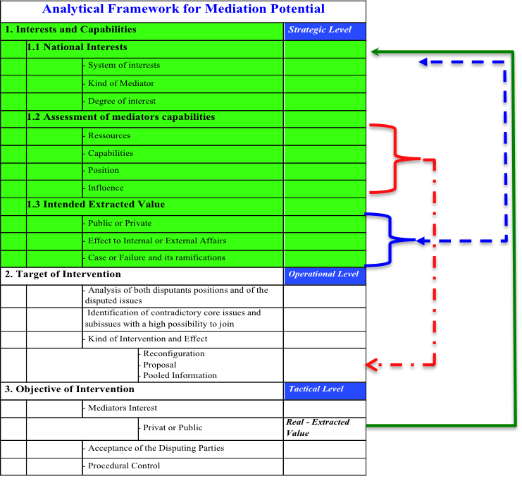

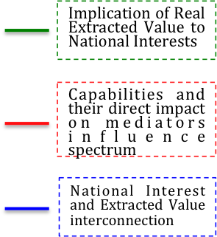

In a sense of a potential analysis the first part of this framework – Interests and Capabilities – is the decisive one **(green part)**. On the basis of the assessment of the three elements – National Interest, Mediators Capabilities, and Intended Extracted Value – it is possible to draw qualified conclusions about the potential - means the possible or probable effectiveness - of an optional mediator to bring a conflict and the involved opponents towards a settlement.

Furthermore, it illustrates the interconnections and interdependency between the different level of the framework – embedded in a hypothetical timeline of a mediation process – and shows the factor of uncertainty not only in the mediation process itself, but also in the effect or outcome generated by the parties. In the next chapter I will focus on this core element of the Analytical Framework – Interests and Capabilities – to set the basis for a further analysis.

# 4. Germany´s and Israel´s National Security Strategy

## 4.1 National Security and National Interests

Within Political Science we can identify two main courses in discussion and research about National Security.[40] On the one hand side there are the closer definitions relate to almost military and state issues (Classical Security Complex Theory - CSCT) and on the other the wider definitions including additionally economic, environmental and social aspects. Barry Buzan describes the wider approach:

***“A security complex is defined as a set of states whose major security perceptions and concerns are so interlinked that their national security problems cannot reasonably be analyzed or resolved apart from one another”****.[41]*

Herewith, a comprehensive approach is used for the conceptualization of security and this theory links study of international conditions in states, relations among states of a specific region, the relations among the different regions and lastly the relations between regions and globally acting great powers. Security in the era of “Globalization” is, as a concept, embedded into a framework of interdependent elements and factors on specific spatial levels as well as interactors of different capabilities and resulting interests. The “spatial” factor is used by Barry Buzan to differentiate the several kinds of interaction by using Sectors and Regions*:*

***“…the military sector is about relationship of forceful coercion; the political sector is about relationships of authority, governing status, and recognition; the economic sector is about relationships of trade, production and finance; the societal sector is about relationships between human activity and the planetary biosphere.”***[42]

This kind of analytic approach or model presents a framework, what overcomes the narrow CSCT and opens up the analysis to assess threats related to objects and the securitization of those threats that are non-military or politically.

In the following I will transfer this idea of model structures into an analytic approach implemented in a matrix style, which accentuates the interdependencies of all elements. First, there are the Levels of Analysis, which will locate the actor’s referent objects and dynamics of interaction that operate in the realm of security. By level it is meant the objects for analysis, which are defined by a range of spatial scales, from small to large. Levels are locations, where both outcomes and sources of explanation can be located. Second, to follow the wider approach to National Security, there will be used the sectors – beyond military and political - to identify specific types of interaction like societal or environmental.

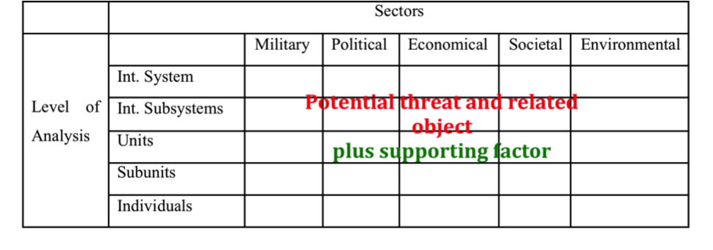

Figure: Analytical Matrix – National Security

Extending beyond this analytical capacity of the above described model for potential threat and therefore security analysis, I would like to add – in a sense of a comprehensive analysis – **a positive factor**. This means to identify and analyze within this framework also specific strengths or positive synergetic interactions. This provides for analytical purposes a more comprehensive system and enables to draw more precise conclusions about threats and their consequences for National Security as well as offers the opportunity to identify specific capabilities – within the system of interdependencies and interactions - to pursue the interests of the actors.

Following Joseph Nye, in *a* ***“democracy the national interest is simply the set of shared priorities regarding relations with the rest of the world.”***[43] The concept of “National Interest” is broader than strategic interests and incorporates them.

The national interest is a reflection of the identity of a people (geography, culture, political sympathies and social consensus) connected with economic prosperity and demographic consistency and development.[44]

In post-modern times the impact of the Information Age to the concept of “National Security” is tremendous. Following the distinction between “hard power” (a country´s economic and military ability to buy, influence, deter or coerce) and “soft power”(the ability to attract through cultural and ideological appeal), the “soft power” in the information age is becoming more compelling than ever before. Following Nye, the information revolution will have long-term benefits for democracies, because democratic societies can create credible information, due to the fact that they are not threatened by it. Authoritarian states will have more trouble. The current developments in the Arab world are evidence for this.

In summery it can be stated, that a National Security Strategy is based on a threat-analysis in combination with an assessment of the strength and capabilities. Based on this assessment national interests can be identified to pursue the strategic goals and to shape the system in a way to strengthen or improve the own position.

## 4.2 Evaluation of the main components of Germany´s National Security Strategy

The scope of the German security policy has expanded since the end of the Cold War. However, former restrictions and political constraints were removed with the reunification of both German states with the 2 plus 4 treaty (12th September 1990) and the accession of the German Democratic Republic into the Federal Republic of Germany (3rd October 1990).[45]

For the first time since 1945, Germany and its allies don´t face any threat concerning their territorial integrity as a substantial threat for the foreseeable future. Rather than using this latitude to steer a more autonomous security policy course, German governments have adhered to the traditional German commitment to NATO, EU and its “multilateralism approach", since 1990. Because of its geo-political position in the center of Europe and in order to safeguard its own National Security interests, Germany has to rely on international cooperation. A further most important aspect is, that Germany is following this multilateralism approach very consciously, to demonstrate and realize a kind of self-containment of its potential and power to the other nations. This interconnection and interwovenness guarantee a far-reaching openness and transparency and contribute to the stability of Europe.

Thus, it was the International Community itself who demanded Germany should bear more responsibility for international security, especially after the terror attacks on 11th September 2001 and to share the burden in relation to Germany´s economical and political power. The National Security Strategy of the Federal Republic of Germany (German White Paper) as well as the Defense Policy Guidelines (DPG) from 27th of May 2011[46] are reflecting not only this development, but also the increasing participation of German forces in joint multinational missions, since 1990.[47]

The German White Paper includes three pillars: [48]

1. Threats to the security must be countered at their source.
2. A comprehensive approach is called for, which in addition to military means, includes all political, diplomatic, economic and development policy instruments.
3. Crisis prevention measures must increasingly be taken in a multinational integrated network. German National Security Policy is driven by the values set forth in its Basic Law and by the Goal of safeguarding the interests of Germany.

In this context, it is to emphasize that every political decision concerning a participation of German Forces in multinational missions is accompanied by heavy debates within the German society and the political arena. Nowadays, German security policy is driven by the core elements of multilateralism and reluctance for using military force.

Following the comprehensive approach to National Security, the Defense Policy Guidelines set the strategic framework for the mission and tasks of the Bundeswehr as a key element of the whole-of-government approach[49] to security. The analysis of the DPG shows concerning the strategic security environment assessment three main elements:

* A direct territorial threat to Germany remains an unlikely event.
* Globalization has led to power shifts between states and groups of states as well as to the rise of new regional powers.[50]
* Developments in regions at the periphery of Europe and outside the European zone can have an immediate impact on the security of Germany.

Germany´s security is inextricably linked to the political developments in Europe and in the sense of globalization throughout the world. The multilateralism approach is Germany´s way to pursue its security objectives and interests in cooperation with its partners. The United Nations, NATO[51] and the EU[52] are the international framework of Germany´s security and defense policy.

So, the White Paper as well as the DPG stated out, that in Germany´s perception exists no existential threat to its state, society, economy or system. But in parallel some threats are estimated as very serious and to identify them the model of Barry Buzan is a very useful one. Like I elaborate in Chapter 4.1 this model is now supplemented with the element of the supporting factor to be able to identify capabilities and strengths.

|  |  |  |  |  |  |  |  |  |  |  |
| --- | --- | --- | --- | --- | --- | --- | --- | --- | --- | --- |
| ***Germany*** | **Sectors** | | | | | | | | | |
| **Level of Analysis** |  | Military | Political | | Economical | | Societal | | Environmental | |
| Int. System |  | **1** | | **9** | |  | | **21** | |
| Int. Subsystems | **2** | **3** | | **10** | **11** | **15** | | **22** | **23** |
| Units | **4** | **5** | | **12** | | **16** | | **24** | |
| Subunits | **6** | **7** | **8** | **13** | | **17** | **18** | **25** | |
| Individuals |  |  | | **14** | | **19** | **20** | **26** | |

Figure 2: Security of Germany – Comprehensive Analysis

Germany as a western democratic state is integrated after the reunification[53] into a framework of political and military organizations that provides to it a quantum of more stability, strength and protection (Figure 2 No.1,2,3: e.g. EU, NATO, UN). Nowadays Germany is “besieged” by allies and friends and deeply embedded into the international community. The Federal Armed Forces are in relation with the Gross Domestic Product (GDP)[54] of Germany somehow “under-dimensioned”, but this is also an attribute to German History and after over 40 years in direct “bloc-border-confrontation” the German Forces are undergoing now (slow but continues) a transformation process to the requirements of the “new” mission spectrum (Fig. 2 No. 4,5).

The DPG states that of high importance for Germany are the *“…developments in regions at the periphery of Europe…can have a immediate impact on the security of Germany…”*. After World War I Germany lost all it´s colonies as well as all colonialistic ambitions (due to the “peace treaty conditions”). In consequence, Germany has been not involved in the colonial struggle of the great powers like Great Britain or France in the Middle East Region. Therefore Germany has no specific affiliation to certain Arab counties, like the former colonial powers in positive or negative characteristics have. In addition, because of the historic relationship and alliance during World War I, Germany has a long grown relationship with Turkey (as a non-Arab country), what perhaps on the surface, due to the stopped integration process into EU and the new direction of Prime Minister Erdogan, is deteriorated, but the supporting or bearing structure is well intact. Also the fact that Germany was very reluctant with its political involvement during the cold war era lead to a situation that it is nowadays in the Middle East Region well connected and accredited.

This standing and reputation to all states in the region can offer Germany special ways of interaction in this complex region. Furthermore, due to the unique historical relationship between Germany and Israel[55], German Chancellor Merkel stated during the governmental talks in Israel January 2011 and the visit of Prime Minister Netanyahu in April 2011 that the security of the state of Israel belongs to the “raison d’Etat”[56] of Germany and proved this in the past with its support of the Israeli Defense Forces with substantial armament supply. This specific kind of relationships and interconnectedness is a strong supporting factor for German involvement and activity towards a stabilization in the Middle East Region (Fig. 2 No. 1,2,3,4,5).

The current serious threats to Germany and its allies are destabilizing factors like failed states, international terrorism, religious extremism and organized crime (Figure 2 No. 6,7): Taliban/ Afghanistan, Balkans/ Kosovo, Piracy, drug trafficking.

In the sense of a comprehensive approach to security, German politics is supporting (financial, administrative, consultive) a lot of NGO´s (party foundations like, Konrad Adenauer,…) and GO´s (Goethe-Institute) to strengthen also in this kind the openness and political exchange in all kinds of measures. (Fig.2 No. 8).

The economy of Germany is the most powerful in Europe and in total the fifth largest in the world (after USA, China, India, Japan).[57] In 2011, despite of the “Euro-crisis”, the value of German export exceed for the first time in history the € 1.000 billion level. Germany is after China the world biggest export nation (before USA and Japan).[58] Furthermore, the unemployment rate in Germany is on its lowest level since the reunification in 1990; the rate was in 2011 in average by 7.1 % and a further decline for 2012 is expected.[59]

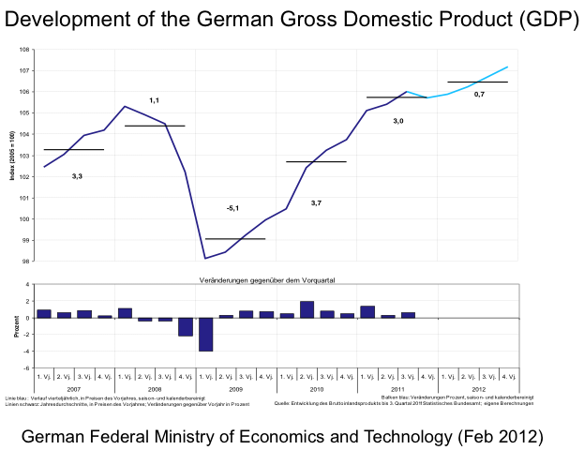Until now Germany is the only state in the European Union, which is not negatively influenced from the Euro-crisis. In fact the contrary is the case. Germany is gaining more and more influence and strength, due to its prosperity (Fig 2 No. 9,11,12,13,14). Inevitable this development poses also threats to Germany, simply because it is be forced to take the lead, more political responsibility and most important more financial guarantee – in relation to its economic power – within the Euro-Group-Countries and therefore lastly also in EU. (Fig 2 No. 10).

The prosperity of the economical sector has direct influence on the societal one. In the German society the pressure concerning social justice is really low. The demand and growth in the labour market and moderate increase of income rates are the main factors for a good development. Especially, the severe demand for qualified workforce in Germany lead to a development within the EU, that from countries affected by the crisis, well educated people move to Germany (Fig 2 No. 15,16,18,20).

From a mid-term point of view exists in Germany a high potential for social tension in the whole spectrum of integration of foreign workers or immigrants. In combination with an ageing German society this could become a threat and measures has to be taken now to counter this (Fig. 2 No. 17,19).

The global warming and the climate change is perceived in Germany as one of the main threats to the German society in the mid and long-term future. The Kyoto-Protocol (2005) and the following conferences like Durban (2011) try to determine under international law upper limits for carbon dioxide emissions for all countries. But, the hesitant posture of countries like USA, China and India to sign legally binding treaties – what could harm their economic prosperity – poses a big challenge (Fig 2 No. 21,22).

After the nuclear disaster in Fukushima (Japan, 2011) the German government decided – under the pressure of the population – to phase out nuclear power in Germany until 2022. This means to shut down all 17 active nuclear power plants and to compensate this amount of around 15.000 megawatt with alternative sources, like natural gas, wind or solar energy. But Germany backed its saved energy supply up with the opening of the Baltic Sea Gas pipeline in November 2011 from Russia direct to Germany, bypassing all countries in between (Fig. 2 No.23,24,25, 26).

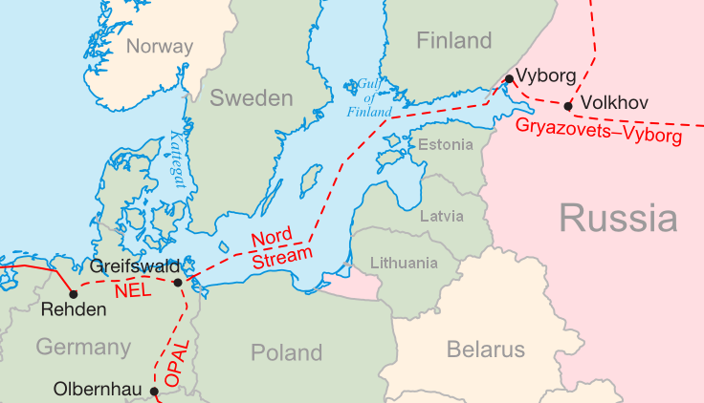

Source (Feb 2012): http://www.nord-stream.com/?r=1

The strategic security environment of Germany has changed in the last years in the course of the progressing globalization. This process led to power shifts between states and groups of states as well as to the rise of new regional powers. Nowadays, risks and threats are emerging above all from failing and failed states, acts of international terrorism, terrorist regimes and dictatorships, turmoil when these break up, climatic and natural disasters, financial crisis, from migration developments, from the scarcity of or shortage in the supply of natural resources and raw materials. Security is not defined in geographical terms only. Developments in regions at the periphery of Europe and outside the European zone of security and stability can have an immediate impact on the security of Germany. Based on this analysis about Germany´s National Security, it´s capabilities and lastly resulting it´s interests, I am identifying following spectrum:

* Integration in Supranational and International Organizations; strengthen an development of the own position and influence
* Strengthen of bilateral relationships with key-players or key-supporters
* International Terrorism remains a major threat to the freedom and security of our country and our allies. International Terrorist groups and networks pose an immediate threat that can have a wide range of implications for state and society.
* Protection of the German economic prosperity (within Euro-group as a leader); control of the finance markets.
* Free trade routes and a secure supply of raw materials are crucial for the future of Germany.
* The scarcity of energy sources and other commodities required for high technology products will have implications for Germany
* Climate change is already threatening the livelihood of many people. Desertification, water and land shortages, uneven population densities and enormous prosperity gaps in connection with social disparity are leading to worldwide migration flows and causing considerable conflict potential for the regions in question.

Safeguarding the German National Interests is only possible in a whole-of-government approach. Therefore it is needed a national, comprehensive and coordinated security policy that includes political and diplomatic initiatives as well as economic, development policy, police, humanitarian, social and military measures. The Middle East Conflict entails in connection to the security interests of Germany and the organizations in which Germany is integrated the most brisance and would offer the opportunity to improve its engagement.

## 4.3 Evaluation of the main components of Israel´s National Security Strategy

Due to the fact, that the State of Israel has not released any official document like a National Security Strategy, White Paper or Defense Political Guidelines it is necessary in the course of the further analysis to research the National Security Situation of Israel on the basis of the determining factors.[60] The results will be analyzed within the concept of Barry Buzan under a comprehensive approach for the conceptualization of security (see Chap 4.1).

The situation and assessment of National Security determine the National Interest of states. The basic interests are the defense of the territorial integrity, the economic prosperity and the preservation of unique values, symbols and institutions or in other words the unique identity of states. Israel is probably the only state in the international community whose right for existence is disputed by its enemies. This National Security Situation I want to analyze on the basis of following determining factors:

a) Geography

Israel is a small and narrow country.[61] It has no strategic depth. In consequence the state can’t afford to fight either a full-scale war or a sustained low-intensity conflict on its own territory without endangering extensive damage to the fundamental structure of Israel.[62] The fight has to be transferred to enemy’s territory. In consequence this has direct implications for the IDF´s force structure and concept of operations. The emphasis of preventive and preemptive strikes results directly from this rationale.[63]

Furthermore, the objective of IDF has to be to create an artificial kind of strategic depth through measures like multilayered Missile Defence Systems[64], constant reconnaissance with UAV´s[65] or at least to generate strategic depth with submarines – like non-Israeli media have reported - as a platform to start cruise missiles with nuclear warheads, a so called protected “second” strike option.

b) Deterrence

Israel’s deterrence posture has to reflect an image of overwhelming strength in a sense that the IDF would inflict to an enemy force such a defeat that any potential benefits bear no relation to the costs of going to war. This logic determines the action of the IDF in low-intensity conflicts to retaliate disproportional against terror organization. In a case of WMD warfare the reaction of IDF would be in the sense of the NATO Doctrine MC 14/2 a massive retaliation.[66] In consequence Israel is committed to offensive maneuver warfare in combination with a strong Homeland Defense Structure.

c) Quantity vs. Quality

The strategic situation of Israel in a sense “few against the many” has forced the IDF to achieve continuously qualitative superiority of its soldiers and arms.[67] The reservist system of Israel and its implication to the Israeli economy in time of war restricts the IDF to short and utmost effective campaigns to avoid larger damage.

d) Self reliance and Patronage

Israel as an “island” surrounded by enemy states or organizations in the uncertain Middle East region[68] has to be as far as is possible self reliant in following spectrum: manpower, training and doctrine, arms. Israel fits this spectrum and it has to be pointed out that especially due to its high-developed defense industry and their ultra-sophisticated weapon systems it can be stated that Israel is as far as it is possible self-reliant.

Nevertheless like Israel´s first Prime Minister David Ben-Gurion said: “Israel should always have at least one great power patron.”[69] Nowadays it is the strong patron-client relationship with the United States of America and this is viewed as crucial to Israel’s national security interests although its is connected with some restrictions in freedom of action.[70] Furthermore, due to the “island” situation it is in the interest of Israel to strengthen the regional partnerships. Unfortunately, a reverse development is taking place. Since 2009 the strategic relationship with Turkey, a partner over decades, is declining and the process of the political upheavals in the Maghreb- and Arab-countries is not contributing to create a more stable security environment.

e) Conventional versus Unconventional Threats

The Yom Kippur War (1973) can be seen as a distinction between the kinds of warfare.[71] Before, full scale wars had been the greatest threat to Israel, after that low intensity conflicts and WMD warfare have come to be seen as much more serious threats. Ballistic missiles in combination with asymmetric warfare[72] have become the most serious threat for Israel.

f) Socio-economic tensions in the Israeli Society

Demonstrations for more social-justice starts mid of 2011 and culminate in the biggest demonstration in Israel´s history on 3rd of September 2011 with up to 500.000 people in Tel Aviv and nation-wide additionally 150.000. This development shows how deep the rifts and how strong the pressure in a society must be, if nearly 10% of a population is demonstrating against the injustice reality. Furthermore, destabilizing effects to the society coming from the varying point of view to religion within the Jewish society (from secular to ultra-orthodox) and the unequal financial burden and participation in society (e.g. military service) of them, as well as from unequal treatment of minorities like Arab-Christians, Arab-Muslims, Bedouins and Druze.

|  |  |  |  |  |  |  |  |  |  |  |  |  |
| --- | --- | --- | --- | --- | --- | --- | --- | --- | --- | --- | --- | --- |
| ***Israel*** | **Sectors** | | | | | | | | | | | |
| **Level of Analysis** |  | Military | | Political | | | Economical | | Societal | | Environmental | |
| Int. System |  | |  | | **4** |  | |  | | **21** | |
| Int. Subsystems |  | | **6** | **5** | | **9** | | **15** | | **22** | |
| Units | **2** | **1** | **8** | **7** | | **10** | | **16** | **17** | **23** | |
| Subunits | **3** | |  | | | **11** | **12** | **18** | **19** | **24** | **25** |
| Individuals |  | |  | | | **13** | **14** | **20** | |  | |

Figure 3: Security of Israel – Comprehensive Analysis

Israel as a state is confronted with existential threats by states like Iran and its most probable nuclear program to develop an atomic bomb in combination with its expressed intend to annihilate the “Jewish entity on the edge of the Mediterranean”. But also from Syria – not in the same extend like by Iran – which posses also WMD weapons and by terror-organizations like Hezbollah – currently participating in the Lebanese government - or Hamas, which pursue the same objective to exterminate the Jewish homeland (Fig 3 No. 1,3).

The USA and in a much less extend, but not to neglect, Germany are supporting Israel with military means and close intelligence relations. German Chancellor Angela Merkel stated during the Governmental Talks in Feburary 2011 that the existence and security of the State of Israel belongs to the “raison d’Etat” of Germany (Fig 3 No. 2).

The Human Rights Council of the United Nations – due to its composition of member states – is regularly condemning Israel in this supranational organization (Fig. 3 No. 4) and the Arab League, as an international organization is threatening Israel politically to such an amount, that this cannot be disregard Fig . 3 No. 5). In contrary Israel is only a member of the United Nations, but is not integrated and in so far not backed – in the same extend like a member - by other international organizations like NATO or EU.

Politically, the existence of the state of Israel – as a homestead or home country for the Jews - is not from all countries accepted[73]; e.g. Iran, Syria – and this in combination with the status of armistice/ war with Syria and Lebanon, as well as without international accepted borders posses within the Middle East Conflict – Palestinian issue - a severe threat to the peaceful existence of Israel (Fig. 3 No. 6). Partner of Israel in this process are the USA and Germany to support and enable a solution (Fig. 3 No. 7).

In the year 2000 the EU-Israel Association Agreement entered into force and covers free trade in industrial and agricultural products, freedom of establishment, free move of capital etc (e.g. Israel is part of the European Global Navigation Satellite System GALILEO); since 2005 Israel is induced in the European Neighborhood Policy (ENP) to deepen the economic, political and cultural cooperation with EU (Fig. 3 No. 6,9). [74]

The Israeli economy has had in the last years an impressive growth and exceeded also 2011 the still high expectations with a growth of 4,8%. In 2010, despite the after-effects of the worldwide economic- and finance-crisis, Israel was able to generate a remarkable growth of 4,6% and for the year 2012 the estimation are around 3%. In fact, with this kind of growth Israel could overcome the effects of the worldwide crisis faster than most of the other industry countries (only two quarters with negative growth: Oct 2008 – March 2009). Symptomatic of this is an upgrade of the credit-worthiness of the State of Israel by the rating agency of Standard & Poor´s in August 2011 to A+. The driving force behind this excellent development is the performance of the Israeli High-Tech and Defense Industry, which not only contribute to the economic growth, but also to the independence and the self-sufficiency of the supply to the Israeli Defence Forces (Fig 3 No. 10, 12, 2).[75]

Problematic in this connection is, that this economic success is not reflected in an appropriate increase of the revenues of the general Israeli workforce. In consequence the Israeli society is diverging in a faction with a big income and in a much broader part, which is struggling to be able to afford a regular and dignified livelihood (Fig 3 No. 11 – 14).

Since 1929, established before the foundation of the State of Israel, the Jewish Agency is representing an international organization, which holds, establish and initiate new contacts and connections between the Israeli people and the Jews in the Diaspora. Furthermore, with its history as an organization, which tremendously has supported Jews worldwide to be able to come to Israel and helped them to establish a homestead for the Jewish people, the Jewish Agency has a much deeper reaching reputation as any political institution and is a unique supporting factor for the State of Israel and is providing a significant contribution to the National Security of Israel (Fig 3 No. 15,17,19).[76]

The divergent development of the economic prosperity for the Israeli society has a direct impact to the social peace in Israel. This creates social tensions, not only between the minority of winner and the big mass, which not has a stake in this prosperity, but also between other factions and groups of the society like ultra-orthodox Jews or others, which not contribute in the same amount to a equal shared burden of the society. In a mid-term point of view this development gets worse, if the demographic development will take into account (Fig 3. No. 16 – 20). Particular importance in this connection has the further development in the Peace Process with the Palestinians – clear borders, question of settlements, clear separated societies, amount and necessity of defense expenditures, external political implications (Fig 3 No. 16, 18, 20).

The threats and challenges of climate-change and alternative energy-supply affect Israel in the same dimension like Germany, but within its geographical position in the Middle East, developments like desertification, water-shortages, scarce biosphere for a growing population makes the situation for Israel more severe. But, Israel is taking action and built and is building desalination plants, is leading nation in scientific research of fertilizing and utilizing of arid areas and is developing nature protection with governmental and private organizations (Fig 3 No. 21 – 25).

The Prime Minister of Israel Binyamin Netanyahu stated in his Speech at the Begin-Sadat Center at Bar-Ilan University on 14th of June 2009 that:

“…I believed and I still believe that unity was essential for us now more than ever as we face three immense challenges – the Iranian threat, the economic crisis and the advancement of peace...”[77]; and during his visit 2011in May he gave a speech to a Joint Meeting of the U.S. Congress an said: “… in an unstable Middle East, Israel is the one anchor of stability…Israel is America´s unwavering ally…you have been very generous in giving us tools to do the job of defending Israel on our own”…”I publicly committed to a solution of two states for two peoples: A Palestinian state alongside a Jewish state.”[78]

Taking these statements of the Prime Minister of Israel and the results of the previous analysis about the main threats to the State of Israel I will identify following spectrum of National Interests of the State of Israel:

* The prevention of developing the capability or producing nuclear weapons of Iran is of highest importance for Israel.
* Making progress in the Middle East Peace Process towards a solution: two states for two people.
* Strong, sustainable and qualitative superior Armed Forces – offensive and defensive – with a high capability to deter or to conduct preemptive operations in combination with a robust Homeland defense
* Strengthening and maintaining of the patron-client relationship with the USA
* Strengthening of bilateral relationships with key players (e.g. Germany) and multilateral relationships with EU and NATO
* Maintaining economic growth and taking measures to strengthening free trade
* Countering the current development of social tensions in the Israeli Society to create social peace
* Maintaining a secured water and energy supply

“It is the fate of the State of Israel to be permanently and irreversible in the position of the ‘few against the many’, from the standpoint of the demographic and geographic balance of power between itself and the Arab world.”*[79]* This describes the struggle of the short history of the State of Israel since its foundation 1948. However, Israel succeeded in convincing the International Community – with independent support of the IAEA - about the tremendous threat of the Iranian Nuclear Program posing to the region and the world. In consequence 1st of July 2012 the next step of sanctions against Iran - EU-Oil embargo - will become effective. In parallel Israel is successful in expression its intention to take action and attack Iran, if the sanctions will fail and tries to gain support from its patron the United States.

Beside the Iranian threat, there is a need to make progress in the Israeli-Palestinian Peace Talks, because the development and ramifications of the “Arab Spring” will lead to a more unstable and uncertain situation in the Middle East from a mid-term perspective.

A closer cooperation with EU would offer the opportunity to improve the framework conditions for a sustained economic growth. This could offer the Israeli government the possibility to generate the necessary resources for an effective modification and compensation of the social tensions in the Israeli society.

## 4.4 Comparisons and Conclusion

The analytic framework identifies clearly two different security situations for Germany and Israel. A direct territorial threat to Germany is an unlikely event. On the one hand Germany is incorporated into a framework of political and military organizations like NATO and EU and can afford to follow a multilateralism approach concerning its threats.

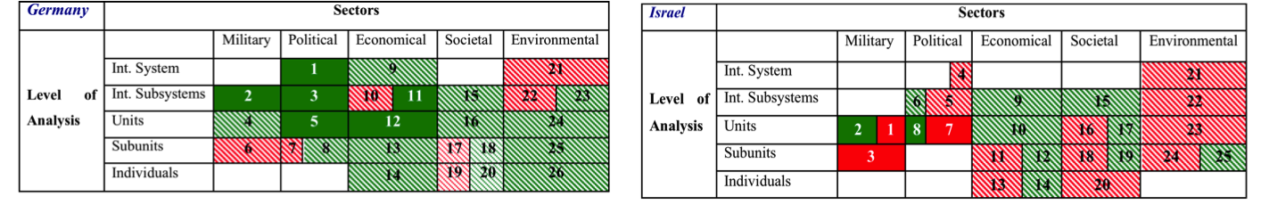

On the other hand Israel is “besieged” by enemy states[80] or terror-organizations, is not integrated into a defense-alliance only supported on a bilateral basis from states like USA or Germany. Israel is facing an existential threat - since its foundation.

Germany is able to focus within a multilateralism approach on safeguarding its security interests from interference-free supply of natural resources and raw materials to fight against the terror in different missions – from the Balkans, ashore on the coast of the Horn of Africa or in Afghanistan. Therefore the Bundeswehr is undergoing a tremendous reform from a conscription army – with a structure stems from the cold war - to a smaller, more flexible and professional one. The future mission spectrum of the Bundeswehr will reach from peacekeeping and nation building until peace-enforcement or fight against terrorism. These kinds of missions need professional soldiers with high-sophisticated weapon systems, who are used to serve in alliances. Deterrence will be established through organizations like NATO or EU and projected with missions abroad.

Germany can pursue its National Interests out of a stable political and social framework, which is continuously strengthened through the excellent prospering economic development. At this juncture, Germany is integrated and embedded into a framework of international organizations and is gaining more and more influence within these, still due to the fact that its economic power is increasing and in parallel the one of the partners is declining. But parallel this development raises expectations by Germany´s partners to take more responsibility – and herewith also more share and burden – in International Relations.

In contrast, Israel has to face its immediate threats on its borders, has to strengthen its deterrence posture and must be able to counter threats beyond its territory deep into the enemies’ countries – e.g. Iranian threat. Furthermore, due to the threat-spectrum from ballistic missiles (with or without WMD) until asymmetric warfare, also in urban terrain, Israel has to prepare its homefront in combination with a multilayered missile defense system. In future the IDF has to stick to the militia-like forces system combined with the challenge to keep its professionalism in face of all necessary high-sophisticated weapon systems. Beside the absolutely necessary military capabilities – again, Israel is not embedded like Germany into a framework of defence organizations – Israel has to promote the Israeli-Palestinian Peace Process towards a solution like Prime Minister Binyamin Netanyahu stated: *Two States for two peoples!*

This would give Israel the opportunity to shift and set free resources, capacity and energy – until, now bound into the struggle with the Palestinians – to invest into the solution of the urgent social tensions within the Israeli society. The positive effects would be twofold, first this would demonstrate Israel´s will to contribute to a more stable Middle East Region and second social peace and justice in combination with equal and better chances for all factions of the society – e.g. education; and mobilizing inactive potential - will lead to a more prospering economy with all further positive effects.

Ultimately the irresistible demographic development is given Israel in the mid- and long-term no other option, if the vision of Theodor Herzl in his novel Altneuland:

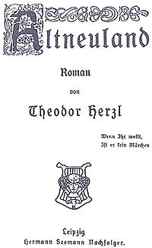

“Wenn Ihr wollt ist es kein Märchen (german original)”

“**אִם תִּרְצוּ, אֵין זוֹ אַגָדַה**”.

for a homestead of the Jewish people should be preserved.

# 5. Analysis of the Catalyzers “Arab Uprising” and “Euro-Crisis”

After the analysis of the National Security Strategy of Germany and Israel I would like to open the focus to the two phenomena “Arab Uprisings” and “Euro-Crisis”. These phenomena is inherent a transforming and accelerating momentum towards the results of the preceding analysis about National Security. I will try to analyze the implications and interconnections between the two phenomena “Arab Uprisings” and “Euro-Crisis” to the respective regions in general and in specific towards Israel and Germany. I will carve out, that these transformation processes are accelerating still existing developments as well as shaping new power balances and constellation. Furthermore these phenomena should not be analyzed separate for each region or country, because in a more and more interconnected and interdependent world, such processes create also effects beyond the own region. Lastly, I want to show that both processes will lead to a antagonisitic security situation (and perception) in which Germany will most probable have the capabilities to act more effective in the Middle East Peace Process.

## 5.1 “Arab Uprising” and its Ramifications towards Israel and the Middle East Region

The so called “Arab Spring” or “Arab Uprisings” was sparked by the first protests that occurred in Tunesia on 18th of December 2010 following Mohamed Bouaziz´s self-immolation in protest of police corruption and ill treatment.[81] Since this ignition, the protests and demonstrations against suppressing regimes in the Muslim and Arab world spread over the whole Middle East and North African Region.

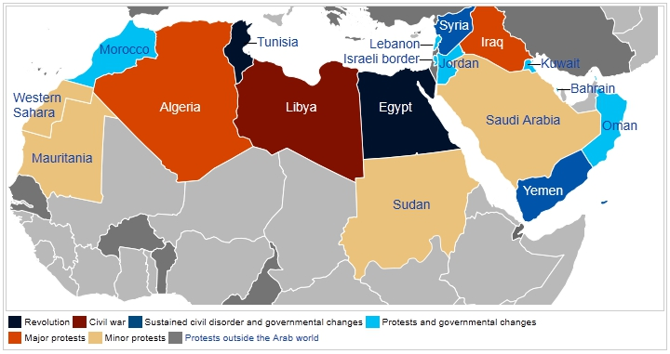

Map: Arab Upheavel in North Africa and Middle East

Source: http://en.wikipedia.org/wiki/File:Arab_Spring_map_reframed.svg

During the first months of the “Arab Uprising”, there was a tendency, at least in Israel, to look at the developments primarily from a perspective of a struggle between two major axes in the Middle East: First the radical, “resistance” axis led by Iran and second the axis of the pragmatic Arab States, led by Egypt and Saudi Arabia.

This perception was the basic assumption inherent, that the fall of the regime – like Mubarak´s in Egypt – would weaken the pragmatic axis and strengthen the radical one. It seems at a first glance obvious, that the fall of Mubarak´s regime and the damage of stability of other regimes, which were within the sphere of influence of the United States and preserved stability, ties and peace with Israel, have been weaken the position of US and therefore also in consequence Israel.[82]

However, the transition process towards a new constellation of powers in the Middle East is inextricably associated with a lack of stability as a result of the uprisings against the ruling regimes. But, every change comprises also opportunities, simply due to the fact that a rigid framework was broken off and every involved and interconnected actor can initiate new and different impulse (for advantage, disadvantage, try to protect old spheres of influence or try to create new ones). Basically, the changes related to the Arab Spring have a longer-term potential to lead to Arab-Israeli peace not only being a matter between rulers but also being carried by Middle Eastern populations. However, the short- to medium-term prospects for progress on the road to peace between Israel and its Arab neighbours are anything but good. On the contrary, the situation in the Eastern Mediterranean has clearly worsened since early 2011. As a consequence Israel finds itself today more isolated in the region than it has been for a long time and relations with its neighbours are extremely tensed.

Analyzing the ramifications of the upheaval in the Arab world, there are five main effects on the conflict constellation in the Middle East, which will be described, in the following passages.

### 5.1.1 Israel loses its “Partners” in the Region

At the governmental level Israel has lost further partners in the region and finds itself increasingly isolated. Operations CAST LEAD (27th of December 2008 to 19th of January 2012) and the “Gaza Freedom Flotilla”-Incident (Mavi Marmara; 31st of May 2010) had already severely frayed Israel´s strategic alliance with Turkey. The relationship took another turn for the worse at the beginning of September 2011 when the panel of inquiry set up by the United Nations published its investigation of the flotilla raid – the so called “Palmer Report”.[83] When Israel continued to refuse to apologies for the deaths of the nine Turkish activists, Turkey expelled the Israeli ambassador, cancelled all military cooperation agreements and announced plans to step up its military presence in the Eastern Mediterranean.[84] The Turkish Prime Minister´s drastic response reflects not only Turkish political and economic ambitions in the Arab world, it is also connected to the conflict over exclusive economic zones in the Eastern Mediterranean[85] as well as the Cyprus question. As a result, Israel has not just lost its only strategic partner in the region, but also an alliance with an increasingly influential regional player. Indeed, while Turkish-Israeli relations have become rather hostile, at least at the level of rhetoric, and in the process have produced stronger Israel-Greece-Cyprus and Turkish-Arab cooperation, considerable room for repairing relations still remains.[86] As a matter of fact, Turkey has taken de facto on responsibility for Israel´s security by installing on its territory the central radar of NATO´s missile defence system, which is intended, above all, to protect Israel from Iranian missiles.[87]

Furthermore, the end of the Mubarak era in February 2011 robbed Israel of one of its most important and reliable Arab partners. Mubarak consistently considered the maintenance of the Israeli-Egyptian Peace Treaty, the confrontation with Islamic extremists, active suppression of terrorists and close coordination with the United States as in the national interest of Egypt. Therefore from a US perspective, what Franklin Delano Roosevelt is alleged to have said about the Nicaraguan dictator Anastasio Somoza, could have been also said about Mubarak: “He may be a son of a bitch, but he´s our son of a bitch.”[88]

Even though some 50 percent of Egyptians demand that the Camp David Accords be revoked, as an April 2011 Pew poll found[89], future Egyptian governments will act on the basis of the national interest – and will therefore want to keep the peace treaty. In the end, the Egyptian budget relies not only on massive military and development assistance from the West, and the United States in particular, but also on revenues from the Suez Canal and tourism. Therefore regional stability and good relations with the West are critical.

Nevertheless, the Israeli-Egyptian bilateral relationship has already deteriorated noticeably since the military´s assumption of power and appointment of a transitional government in Cairo. Egyptian gas supplies, which used to cover about 40 percent of Israeli demand, have repeatedly been interrupted by attacks on pipelines in the Sinai, reducing deliveries to about a quarter of the pre-revolution level.[90]

This other source of tension stems from the very fragile situation in the Sinai, which has not only entailed repeated attacks on the gas pipeline but also serious cross-border attacks on civilians and military personnel in Israel, leading to the killing of Egyptian border guards in August and again in November 2011. A crisis erupted when the Israeli embassy in Cairo was stormed and besieged in reaction to the August incident and its staff had to be evacuated amidst escalating rhetoric on both sides. Further attacks from the Sinai would bring the danger of violent escalation as well as of further deterioration of Israeli-Egyptian relations.[91]

Even the weakening of the Assad regime by the Syrian uprising turns out to be problematic for Israel. Officially the two sides are still at war and Bashar al-Assad´s regime has expanded Syria´s alliance with Iran. Syria is trying to represent itself as the avant-garde of the “resistance to Israeli and American regional hegemony”, and support militant movements, especially Hamas and Hezbollah. But, at the same time the Israeli-Syrian “border” (1973 cease-fire-line) has been the calmest one for almost four decades now. While the fall of the Assad regime raises medium-term prospects of a severing of the close Syrian-Iranian alliance and a thawing of Israeli-Syrian relations, this is by no means guaranteed.[92] After all, it is rather unlikely that a new Syrian leadership would be any less robust in its demands for the return of the Golan-Heights. In addition, mid-March 2012, a gradual and peaceful transfer of power in Damascus seems to be rather unrealistic. Confrontations between regime, defectors and protesters have developed into an armed power struggle and bear the imminent danger of large-scale civil war and atrocities between ethnic and religious communities, with all destabilizing effects for Syria´s neighbours and the region.[93]

In consequence, Israel is losing its well-known framework of “old” partners and opponents and is facing a more and more instable situation.

### 5.1.2 Increasing Influence of Arab Populations

The influence of Arab populations on regional relations has increased or, vice versa, the foreign policy latitude of Arab regimes has diminished. The Arab Uprising is in the first place driven by domestic political and socio-economic demands.[94] Also, Arab populations are no longer willing to accept domestic repression as the price of the Arab-Israeli stand-off or be distracted by the latter from grievances at home. Until now there is no warm peace between Israel and its neighbours and normalization of relations at the societal level has not taken place. In fact, Arabs overwhelmingly reject the very notion of such a rapprochement, as long as the Israeli occupation of “Arab-territories” endures.[95] Therefore the growing influence of Arab people or factions on regional relations is at least initially a problem for Israel, as more representative governments will have to align their policies more closely with majority opinion at home, rather than following those of external actors like the United States or the self-interest of regime elites.

As a consequence, in the present situation it is very unlikely that an Arab government would going to approach Israel´s right-wing government with peace initiatives or would want to be seen taking Israel´s side. In contrary, rulers in the region might regard clashes between Palestinian exiles and the Israeli Military on Israel´s external borders as a welcome distraction from their domestic problems (Israeli-Syrian “border” on 5th of June 2011).[96] In total, the interdependency between the future governments and their populations or factions within it increases and therefore remains less room for “maneuver”.

### 5.1.3 Iran´s Challenged Ambition and the Turkish Role Model

The Islamic Republic of Iran stands in competition with Saudi Arabia and increasingly also with Turkey. In essence it is about two questions: leadership in the Islamic world and defining spheres of influence. In the Persian Gulf Iran seeks classical nationalist hegemony. In the Levant it supports the Palestinian case in search of recognition as a leading Islamic power among the Arab nations and to maintain or increase strategic pressure on Israel (cooperation with Hezbollah and Syria).[97] The Iranian nuclear program and the technological, economic and social development course laid out in the “Twenty-Year Vision Plan” serve largely to back up these ambitions.[98]

After more than one year of the transition process of the “Arab Uprising” in the Middle East Region it is becoming clear, that the strategic balance has shifted to Iran´s detriment.[99] The Iranians placed their biggest hope in Egypt, which they believed to have been ripe for a Islamic revolution for a long time. But, the Iranian hopes failed, due to the result of the Egyptian elections and the remaining strong position of the Egyptian Armed Forces. Egypt will most probably continue to make small conciliatory gestures towards Iran (like for example the granted permission for Iranian warships to pass through the Suez Canal), but only to the extent that these serve its own interests. Looking beyond that, a more active Egyptian role in the Palestinian question will automatically weaken Tehran´s standing in the region.[100]

The shift in the balance of power is especially apparent in the relationship with Saudi Arabia, where the initiative in the conflict between “revolutionary” Iran and the “reactionary” Saudis lies with the latter. The intervention of the Gulf Cooperation Council in Bahrain, which took place at the Saudi´s pressure, allowed Riyadh to strengthen its claim to hegemony in the Gulf region at Teheran´s expense.[101]

The situation in Syria has reaffirmed Teheran´s anti-Western and anti-Israel stance. Iran values Syria´s commitment as a “frontline state” against Israel and as a partner in Lebanon. Teheran has tied its own as well as its most important regional ally (Hezbollah) to the fate of the Syrian regime. If the regime falls, it will be a dramatic setback for Teheran´s regional role and in case the regime will survive, Teheran will have a dramatically weakened partner, perhaps more a burden rather than an ally.[102]

In contrast, however the confrontation in Syria ends, Turkey will come out looking better than Teheran. If Assad falls Turkey´s position in its regional political competition with Iran will be further strengthened. This is backed up by the transformation process, which Turkey underwent in the last years, from a secular regime in the mode of Ataturk to a system in which an Islamic party rules successfully the country. It seems that Turkey was able to combine modernity and economic prosperity with tradition, and democracy with Islam. This could present a role model for the countries in transition in the Arab World and stands in sharp contrast to the suppressing Iranian regime.[103]

The “Arab Uprising” can be expected to fundamentally narrow Iran´s room for maneuver. In the medium term Iran will lose some of its regional strength, even though Iranian leaders play down the new reality when they talking to their domestic audience. This became quite clear during the Bahrain crisis. Teheran´s intention will probably be to play for time and hope to exploit political errors made by its adversaries in combination with a hard posture in the nuclear dispute.

### 5.1.4 Israel´s “wagon fort” perception

The unrest related to the Arab Uprising, the election victory of the Muslim Brotherhood and Salafis in Egypt, the anti-Israel rhetoric of Turkey´s Prime Minister, the growing influence of Hezbollah in Lebanon, the perception of increased Iranian influence in the region and worries about Tehran´s nuclear program have reinforced the “wagon fort” mentality of Israel´s right-wing government.[104] The coalition led by Prime Minister Benjamin Netanyahu has felt confirmed in its conviction that the time was not ripe for peace initiatives or a peace agreement. While parts of the Israeli left, the centrist opposition (Kadima) and even representatives of the security establishment have called for reaching out to neighbours and strengthening efforts at reaching a peace settlement, the government has instead concentrated on expanding its military advantage over its Arab neighbours and Iran[105], on a diplomatic campaign to prevent recognition of Palestine and its admission as a full member to the United Nations[106] and on shifting the debate towards the Iranian threat.

### 5.1.5 Palestinian Power Sharing and unilateral UN Approach

The Arab Uprising brought new impetus to overcoming the internal Palestinian division. In early May 2011, Hamas and Fatah, together with smaller Palestinian factions, signed a power-sharing agreement, after years of earlier talks and different mediators had failed to overcome the differences between the main competitors. The deal reflected the realization of the leaderships in Ramallah and Gaza-City (or Damascus) that the people of the West Bank and the Gaza-Strip were no longer willing to accept their competing governments´ intransigence. Unlike in other Arab states, Palestinian protests in mid-March 2011 focused not on the demand to overthrow the regime(s) but on overcoming internal divisions.[107] Both sides saw their regional supporters weakened or overturned: the Mubarak regime, the main supporter of Fatah, had already been displaced; the Syrian regime, Hama´s principal sponsor, was wobbling, which necessitated a reorientation of the Hamas leadership. Still, due to mutual mistrust and contradictory interests of Fatah and Hamas, implementation of the agreement did not see progress until early 2012.[108]

Another factor that opened the way for the power-sharing agreement to be concluded was the lack of progress in the peace process. Bilateral talks between Israel and the PA had already ceased in September 2010 with the end of the partial Israeli moratorium on settlement construction.[109] The Palestinian leadership focused its political efforts not on a renewal of negotiations but on mobilizing international support for full membership in the United Nations, thereby trying to improve its international standing and internationalizing the resolution of the conflict.[110] Although it was able to count on broad international empathy and recognition of their progress in state- and institution-building, e.g. by international organizations like the International Monetary Fund, the World Bank and the UN, it was also clear that the road to full membership was blocked at the current point in time as the United States had announced early in the process that it would veto such a move in the Security Council.

### 5.1.6 Conclusions

The interaction of the changes induced by the “Arab Uprising” with stagnation in the peace process has worsened the Arab-Israeli conflict. It has been further complicated and exacerbated by Israeli-Turkish tensions. As a result, stabilizing alliances and structures are heavily deteriorated. Israel finds itself increasingly isolated – not only in the region but also, against the background of the Palestinian application for UN membership, internationally (with the exception of continuing US and, to a less extent, European support). Domestic tensions coming to a head in the region, especially in Syria, could have the effect of further heightening the conflict.

The conflict with Iran over its nuclear program also risks dramatic repercussions for the Middle East should it escalate into war. Teheran will be able to exercise restraint only as long as it can rest assured of the Lebanese Hezbollah´s situation and thus its own position in the Levant. Here is where the greatest danger lies. As soon as the regime in Damascus falls, Teheran´s adversaries will regard the Islamic Republic as substantially weakened. Then international pressure on Hezbollah and its Iranian supporters will increase. Following this assessment, a combination of US isolation of Teheran, an expanded regional role for Turkey, a hardening of the Saudi position and Israeli pressure on the Lebanese Hezbollah could be a realistic future scenario.

In addition, the prospects for an Israeli-Palestinian settlement are anything but good. On the contrary: the mutual reinforcement of negative tendencies and the increased insecurity in the region make a constructive approach to conflict resolution increasingly unlikely. After the failure of the Palestinian UN initiative and with no concrete perspective for an end to the Israeli occupation or for Palestinian independence, there is a very real risk of a third Intifada that, even if it were to begin as “civil resistance”, might spiral into regional conflict.

The persistence of the Arab-Israeli conflict, but even more its violent escalation, will make the consolidation of more open and participatory political systems in Israel’s neighbourhood less likely, as it will entail: oversized armies and an allocation of resources that favours military and defence over human development, a dissent-intolerant atmosphere, an unfavorable investment climate, a strengthening of radical forces and terror-organizations and the further weakening of states as well as the Palestinian Authority.

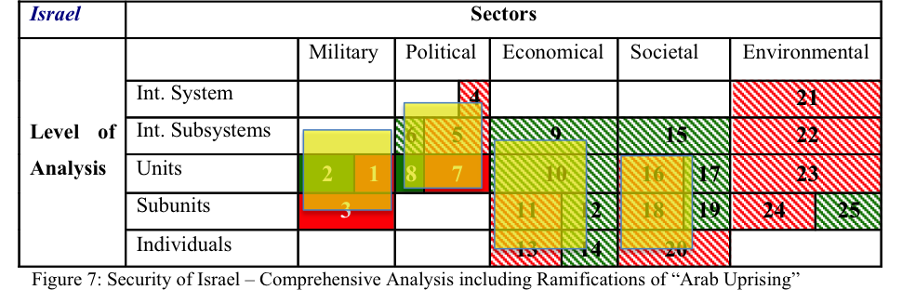The transformation process of “Arab Uprising” in the Middle East Region has clearly the quality and energy to accelerate developments, to shape new power balances and to worsen the Israeli National Security Assessment about the more and more instable situation with an tremendous amount of uncertainty. Like I elaborate in Chapter 4.3 this catalytic development has direct influence to the Comprehensive Analysis of Israel´s National Security and I have highlighted the “catalytic” ramifications in the chart with “yellow fields”. This clearly demonstrates the deep impact of the transforming process of the “Arab Uprisings” to a broad spectrum of Israel´s security perception.

## 5.2 The EU and the catalyzing effects of the “Arab Uprising”

Germany as a founding member of the European Community and the European Union is deeply embedded – politically, economically and militarily – into these institutional and organizational framework and is today one of the most important member states. Therefore it is necessary to assess the catalyzing ramifications of the phenomena “Arab Uprisings” also towards the EU, to be able to conduct a comprehensive analysis about the potential and capabilities of Germany – under consideration of all interconnected implications - towards the Middle East Region in general and to the Israeli- Palestinian Conflict in specific.

In the European Security Strategy of 2003, the EU expressed that to settle the conflicts in the Middle East Region – belonging to the “direct neighbourhood” of the EU – is one of EU´s central strategic objectives.[111] Nevertheless, the sudden outbreak of the Arab Uprisings with the “Jasmine Revolution” in Tunisia and the “Lotus Revolution” in Egypt surprised the EU, their member countries as well as also the United States. Until the outbreak, the EU as an organization and many of its member states had encouraged the cooperation with Arab rulers with the intention to “ensure the regular supply of energy, to contain the spread of radical Islam, and to prevent illegal immigration.”[112]

The ignition of the uprisings and the transformation processes in the Arab World themselves, have demonstrated, that the EU or also the US were not able to foresee them and may only assist or obstruct the developments, but they cannot determine the course of the events.[113] However, the limited influence of Europe and the international community on the timing and progress of the Arab Uprisings could be also an advantage. The generally peaceful trajectory of the Egyptian and Tunisian revolutions comprises the prominent element, that they were “autochthonous and immune to accusations of foreign meddling”[114], especially from western countries. Therefore, it offers, especially due to the fact that the Middle East Region is perceived as “direct neighbourhood and of major importance for EU”[115], the opportunity to support the processes and create trustworthy and unburdened cooperation, to serve the European need for stability and security.

### 5.2.1 Regional Connection and Regional Interest

The EU is not the only international player in the Middle East and North Africa, but the interests of other powers are much more selective. The US strategic interest is focused all above on the Persian Gulf and on Israel and its immediate neighbours. The Arab Gulf States depend on American assistance to obtain Iran, and even Arab States that accuse the United States of taking sides in the Middle East accept that there can be no peaceful settlement of the Israel-Palestine conflict without decisive US involvement. In consequence, the US will also in the future be involved in both areas, but the strategic interests of Washington in the Mediterranean are limited. This become very clear in connection with the Libyan war, which the US would have preferred to leave completely in European hands.[116]

Therefore Europe, with its political and security relations as well as trade, economic and development interests, will remain as the only major international actor tied to the region. Europe has – because of its own value system - the strongest interest in the success of the political Arab Uprisings and it is also a serious test for the EU´s Common Foreign and Security Policy and Neighbourhood Policy.[117] The EU has established frameworks for regional cooperation (Barcelona Process - 1995, the Mediterranean Union - 2008, and the European Neighbourhood Policy - 2004)[118], backed by bilateral cooperation agreements of the different member states with own specific interests. Europe must be open and honest about its own interests, because also in a Union, all member states have their own economic, political and security interests and try to promote them. The political fact of different interests found its expression in the course of action and kind of involvement of the different members states of the EU in the Libyan Campaign 2011.

### 5.2.2 European Unions Toolbox

In situations, where the consolidation of democratic initiatives, economic development and social stabilization are concerned, there is a particular role for Europe. The challenges combined with the Arab Uprisings and the further transformation process offers useful starting points for EU Policy Initiatives in the fields of political, social and economic development.[119] For a positive development it is most important, that the new democratic governments in Tunisia, Egypt and other states are not dragged down by problems originate from their predecessors. The European Union needs to set its priorities clearly and must give support first and foremost to states that are moving towards democracy. Therefore, EU should concentrate much of its political energy and resources on supporting the process in Tunisia and Egypt to make it a success, because a successful transformation has the capability to radiate out across the region and could generate multiplying effects.[120]

In March 2011 – soon after the Uprisings in Egypt and Tunisia -, the European Commission presented plans for a “Partnership for democracy and shared prosperity with the Southern Mediterranean”.[121] These plans, including financial assistance – “Approximately € 4 billion is currently available for the period to the end of 2013 to support our Southern neighbours under the European Neighbourhood and Partnership Instrument…Tunisia € 240 million … Egypt € 445 million”[122] – and improved market access. The three M´s that characterize European Union Institutions – money, market and mobility are the most effective tools and especially mobility could become most important in the mid-term future.[123]

Although the Arab Uprisings and revolts have diverted the attention of the international actors and regional observers, the Palestine conflict (specially the occupation of Palestinian territory and the unfulfilled aspirations of the Palestinians to independence) remains the most important basis for radical Islamists. Until Israel and the future Palestinian state have settled their dispute – which is the core of the conflict – Israel will never be regarded as a full and equal regional partner, and many opportunities for cooperation will remain untapped: in commerce and trade, environmental protection and regional water management, and in the realm of security.[124] Europe´s credibility in many Muslim societies still depends substantially on it at least actively attempting to bring about a fair resolution.[125] The European Security Strategy from 2003 expressed this like following:

“**Resolution of the Arab/Israeli conflict is a** **strategic priority for Europe**.”

Without this, there will be little chance of dealing with other problems in the Middle East. The European Union must remain engaged and ready to commit resources to the problem until it is solved. The two state solution - which Europe has long supported- is now widely accepted. Implementing it will require a united and cooperative effort by the European Union, the United States, the United Nations and Russia, and the countries of the region, but above all by the Israelis and the Palestinians themselves.”[126]

### 5.2.3 Energy and Migration

In 2011 the global energy system was deeply shaken by two events. The nuclear catastrophe in Japan and the unrest in the Arab World have suddenly pushed the very physical availability of fuels to the fore of the energy security debate. The beginning of 2012 has seen tensions increasing between Iran and the West. The threat of a closure of the Straits of Hormuz is fuelling major concerns in the markets. For the energy economy, whose projects are very capital-intensive, geographically inflexible and long-term, stability is of central importance.[127] Until recently the authoritarian Arab regimes have been relied upon to ensure this. The unrest in the Arab world contains considerable risks for fossil-based energy supplies – especially for all export-oriented countries in the European Union, like foremost Germany -, but also opportunities for an overdue turn to a sustainable low-carbon system.

The Arab world and Iran are the heart of the world´s conventional oil and gas supply. The region provides about 35 percent of global oil production and 20 percent of the world´s natural gas. In terms of reserves its importance is even greater, especially as these are relatively easy and cheap to develop.[128] Oil and gas from North Africa in particular are of physical importance to Europe.[129]

Energy exports from the Middle East are economically sensitive because of their effect on prices, and political turmoil in the region is associated with considerable risks of short-term supply loss through damage to infrastructure.

For example, the loss of Libyan oil exports caused the oil price to shoot up to $ 120/barrel in June 2011, the highest level since the record of 2008, leading the International Energy Agency to decide for the fourth time in its history – at the first time in connection with prices – to tap strategic reserves.[130] The conflict over the nuclear program in Iran and the fear of interruptions in oil trade through the Straits of Hormuz have brought up oil prices to the same level again, despite the fact that Libyan oil is back on the market with around one million barrels daily at the end of January 2012 (before the uprising in Libya the production was almost 1.8 million barrels a day).

Iran is exporting 2.3 billion barrels a day, and a reshuffle of trade flows will have to take place after the EU´s imposition of an oil import embargo. In that respect the EU sanctions against Iran have sent a very strong signal in a period of relatively tight supply-demand balance, nervous markets, and persistently high levels of oil prices despite ongoing debt and economic crises in the EU and the United States.[131]

One central characteristic of oil and gas markets is their small elasticity of demand, meaning the very restricted possibilities for responding quickly to loss of supplies. If unrest should spread to affect other strategically important exporters, Europe´s short-term options are scant. The necessity to engage consumers (especially India and China) in strategic dialogue is obvious. On the other hand, Europe – and especially Germany as the biggest energy consumting country - has obvious and well-known medium- and long-term options: diversification, energy saving, increasing energy efficiency and expanding renewable energy production. In this lies a great future opportunity for Europe to establish a close cooperation with the countries in the Middle East and North African Region.

Until 2030, there is an average increase in demand for electricity of 5-7% per year expected. Climate change, desertification, the need for desalination and a rising population are the major driving factors. The growing demand will affect the will and ability to export fossil fuels to Europe, depending on the future electricity mix.[132] Cooperation in this field can promote shared prosperity by, first and foremost, improving the local electricity supply and benefiting the local labour markets through investments in photovoltaics, concentration solar power and wind farms, fitting with Europe´s own climate, industry and technology interests.

Many transition states in the Middle East and North Africa have seen substantial legal and irregular migration to the European Union by labour migrants and asylum seekers in recent years. Even if the political transformation proceeds smoothly and successfully, migration pressure from the transition states is likely to remain strong.[133] At the same time the EU and especially Germany will need more immigrants, principally for economic and demographic reasons.[134]

There is little doubt that the willingness to emigrate will increase if the transformation process becomes bogged down or suffers setbacks, but the same will probably also happen even if the political and social transition goes well and living conditions improve. Demography is the core factor behind this migration pressure. All Middle East and Northern African countries still have substantially higher birthrates than European countries and the shares of younger citizens, for example 37 percent of the under 15 years of age in the Palestinian population, 34 percent in Jordan, 28 percent in Egypt and 25 percent in Tunisia. These youth bulges are so large that even under better economic conditions a considerable proportion of the young generation is not going to find adequate employment opportunities on the domestic labour market in the foreseeable future.[135] In 2005 the EU heads of state and government responded to the growing migration pressure and increasing national inability to control irregular immigration with the “Global Approach to Migration”[136], an initial attempt to develop a comprehensive common migration policy. The political turmoil in the Middle East and North African Region has further increased the importance of this approach. Therefore the EU member states should actively promote the “Global Approach to Migration”[137] and foster mobility partnerships as the “most innovative and sophisticated tool to date of the Global Approach to Migration” - EU Commission 2009 [138].

### 5.2.4 Conclusion: Chance for Europe and therefore for Germany

The strategic interest of Europe as the only major international actor in the Middle East and North African Region will remain and will gain in the future more importance. This interest is based on the direct regional connection and in the desire for a secure and stable environment – “neighbourhood”. Germany has the relative advantage of a geopolitical position, which is not direct connected to the regions, but the effects have nevertheless to be borne by Germany within its EU and NATO membership. This offers Germany the chance to take influence and direct these organizational initiatives to its own interests and needs.

Especially Germany is proving advantage about the necessary tools to act and react towards the transformation processes in the Arab World. The spectrum to become active reflects Germany´s comprehensive approach stated in the German White Paper – second Pillar: “…in addition to military means, includes all political, diplomatic, economic and development policy instruments…” (see Chap 4.2) and in the Defense Policy Guidelines of May 2011 – “…Developments in regions at the periphery of Europe …can have an immediate impact on the security of Germany…” (see Chap 4.2). In consequence Germany is on the one side highly interested for a prospering development and on the other side financially wise heavily involved about its contribution to EU and NATO as well as on bilateral cooperation.

The Trans-Atlantic dynamic towards states like Tunisia, Libya and to a less degree Egypt, differs from the war in Afghanistan or the “War on Terror”, where the Americans demanded support without involving Europe in fundamental strategic decisions. As an immediate neighbour, Europe is much more directly affected by developments in these states. And because Washington is looking for ways to reduce its engagement in crisis regions, European initiatives are welcome, especially in states like Libya and Tunisia that are not central to American interest. Although the US was caught off guard by the Franco-British call for military intervention it gave its support and was satisfied to take a back seat. Still, the operation would have been impossible without the US military contribution. When it comes to civilian and diplomatic initiatives supporting democratic reforms and economic development, Europe is less dependent on American backing. Such measures are not only less controversial within Europe; they also elicit no resistance from Washington.

The situation is different in states that represent central arenas in the fight against terrorism or are directly tied to Israel´s security and the Iran issue. Here the Obama administration seeks to assert control and American tolerance for independent European policies is limited. Nevertheless, Washington´s ambivalence with regard to Egypt´s future may make it necessary for Europe to formulate its goals independently form US policies.

The settlement of the Israeli-Palestinian Conflict is one of the core objectives of EU and against the backdrop of the US administration´s paralysis in an election year, there could be the chance for new European (or within the different frameworks of Germany) initiative to set new impulses. Especially in a transformation process after and during the “Arab Uprisings” a new momentum in the stalemate-situation between Israel and the Palestinians could contribute to an essential part to support the positive developments towards democracy and freedom in the region. For example the E3 (Germany, France and the United Kingdom) could take the imitative to move the Quartet process forward after its-relaunch in September 2011. This would require active and consistent mediation focused on balancing rather than amplifying the asymmetrical relationship between the parties.

A secured and regular energy supply of the EU form North Africa and a stabilized situation in the Middle East to enable stable prices is in the main interest of the high industrialized and export oriented countries of Europe. However in March 2011, after the nuclear catastrophe in Japan, Germany made a clear-cut and deep reaching decision to step out of nuclear energy until the year 2022 and replace it by renewable energy production. Furthermore, in November 2011 the Baltic Sea Gas Pipeline – a direct gas pipeline from Russia to Germany bypassing all countries in between – was taken into operation. These developments underline, that Germany is directing its energy supply - in a very ambitioned timeframe - towards diversification, more independency from the Arab World, increasing energy efficiency and tremendous expanding of renewable energy production. Therefore, Germany would have not only because of its geopolitical position, but also due its more far reaching independence from the Middle East and North African oil export countries (in contrast to France, United Kindom, Spain, Italy) and due to its consequent development of renewable energy production, the better ability to act as a more independent and technologically high developed partner of the Arab countries under transformation.

In Germany, the Institute for Employment Research estimates that without immigration the national labour force will shrink by 6.5 million by 2025 if participation rates remain constant. Even with significantly higher participation rates and annual netto immigration of 100.000 the labour force would still contract by 3.5 million. This figures demonstrates very clearly that it is in Germany´s very own interest – as the third largest export nation (after China and US)[139] in to find new ways to enable qualified immigration. Obviously, mobility partnerships present considerable political management requirements. They are medium- and long-term programs that must be carefully planned and executed, and are not suitable for managing short-term migration. Mobility partnerships ultimately depend on the participation and engagement of EU member states. Germany, for example, possesses valuable experience in supporting remittances, promoting development activity among Diasporas living in Germany, and providing development-relevant support to returning migrants. Germany has for decades organized large-scale temporary and circular migration flows, mainly of seasonal worker and skilled workers from Eastern European. This experience can be used in the future to establish an migration flow of skilled worker (or such who will be trained under German supervision before) from such Arab countries, what will also stabilize the development through qualified knowledge gain and money transfer of foreign workers to their families[140] and could create a “win-win” situation for both partner.

The uprisings in the Middle East and North African Region are accelerating general developments and process for the European Union Region and therefore for Germany. A specific uncertainty concerning the security of energy supply and the stability of price is inherent in this development, but Germany has still initiated its change to renewable energy production as well as to diversify its supplier.

Concerning the demographic development and its implications to the needed workforce Germany has to build up on its experiences and has to find new creative ways to solve this challenge for its future. In summary can be stated, that the “Arab Uprisings” presenting a challenge for the European Union and Germany, but on the other side also open opportunities, which wouldn´t be able to take place in the same kind and dynamic like under the old order and systems.

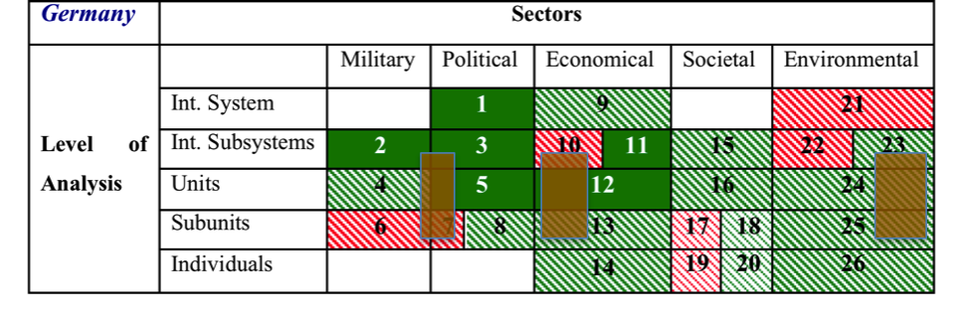Due to the fact the ramifications of the “Arab Uprisings” have the potential to influence the different sectors in the chart of National Security Assessment in a positive as well as in a negative way the basic perception is in specific areas different to the analysis for Israel. Therefore, I would like to implement these challenges/ opportunities in orange color into the chart of the National Security Assessment (not yellow like in the Israeli analysis), due to their ambivalent nature.

## 5.3 Catalyzer “Euro Crisis” and Germany

The global Finance- and Economy-Crisis, which started in the year 2007 as the Real-Estate-Crisis in the United States, developed further especially in the Eurozone to a crisis of the public authorities – European Sovereign Debt Crisis (ESDC) –, which endanger the existence of the EU Economic and Monetary Union (EMU).

In the time between October 2009 until April 2010, the ESDC has begun, when in Greece a new Government revealed the real dimension of it’s - until then veiled - budget deficit and the national debts. Greece asked the European Union and the International Monetary Fund for help to prevent a national bankruptcy.[141]

After Greece, also Ireland and Portugal came into struggle and couldn´t served their debts anymore. In a smaller extend Italy and Spain had some problems to raise credits on the capital markets and are be seen as states in crisis.

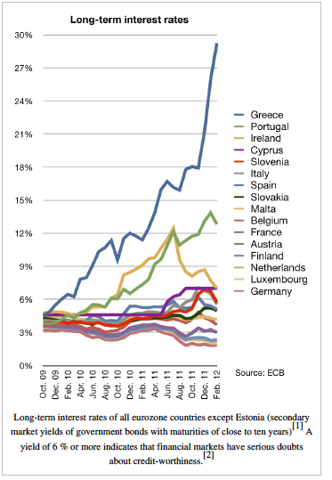

Source: http://www.ecb.int/stats/money/long/html/index.en.html

Concerns intensified in early 2010 and thereafter, that the leading Europe´s finance ministers meet on 9th of May 2010 to approve a rescue package worth €750 billion aimed at ensuring financial stability across Europe by creating the European Financial Stability Facility (EFSF).[142]

The internal political struggle was so severe, that the governments in all five countries affected by the ESDC, changed unregularly in the year 2011. To prevent the collapse of EMU member states, the leading countries of EMU agreed on more measures in October 2011 and February 2012. First, banks would accept a 53.5% write-off of Greek debts owed to private creditors[143], second the EFSF will increase to about €1 trillion, and third that European banks will have to achieve 9% of capitalization.[144]

Furthermore, Germany prevailed to create a common fiscal union including the commitment of each participating state to introduce a balanced budget amendment into their constitutions or basic law, to restore the confidence in Europe.[145]

In several analyses are mentioned as main reason for the ESDC in Greece the inefficient and over-dimensioned public administration, nepotism, abuse of the administration and corruption and the big untaxed black economy.[146]

Also in Spain and Italy tax evasion led to a tremendous loss of governmental income. In Italy the amount of the yearly tax evasion is calculated to €120 billion and in Greece between €10 to €30 billion.[147]

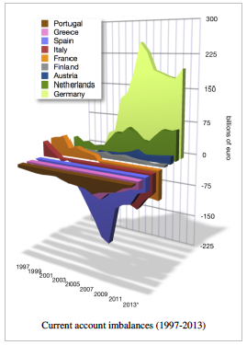

Since the introduction of the Euro in Spain and Italy, the pay increase in these countries were over the EU-average, but haven´t been covered by a parallel increasing working productivity. Furthermore, due to the introduction of the Euro, these governments hadn´t anymore the possibility to devalue its currencies as a balancing financial instrument. In consequence, the economic competitiveness of Spain and Italy decreased and the current account deficit increased.

This dramatic development has deep impact to the framework of the EMU member-states and above, to all countries of the European Union. The ESDC revealed the hard truth and reality of the individual economic situation of each member-state, not anymore comfortably covered under the “warm” blanket of EU subsidies or behind internal trickery. This development forced the certain governments also to tell their own population the truth and showed quite plainly the political failures and misbehaviour in the past. The consequences had to be borne now by the people, like budget-cuts, rising unemployment, shrinking wages, etc..

The catalytic effects and their ramifications are at least two-fold. First internally, because the condition of every state´s economy is the main-basis for its political power – or weakness - and future opportunity for action – or dependency – and second, the external implications, means the status – power position - of the state in relation to the other member-states in EMU and EU.

Germany is in a position, diametrically opposed to the struggling countries like Greece, Spain, Italy and also to France and the United Kingdom. In the Middle of this ESDC, Germany is arising as **the** geo-economic power in the EU. The catalytic effects of the ESDC are influencing and accelerating the processes and developments concerning Germany - internal and external – and still on this point it can be stated that the power-position for Germany within EU and also on a global level after the ESDC will be far more important.

In course of my analysis and to be able to conduct a potential assessment of Germany in the following Chapter 6, I will focus in the next paragraphs on three fields: First, the internal Transformation Process of Germany, to be able to understand the political change and the internal power-basis, second the new shape of the political reality in EU driven by the ESDC – and Germany´s position - in relation to the Lisbon Treaty of 2009, and third the implications, which result out of this for the future German Foreign Policy and its own perception, understanding and – possible – international role.

### 5.3.1 Germany´s internal Transformation Process

Former British Prime Minister Margret Thatcher minced no words in a candid roundtable discussion about German unification at the end of the cold war with Francois Mitterrand, George H.W. Bush and Mikhail Gorbachev published in the journal NPQ in 1995: “I was opposed to German unification from early on for the obvious reasons. To unify Germany would make her the dominant nation in the European community. They are powerful, and they are efficient,” she said at the time. (Further talk, see Appendix 3)

#### Economy

With the End of the Cold War and the remove of the former restrictions and political constraints of the Allied Powers with the 2 plus 4 treaty (12th September 1990; 2 German states and 4 Allied Powers) and the accession of the German Democratic Republic into the Federal Republic of Germany (3rd October 1990 – German National Day) the reunification had took place successfully. To build up the new five “eastern” countries, an unprecedented development started with a taxed based money transfer from the western part of Germany; until today about €2 trillion.[148]

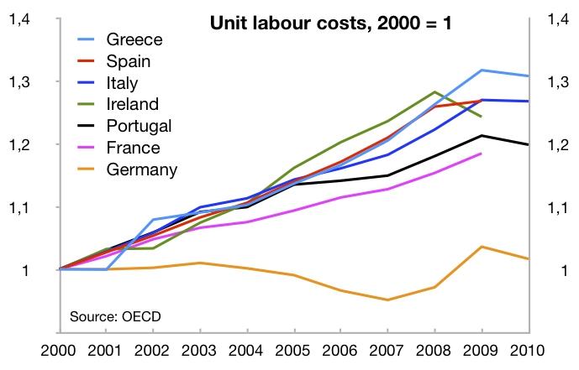

Change in unit labour costs (2000-2010)

This burden, as well as the economic crisis (Asia 1997/98 and DotCom 2000) initiate and forced a rethinking process, how Germany could become more efficient in public and in private sector. In early 2005 Chancellor Gerhard Schröder (today chairman of Nord Stream Gas Pipeline Company) pushed through the parliament a massive reform program called Agenda 2010. This program rolled back the German welfare state by, among other things, paring unemployment benefits to encourage work, relaxing stultifying regulatory practices, and forgoing a grand bargain with labour unions whereby the unions agreed to hold down wages and the government assured job security for workers.[149] In combination with fiscal discipline and an industrial success in especially two manufacturing sectors (sophisticated machine tools, automobile industry) created these factors the basis for the current successful development of Germany´s economy.

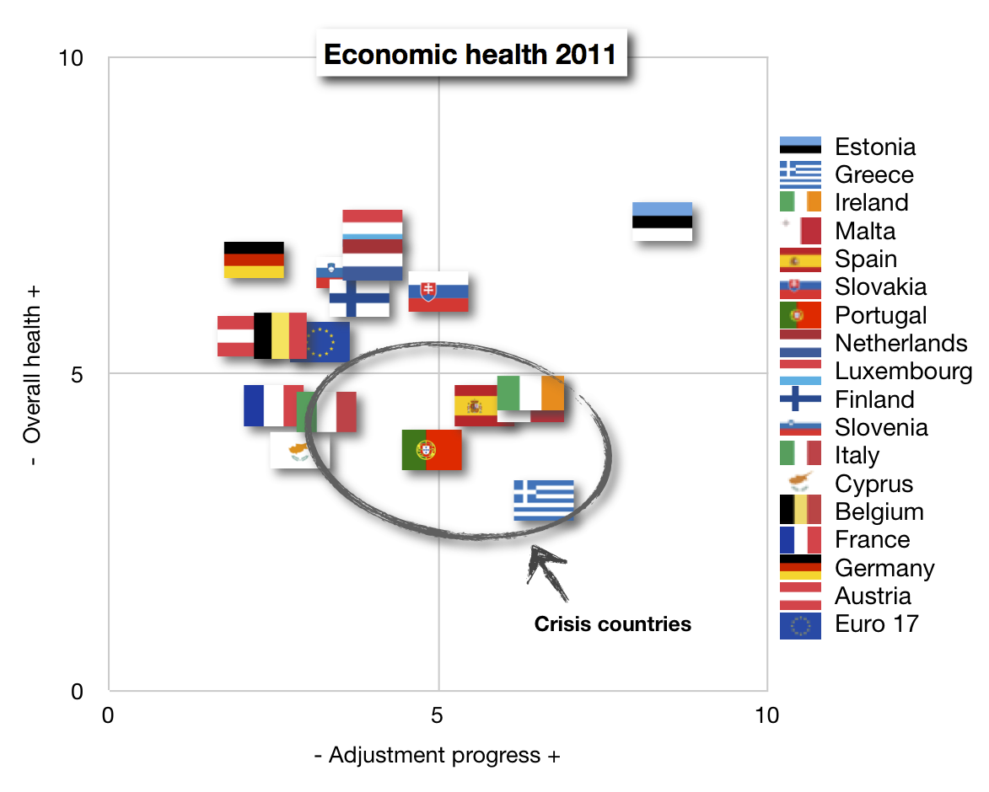

Eurozone economic health and adjustment progress 2011 (Source: Euro Plus Monitor)

The nuclear catastrophe in Japan beginning 2011, led to the clear-cut and deep reaching decision of the German Government to step out of nuclear energy until the year 2022 and provide herewith the German Green Energy Industry the opportunity to establish itself in this prospering and future oriented market niche.

#### From “Bonn Consensus” to “Berlin Consensus”

The first Chancellor of the Federal Republic of Germany, Konrad Adenauer developed his concept of “Westbindung” for the foreign policy of the young Federal Republic of Germany. This concept, based on the following foundation pillars: Member in the Euro-Atlantic security architecture, integration into the Western Europeans economical and political organizations and structures, as well as the conciliation with France.[150]

Therefore, he was willing to give up sovereignty of the Federal Republic of Germany to international organizations and structures, to regain integration, political sovereignty and acceptance in the same way. While doing this, he guaranteed the peaceful integration of the Federal Republic of Germany into the western community to the allied powers.[151] All Governments and Chancellors until the ESDC began, followed the demand of the famous German Littérateur Thomas Mann who stated that he wants to have “a European Germany and not a German Europe.”[152] A deep-seated multilateralism, especially evident in Germany´s integrationist enthusiasm for a united Europe, and a focus on economic development became the defining characteristics of the country´s post-war history. These principles can be summarized in the term “Bonn Consensus”, after the former West German capital.[153]

This direction of German policy and the Franco-German relationship, in which France had the political lead and Germany the economical one worked excellent (evidence for this is the relationships between Helmut Schmidt and Valéry Giscard d’Estaing or Helmut Kohl and Francois Mitterand) until the ESDC and its ramifications came into effect. France is imminent to become also a problematic case; the Rating-Agency Moody´s detract the creditworthiness rating of “Triple A”, the budget deficit in 2011 was 5.7 percent of the GDP and French banks are deeply engaged in Greece state bonds. The map on the right side shows it very clear, that the economic prosperity is centered in and around Germany. The Financial Times stated in an article that the Franco-German Axis is today only a polite fiction[154] and the former President of the EU-Commission Romano Prodi stated: ***“The Lady (Angela Merkel) is making the decisions and the French President can give later on a press conference to explain the decisions.”***[155]

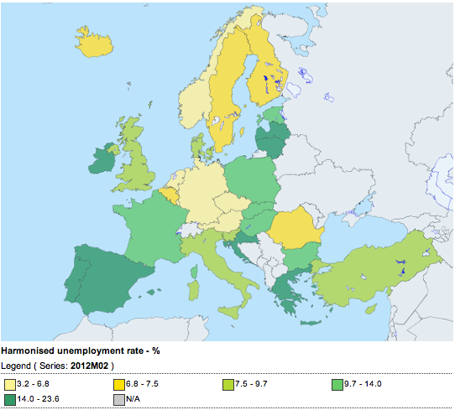

http://epp.eurostat.ec.europa.eu/guip/mapAction.do?mapMode=dynamic&indicator=teilm020_1#teilm020_1

Since the ESDC has begun and most of the EMU member states slipped more and more into the crisis, Germany´s economy still grows. The GDP has risen around 8 percent and the exports could be increased more than 25 percent. Within a EMU it is logic and belongs to the construction principle, that the strong is willing to strap the others on his shoulders, but at the same time he will give the directions. However, Germany was not prepared for this fast development – accelerated by the ESDC - to take this role and also not intended to do so. This role falls more to Germany, than it is taken by it. Germany is a hegemon against it´s will. The German Government is acting in it´s un-intended leadership role of the EMU member-states (and to a great extend also for the EU countries) mainly in it´s own interest to provide – through support of the common currency – stability for the own economy and society. In consequence, Germany provide herewith value stability for the EMU countries. This kind of acting enables German economy to act also in the future as the locomotive of the EMU and EU member states and is now combined with an evolving of a new political self-perception. The, in the first 5 decades after the second world war, at the surface uncritical and largely emotionally driven euro-enthusiasm is being replaced by a rationalized cost-benefit approach and the fundamentals of German power have not altered. In substance the new “Berlin Consensus” is in many ways the organic successor of the Cold War Bonn Consensus. Katinka Barysch of the Centre for European Reform correctly remarks that whereas “for the generation of Helmut Kohl, the EU was a matter of war and peace, for Merkel it is one of costs and benefits”[156]

#### Perception and Understanding of National Security and Defence

The National Security and military posture remain the most sensitive issues as Germany is growing more powerful in this economic process of the ESDC. This policy area and the decision making process is still deeply influenced by the memory and experiences of two World Wars and the crimes of the Nazi-regime.

In the Cold War era, the German Forces (“Bundeswehr”) had been deployed on the “inner”-German border in a “front”-state in the block-confrontation. In 1994, a ruling of the German Federal Constitutional Court ended the legal ambiguity by giving the approval for German military operations abroad within the framework of UN, NATO, or WEU mandates. Under the social-democrat-green coalition of Chancellor Gerhard Schröder in 1999 – another watershed – the “Bundeswehr”, for the first time in post-war history participated in combat missions in Kosovo. Today, the “Bundeswehr” operates in Balkans, the Horn of Africa, Afghanistan and other conflict zones.

The White Book of 2006 – strategic paper on German defense policy – considerably widened the scope of German National Security to economic matters and geographical areas far outside of Germany´s immediate neighbourhood and had been specified by the Defence Policy Guidelines of the German Ministry of Defense 2011 (see Chapter 4.2).

Since the reunification 1990, the “Bundeswehr” reduced the Forces from a size of 650.000 soldiers (Bundeswehr 500.000 and National People´s Army 150.000) until 2011 down to 240.000 soldiers. In 2011 the German Parliament (“Bundestag”) decided to suspend the conscription in Germany and to transform the “Bundeswehr” into a professional army with a size of 185.000 soldiers.[157] This size conforms approximately to the one of France and the United Kingdom Forces, with the main difference, that Germany doesn´t posses nuclear weapons. In essence, the over five decades matured “German” values of pacifism and multilateralism have changed to a certain minor extend, but military unilateralism remains an impossibility as German governments remain bound by the Basic Law to use armed forces only under the directive of a wider alliance or cooperative framework like NATO. Therefore, the new Germany is more than just an “unadventurous eagle” as The Economist proclaimed.[158] It remains a responsible stakeholder in the International System, which fundamentally prefers to exert power through diplomatic, institutional and commercial means.

### 5.3.2 After Lisbon Treaty the “Euro Crisis” is shaping a New Power Balance

The Treaty of Lisbon – as an international agreement that amends the two treaties, which form the constitutional basis of the European Union[159] – was signed by the EU member states on 13 December 2007 and entered into force on 1 December 2009. Initiator of this Treaty was Germany during its EU Presidency in 2007. Prominent changes - among others - included the move from unanimity to qualified majority voting in several policy areas in the European council and the Council of Ministers, the establishment of the European Central Bank, the creation of a long-term President of the European Council and a High Representative of the Union for Foreign Affairs and Security Policy (including a common Foreign and Security Policy) with an on apparatus of EU Foreign Service. The Treaty of Lisbon shaped the power balance within the EU in correspondence to the share of population of each member state and in result, Germany has the most share of votes, because it is the country with the largest population in EU.

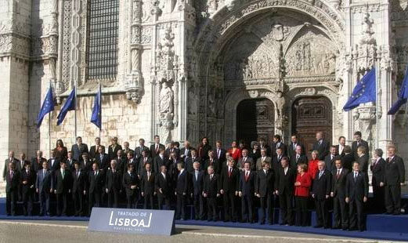

Signing of the Treaty of Lisbon; The [plenipotentiaries](http://en.wikipedia.org/wiki/Plenipotentiary) standing outside the 15th century [Jerónimos Monastery](http://en.wikipedia.org/wiki/Jer%C3%B3nimos_Monastery)

The ESDC intensified and accelerated the development of a shift of political power towards Germany as the most important remaining economic power in EU and EMU. The EMU member states agreed in the face of the ESDC, that a specific institution is necessary to safe struggling and threatened countries of bankruptcy: Germany proposed in October 2010 the European Stability Mechanism (ESM) as a permanent rescue funding program to succeed the temporary ESDC and will come into force in July 2012. The ESM will have €500 billion available and in combination with the European Financial Stability Facility (EFSF; authorized to borrow up to €440 billion) and the European Financial Stabilisation Mechanism (EFSM; a program reliant upon fund up to €60 billion) the EMU member states will have in this safeguarding mechanism €1 trillion.

The ESM is also an expression of new German demands to link financial contribution to decision-making power. It has been established at the European Council that voting rights in the EMS will be linked to capital subscriptions to the fund. With Germany´s contribution of more than one quarter of the EMS´s financial resources, this will grant the German government an effective veto over all decisions taken by the ESM since even less consequential decisions will need to be made by a qualified majority of 80%.[160] The German Finance Minister Dr. Schäuble stated in a German weekly: “A state that is experiencing problems and receives help, must in return be willing to give some of its sovereign rights to the EU.”[161]

The German government has become more convinced of its own capabilities in shaping the European project at the expense of European authorities like the Commission and also member states. When Angela Merkel laid out her condition for granting billions of Euros worth of loans to Greece to the German “Bundestag”, she asserted that “the rules must not be oriented toward the weak, but toward the strong”. She called this a “hard message” but an economic necessity.[162]

### 5.3.3 Germany´s Foreign Policy in a Transition Phase

Germany is finding itself in a transition phase, slowly growing out of its pre-unification paradigm, but is – at the same time – clinging to certain tenets of this old framework in order to give meaning and add content to its foreign policy.

In the last decade a twin process has proceeded, whereby Germany has simultaneously become more powerful and less convinced of the European project. While the increase in power and influence has given Germany the means to act more effectively with its new political and economic weight and also becoming more demanding towards others, it has also kept it entrenched in its European framework and soft foreign policy methods which are the foundation of German power in the first place. The ESDC highlighted the dimension of German economic hegemony in Europe with unprecedented force. When Greece “suddenly” came close to a bankruptcy, the EMU member states unanimously looked to Germany at the heart of the Euro-zone for relief and the Merkel government took up the dominant role in the resolution of the crisis. In consequence, Germany´s predominance has led to a situation to take more assertive stance to the economic governance in the EU. The gain in economic weight has thus, on the one hand, allowed Germany to increase its influence as an individual nation in the global arena. On the other hand, the same economic success has also linked Germany more closely to its European partners. Therefore the effectiveness of the common currency and the European Union is the central issue in that the German leadership spends most of its energy and resources. Lastly, the common currency, market and the European Union is the basis for the German economic success.[163]

The German Foreign Minister Guido Westerwelle stated to a critique of the former Chancellor Helmut Kohl, that Germany had lost its compass in the world by forgetting its European destiny:

***“For us it is not only decisive to honor old partnerships and deepen friendships, but in this 21-century world we also need to seriously consider new global centers of power. This is not a change of course, nor does it mean we are forgetting that course or loosing our compass; it is simply the recognition of a new era.”***[164]

The economy remains the backbone of German power and influence, but beside this there are complementing elements, that supported Germany to become the most influential player in Europe. First of all Germany is the largest country by population (share in EU decision making process), second it is the EU´s largest financial contributor and the UN´s third-largest (without a permanent seat at the security council) and third Germany´s foreign aid budget has been consistently among the world´s highest and goes herewith in correlation with its comprehensive approach of National Security (see Chapter 4.2).

Germany´s history of reconciliation and the East-West division during the Cold War have created a positive attitude among its neighbours. This image of self-containment and the approach to balance interests with non power-politics means creates a very positive image of Germany in Eastern Europe. Additionally to this comes the shared experience of living in the communist bloc (current German Chancellor Angela Merkel grew up in the former communist German Democratic Republic), Chancellor Willy Brand´s “Ostpolitik” and Chancellor Helmut Kohl´s vocal support for the EU´s Eastern enlargement despite the skepticism in other European capitals. Herewith Germany earned a special position in the Eastern European mindset.[165]

In the development and build-up process of the EU German governments paid a lot of attention to the fact to shape the EU from within to suit the German interests and political norms. As an example, after two World Wars combined with catastrophic inflations and currency reforms the Germans are highly concerned about the stability of their currency. Therefore the European Central Bank is not by “accident” located in Frankfurt and this institutions is constructed like the “German Bundesbank”, means politically independent and focus on monetary stability; totally contradictory to the expansionist monetary policy in the United Kingdom and US and especially France (1960 currency reform and from 1981- 1995 massive nationalization of companies and bancs). The German insistence on preventing inflation and the economic model has been translated to the European level on the expense of the French one.[166] The Euro, which is part of this international strategy, remains the founding stone of Germany´s current economic boom and its political influence abroad, which is resting precisely on Germany´s economic success.

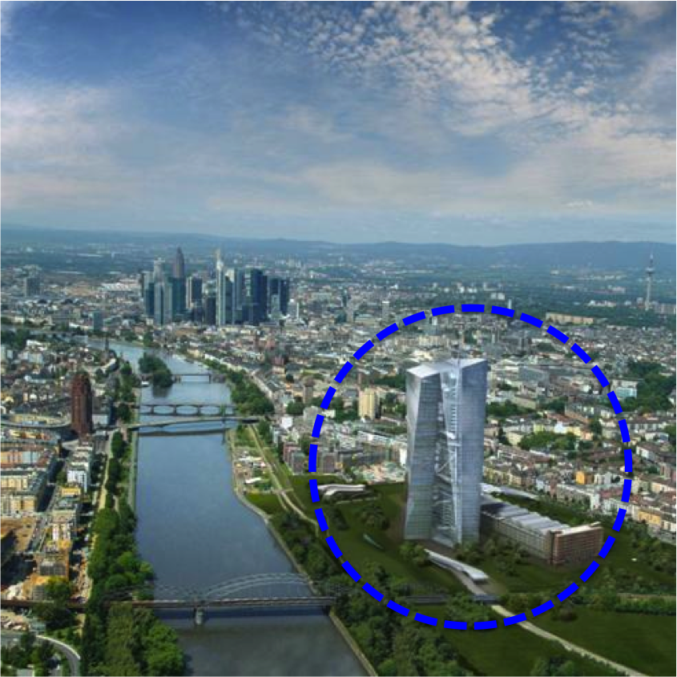

European Central Bank Frankfurt

### 5.3.4 Conclusions

Germany is arising out of the catalytic process of the ESDC as the dominating geo-economic power in the EU. This hegemonic position reflects also the importance of Germany in the future on the global level.

The assessment of the former British Prime Minister Margret Thatcher was correct in the sense that Germany will become the leading and dominating country of the EU, but her assessment about the implications what this position will bring with it are different. Now it is in the core interest of Germany to “safeguard” the common currency and the common economic zone for the own sake, and stabilize with this objective the situation of the other member states.

The success of the internal economic transformation process of Germany was revealed by the ESDC and is showing clearly the current political and economic potential.

However, Germany - following its own policy - is perceiving itself more as a Hegemon against its own will and is more or less forced by the ESDC to take the driving seat and lead. The former general political direction of the “Bonn-Consensus” is now in transition and at the moment its is only possible to identify rough structures and probable main directions of a future “Berlin-Consensus”. The basic line of a rationalized cost-benefit approach in pursuing German National Interest will be the dominant element.

The use of “hard power”, means the use of military force, for Germany will remain a means of the “last resort” and then only in a wider alliance or cooperative framework. Nevertheless, like the official White Book and the Defence Political Guidelines clearly are stating, the scope for the use of military power is widen – especially in connection to economic interests – and the participation of German Forces in current missions are giving testimony about this fact.

The ESDC increased the shift of political power – moved the new structure and balance of the Treaty of Lisbon still more to the German benefit - plainly because of the economic dependencies and necessities. Germany “utilized” the ESDC in a sense of best “Economic Statecraft”[167] to link financial contribution to the – political – decision making power. Furthermore, it showed also to the German political landscape very clear the own powerful capabilities and this influenced also the German self-perception.

The transition from the “Bonn-Consensus” to a future “Berlin-Consensus” inextricable connected is also a transition to an adapted German Foreign Policy. The European Project of German Foreign Policy – further integration-process of the member-states and further transfer of power and authority towards Brussels – will be not anymore the central topic. It will remain one of the core issues, to secure the framework for German economic interest and to exert political power through the EU institutions.

Germany will most probable also pursue own, unilateral interests – like the North-Stream Gas pipeline project – in contrast to the past, without coordination with other EU member states. But, unilateral steps like this will serve indirectly to the European Project, due to the fact that this will strengthen the German economy and therefore the common position.

As a consequence thereof, Germany will be more active on the “global” level, what also imply as the third biggest financial contributor to the United Nation, that the intention to gain a permanent seat in the UN Security Council belongs to the agenda of German Foreign Policy.[168] Furthermore, initiated through the strategic redirection of the United States in the mid-term future towards the Pacific Region and the ramifications of a “slight” overstretched superpower, Germany – within EU – could identify fields of action to cooperate in its new powerful position with the US – e.g. Middle East Peace Process – to combine power (and share burden) to a certain extend and to support the US on a global level.

Germany is basing its future capabilities on its economic and political hegemonic position in EU and on a circle of affiliated countries like for example from the “Eastern Part” of the EU. Evidence to this provided the Polish Foreign Minsiter Sikorski during a meeting in Berlin when he stated: ***“ The biggest threat to the security and prosperity of Poland is not terrorism, not the Taliban, not German tanks, nor Russian missiles, but the collapse of the Eurozone…I will probably be the first Polish Foreign Minister in history to say so, but here is: I fear German power less than I am beginning to fear German inactivity. You have become Europe´s indispensable Nation. You must not fail to lead!”***[169]

Germany was and will be very active in the build-up and organization of the EU institutional structure to shape the necessary supporting framework of the common economic market what is and will remain the founding stone of all German power.

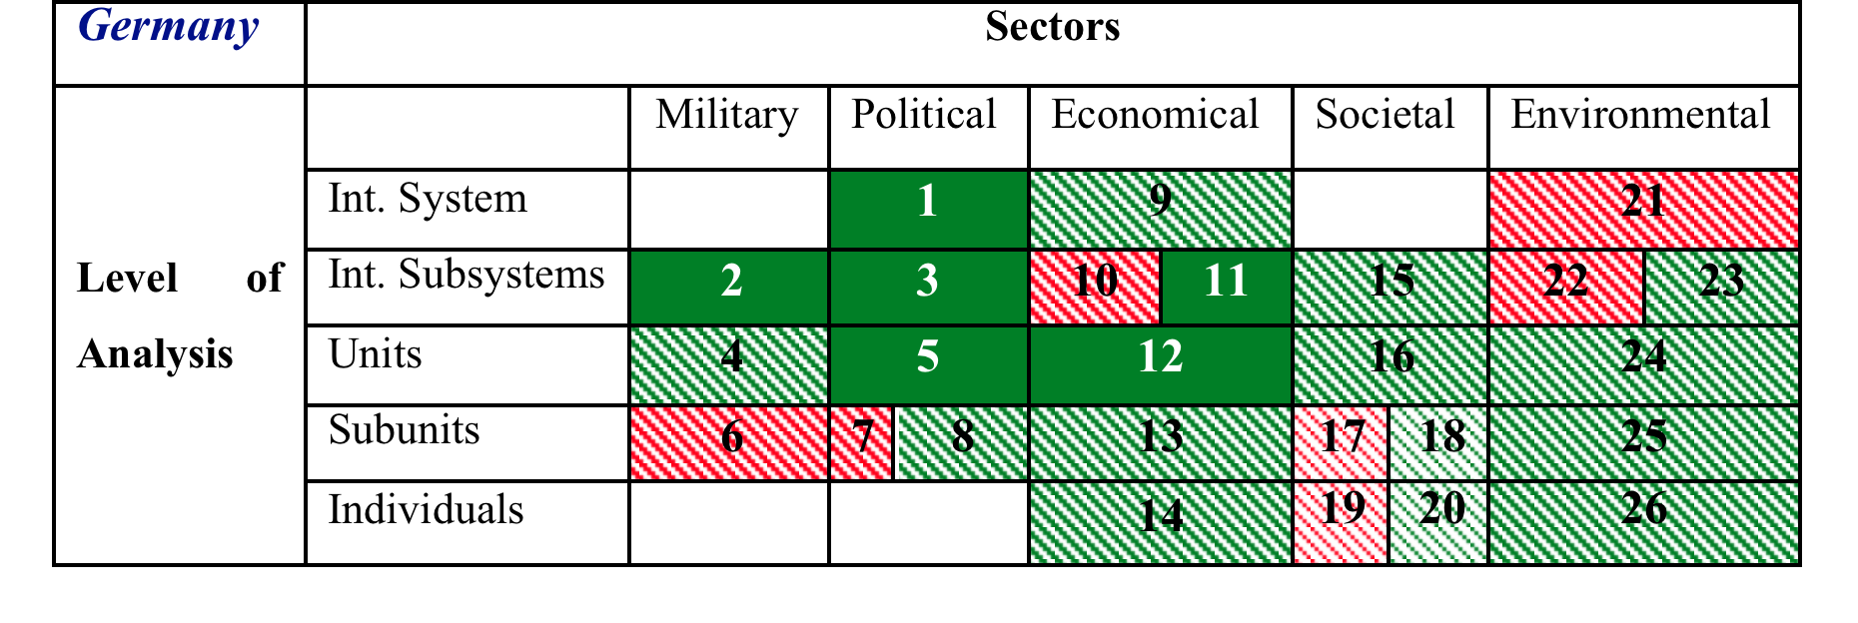

Catalyzer „Euro-Crisis“

Catalyzer „Arab-Uprisings“

The analysis and assessment process of the catalytic effects of the Euro-Crisis to Germany carved clearly the ramifications on the different sectors and on the certain levels out. The implementation of these results into the matrix demonstrate very descriptive the tremendous amount of influence and change towards Germany in a positive and as well challenging way.

## 5.4 Implications of the Catalyzers towards the potential future role of Germany in the Middle East

The catalyzing process of the “Arab Uprisings” brought Israel in a more and more isolated situation. The stagnation in the Peace Process has worsened the Arab-Israeli Conflict. It has been further complicated and exacerbated by the Israeli-Turkish tensions. The isolation is not confined to the region, also the unilateral approach of the Palestinian application for UN membership showed clearly the extend of international isolation. Furthermore the situation is heated up by the conflict with Iran over its nuclear program combined with the risks of dramatic repercussions for the Middle East should it escalate into war.

All these development directions have reinforced the “wagon fort” mentality of Israel´s right-wing government. In consequence, an Israeli approach towards a new initiative for the settlement of the Israeli-Palestinian conflict is not to be expected.

Instead, from European point of view, the resolution of the Israeli-Palestinian conflict is one of the cornerstones for more stability in the region. The Trans-Atlantic dynamics between Europe and the United States concerning Libya gave evidence to the fact, that the US are not willing anymore to take action in cases what are not in specific US interest. However, the strategic interest of Europe as the only major international actor with a direct regional connection to the Middle East and North African Region will remain and will gain importance in the future. Therefore, especially in a transformation process like the “Arab Uprisings”, a new momentum in the stalemate-situation between Israel and the Palestinians could contribute to an essential part for a further positive development of the uncertain process and could contribute to a stabilization of the region. Against the backdrop of the US administration´s paralysis in the election year 2012, there could be the chance for a new German-lead-European-initiative to set new impulses.

In connection to the Arab-Israeli conflict, Germany has three decisive interests:

* First, deriving from Germany´s historical responsibility, to guarantee Israel´s security and right to exist;
* Second, to defend against security risks coming from the region, e.g. in form of terrorism, irregular migration or organized crime;
* Third, to maintain good relations with the resource-rich Arab States, not at least for the sake of Germany´s energy security (stable price level and security of supply for the European market).

German and European leaders share the consensus that these three main interests would be best served by a peaceful resolution of regional conflicts, first and foremost the antagonisms between Israel and its neighbours. In this, the Israeli-Palestinian conflict is rightly seen as the key. Consequently, Germany has from the outset engaged bilaterally and in the EU framework to support the Middle East peace process, and has made notable contributions.

Despite the development of new foreign policy instruments at the European level and the EU´s growing ambitions to play a role in global governance, Germany and its European partners continue basically to accept the United States as the main power broker in the Middle East. Nevertheless, there were always phases marked by more political engagement with Germany – also in the frame of the EU – working towards conflict resolution like 2002, when the German Foreign Minister Joschka Fischer presented its Seven Point Plan and induced a European discussion which later led to the Middle East Quartet´s “Road Map” of 2003.

The consequence of the catalytic process of the ESDC is, that Germany is arising as the dominating geo-economic power in the EU. This “hegemonic position” has also direct implications for Germany to its position and responsibility on a global level. Perhaps now the time is ripe to take the offer, made by former US President Bush senior over two decades ago, of a “partnership in leadership”[170] and to become the key-partner of the US in Europe.

The tendency that the US withdrawal step by step from Europe and are shifting its global strategic focus towards Asia is a fact and would support this opportunity of cooperation and burden sharing. Not only from the US point of view the economic markets of the future are perceived in Asia and in parallel it is of strategic importance– and a security policy mammoth task – also not only for the US, to shape the general conditions for a peaceful and stable rise of China to a major power in a more multipolar world. This kind of cooperation would also serve one of Germany´s long-term core interests in Foreign Policy to be accepted in the world as a major power and visible sign for this would be a permanent seat in the UN Security Council.

A direct comparison of the current status of Germany and Israel in connection with the implications of the Catalyzers “Euro-Crisis” and “Arab Uprisings” within the extended analytical framework of Barry Buzzan to National Security and National Interest shows clearly two developments:

The catalyzing process of the “Euro-Crisis” is strengthening the position of Germany in a unprecedented way and will shape a new power balance in the European Region. It seems to be very probable that Germany will - and have to take – a kind of hegemonic position in the European Union. The “Euro-Crisis” revealed the economic and in consequence the political power potential of Germany and is still enforcing it. The development of the “Arab Uprisings” presenting for Europe and Germany on the one hand intensified challenges and uncertainty, but on the other side this development seems also to incorporate new opportunities and to promote the values of Europe (freedom and democracy). In a mid-term range this process could present a chance to create a more secure and stable “neighbourhood” with complementary and supporting aspects to “negative” trends (demography) in Europe. Like the chart very clear reflects, it is possible to analyze and identify a fundamental change and progress of the influence- and power-position of Germany – in comparison to the last five decades. Like the European Council on Foreign Relations in 2011 has postulated: “The Middle East needs Germany.”[171]

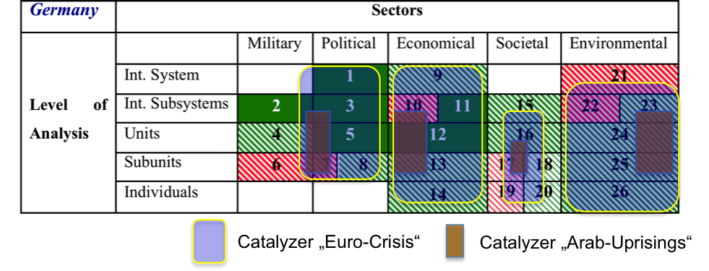

The catalytic effects of the “Arab Uprisings” have shaped a more precarious National Security Situation for Israel. It is influencing core “sectors” of the analytical matrix and creates a more unstable and volatile security environment. In addition to this process the Israeli government is taking up a position of “all-round” defence (also with the option of preemptive strikes) and is in so far not able (or willing) to develop new strategies to counter these challenges in a sense of using opportunities.

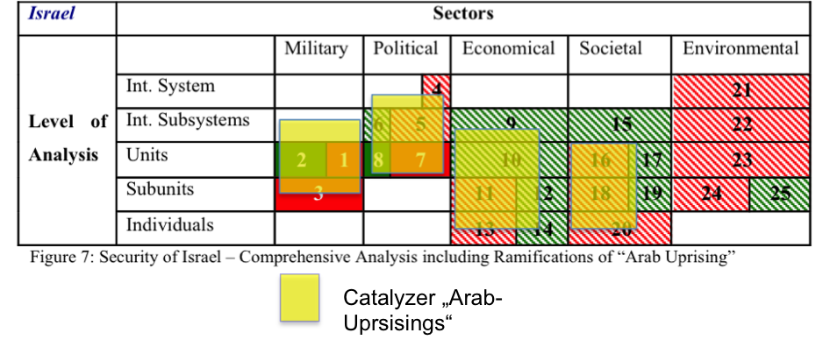

This perception of “Block-Confrontation” will not bring progress, on the contrary it has a huge potential to deteriorate the situation.

Therefore, to open this stalemate and to bring a new momentum in this constellation, a potential and trustworthy partner of all sides – like Germany - could have and bring enough impetus in it, to use these catalyzing effects and utilize this phase of transformation also to enable progress in the Israeli-Palestinian Peace Process.

# 6. Mediation-Potential Analysis of Germany

***National Interests***

The analysis of the German system of interests is the basis for a further decision process to take action in a specific conflict or not (Chapter 3.5.1). The nature of the system of interests is based on the inherent national interests of Germany (Chapter 4.2). Possible ramifications of a conflict to Germany´s national interests determine the degree of political motivation to intervene.

The geo-political position in the center of Europe and the integration into the organizational framework of the “Western Community” after two World Wars determine also in the Post-Reunification-Era, Germany´s “Multilateralism Approach” to pursue its national interests in Foreign Policy. The German White Paper (2006) and the Defense Policy Guidelines (2011) emphasize this explicitly. Furthermore, the International Community and in this the 27 EU-Countries particularly, are demanding that Germany should bear more responsibility and take more burden in relation to its economical and political power. Enhanced was this process by the “Euro-Crisis” and is transforming and will lead to a new power-balance in EU, with deep implications also to the global level. Germany will and has to take more action in international affairs – specifically in the settlement of international conflicts –, to pursue its own interests in a appropriate and responsible way.

In consequence, Germany will further improve its position within the EMU and EU countries, to shape a broad political basis to protect its economic prosperity, which is the core and basis of all German (Geo-Economic) Power. Due to the safeguarding role of Germany in the “Euro-Crisis” this is also in the interest of most of the other EU countries (Chapter 5.3.4).

The result of the catalytic transition-process of the ESDC with Germany as the dominating geo-economic power in the EU and the very positive common history with the USA after World War II[172] (Marshall-Plan and Reconstruction – Ally and Protector of Germany during Cold War – strong supporter of Reunification; common western value basis;…) will most probable lead to an German acceptance of the US-offer made by the former President Bush senior of a “partnership in leadership” (Chapter 5.4). The probability of this development will be intensified by the fact that the USA are shifting its global focus towards Asia and the Pacific-Region. Therefore it is also from a US perspective essential to have a cooperation with a capable partner in the European Region, who can be influential and project power successfully to the EU-Periphery. This kind of relationship would bring Germany – because of its hegemonic role in EU - into a position of an actor in security-policy affairs on a (more) global level. Furthermore, this development would coincide with the protection of Germany´s economic-interests, but the “price” would be to “invest” more into the stability of regions, important for sustainable and stable resources supply as well as the “friction free” connection to foreign markets (Chapter 4.2). This is an important element of the transition process from the former “Bonn-Consensus” to the future “Berlin Consensus” and means to become more active and involved in international affairs.

The catalytic effects of the “Arab-Uprisings” in the Middle East and Maghreb - a region with a “per se” instable and fragile security situation and with the Israeli-Palestinian-Conflict as one of its core issues - with its ramifications and possible spill-over effects, due to its direct connection to the European sphere and economy, are of high importance for the National Interests of Germany. This is not only in German national documents declared, also the European Security Strategy from 2003 identifies the resolution of the Arab-Israeli conflict as a ***“strategic priority for Europe”,*** underlying that ***“without this, there will be little chance of dealing with other problems in the Middle East”.*** This highly political declaration demonstrates the European will to play an important role in the resolution process and is herewith complementary to Germany´s National Interest stated by the German Chancellor Angela Merkel, that the security of the state of Israel belongs to the ***“Rasion d’Etat”*** of Germany. The settlement of the Israeli-Palestinian conflict would be therefore, not only from a German point of view, a major contribution to the security of the State of Israel.

Within the Analytical Framework for Mediation Potential (Chapter 3.5.4) it can be stated, that the system of German National Interests generates a high degree of interest and motivation to settle conflicts in the “European Periphery”. Germany, in its current and future hegemonic role within EU, is, because of its strategic interests, in a position of a “Principal Mediator” and is highly interested in a stabilization of the security situation in the Middle East.

***Mediators Capabilities***

After the identification of Germany´s System of National Interests and its most probable future position as the dominating geo-economic power in Europe, I would like to draw the attention to its capabilities and resources of power and influence.

The catalyzer “Euro-Crisis” accelerated not only the transition process from the “Bonn-Consensus” (“Westbindung”; euro-enthusiasm; Chapter 5.3.1) to the “Berlin-Consensus” (rationalized cost-benefit approach) as the organic successor, but carved clearly out, that Germany´s power will continue to derive from soft institutional structures and economic capabilities, rather than from a robust and hard powered foreign policy. The old synopsis of global power by Henry Morgenthau, that states pursuing interests defined in terms of power is here under test. Germany could be seen as the first ***“soft-power superpower”***. This means a nation with realistic objectives, pursuing its interest defined in terms of power, but the methods based on soft power.[173] In consequence, Germany is and will be naturally more active on the “global” level (Chapter 5.3.4). The participation of Germany in the negotiations with Iran about its Nuclear Program – recently in Istanbul (14/15 April 2012) and in the next future in Bagdad – as the only non-permanent member of the UN Security Council, gives clear evidence about this.

In the Middle East Region, Germany has no affiliation to certain Arab countries or groups, like other former colonial powers (e.g. France, United Kingdom) or the USA during and after the Cold War era (e.g. Egypt or today Saudi Arabia). This provides Germany a more impartial reputation within the Arab factions. Furthermore, the special relationship with Israel is well known and accepted in the region, and is not an obstacle for German mediation activities (e.g. Gilad Shalit; return of two dead IDF soldiers against prisoners/ ISR-Hezbollah 2006; Chapter 2). In addition, Germany has a long lasting and good relationship to one major regional player – Turkey. The common history and the ability to talk with Turkey at “one eye level” is a big advantage, especially after the cooled down Israeli-Turkish relations.

This standing and reputation to all states in the region can offer Germany special ways of interaction in this complex constellation. Germany in its position as the hegemonic and dominant nation in Europe and EU has and will possess enough resources, capabilities and influence – amplified through the structure of EU and other international organizations (NATO, UN, Quartet) - to apply these in a mediation process (Chapter 3.5.4). However, the main focus will rely on soft-power and only, if it becomes really essential, Germany would be willing to take part in an multinational – hard-power – mission (e.g. stabilization operation, peace keeping). Nevertheless, Germany is preparing its forces also in this spectrum and since autumn 2011 a hard transformation process has been taking place from a conscription army to a professional one.

***Intended Extracted Value***

Based on the national interests and capabilities of Germany it is possible to identify the incitement to become a mediator in a conflict situation and conclude and deduce the intended value, which can arise or be gained out of an intervention. In the case of Germany, as a rising ***“soft-power superpower”***, exists a complex system of combinations of public and private values, which results out of the transition process and is based on the changed German role and position in the power-balance network of European countries.

In terms of the Analytical Matrix for Mediation Potential, the intended Public Value is a visible sign of the international acceptance and acknowledgement of its new position and role as a global actor (within and through the international organizations). This could be for example an appointment as a permanent member of the UN Security Council. Furthermore, an activity as a mediator would add to the reputation of Germany and strengthening also the position of a leading integrator wtihin EU.

With these Public Values are combined and connected also the Private Values. A stabilization of the Middle East region would not only strengthen the reputation of Germany as a successful Mediator, it would have direct implications to Germany´s economy. The prosperity would be protected by a sustained supply and a stabilizing effect to the price level of fossil energy and oil. Furthermore, the demographic pressure could be channeled and controlled by “European Neighbourhood Programs” to establish new sources for the European employment market. In contrary, this would have positive effects for the cooperative countries and could initiate a self-sustaining economic and social development.

***Germany´s Mediation Potential***

This constellation of Germany as an emerging global player, as a geo-economical power, pursuing foreign policy as a hegemonic actor within the European Union, based on clear-cut National Interests, demonstrates very clear the inherent growing motivation to become more active in international affairs. The equation between National Interests, growing capabilities and pressure from the International Community to take more responsibility, is leading directly to a National Security Strategy – even not “expressis verbis” in a German official document with this title published– and shape the basis for future actions in this sense. The initiative will be taken in the clear rationale of pursuing the own National Interests with the objective to gain the intended Public and/ or Private Values. Germany is coming in a pivotal position to take the initiative as a Mediator in international affairs and especially in the periphery of its own sphere of influence.

# 7. Conclusions/ Summary

The direction of the future German Foreign Policy towards a close cooperation with the USA - a “renewed transatlantic partnership” (with shared burden and cooperative focus to different regions) - would strengthen the liberal world order and is of high interest of Germany. Economy wise, because Germany´s power is basing on free and safe international trade and politically, due to the fact that the chances of peace and freedom are in a liberal world order more likely, than in a world, in which autocratic and democratic poles are engaged in an ever-lasting struggle.

The international political arena is also in transition to a multipolar world, but the gravity of the poles will be of different power and influence. Nations like China and India are building up a tremendous military potential, but in parallel have a lot of inherent uncertain variables like social development and social justice. Nevertheless, the markets of the future are in Asia and it is a mammoth task for Europe and the USA to shape the framework for a peaceful rise.

A Common Foreign and Security Policy of Europe under German lead, would not only contain and channel German Power within an international organization, it could effectively stabilize the eastern and southern Periphery of the European Union and could bring Europe´s power and influence back to the world scene. Reasonably applied, German Power could be a blessing, as far as German Policy is aware about its on possibilities and limitations.

The foundation of the first German Nation – the Second German Reich - took place after a successful war against France in the hall of mirrors in Versailles, fully in terms of a “belated nation”. Since then Germany initiated two catastrophic World Wars with unspeakable distress, genocide and crime against humanity in the Holocaust, was separated in the Cold War era and thanks to the political self-containment and integration into the Western Community as well as trust of its main allies, the peaceful reunification 1990 could take place. The catalytic effects of the ESDC revealed the current and future power position of Germany, but in contrast to the foundation in 1871, the reunification was a peaceful process and the current Germany is aware about its necessity for self-containment and integration into international organization like EU. It seems that after 140 years, Germany as a “belated nation”, found its way into the community of the global nations. Germany´s key concept to exert power has to be via integration, self-containment and focusing very consciously not on the military spectrum of hard-power. As the hegemonic leading nation in EU, Germany has to balance the different interests of the other members and is therefore also in the role of a mediating power, fully in the positive sense and meaning of Shakespeare’s “Measure for Measure”:

***O! it is excellent***

***To have a giant´s strength; but it is tyrannous***

***To use it like a giant.***

**Appendix 1: Third Party USA**

By illustration this on the basis of the Middle East conflict, the two “principal parties”, Israel and the Palestinians, have direct interest in the dispute e.g. territory and a two state solution. The United States has no direct interests in the occupied territories, but it does have a strategic interests in the region as well as a commitment to the survival and security of the Jewish State. These indirect interests may compel the U.S. to enter the dispute, not as a fellow disputant, but as a “principal mediator”.



Source: Princen; Intermdiaries in Internat. Conflict, p. 21

**Appendix 2: Reconfiguration and Bargaining Range**

a) Reconfiguration

A Mediator reconfigures the structure of a bargain in one of two ways: First, the number of parties changes from two to three – two disputants and a mediator. Following game theory and sociology the coalition-creating effect has a deep influence. When a third bargainer enters as dispute, each of the original two disputants must assess the potential increase in value brought by the third party and in parallel also the potential loss in value. The third party may offer both disputants a better deal than they could have between the original two. The risk also enters with the possibility of being excluded when a third party forms a coalition with the other disputant. In this way, intervention presents not only opportunities, but also risks.

A reconfiguration of a bargain can also be done by rearranging the disputed issues themselves. If bargaining has centered on a single issue, the intermediary can disaggregate that issue and find creative ways to trade across subissues to benefit both sides. Or, it can add issues by way of economic or military aid (PMed: expand the bargaining range), improved relations and so forth. Concessions may be still needed, but joint gains are possible.

a) Bargaining Range:

The bargaining range is bound by the value of each party´s no-agreement alternative, what is often termed the reservation value. For understanding bargaining dynamics the feature of the indeterminacy of outcome is of importance. Bargaining can be defined like this: “It is an interdependent decision-making process characterized by both strategic interaction and imperfect information.”

(Princen; Intermediaries in Internationl Conflict; p. 33.)

**Appendix 3: Description of the Security model systematics**

|  |  |  |  |  |  |  |
| --- | --- | --- | --- | --- | --- | --- |
|  | Sectors | | | | | |
| Level of Analysis |  | Military | Political | Economie | Societal | Environmental |
| Int. System |  |  |  |  |  |
| Int. Subsystems | Potential | Threat | And | Related | Object |
| Units |  |  |  |  |  |
| Subunits |  |  |  |  |  |
| Individuals |  |  |  |  |  |

|  |  |
| --- | --- |
|  | Existential Threat |
|  | Neutral – no threat |
|  | Supporting Factor to National security |
|  | Threat – but not existenial |

Color Code:

Level of Analysis:

1. International System: Units that have no system level above them (e.g. United Nations)
2. International Subsystem: Groups/ Units distinguished by the particular nature or intensity of their interactions with or interdependence on each other
3. Units: States, nations, transnational companies
4. Subunits: Bureaucracies, lobbies: organized groups of individuals
5. Individuals

Sectors:

1. Military: the related object is the state or other kinds of political entities
2. Political: threats in terms of constituting principles (sovereignty, ideology)
3. Economic: threatened by factors that might undermine the rules, norms and institutions
4. Societal: Related object is large-scale collective identities that can function independent of the state. This identities evolve and change in response to internal and external developments.
5. Environmental: Survival of individual species, types of habitat, planetary climate and biosphere

**Appendix 4: Quotation Former British Prime Minister Margaret Thatcher**

Addressing Mr. Bush and Mr. Gorbachev, she continued: “President Mitterrand and I know. We have sat there at the table [with Germany] very often indeed. Germany will use her power. She will use the fact that she is the largest contributor to Europe to say, ‘Look, I put more money in than anyone else, and I must have my way on things which I want.’ I have heard it several times. And I have heard the smaller countries agree with Germany because they hoped to get certain subsidies. The German parliament would not ratify the [Maastricht Treaty](http://www.csmonitor.com/tags/topic/Maastricht+Treaty) unless the central bank for a single currency was based there. What did the European Union say? Yes, you shall have it.”

Thatcher said then what is surely on Cameron’s mind today: “All this is flatly contrary to all my ideals. Some people say you have to anchor Germany to Europe to stop these features from coming out again. Well, you have not anchored Germany to Europe, but Europe to a newly dominant Germany. That is why I call it a German Europe.”

In the 1995 discussion, neither Bush nor Gorbachev shared Thatcher’s alarm. “I felt German unification would be in the fundamental interest of the West,” Bush said. “I felt the time had come to trust the Germans more, given what they had done since the end of World War II.” Despite the [Soviet Union](http://www.csmonitor.com/tags/topic/U.S.S.R.)’s early opposition to German unity, Moscow ultimately agreed. As Gorbachev put it: “[President Bush](http://www.csmonitor.com/tags/topic/George+W.+Bush) was right about Germany. The Germans had accepted democratic values. They had behaved responsibly. They had recognized their guilt. They had apologized for their past, and that was very important. So, as difficult as it was to accept, it was inevitable that the Soviet leadership took decisions consistent with this reality.”

**Source:** Gardels, Nathan (12 December 2011); The Christian Science Monitor; available at (April 2012): http://www.csmonitor.com/Commentary/Global-Viewpoint/2011/1212/Euro-crisis-and-Germany-Is-this-indispensable-nation-to-be-feared-or-welcomed/(page)/2

**Appendix 5: Development of EU Treaties**



**Appendix 6: Voting weights- EU Parliament – European Council**

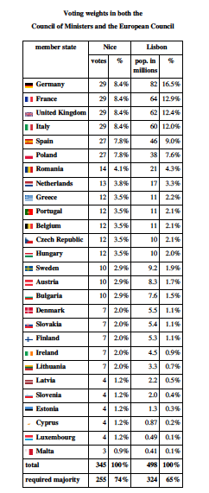

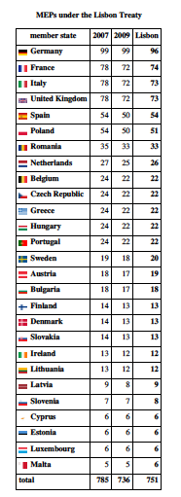

**Bibliography**

|  |  |
| --- | --- |
| Bercovitch, Jacob (1992) | The Structure and Diversity of Mediation in International Relations; in: Mediation in International Relations; Ed. Jacob Bercovitch and Jeffrey Rubin; St. Martin´s Press; New York. |
| Bercovitch, Jacob (2000) | Who Mediates? The Political Economy of International Conflict Management; Journal of Peace Research; Vol 37, No. 2, 2000; pp. 145-165. |
| Bercovitch, Jacob (2002) | Putting Mediation in Context; in: Studies in International Mediation; Ed. Jacob Bercovitch; Palgrave MacMillian; New York. |
| Berkowitz, Peter (2012) | „Reconsidering the Arab Spring“; Hoover Institution Stanford University; available at (April 2012): http://www.hoover.org/publications/policy-review/article/112251 |
| Blanchard, Jean- Marc (2000) | „Power and the Purse“; Economic Statecraft, Interdepence, and National Security; Ed. Jean-Marc Blanchard et alia; Frank Cass, London |
| Brom, Shlomo (2012) | “The Regional Ramifications of the Arab Spring”; in: „One Year of the Arab Spring: Global and Regional Implications”; INSS – The Institute for National Security Studies; Memorandum No. 113; Tel Aviv University; Tel Aviv; March 2012; pp. 39 – 42. |
| Buzan, Barry; Weaver, Ole, De Wild, Jaap (1998) | Security: A Framework for Analysis, Lynne Rienner Publishers; USA. |
| Carnegie Endowment (2011) | „Can Turkish Model gain traction in New Middle East“ (19 Dec 2011); available at (April 2012): http://carnegieendowment.org/2011/12/19/can-turkish-model-gain-traction-in-new-middle-east |
| Carnevale, Peter (2002) | Mediating from Strength; in: Studies in International Mediation; Ed. Jacob Bercovitch; Palgrave MacMillian; New York. |
| Chaillot Papers (2010) | European Involvement in the Arab-Israeli Conflict; Ed. Esra Bulut Aymat; December 2010; European Union – Institute for Security Studies, Paris; available (March 2012) at: http://www.iss.europa.eu/uploads/media/cp124-European_Involvement_in_the_Arab-Israeli_Conflict.pdf |
| Duncan, Andrew;  Opatowski, Michel  (1998) | War in the Holy Land - From Meggido to the West Bank, Gloucestershire, 1998 |
| Eiland, Giora (2011) | “The Upheavals in the Middle East and Israel´s Security”; Strategic Assessment; Volume 14; No. 2; July 2011; available at (April 2012): http://www.inss.org.il/upload/(FILE)1311767504.pdf |
| Etzion, Eran (2009) | The Ministry of Foreign Affairs Situation Assessment for 2008-2009, Strategic Assessment, vol.12, No. 1, pp. 47-58. |
| EU – Arab Spring (2011) | „The EU´s Response tot he Arab Spring“; EU Press Release; Brussels 16 December 2011: available at (April 2012): http://europa.eu/rapid/pressReleasesAction.do?reference=MEMO/11/918 |
| EU – Commission (2009) | “Mobility Partnerships as a Tool of the Global Approach to Migration”, Commission Staff Working Document, SEC (2009) 1240, Brussels, 18 September 2009; available at (April 2012): http://register.consilium.europa.eu/pdf/en/09/st13/st13489.en09.pdf |
| EU – Demograhic Challenges (2008) | Regions 2020: Demographic Challenges for European Regions; Commission of the European Communities; available at (April 2012): http://ec.europa.eu/regional_policy/sources/docoffic/working/regions2020/pdf/regions2020_demographic.pdf |
| EU Sec Strat (2003) | European Security Strategy 2003; p. 8; availabel at (April 2012): http://www.consilium.europa.eu/uedocs/cmsUpload/78367.pdf |
| Fargues, Philippe (2008) | “Emerging Demographic Patterns across the Mediterranean and their Implications for Migration through 2030”; Center for Migration and Refugee Studies, the American University in Cairo; November 2008; available at (April 2012): http://www.migrationpolicy.org/pubs/Fargues-Paper.pdf |
| German Defence Policy Guidelines (2011) | Defence Policy Guidelines, The Federal Ministry of Defence - The Minister, Berlin, 27th of May 2011, available at: http://www.rk-marine-kiel.de/files/bundeswehr/sicherheitspolitik/defence_policy_guidelines_(2011).pdf |
| German White Paper (2006) | White Paper 2006 on German Security Policy and the future of the Bundeswehr, The Federal Ministry of Defence, Berlin, 2006, available at: http://www.bmvg.de/portal/a/bmvg/sicherheitspolitik/angebote/dokumente/weissbuch. |
| Görtemaker, Manfred (1999) | Geschichte der Bundesrepublik Deutschland - Von der Gründung bis zur Gegenwart, Beck-Verlag, München, 1999. |
| Görtemaker, Manfred (1999) | Geschichte der Bundesrepublik Deutschland - Von der Gründung bis zur Gegenwart, Beck-Verlag, München, 1999. |
| Görtenmaker, Manfred (1999) | Geschichte der Bundesrepublik Deutschland – Von der Gründung bis zur Gegenwart, Beck-Verlag, München, 1999. |
| Guzansky, Yoel and Heller, Mark (2012) | „One Year of the Arab Spring: Global and Regional Implications”; INSS – The Institute for National Security Studies; Memorandum No. 113; Tel Aviv University; Tel Aviv; March 2012. |
| Hafdell, Sofia (2012) | “Turkey-NATO Relations at the 60th Anniversary”; Global Political Trends Center – Policy Update 2; Istanbul Kültür University; Turkey; March 2012; available at (April 2012): http://www.google.com/search?client=safari&rls=en&q=central+radar+of+NATO´s+missile+defence+system+Turkey&ie=UTF-8&oe=UTF-8 |
| Hampson, Fen Olser (2006) | The Risks of Peace: Implications for International Mediation; in: Negotiation Journal – January 2006; Blackwell Publishing, Oxford UK; pp. 13 – 30. |
| Heller, Mark A. (2012) | “Israeli Response to the Arab Spring”; in: „One Year of the Arab Spring: Global and Regional Implications”; INSS – The Institute for National Security Studies; Memorandum No. 113; Tel Aviv University; Tel Aviv; March 2012; pp. 75 – 77. |
| Herzog, Chaim; Gazit, Shlomo (2005) | The Arab-Israeli Wars - War and Peace in the Middle East, London, 2005 |
| Hoffmann, Frank G. (2009) | Hybrid Threats: Reconceptualizing the Evolution Charakter of Modern Conflict; Strategic Forum, No. 240, Institute for National Strategic Studies, National Defense University. |
| Hoffmann, Stanley (1987) | Janus und Minerva: Essays in the Theory and Practice of International Politics. Boulder, Colo.: Westview Press. |
| Hollis, Rosemary (2010) | “The basic stakes and strategy of the EU and Member States”; ; in: European Involvement in the Arab-Israeli Conflict (2010); EU Institute for Security Studies; pp 31 - 42; available at (April 2012): http://www.iss.europa.eu/uploads/media/cp124-European_Involvement_in_the_Arab-Israeli_Conflict.pdf |
| Inbar, Efraim (2008) | Israel´s National Security - Issues and challenges since the Yom Kippur War, New York, 2008. |
| Inbar, Efraim (2011) | “The Deterioration in Israeli-Turkish Relations and its Internal Ramifications”; The Begin-Sadat Center for Strategic Studies; Bar-Ilan University; Mideast Security and Policy Studies No. 89; available at (April 2012): http://www.biu.ac.il/SOC/besa/MSPS89.pdf |
| Information (2009) | Information to German Foreign Policy – Informationen zur politischen Bildung – No 304; Deutsche Außenpolitik, Bonn; available (March 2012) at: http://www.bpb.de/files/9K9KDC.pdf |
| Information to German Foreign Policy (2009) | Informationen zur politischen Bildung - 304: Deutsche Außenpolitik, Bonn, 2009, available at: http://www.bpb.de/files/9K9KDC.pdf |
| Jervis, Robert (1976) | Perception and Misperception in International Politics; Princeton, N.J.: Princeton University Press. |
| Judah, Ben and Korski, Daniel (2011) | “The Middle East needs Germany”; European Council on Foreign Relations; available at (April 2012): http://ecfr.eu/content/entry/commentary_the_middle_east_needs_germany |
| Kam, Ephraim (2012) | “Iran and the Turmoil in the Arab World”; in: „One Year of the Arab Spring: Global and Regional Implications”; INSS – The Institute for National Security Studies; Memorandum No. 113; Tel Aviv University; Tel Aviv; March 2012; pp. 43 – 47. |
| Kindermann, Harald (2008)  (2006 – 2011 GER Ambassador to ISR) | „A Unique Relationship?“; American Institute for Contemporary German Studies; John Hopkins University  http://www.aicgs.org/site/wp-content/uploads/2011/10/germanamerican8.pdf |
| Kurz, Anat (2012) | “The Arab Spring and the Israeli-Palestinian Arena”; in: „One Year of the Arab Spring: Global and Regional Implications”; INSS – The Institute for National Security Studies; Memorandum No. 113; Tel Aviv University; Tel Aviv; March 2012; pp. 67 – 70. |
| Lindenstrauss, Gallia (2012) | “Turkey and the Arab Awakening”; in: „One Year of the Arab Spring: Global and Regional Implications”; INSS – The Institute for National Security Studies; Memorandum No. 113; Tel Aviv University; Tel Aviv; March 2012; pp. 57 - 60. |
| Liotta, P.H. (2003) | Liotta, P.H.; „Still worth dying for“ – National Interests and the Nature of Strategy; Naval War College Review, Vol.1. VI, No.2, pp. 123-138. |
| NATO (2010) | Active Engagement, Modern Defence - Strategic Concept for the Defence and Security of the Members of the North Atlantic Treaty Organisation adopted by Heads of State and Government in Lisbon; available at: http://www.nato.int/cps/en/natolive/57772.htm |
| Netanyahu, Binyamin (2009) | Prime Minister´s Speech at the Begin-Sadat Center at Bar-Ilan University, Prime Minister´s Office Communication Department, June 14, 2009. |
| Netanyahu, Binyamin (2011) | Speech by PM Netanyahu to a Joint Meeting of the U.S. Congress; http://www.mfa.gov.il/;MFAHeb/Diplomatic+updates/Events/Speech_by_PM_Netanyahu_to_a_Joint_Meeting_of_the U.S._Congress_250511 |
| Nye, Joseph (1999) | Redefining the National Interest; Foreign Affairs 78. 4.; pp. 22-35. Available: <http://www.foreignaffairs.com/articles/55209/joseph-s-nye-jr/redefining-the-national-interest> |
| Palmer Report (2011); | available at (April 2012): http://www.un.org/News/dh/infocus/middle_east/Gaza_Flotilla_Panel_Report.pdf |
| Perthes, Volker (2012) | “Europe and the Arab Spring”; in: Survival; Vol 53 No. 6; pp 73 – 84; available at (April 2012): http://www.swp-berlin.org/fileadmin/contents/products/fachpublikationen/111123_Survival_EU_ArabRev_Prt_KS.pdf |
| Prime Minister Netanyahu (2009) | Netanyahu, Binyamin; Prime Minister´s Speech at the Begin-Sadat Center at Bar-Ilan University; Prime Minister´s Office – Communication Department, June 14, 2009: available (March 2012) at: http://www.pm.gov.il/PMOEng/Archive/Speeches/2009/06/speechbarilan140609.htm |
| Prime Minister Netanyahu (2011) | Israel PM Office, (2011); Speech by PM Netanyahu to a Joint Meeting of the U.S. Congress; available (March 2012) at: http://www.mfa.gov.il/MFA/Government/Speeches+by+Israeli+leaders/2011/Speech_PM_Netanyahu_US_Congress_24-May-2011.htm |
| Princen, Thomas (1992) | Intermediaries in International Conflict, Princeton, N.J.: Princeton University Press. |
| Pruitt, Dean (2002) | Mediator Behavior and Success in Mediation; in: Studies in International Mediation; Ed. Jacob Bercovitch; Palgrave MacMillian; New York. |
| Razi, Efron and Yehezkeally, Pinhas (2011) | Real Life is Not Linear – Introduction to Complex System Theory; Israel National Defense College; Research Center; Israel Defense Forces. |
| Rodman, David (2005) | Defense and diplomacy in Israel´s national security experience, Brighton: Sussex Academic Press, 2005. |
| Schaller, Christian (2010) | Schaller, Christian; „Deutschland im UN-Sicherheitsrat 2011/12; Stiftung Wissenschaft und Politik, Berlin; available at (April 2012): http://www.swp-berlin.org/de/publikationen/swp-aktuell-de/swp-aktuell-detail/article/deutschland_im_un_sicherheitsrat.html |
| Schweitzer, Yoram (2011) | Evil Develops in the South; INSS; Insight No. 295; (21 Nov 2011); available at (April 2012): http://www.inss.org.il/research.php?cat=45&incat=&read=5721&print=1 |
| Siboni, Gabi (2012) | “The Upheavals in the Arab World”; in: „One Year of the Arab Spring: Global and Regional Implications”; INSS – The Institute for National Security Studies; Memorandum No. 113; Tel Aviv University; Tel Aviv; March 2012; pp. 71 – 74. |
| Stein, Janice Gross (1985) | “Structures, Strategies, and Tactis of Mediation”, Negotiation Journal 1(4): 331–347. |
| Stein, Shimon (2008)  (2001-2007 ISR Ambassador to GER) | German-Israeli Relations 60 years later: Are they still unique?; American Institute for Contemporary German Studies; John Hopkins University  http://www.aicgs.org/site/wp-content/uploads/2011/10/germanamerican8.pdf |
| Stein, Shimon (2012) | “The European Union and the Arab Spring”; in: „One Year of the Arab Spring: Global and Regional Implications”; INSS – The Institute for National Security Studies; Memorandum No. 113; Tel Aviv University; Tel Aviv; March 2012; pp. 25 – 28. |
| Straubhaar, Thomas (2008) | “Einwanderungsland Deutschland”; Friedrich Naumann Foundation; available at (April 2012): http://www.hwwi.org/fileadmin/hwwi/Publikationen/Dossier/Zuwanderung_in_Deutschland/Straubhaar-Einwanderung.pdf |
| Tal, Israel (2000) | National Security - The Israeli Experience, Westport, CT: Praeger Publishers; vii-vx,3,11-17,39-44. |
| Teti, Andrea (2011) | “The Unbearable Lightness of Authoritarianism: Lessons from the Arab Uprisings”; Mediterranean Polititcs; 16:2; Routledge; UK (2011); available at (April 2012): http://dx.doi.org/10.1080/13629395.2011.583758 |
| Tocci, Nathalie (2010) | “The conflict and EU-Israeli Relations; in: European Involvement in the Arab-Israeli Conflict (2010); EU Institute for Security Studies; pp 55 – 64; available at (April 2012): http://www.iss.europa.eu/uploads/media/cp124-European_Involvement_in_the_Arab-Israeli_Conflict.pdf |
| Ulutas, Ufuk (2011) | A new Israel-Turkey relationship , UFUK ULUTAS; Jerusalem Post; May 31, 2011; pg. 16; available at: http://www.jpost.com/Cooperations/Archives/ |
| Van Creveld, Martin (1991) | The Transformation of War; New York: Free Press. |
| Van Ginkel, Eric (2004) | The Mediator as Face-Giver; in: Negotiation Journal - October 2004; Blackwell Publishing, Oxford UK. |
| Yadlin, Amos (2012) | “The Arab Uprising One Year On”; in: „One Year of the Arab Spring: Global and Regional Implications”; INSS – The Institute for National Security Studies; Memorandum No. 113; Tel Aviv University; Tel Aviv; March 2012; pp. 11 - 19. |

**Newspaper:**

Hurriyet – Daily News: The Eastern Mediterranean – Back to Power Politics (8 Sep 2011); available at (April 2012): http://www.hurriyetdailynews.com/default.aspx?pageid=438&n=the-eastern-mediterranean-back-to-power-politics-2011-09-08

Haaretz Newspaper (23 Jan 2011); „Delek proposes Cyprus facility to process Israeli gas“; available at (April 2012): http://www.haaretz.com/business/delek-proposes-cyprus-facility-to-process-israeli-gas-1.338603

The Times of Israel (6 April 2012): Can Science save Israeli-Turkish Relations?; available at (April 2012): http://www.timesofisrael.com/can-science-save-israeli-turkish-relations/

The Washington Times (14 Sep 2011): Turkey joins NATO´s Missile Defense Shield; available at (April 2012): http://www.washingtontimes.com/news/2011/sep/14/turkey-joins-natos-missile-defense-shield/?page=all

The Harvard Kennedy School Review 2011 Edition; Jonathan Edwards: Is he really “our son of a bitch”?; available at (April 2012): http://isites.harvard.edu/icb/icb.do?keyword=k74756&pageid=icb.page414667

* The Washington Post (25 April 2011); “Poll: Egyptians have unfavorable view of U.S., are divided on fundamentalists”; available at (April 2012): <http://www.washingtonpost.com/world/poll-egyptians-have-unfavorable-view-of-us-are-divided-on-fundamentalists/2011/04/25/AFxCzFjE_story.html>
* Haaretz Newspaper (5 June 2011): Calm returns to Israel-Syria border after day of deadly violence; available at (April 2012): http://www.haaretz.com/news/diplomacy-defense/calm-returns-to-israel-syria-border-after-day-of-deadly-violence-1.366147

BBC News Middle East (27 Sep 2010); US “disappointed” as settlement building bans ends; available at (2012): http://www.bbc.co.uk/news/world-middle-east-11422065

Westney, Richard (2011); “Assessing the risk in capital intensive opportunities“; in: Oil and Gas Financial Journal (March 2011); available at (April 2012): http://www.westney.com/publications/Oil%20Gas%20Financial%20Journal/Assessing%20the%20Risk%20in%20Capital%20Intensive%20Investments.pdf

* Forbes (3 March 2011); “The Lybian Crisis: Where are Oil Prices going?”; available at (April 2012): http://www.forbes.com/sites/energysource/2011/03/03/the-libyan-crisis-where-are-oil-prices-going/

The Economist (23 June 2011); “The IEA opens the taps”; available at (April 2012): http://www.economist.com/blogs/schumpeter/2011/06/oil-market

Iran Energy Data, Statistics and Analysis; International Energy Agency; available at (April 2012): http://www.eia.gov/cabs/iran/Full.html

World Energy Outlook 2005; International Energy Agency; available at (April 2012):

http://www.iea.org/weo/database_electricity/WEO2005-Chapter%206.pdf

* EU Press Release (2007); “Global Approach to Migration”; available at (April 2012): http://europa.eu/rapid/pressReleasesAction.do?reference=MEMO/07/549

Jackson, Janes (24 November 2011): „Seiltanz zum „europäischen Deutschland“; in: Newspaper Sueddeutsche.de; available at (April 2012): http://www.sueddeutsche.de/politik/euro-krise-merkels-seiltanz-zum-europaeischen-deutschland-1.1217287

Barber, Tony (20 October 2011): “Germany has leading role in Eurozone drama”; in Financial Times; available at (April 2012): http://www.ft.com/cms/s/0/2cbe25b8-fb2c-11e0-8756-00144feab49a.html#axzz1ru9EPKWl

Brost, Marc (27 October 2011): “Alle Macht den Deutschen?”; in: Zeit Online; available at (April 2012): http://www.zeit.de/2011/44/Europagipfel

Newspaper: Frankfurter Allgemeine Zeitung (25 August 2011): „Merkel weist Kohls Kritik zurück“; available at (April 2012): http://www.faz.net/aktuell/politik/inland/merkel-weist-kohls-kritik-zurueck-jede-zeit-hat-ihre-herausforderungen-11125214.html

Sikorski, Radoslaw (28 November 2011): „I fear Germany´s power less than her inactivity“; in: Financial Times; available at (April 2012): http://www.ft.com/intl/cms/s/0/b753cb42-19b3-11e1-ba5d-00144feabdc0.html#axzz1s18BscBC

1. British Empire, France, Russia and to a minor extent Spain and the Ottoman Empire.
2. The **Congress of Berlin** (13 June – 13 July 1878) was a meeting of the European Great Powers' and the Ottoman Empire's leading statesmen in [Berlin](http://en.wikipedia.org/wiki/Berlin) in 1878. In the wake of the [Russo-Turkish War of 1877–78](http://en.wikipedia.org/wiki/Russo-Turkish_War,_1877%E2%80%9378), the meeting's aim was to reorganize the countries of the [Balkans](http://en.wikipedia.org/wiki/Balkans). German Chancellor [Otto von Bismarck](http://en.wikipedia.org/wiki/Otto_von_Bismarck), who led the Congress, undertook to stabilize the Balkans, recognize the reduced power of the Ottoman Empire, and balance the distinct interests of [Britain](http://en.wikipedia.org/wiki/Great_Britain), [Russia](http://en.wikipedia.org/wiki/Russian_Empire) and [Austria-Hungary](http://en.wikipedia.org/wiki/Austria-Hungary).
3. Bismarck facilitated the Mediterranean Entente between England, Italy, Spain and Austria-Hungary to maintain the “Status Quo” in the Mediterranean region.
4. **Endnotes:**

   **Chapter 2:**

   Görtenmaker (1999), p. 24 et seq.; Information (2009), p. 14 et seq.
5. Görtenmaker (1999), p. 86 et seq.; Information (2009), p. 16 et seq.
6. The most important steps in Chancellor Adenauers concept of “Westbindung” have been:

   European Coal and Steel Community 1952, accession to Western European Union (European defence organization; 07th May 1955) and to North Atlantic Treaty Organisation (NATO, 09th May 1995) at the same time abolishment of the occupation statute, Treaty of Rome (EURATOM and European Economic Community 1957).
7. The BOW Group (2011); pp. 25 et seq.
8. Germany facilitated with its representative Gerhard Conrad the return of two dead IDF soldiers from Hezbollah and arranged the exchange of the abducted IDF soldier Gilad Shalit against over 1000 Palestinian prisoners.
9. **Chapter 3:**

   Princen; Intermediaries in International Conflict; p. 9
10. Princen; Intermediaries in International Conflict; p. 8.
11. Jervis; Rational Deterrence; p. 198.
12. Pruitt; Mediator Behavior; p. 45 et seq.
13. Bercovitch; The Structure and Diversity of Mediation; p. 17 et seq.
14. Princen; Intermediaries in International Conflict; p. 13.
15. Bercovitch; Putting Mediation in Context; p. 9.
16. Princen; Intermediaries in International Conflict; p. 19 et seq.
17. Three bargaining dynamics are possible:

    The Principal Mediator can bargain directly with a disputant to strike a side-deal.

    It can form a coalition with one disputant to compel a concession from the other disputant.

    The Principal Mediator can create a three-way, circular bargain in which the mediator makes a deal with one disputant who, in turn, makes a deal with the other diputant who, to compel the circle, makes a deal with the mediator
18. Stein; „Structures, Strategies, and Tactics“, p. 333-334.
19. Princen; Intermediaries in International Conflict; p. 23 et seq.

    Van Ginkel; The Mediator as Face Giver; p. 477 et seq.
20. Princen; Intermediaries in International Conflict; p. 25 et seq.
21. Princen; Intermediaries in International Conflict; p. 30.
22. Princen; Intermediaries in International Conflict; p. 37 et seq.
23. For a more deep-reaching reflection see: Appendix 1
24. Razi and Yehezkeally: Complex System Theory; p. 84 et seq.
25. Princen; Intermediaries in International Conflict; p. 40.
26. Van Ginkel; The Mediator as Face Giver; p. 478 et seq.
27. Princen; Intermediaries in International Conflict; p. 44.
28. Bercovitch; Who Mediates?; p. 148.
29. Princen; Intermediaries in International Conflict; p. 48 et seq.
30. Bercovitch; Putting Mediation in Context; p. 12 et seq.
31. Princen; Intermediaries in International Conflict; p. 48.

    Bercovitch; Putting Mediation in Context; p. 9 et seq.
32. Princen; Intermediaries in International Conflict; p. 50 et seq.
33. Carneval; Mediating from Strength; p. 27 et seq.

    Bercovitch; Putting Mediation in Context; p. 14 et seq.
34. Princen; Intermediaries in International Conflict; p. 54.
35. Hampson; The Risks of Peace; 13 et seq.
36. Princen; Intermediaries in International Conflict; p. 58.

    Hampson; The Risks of Peace; 16 et seq.
37. Princen; Intermediaries in International Conflict; p. 60 et seq.
38. Bercovitch; Who Mediates?; p. 149.

    Bercovitch; Putting Mediation in Context; p. 9.
39. Princen; Intermediaries in International Conflict; p. 62.
40. **Chapter 4:**

    Buzan; Security: A New Framework for Analysis; p.1.
41. Buzan; Secuirty: A New Framework for Analysis; p.12.
42. Buzan; Secuirty: A New Framework for Analysis; p.7.
43. Nye, Joseph: Redefining the national interest; Foreign Affairs 78. 4 (1999), p. 23.
44. Liotta, P.H.; „Still worth dying for“ – National Interests and the Nature of Strategy; Naval War College Review, Vol.1. VI, No.2, (2003); p.129,130.
45. Görtemaker (1999), 739 et sqq.; Information (2009), 28 et sqq.
46. German Defense Policy Guidelines (2011)
47. 1991 Iraq, 1992 Yugoslavia, 1992 Somalia, 1999 Kosovo, 2003 ISAF, 2006 UNIFIL; White Paper (2006), 24 et sqq.
48. German White Paper 2006.
49. Germany needs a national, comprehensive and coordinated security policy that includes political and diplomatic initiatives as well as economic, development policy, police, humanitarian, social and military measures.
50. Risks and threats are emerging above all from failing and failed states, acts of international terrorism, terrorist regimes and dictatorships, from migration developments, from the scarcity of or shortages in the supply of natural resources and raw materials, from epidemics and pandemics, as well as from possible threats to critical infrastructure such as information technology.
51. NATO (2010)
52. EU: Common Security and Defense Policy (CSDP)
53. After the collapse of the Eastern Bloc - with its conflict suppressing effect - and in the course of Globalization.
54. A measure of the [economic](http://en.wiktionary.org/wiki/economic) [production](http://en.wiktionary.org/wiki/production) of a particular [territory](http://en.wiktionary.org/wiki/territory) in [financial](http://en.wiktionary.org/wiki/financial) [capital](http://en.wiktionary.org/wiki/capital) terms over a specific time period.
55. Shimon Stein (2008); Harald Kindermann (2008).
56. The expression of “Raison d’Etat” focus from his notion to pursue the objetives of security and assertiveness of a state with all measures and means. In the Italian Renaissance – see Machiavelli – initially introduced as a guiding principle for the sustainment and improvement of state.
57. CIA World fact book: https://www.cia.gov/library/publications/the-world-factbook/geos/gm.html
58. CIA World fact book: https://www.cia.gov/library/publications/the-world-factbook/rankorder/2078rank.html
59. German Federal Employment Agency (February 2012); http://www.arbeitsagentur.de/nn_426140/EN/Navigation/zentral/Presse/Presse-Nav.html
60. Rodman (2005), 63 et sqq.
61. On the smallest part 9 miles. Inbar (2008),10; Israel (2000),41.
62. Like population, infrastructure, economy, society, etc.
63. e.g.:1967 Six Day War,1982 Iraq nuclear reactor, 2008 Syrian reactor; Duncan (1998), 159 et sqq.;

    Herzog (2005), 440 et sqq.; Inbar (2008),4,20.
64. To break the force of an attack.
65. Unmanned Aerial Vehicle (UAV) - to gain advance warning time.
66. NATO document available: http://www.nato.int/cps/en/natolive/topics_56626.htm
67. A special challenge for the IDF as a militia-like army is in this context to train their reservists cadre in a sufficient manner that they are able to use this high sophisticated weapons so effective as the professional soldiers.
68. Israel (2000), vii.
69. Rodman (2005), 20.
70. Inbar (2008), 22; Netanyahu (2011).
71. Inbar (2008), 5.
72. Definiton of asymmetric warfare: warfare in which opposing groups or nations have unequal military resources, and the weaker opponent uses unconventional weapons and tactics, as terrorism, to exploit the vulnerabilities of the enemy.
73. The right of Israel to exist is based on international law, what guarantees the continued existence of a state within internationally accepted borders and right for protection of all existence-threatening attacks of all kinds. This right have all 193 states recognized as subject to international law by the United Nations. The UN and most of their member states approve the right to exist of Israel on the basis of UN-resolutions 181 and 242.
74. Chaillot Papers: European Involvement (2010); p. 55 et seq.
75. German Foreign Ministry; available (March 2012) at: http://www.auswaertiges-amt.de/DE/Aussenpolitik/Laender/Laenderinfos/Israel/Wirtschaft_node.html
76. Jewish Agency; available (March 2012) at: http://www.jafi.org.il/JewishAgency/English/Home/
77. Prime Minister Netanyahu (2009).
78. Prime Minister Netanyahu (2011).
79. Tal (2000); p. 41.
80. disregarding the cold peace situation with Jordan and Egypt. Since 18th of August 2011 the situation on Israel´s border to Egypt is becoming worse, due to the fragile security situation on the Sinai-Peninsula.
81. **Chapter 5**

    Fahim, Kareem (22 January 2011). ["Slap to a Man's Pride Set Off Tumult in Tunisia"](http://www.nytimes.com/2011/01/22/world/africa/22sidi.html?pagewanted=1&_r=1&src=twrhp). *The New York Times*. Retrieved 1 February 2011.

    Noueihed, Lin (19 January 2011). ["Peddler's martyrdom launched Tunisia's revolution"](http://uk.reuters.com/article/2011/01/19/uk-tunisia-protests-bouazizi-idUKTRE70I7TV20110119). *Reuters UK*. Reuters. Retrieved 1 February 2011.
82. Brom, Shlomo (2012); The Regional Ramifications of the Arab Spring; p. 39.
83. Palmer Report (2011); available at (April 2012): http://www.un.org/News/dh/infocus/middle_east/Gaza_Flotilla_Panel_Report.pdf
84. Inbar, Efraim (2011); Deterioration in ISR-TUR Relations; pp.2 et seq.

    Hurriyet – Daily News: The Eastern Mediterranean – Back to Power Politics (8 Sep 2011); available at (April 2012): http://www.hurriyetdailynews.com/default.aspx?pageid=438&n=the-eastern-mediterranean-back-to-power-politics-2011-09-08
85. Haaretz Newspaper (23 Jan 2011); „Delek proposes Cyprus facility to process Israeli gas“; available at (April 2012): http://www.haaretz.com/business/delek-proposes-cyprus-facility-to-process-israeli-gas-1.338603
86. Lindenstrauss, Gallia: “Turkey and the Arab Awakening”; pp. 57 et seq.

    The Times of Israel (6 April 2012): Can Science save Israeli-Turkish Relations?; available at (April 2012): http://www.timesofisrael.com/can-science-save-israeli-turkish-relations/
87. The Washington Times (14 Sep 2011): Turkey joins NATO´s Missile Defense Shield; available at (April 2012): <http://www.washingtontimes.com/news/2011/sep/14/turkey-joins-natos-missile-defense-shield/?page=all>

    Hafdell, Sofia (2012); “Turkey-NATO Relations at the 60th Anniversary”; March 2012.
88. The Harvard Kennedy School Review 2011 Edition; Jonathan Edwards: Is he really “our son of a bitch”?; available at (April 2012): http://isites.harvard.edu/icb/icb.do?keyword=k74756&pageid=icb.page414667
89. The Washington Post (25 April 2011); “Poll: Egyptians have unfavorable view of U.S., are divided on fundamentalists”; available at (April 2012): http://www.washingtonpost.com/world/poll-egyptians-have-unfavorable-view-of-us-are-divided-on-fundamentalists/2011/04/25/AFxCzFjE_story.html
90. The transitional government also announced its intention to renegotiate cooperation agreements with Israel, especially concerning gas deliveries – the amount and below-world-market-price of gas sales having been a matter of political contention for years. In early 2012 negotiations on a modified gas deal were well under way between Egypt and Israel while a new deal between Egypt and Jordan had already been struck earlier.
91. Eiland, Giora (2011); The Upheavals in the Middle East and Israel´s Security; pp. 7 et seq.

    Schweitzer, Yoram (2011); Evil Develops in the South; INSS; available at (April 2012): http://www.inss.org.il/research.php?cat=45&incat=&read=5721&print=1
92. Eiland, Giora (2011); The Upheavals in the Middle East and Israel´s Security; pp. 9 et seq.

    Brom, Shlomo (2012); The Regional Ramifications of the Arab Spring; pp. 40 et seq.
93. UN Initative; Kofi Annan – Joint Special Envoy of the UN – League of Arab States- proposes cease fire on 12 April 2012. Available at (April 2012): http://www.un.org/apps/news/story.asp?NewsID=41714&Cr=Syria&Cr1=
94. Yadlin; Amos (2012): The Arab Uprising One Year On; pp.12 et seq.
95. Teti, Andrea: The Unbearalbe Lightness of Authoritarianism: Lessons from the Arab Uprisings; pp. 322 et seq.
96. Haaretz (5 June 2011): Calm returns to Israel-Syria border after day of deadly violence; available at (April 2012): http://www.haaretz.com/news/diplomacy-defense/calm-returns-to-israel-syria-border-after-day-of-deadly-violence-1.366147
97. Kam, Ephraim (2012); Iran and the Turmoil in the Arab World; pp. 43 et seq.
98. World Bank; (7 April 2012): <http://web.worldbank.org/WBSITE/EXTERNAL/COUNTRIES/MENAEXT/IRANEXTN/0,,contentMDK:20146413~menuPK:312964~pagePK:141137~piPK:141127~theSitePK:312943,00.html>
99. This does not apply for Iran´s position in Iraq and Afghanistan, where its influence is likely to be secure because of the external, US-led interventions.
100. Brom, Shlomo (2012); The Regional Ramifications of the Arab Spring; p. 41.
101. Eiland, Giora (2011); The Upheavals in the Middle East and Israel´s Security; pp. 11,12.
102. Kam, Ephraim (2012); Iran and the Turmoil in the Arab World; pp. 44 et seq.
103. Carnegie Endowment: Can Turkish Model gain traction in New Middle East (19 Dec 2011); available at (April 2012): http://carnegieendowment.org/2011/12/19/can-turkish-model-gain-traction-in-new-middle-east
104. Heller, Mark (2012); Israeli Response to the Arab Spring; pp. 75 et seq.
105. Siboni, Gabi (2012); The Upheavals in the Arab World: Implications for the IDF; pp. 71 et seq.
106. Kurz, Anat (2012); The Arab Spring and the Israeli-Palestinian Arena; pp. 67 et seq.
107. Kurz, Anat (2012), ibid.; pp. 67,68.
108. Kurz, Anat (2012); ibid.; pp. 69,70.
109. BBC News Middle East (27 Sep 2010); US “disappointed” as settlement building bans ends; available at (2012): http://www.bbc.co.uk/news/world-middle-east-11422065
110. New York Times (16 May 2011); Opinion Page: “The Long Overdue Palestinian State” by Mahmoud Abbas; available at (April 2012): http://www.nytimes.com/2011/05/17/opinion/17abbas.html?_r=2&ref=world
111. European Security Strategy 2003: „A Secure Europe in a Better World“; pp. 4 and 8; availabel at (April 2012): http://www.consilium.europa.eu/uedocs/cmsUpload/78367.pdf
112. Stein, Shimon (2012); „The European Union and the Arab Spring“; p.25.
113. Berkowitz, Peter (2012); Reconsidering the Arab Spring; available at (April 2012): http://www.hoover.org/publications/policy-review/article/112251
114. Perthes, Volker (2012): „Europe and the Arab Spring“; p. 73.
115. European Security Strategy 2003; p. 8; availabel at (April 2012): http://www.consilium.europa.eu/uedocs/cmsUpload/78367.pdf
116. Perthes, Volker (2012); ibid. p. 74.
117. EU Regional Policies; available at (April 2012): http://eeas.europa.eu/regional_policies/index_en.htm
118. EU Policy; available at (April 2012): http://eeas.europa.eu/euromed/index_en.htm
119. „The EU´s Response tot he Arab Spring“; EU Press Release; Brussels 16 December 2011: available at (April 2012): http://europa.eu/rapid/pressReleasesAction.do?reference=MEMO/11/918
120. Ibid.
121. Common Foreign and Security Policy of EU – Plan for Partnership for Democracy and Shared Prosperity with the Southern Mediterranean; available at (April 2012): http://eeas.europa.eu/euromed/docs/com2011_200_en.pdf
122. Ibid.; p. 12.
123. High Representative of the Union for Foreign Affairs and Security Cathrine Ashton (11 March 2011); available at (April 2012): http://www.enpi-info.eu/mainmed.php?id_type=1&id=24485
124. Tocci, Nathalie (2010); “The conflict and EU-Israeli Relations; in: European Involvement in the Arab-Israeli Conflict (2010); pp 55 et seq.
125. Hollis, Rosemary (2010); “The basic stakes and strategy of the EU and Member States”; pp. 33 et seq.

     Perthes, Volker (2012); pp. 79 et seq.
126. European Security Strategy 2003; p. 8; availabel at (April 2012): http://www.consilium.europa.eu/uedocs/cmsUpload/78367.pdf
127. Westney, Richard (2011); „Assessing the risk in capital intensive opportunities“; in: Oil and Gas Financial Journal (March 2011); available at (April 2012): http://www.westney.com/publications/Oil%20Gas%20Financial%20Journal/Assessing%20the%20Risk%20in%20Capital%20Intensive%20Investments.pdf
128. Almost 50 percent oft he world´s natural gas and about 62 percent of its known oil reserves lie in this region.
129. Forbes (3 March 2011); “The Lybian Crisis: Where are Oil Prices going?”; available at (April 2012): http://www.forbes.com/sites/energysource/2011/03/03/the-libyan-crisis-where-are-oil-prices-going/
130. The Economist (23 June 2011); “The IEA opens the taps”; available at (April 2012): http://www.economist.com/blogs/schumpeter/2011/06/oil-market
131. Iran Energy Data, Statistics and Analysis; International Energy Agency; available at (April 2012): http://www.eia.gov/cabs/iran/Full.html
132. World Energy Outlook 2005; International Energy Agency; available at (April 2012):

     http://www.iea.org/weo/database_electricity/WEO2005-Chapter%206.pdf
133. Regions 2020: Demographic Challenges for European Regions; pp. 3 et seq.
134. Prof. Straubhaar; Immigration Country Germany; pp. 18 et seq.
135. Fargues, Philippe (2008); “Emerging Demographic Patterns across the Mediterranean and their Implications for Migration through 2030”; pp. 5 et seq.
136. EU Press Release (2007); “Global Approach to Migration”; available at (April 2012): http://europa.eu/rapid/pressReleasesAction.do?reference=MEMO/07/549
137. The Global Approach is led by the realisation that a migration policy can only be effective ans sustainable if it succeeds in linking at least three fields – legal migration, irregular migration and development (and according tot he 2011 proposal, a fourth field: international protection) – in such way that the partner countries have an interest in cooperation. The EU places great hopes in such migration policy. The Commission is convinced that it is possible to develope a comprehensive and coherent policy that benefits all involved. Such a „tripple win situation“ would help to stabilise the transformation states, ameliorate skilled labour shortages in the EU and offer migrants themselves the chance for a better life.
138. EU – Commission (2009); Mobility Partnerships as a Tool of the Global Approach to Migration, Commission Staff Working Document, SEC (2009) 1240, Brussels, 18 September 2009, p. 4.
139. World Trade Organization; available at (April 2012) : http://stat.wto.org/CountryProfile/WSDBCountryPFView.aspx?Language=E&Country=DE,US,CN
140. The World Bank estimates that migrants transferred at least $325 billion to developing countries in 2010, of which $ 35 billion went to the Middle East and North African countries alone. Altogether these transfers amount to about two and a half times the global volume of public development aid.
141. Deutsche Welle 'Schuldenkrise: Stationen einer Krise' (http:/ / www. dw-world. de/ dw/ article/ 0,,15468111_page_10,00. html), 19.

     Dezember 2011, Börsen-Zeitung 'Europäische Chaostage' (http:/ / www. presseportal. de/ pm/ 30377/ 2133531/

     boersen-zeitung-europaeische-chaostage-kommentar-zum-eskalierenden-nervenkrieg-um-die-bewaeltigung), Börsen-Zeitung, veröffentlicht in

     pressemeldungen.com, 20. Oktober 2011
142. "EU ministers offer 750bn-euro plan to support currency"; available at (April 2012): http:/ / news. bbc. co. uk/ 1/ hi/ business/ 8671632. stm). BBC News. 10 May

     2010.
143. Willem Sels (27 February 2012). "Greek rescue package is no long term solution, says HSBC's Willem Sels"; available at (April 2012): http:/ / www.

     investmenteurope. net/ investment-europe/ opinion/ 2155438/ greek-rescue-package-term-solution-hsbcs-willem-sels). Investment Europe.
144. "Leaders agree eurozone debt deal after late-night talks"; available at (April 2012): http:/ / www. bbc. co. uk/ news/ world-europe-15472547). BBC News. 27 October
145. Pidd, Helen (02 December 2011). "Angela Merkel vows to create 'fiscal union' across eurozone"; London: Guardian ; available at (April 2012): http:/ / www. guardian. co. uk/ business/ 2011/ dec/

     02/ angela-merkel-eurozone-fiscal-union

     Article London Guardian (02 Decmber 2012): "European fiscal union: what the experts say"; available at (April 2012): http:/ / www. guardian. co. uk/ business/ 2011/ dec/ 02/ european-fiscal-union-experts
146. Andrzej Rybak: Griechenland und Euro-Krise: Drachme oder Tod?, Financial Times Deutschland (7 June 2011); available at (April 2012) http:/ / m. ftd. de/ artikel/ 60062076. xml?v=2. 0

     Matthias Breitinger: Griechenland: Abkehr von den Fakelaki; Zeit online (6 May 2010); available at (April 2012): http:/ / www. zeit. de/ wirtschaft/ 2010-05/

     griechenland-korruption-schwarzarbeit

     Ulrich Pick: Steuerhinterziehung und Schattenwirtschaft in Griechenland: Anzeichen für die Krise gab es schon lange. Tagesschau ( 3 March 2010); available at (April 2012): http:/ / www.

     tagesschau. de/ wirtschaft/ griechenlandsteuerhinterziehung100. Html

     Gerd Höhler: Griechenland, Steuerhinterziehung: Bargeld lacht – aber nicht mehr in Griechenland.; Newspaper Handelsblatt (11 February 2011); available at (April 2012): http:/ / blog. handelsblatt. com/

     global-reporting/ 2011/ 02/ 11/ bargeld-lacht-aber-nicht-mehr-in-griechenland

     Financial Times Deuschland (December 2011): Das griechische Betrugssystem 40-40-20. - In Griechenland grassiert die Steuerhinterziehung; available at (April 2012): http:/ / www. ftd. de/

     politik/ europa/ :am-fiskus-vorbei-das-griechische-betrugssystem-40-40-20/ 60142736. html
147. spiegel.de (19. Januar 2012): Italiener betrügen Staat um 120 Milliarden Euro im Jahr; available at (April 2012): http:/ / www. spiegel. de/ wirtschaft/ soziales/

     0,1518,810118,00. html

     spiegel.de: Im Land der steinreichen Armen; available at (April 2012): http:/ / www. spiegel. de/ wirtschaft/ unternehmen/ 0,1518,807533,00. html
148. [Deutsche Einheit – 100 Milliarden Euro fließen pro Jahr in den Osten.](http://www.welt.de/wirtschaft/article4363237/100-Milliarden-Euro-fliessen-pro-Jahr-in-den-Osten.html) In: Welt Online. (21 August 2009); available at (April 2012): http://www.welt.de/wirtschaft/article4363237/100-Milliarden-Euro-fliessen-pro-Jahr-in-den-Osten.html
149. According to a 2009 report by the Organization for Economic Cooperation and Development, the program saved approximately 500.000 jobs during the recent economic recession.
150. Görtemaker (1999), 86 et sqq.; Information (2009), 16 et sqq.
151. The most important steps in Chancellor Adenauers concept of “Westbindung” have been:

     European Coal and Steel Community 1952, accession to Western European Union (European defence organization; 07th May 1955) and to North Atlantic Treaty Organisation (NATO, 09th May 1995) at the same time abolishment of the occupation statute, Treaty of Rome (EURATOM and European Economic Community 1957).
152. Jackson, Janes (24 November 2011): „Seiltanz zum „europäischen Deutschland“; in: Newspaper Sueddeutsche.de; available at (April 2012): http://www.sueddeutsche.de/politik/euro-krise-merkels-seiltanz-zum-europaeischen-deutschland-1.1217287
153. The Bow Group (2011); pp. 10 et seq.
154. Barber, Tony (20 October 2011): “Germany has leading role in Eurozone drama”; in Financial Times; available at (April 2012): http://www.ft.com/cms/s/0/2cbe25b8-fb2c-11e0-8756-00144feab49a.html#axzz1ru9EPKWl
155. Brost, Marc (27 October 2011): “Alle Macht den Deutschen?”; in: Zeit Online; available at (April 2012): http://www.zeit.de/2011/44/Europagipfel
156. Katinka Barysch (7 May 2010): „The Dangers of a Disgruntled Germany“; Centre for European Reform; available at (April 2012): http://centreforeuropeanreform.blogspot.com/2010/05/dangers-of-disgruntled-germany.html
157. Under economic and demographic consideration, this measure enables Germany to cap the budget for defense expenditure(planning security in a financial crisis), creates a more professional and effective „Bundeswehr“ for worldwide deployment and lastly saved one year of service of a big part of the young society to be available for the labour market.
158. The Economist (12 May 2011); German Foreign Policy – The unadventurous Eagle; available at (April 2012): http://www.economist.com/node/18683155
159. The Treatey of Lisbon amends the Maastricht Treaty (also known as the Treaty on European Union) and the Treaty establishing the European Community (TEC; also known as the Treaty of Rome).
160. Conclusion of EU Council meeting, 24/25 March 2011; available at (April 2012): http://www.consilium.europa.eu/uedocs/cms_data/docs/pressdata/en/ec/120296.pdf
161. Wolfgang Schäuble in STERN-Interview: „Das letzte Jahr war lausig“; STERN (27 July 2011); available at (April 2012): http://www.stern.de/politik/deutschland/wolfgang-schaeuble-im-stern-interview-das-letzte-jahr-war-teilweise-lausig-1710295.html
162. Plenary Protocol 17/42 of the German Bundestag, 42. Session; (19 May 2011); available at (2012): http://dipbt.bundestag.de/dip21/btp/17/17042.pdf
163. The Bow Group (2011); pp. 18 et seq.
164. Newspaper: Frankfurter Allgemeine Zeitung (25 August 2011): „Merkel weist Kohls Kritik zurück“; available at (April 2012): http://www.faz.net/aktuell/politik/inland/merkel-weist-kohls-kritik-zurueck-jede-zeit-hat-ihre-herausforderungen-11125214.html
165. The BOW Group (2011); pp. 18 et seq.
166. Ibid. pp. 12 et seq.
167. Blanchard, Jean- Marc (2000); “Power and the Purse“; pp. 3 et seq.
168. Schaller, Christian; „Deutschland im UN-Sicherheitsrat 2011/12; pp. 2 et seq.
169. Sikorski, Radoslaw (28 November 2011): „I fear Germany´s power less than her inactivity“; in: Financial Times; available at (April 2012): http://www.ft.com/intl/cms/s/0/b753cb42-19b3-11e1-ba5d-00144feabdc0.html#axzz1s18BscBC
170. German Council for Foreign Relations (1 January 2012); Ulrich Speck: „Macht gestalten“; available at (April 2012): https://zeitschrift-ip.dgap.org/de/article/20256/print
171. Judah, Ben and Korski, Daniel (2011): “The Middle East needs Germany”; European Council on Foreign Relations; available at (April 2012): http://ecfr.eu/content/entry/commentary_the_middle_east_needs_germany
172. For the first time in history a winner of a war reached out its hand to the foe´s people and help them – without repressive measures - with tremendous effort to come up again.
173. **Chapter 6:**

     The BOW Group (2011); pp. 32 et seq.