

Russia
Tour File

18-22 June 2017

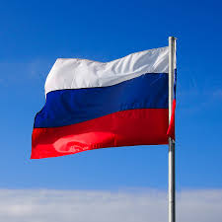

Instructor in charge: Mr. Haim Waxman

General:
      - On June 18-22, 2017, the National Security College will hold a study tour in Russia.
Target:
      - The recognition of Russia and its strategic concept as a central player in the international system has a great influence on important dimensions of Israeli national security
Tour Goals:
      - Knowledge of the culture, heritage and roots of the Russian nation
      - The role of the president, the structure of the political system and decision-making processes
      - Understanding Russia's foreign relations fabric with an emphasis on relations with the United States and NATO
      - Understanding Russia's interests and conduct in the Middle East
      - Knowledge of the main issues in Israeli-Russian relations
      - Knowledge of the main trends in politics, society and the economy
      - Familiarity with the Russian strategic system and operating concept
Conduct:
      - The trip to Russia is, first and foremost, a meaningful learning experience, which we must exhaust to the full. Therefore, we are expected to discover a great deal of stateliness, attention and interest in the various events and to maintain an active, polite and mature dialogue with the various speakers.
      - The delegation represents not only the IDF but also the State of Israel, the IDF and the various organizations whose representatives are represented in the delegation.The special honor accorded to the group rests on the fact that this is the most senior course in the State of Israel for the training of officers and clerks Senior citizen of the State of Israel, please be respectful and respectful behavior.
      - Be sure to follow the schedule, the dress code (suit and tie / uniform), listening during the lectures, how to formulate our statements and respectful attitude to our interlocutors.
      - There is a duty to participate in the entire tour program, and it is essential to refrain from taking part in the lectures. Any deviation from the plan requires explicit approval from the instructor.
      - The cooperation of the trainees with the mentor and the instructors is essential for proper conduct of the tour. The student will ensure, among other things, the readiness of the students with the gifts, the presence of all the trainees and the staff on the bus, the transfer of current information to the trainees and the preparation of questions by the students for each review.
      - Time - Departure time to be defined in the schedule is the time of the bus's departure, and accordingly, take into account temporary elevators, loading of equipment, etc. The bus was always on time! (For latecomers it is recommended to get money for taxis).
      - The list of students who will be thankful for the presentation of the gifts appears on the visit schedule (see below).
      - Dress Code appears every day in the schedule, please be mindful.
      - Please bring with you copies of your flight ticket and passport, and keep them separate from your passport.
      - You must carry with you at any time a passport and an additional ID (with photo) (such as a driver's license). In some of the places we visit, we may be required to present both.
      - Communications packages for mobile phones - under the responsibility of the trainees. Do not put mobile phones into lectures.
      - Medicine - first aid - under the responsibility of Dr. Tarif Bader. In the event of an emergency, we will rely on the local health services.
      - Leisure - In the leisure hours, be vigilant with regard to personal security (refrain from wearing clothes with Hebrew writing, traveling on unregulated transportation, etc.), accompanied by a Russian-speaking security guard.
      - For the avoidance of doubt - any purchase at the hotel, including room service, is at the expense of the purchaser only. There is no room charge for hotel purchases.
      - Physical training - It is recommended to bring sports clothes (as stated, without a Hebrew inscription).
      - Transportation to the airport: On Sunday, June 18, at 12:00, a bus from Maval left by bus to Ben Gurion Airport. Those who are not interested in this transportation will arrive at Ben-Gurion Airport by 12:30 (no refund will be given for a taxi for an independent ride to Ben-Gurion airport).
      - Transportation back from Ben Gurion Airport to the Lambal - We are expected to land in Israel on Thursday (the night between Thursday and Friday), 23.6.17, at 00:50. If you are not interested in this transportation, you will have an independent transportation (without receiving a refund).
      - Make sure you do not have military certificates, classified material, laptops, ammunition or other military equipment.
      - Make sure that in the bag you are taken to the plane there will be no sharp instrument such as a pocket knife, scissors, tweezers, etc., or bottles with liquids. It is important to take with you another personal bag where you can carry personal equipment for a minimum of two days, both for the tour and in case your luggage will be delayed at the airport.

Dress code | Notes | Activity | Time
Dress code of your choice | Buses | Departure from Mabal to Airport | 12:00
Dress code of your choice | 12:30 - Meeting at the entrance to the terminal hall  Opposite the inspection lane | Flight to Moscow (LY613) | 15:15
Dress code of your choice |  | Landing in Moscow | 19:30
Dress code of your choice | Teatranly,Proezd 2,109012,Moscow | Departure to Hotel Metropol | 20:00-21:00
Dress code of your choice | Hotel | A light dinner and an opening conversation with the IDF attache in Russia,  Colonel Tzafrir Orpaz | 21:00-22:00
Wishing you an enjoyable study tour!

Visiting Schedule

18.06.17 - Sunday
Toren - Dado Bar Kalifa

19.06.17 - Monday
Torah initiation - Yael Hess

Dress Code | Notes | Activity | Time
Suit and Tie |  | Breakfast At Hotel | 08:00-09:00
Suit and Tie | Token:  Doron Ben Barak | The Israeli Ambassador to Russia  Mr. Gary Koren | 09:00-10:00
Suit and Tie | Token:  Mimi Regev | The political situation in Russia  Mrs. Maria Lipman | 10:00-11:00
Suit and Tie |  | Break | 11:00-11:30
Suit and Tie | Token:  Doron Levin | The economic situation and its impact on domestic policy  Mr. Yevgeny Guntmacher | 11:30-12:30
Suit and Tie | Token:  Yonatan Miller | Russia's foreign policy  Mr. Ivan Timofeyev | 12:30-13:30
Suit and Tie | In Hotel | Light Lunch | 13:30-14:00
Suit and Tie |  | Departure | 14:00-14:30
Suit and Tie |  | guided tour:  The Patriarch's Bridge, the Alexander Gardens, the Kremlin compound, Red Square | 14:30-17:30
Suit and Tie |  | A trip to the ambassador's house | 18:30-19:00
Suit and Tie | Including Dinner | Reception at the Ambassador's Residence | 19:00-21:00
Suit and Tie |  | Departure to Hotel | 21:00-21:30
20.06.17 -Tuesday
Toren - Yoav Yarom
Dress Code | Notes | Activity | Time
Suit And Tie |  | Breakfast In Hotel | 07:00-08:00
Suit And Tie | In Hotel | Processing teams | 08:00-09:00
Suit And Tie | Token:  Peleg Niago | Foreign and Security Policy  Mr. Pavel Flagnor | 09:00-10:00
Suit And Tie | Token:  Yuval Shimoni | Russian policy in the Middle East  Mr. Yuri Barmin | 10:00-11:00
Suit And Tie |  | Departure To Museum | 11:00-11:30
Suit And Tie |  | Visit to the National War Museum 1812 | 11:30-13:00
Suit And Tie |  | Lunch and a trip to the Foreign Ministry | 13:00-14:30
Suit And Tie | Token:  Eli mumbled  Terry Lee | Foreign Ministry reviews:  Russia - Middle East  Deputy Foreign Minister Michael Bogdanov  Foreign Policy Planning  Deputy Head of the Political Planning Department | 14:30-17:00
Suit And Tie |  | Free time on old Arbat Street | 17:00-19:00
Free evening, independent dinner
21.06.17 -Wednesday
Toren - Gilad Peled
Dress Code | Notes | Activity | Time
 |  | Breakfast | 07:30-08:30
 |  | Walking From Hotel To Ceremony | 08:30-09:00
Office Clothes | A ceremony for laying a wreath in the Tomb of the Unknown Soldier | Standing in order according to a chart | 09:00-10:00
 | Gadi Barkai  Marcus Schneider  Yael Grossman | Visit to the Military Academy | 10:00-12:00
 | Changing Into Mabal Dress Code | Travel to the hotel and lunch | 12:00-14:30
 | Shiko Bar-Dov | The role of defense exports in foreign policy  Mr. Ruslan is scared | 14:30-15:30
Code Mabal (Dress Shirts) |  | Political-security relations  Army Attaché in Russia - Colonel Tzafrir Orpaz | 15:30-16:30
 |  | Break | 16:30-17:00
 |  | Processing teams | 17:00-18:00
 |  | A ride to the show | 17:00-18:00
 | Not Including Dinner |  | 17:00-18:00
 |  | The Kostroma Show | 17:00-18:00
 |  | Departure To Hotel | 17:00-18:00

22.06.17 -Thursday
A student of Toren - Shay Blaish

Dress Code | Notes | Activity | Time
Code Mabal (Dress Shirt) | Luggage loading at 08:30 | Breakfast and room clearance | 08:00-09:00
Code Mabal (Dress Shirt) |  | A tour of the Victory Park and the Great Patriotic War Museum (World War II( | 09:00-12:00
Code Mabal (Dress Shirt) |  | Departure to Restaurant | 12:00-12:30
Code Mabal (Dress Shirt) |  | A summary lunch at the Jerusalem restaurant | 12:30-14:30
Code Mabal (Dress Shirt) |  | Departure To Mosque | 14:30-15:00
Code Mabal (Dress Shirt) | Token:  Yehuda Hakohen | Tour of religious minorities in Moscow - visit to the mosque | 15:00-16:30
Code Mabal (Dress Shirt) |  | Departure To Airport | 16:30-17:30
Code Mabal (Dress Shirt) |  | Flight To Tel Aviv (LY614) | 20:35
Code Mabal (Dress Shirt) |  | Landing In Tel Aviv And Departure Back To Mabal | 00:50

Appendix - Curriculum vitae of the main lecturers

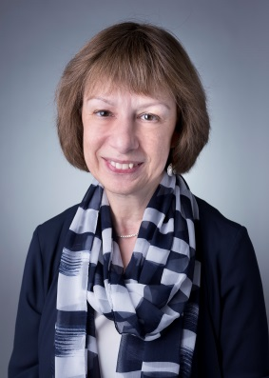
Maria Lipman
Editor-in-Chief of the socio-political magazine “Counterpoint”
From 2004 to 2014 she was the editor-in-chief of the journal “Pro et Contra”, published by the Carnegie Moscow Center. Co-founder and deputy editor-in-chief of weekly magazines “Itogi” (1995-2001) and Weekly Journal (2001-2003). Co-editor and co-author of several digests : “The State of Russia: What Comes Next? “(Palgrave Macmillan, 2015), and “Putin's Russia Past Imperfect, Future Unknown,”(Ed Stephen Wegren, Rowman & Littlefield, Sixth Edition, 2015), and author of numerous publications and comments on Russian politics and society in Russian and English-language media.

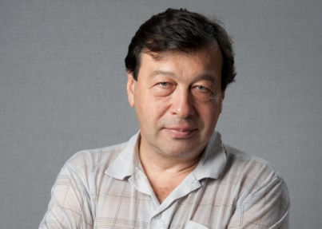
Yevgeny Gontmacher
Member of the Board of the Institute of Contemporary Development
Deputy Director of the Institute of World Economy and International Relations (IMEMO). He graduated from the Geography Department of Moscow State University. Doctor of Economics, Professor. He held the posts of Deputy Minister of Social Protection of the Population of the Russian Federation (1993-1994), Head of the Department of the Presidential Administration of the Russian Federation (1994-1995), and Head of the Social Development Department of the Government Staff of the Russian Federation (1998-2003). In 2003-2004, - Vice-President of the Russian Union of Industrialists and Entrepreneurs. 2006-2009 - Head of the Center for Social Policy of the Institute of Economics, RAS. Member of the Presidium of the Russian Jewish Congress
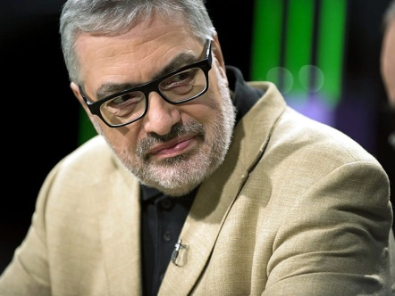
Pavel Felgenhauer
Russian biologist, journalist, military observer.
By education is a biologist, graduate of the Faculty of Biology, Moscow State University (1975), PhD (1987). After the collapse of the Soviet Union, he went into journalism. Worked as a regular military reviewer of the "Nezavisimaya Gazeta" (1991-1993) and the newspaper "Segodnya" (1993-1999). Was a member of the editorial board of ‘Segodnya”. Since 1999, not being a staff member of any media, he acts as an independent military analyst and analyst. During the five-day war in 2008, in an interview with BBC, he highly appreciated the actions of the Georgian artillery units and predicted very high losses for Russian troops . Author's materials appear on the pages of The Moscow Times and Novaya Gazeta, and his expert opinions can be found in a number of Russian and foreign media. Regular guest of radio stations "Echo Moskvy" and "Radio of Moscow".

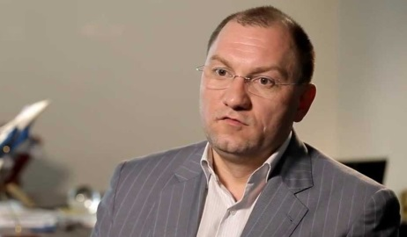
Ruslan Puhov
Director of the Center for Analysis of Strategies and Technologies.
In 1994 he graduated from the International Information Department of the Moscow State Institute of International Relations of the Russian Ministry of Foreign Affairs. In 1994-1996 years. - Listener of the Franco-Russian Master's in Political Science and International Relations. In 1996-1997 years. - Officer of the project on conventional weapons of the Center for Political Studies in Russia. From 1997 to the present - Director of the Center for Analysis of Strategies and Technologies, publisher of the magazine "Export of Arms". He is the author of a number of articles on the trade in conventional arms and the situation in the defense and industrial complexes of Russia and France.
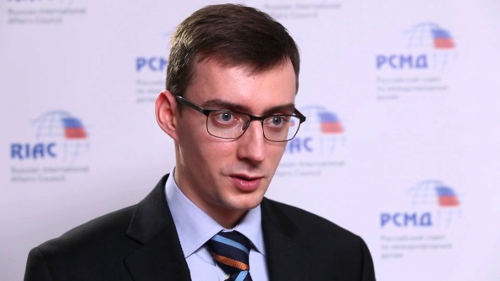
Ivan Timofeev
Program director of Russian International Affairs council
Assistant Professor, PhD. Ivan Timofeev is an author of more than 50 publications, issued in Russia and abroad. He published a monograph “Russian Political Identity: Alternatives and Trends”. Until recently he was entrusted to become a Director of the Analytical Centre of MGIMO-University. A number of its analytical products were highly assessed by the Russian state authorities. Along with his research and teaching activities, Timofeev did an important administrative job in MGIMO. In 2008 he became an Academic Secretary of the Dissertation council in Political Science and in 2011 – an Academic Secretary of MGIMO. In 2011 he occupied a position of Programme Director of the Russian International Affairs Council.

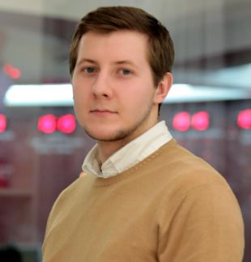
Yuryi Barmin
Analyst on Russia's strategy in the Middle East.
Expert at the Russian International Affairs Council covering the Middle East and North Africa, and Moscow’s policy towards the region including its strategy in Syria and Libya. Yury also works as a risk consultant whose work focuses on issues related to the Middle East and Russia’s positioning there. He holds an MPhil in International Relations from the University of Cambridge and his dissertation looked into the failed Arab Spring protests in Bahrain and Kuwait. He is interested in the politics of the Gulf and the ties that exist between Russia’s North Caucasus and the GCC Monarchies.

