**INDC, European Tour (Greece) Team 2 / The Interview Stage**

**The General Question**

**The effects of the economic crisis in Greece and its impact on Greek society and the younger generation in particular in the present and future. Causes of the crisis, its implications and ways of action to resolve.**

**The Political Realm**

1. After four years under the leadership of Tsipras of the Left Party "Syriza", the Greeks voted in the last elections held in July this year Mitsutakis as head of the New Democracy Party. What do you think were the key factors that made the last elections, and whether the economic crisis was a significant factor contributing to the government's upheaval?
2. How does the new government intend to deal with the economic crisis and its implications, what are the issues and priorities for dealing with the crisis and how is the current strategy for action different now from before?
3. In the peak years of the crisis, the Greek company expressed its opposition to the terms of the European Union's extraction agreements in the 2015 referendum, the previous government headed by Tsipras opposed the austerity policy and even threatened not to meet its obligations to European countries unless a significant debt relief agreement was reached. What is the current government's policy regarding the terms of the bailouts?
4. Do the terms of the agreement restrict the government's freedom of action in formulating policy and the solution strategy on the timeline and to what extent?

**Economic field**

5. The global economic crisis that hit us in 2008 hit hard in almost all economies of developed countries. What are the circumstances and causes that led to Greece being one of the countries that was particularly hard hit by the crisis?

6. What is the explanation for Greece's recovery from the crisis only at the beginning of a decade after the outbreak of the crisis?

7. In recent years, we are beginning to see signs of the Greek economy's recovery. Raising the credit rating, declining unemployment, jumping the local stock market by more than 40% (ASE Index) from the beginning of the year, which actually indicates an increase in the trust of investors. Are there long-term positive expectations and what rooted issues still need to be addressed to strengthen and maintain positive momentum?

8. About half a million Greeks have left the country since the crisis began about a decade ago, one of the largest migrations from EU countries. Young unemployment in Greece is among the highest in the OECD countries and is characterized by longer periods of disconnection from a school or work setting. Today, the proportion of young people aged 25-29 who are unemployed and who do not study is about 25%. Those unable to find employment are forced to leave and emigrate due to livelihood constraints. In your opinion, has the wave of immigration in the last decade changed its characteristics from the waves of immigration that occurred in the past?

9. The current wave of immigration appears to be a considerable proportion of educated people leaving the country with their families, probably without any intention of returning (doctors, engineers, architects and other free professionals so necessary to the Greek economy). On the other hand, the jobs offered in the labor market are mainly from the services sector (waiters, hotels, etc.) and are not suitable for the fields of study and profession of university graduates. How does the government intend to deal with this phenomenon of brain drain?

10. Are there any plans on the government's part not only to prevent the departure of young people, but also to encourage those who have already immigrated from Greece to return to their country? <https://nujournalismingreece2017.wordpress.com/2017/05/20/facing-high-unemployment-greece-suffers-brain-drain-of-its-young-and-educated/>

**The Social Field (Society, Welfare and Demographics(**

1. The economic crisis affecting the country also negatively affected the welfare sector. Damage to health and education systems in parallel with cuts in salaries and pension payments. As a result, we witnessed a sharp increase in mental health and suicides in the prime of the crisis. What is the current situation and where is the welfare issue placed under the government's priorities today?

12 . In light of the encouraging signs that point to the recovery in the economic sphere, are the achievements also seething and felt among the middle-class struggling with the burden of livelihood, what are the current feelings among the public and can it be identified in improving the national mood and hoping to end the crisis?

13. Do you see the importance of preserving Greek identity, culture and tradition, and is it possible in the age of globalization and modernization when Greece is a member state of the European Union and when the younger generation is much more exposed to foreign and Western influences?

14. In your opinion, what are the reasons for the low birth rate in Greece?

15. To what extent does this phenomenon bother the Greek society / government, do they intend to address it and how?

**Reference**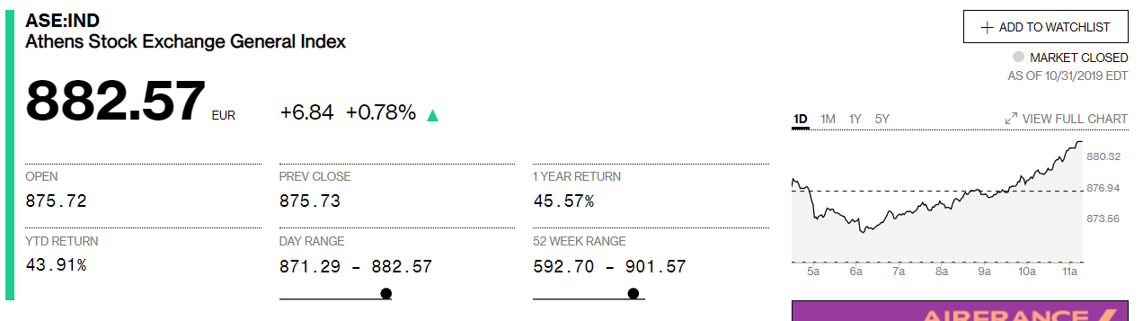

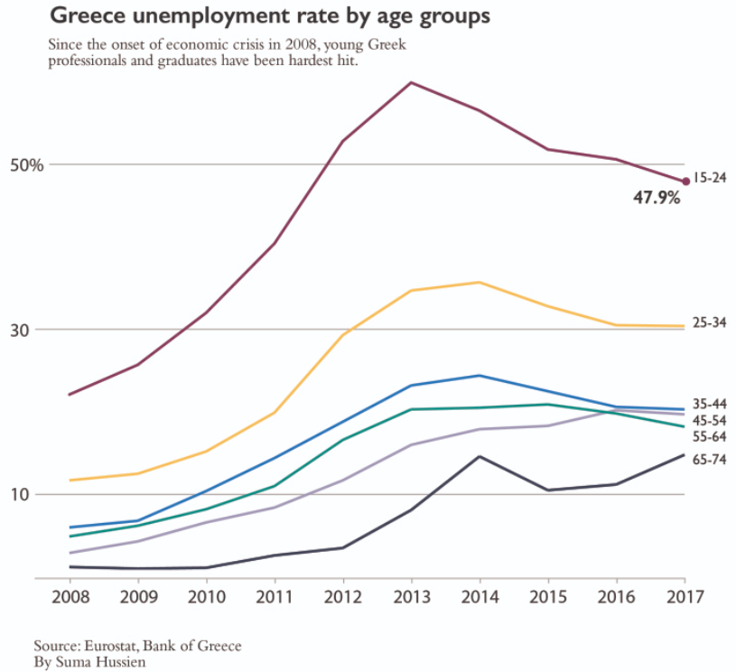

<https://nujournalismingreece2017.wordpress.com/2017/05/20/facing-high-unemployment-greece-suffers-brain-drain-of-its-young-and-educated/>