***Brigadier General Doron Turgeman -*** Visiting at the Shu'fat refugee camp

**Commander of Kedam, Jerusalem District**

Served in the IDF at the **Golani Brigade**.

After his military service, he joined the Israeli police. During his service

**Has held a number of senior positions at the core of the organization's operational activities:**

* Intelligence officer and detective in Zion space
* Jerusalem District Operations Officer.
* Head of Operations Branch in Jerusalem District, Chief Superintendent .
* From 2010-2013 he commanded Lod Station.
* And then served as commander of the Netanya station.
* In 2015, he was appointed commander of David's Space District, Jerusalem District.

**And in July 2017 he got premoted to the rank of Brigadier General and appointed to be the Commander of Kedam**

During his service, **he received the police masterpiece**.

**Married and father of five.**

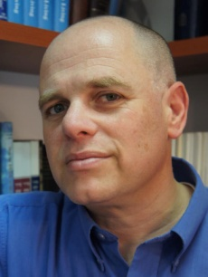

***Dr. Adv. Yizhar Hess***

**Born and raised in Jerusalem**, he studied at the **Hebrew Gymnasium in Rehavia.**

Served as **a combatant in the Armored Corps and as an Information Officer in the** Education Corps

He commanded **the information command unit for commanders on Har Gilo** and was released from the IDF **in 1990.**

**Worked as a copywriter in an advertising office** and later **as a journalist in the 'Friday' newspaper.**

During his studies at the Hebrew University, he joined the **"Shorashim Institute"-**

Jewish Studies Center, which specialized in pluralistic Jewish occupation in various fields of opinion.

**From 1996-1999, he served as VP of the Institute**. One of the initiators of the Jewish Studies Festival in Kfar Blum, together with Elazar Sturm, edited the book Questions about God.

**In 2000 he went on a mission on behalf of the Jewish Agency in the United States.** Served as a Community Envoy and as the "Central Israel" Director of the Jewish Federation in Tucson, Arizona.

From 2001-2003, he wrote a **bi-weekly personal column in the Arizona Jewish Post. Won the North American Jewish Center Excellence Award and the Jewish Federation Excellence Award.**

Upon returning to Israel, he continued with the Jewish Agency **and served as director of partnerships between Jewish communities abroad and areas in Israel.**

Since 2007, he has served **as the CEO of the traditional movement,** taking part in promoting the arrangement **and I pray:** an Israeli arrangement, the reorganization of the traditional movement. As well as leading the fight for a Kotel outline.

Serves as director of the Jewish Settlement Treasury.

**Frequently published opinion articles in the press in Israel and abroad**.

**He holds a BA in Hebrew Literature and Political Science** from the Hebrew University of Jerusalem. **Has a law degree** from the IDC Herzliya.

**He holds a MA in Jewish Studies from the Schechter Institute in Jerusalem** and a **Ph.D from the Department of Education Philosophy** at Sussex University in Brighton, England.

**Married to Col. (Res.) Yael Hess, former chief of education at the head of the Chief Education Officer.**

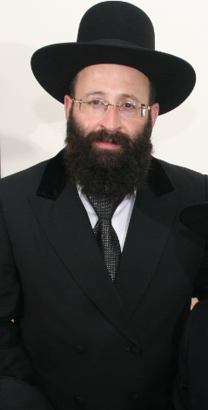***Rabbi Shmuel Ben Zion Rabinowitz***

**Western Wall Rabbi and Holy Places**

Born and raised in Jerusalem. Attend a Kol Torah Yeshiva**.**

**Served in the IDF** as part of the military rabbinate**.**

After his military service, he was appointed regional rabbi in southwest Jerusalem.

In 1994, Shimon Shitrit was appointed Minister of Religious Affairs and in 2000 was appointed by Minister of Religion Yossi Beilin to serve as Rabbi of the Western Wall

**Rabbi Rabinowitz serves as chairman of the Western Wall Heritage Foundation**

In addition, he holds public and representative positions, in various bodies and organizations:

* Was a member of the Committee For approval of agreements to carry fetuses
* Member of the Egg Donation Review Committee.
* Member of the Public Environment Council.
* Member of the Israel Monitoring and Burial Committee.
* Vice President of the "Aleh" Association For cerebral-damaged children.
* Appointed by the Supreme Court as chair of the Rashbi Tomb Management in Meron.

**He has written several articles and two books:**

1) Questions and Answers Sha'arei Zion - Responses to the Western Wall and the Holy Places

2 ) Western Wall - Halacha (Jewish law) and customs Book at the Western Wall.

As part of his role as the Western Wall and Holy Places**, he maintains a state line.**

**Also working to increase the advertising of the Western Wall through interactive online sites.**

**Rabbi Rabinowitz is married to Yael and a father of eight.**

**.**