***Brigadier General Doron Turgeman –*** Visiting at the Shu'fat refugee camp

Commander of Kedam Area, Jerusalem District

Served in the IDF at the Golani Brigade.

After his military service, he joined the Israel Police. During his service he held a number of senior positions at the core of the organization's operational activities:

* Intelligence officer and detective at the Zion area.
* Operations Officer in the Jerusalem District.
* Head of Operations in the Jerusalem District, ranked Chief Superintendent.
* From 2010-2013 he commanded Lod Station.
* And then served as commander of the Netanya station.
* In 2015, he was appointed commander of the David area in the Jerusalem District.

In July 2017 Turgeman got promoted to the rank of Brigadier General and appointed to be the Commander of Kedam area.

During his service, he received the Israel Police Exemplary Ribbon.

Turgeman is married and a father of five.

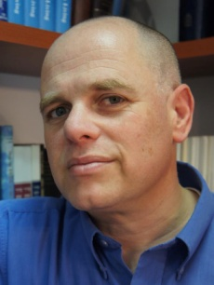***Dr. Adv. Yizhar Hess***

Born and raised in Jerusalem, he studied at the Hebrew Gymnasium in Rehavia.

Served as a combatant in the Armored Corps and as an Information Officer in the Education Corps.

He commanded the information command unit for commanders on Mt. Gilo and was released from the IDF in 1990.

Worked as a copywriter in an advertising office and later as a journalist in the 'Friday' newspaper.

During his studies at the Hebrew University, he joined the "Shorashim Institute"-

A Jewish Studies Center, which specialized in pluralistic Jewish occupation in various fields of study.

From 1996-1999, he served as VP of the Institute. One of the initiators of the “Jewish Studies Festival” in Kfar Blum.

Together with Elazar Sturm, he edited the book ‘Questions about God’.

In 2000 he went on a mission on behalf of the Jewish Agency in the United States. Served as a community representative and as the "Central Israel" Director of the Jewish Federation in Tucson, Arizona.

From 2001-2003, he wrote a bi-weekly personal column in the Arizona Jewish Post. Won the North American Jewish Center Excellence Award and the Jewish Federation Excellence Award.

Upon returning to Israel, he continued working with the Jewish Agency and served as director of partnerships between Jewish communities abroad and Israel.

Since 2007, he has served as the CEO of the ‘Traditional Movement’, taking part in promoting the prayer book “and I pray”: an Israeli prayer book, the renewed prayer book of the Traditional Movement, as well as leading the fight over the Western Wall Plan.

Serves as director of the Jewish Settlement Treasury Company.

Frequently published opinion articles in the press in Israel and abroad.

He holds a BA in Hebrew Literature and Political Science from the Hebrew University of Jerusalem. Has a law degree from IDC Herzliya.

He holds an MA in Jewish Studies from the Schechter Institute in Jerusalem and a Ph.D from the Department of Education Philosophy at Sussex University in Brighton, England.

Married to Col. (Res.) Yael Hess, former Chief of Education at the Central Education Officer’s HQ.

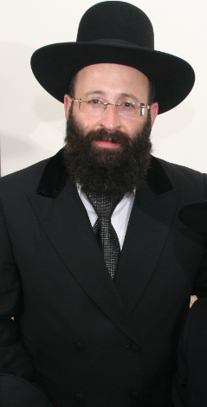***Rabbi Shmuel Ben Zion Rabinowitz***

Rabbi of the Western Wall and Holy Sites

Born and raised in Jerusalem. Attended the ‘Kol Torah’ Yeshiva.

Served in the IDF as part of the Military Rabbinate.

After his military service, he was appointed regional rabbi in southwest Jerusalem.

In 1994, was appointed by Minister of Religious Affairs Shimon Shitrit as Rabbi of the Holy Sites and in 2000 was appointed by Minister of Religious Affairs Yossi Beilin to serve as Rabbi of the Western Wall.

Rabbi Rabinowitz serves as chairman of the Western Wall Heritage Foundation.

In addition, he holds public and representative positions, in various bodies and organizations:

* Was a member of the Committee For Approval of Surrogacy
* Member of the Egg Donation Review Committee.
* Member of the Public Environment Council.
* Member of the Israel Monitoring and Burial Committee.
* Vice President of the "Aleh" association for cerebral-damaged children.
* Appointed by the Supreme Court as chair of the Committee for Managing the Tomb of Rabbi Shimon Bar Yochai in Meron.

He has written several articles and two books:

1. Questions and Answers Sha'arei Zion – Matters of the Western Wall and the Holy Sites
2. Western Wall - Halacha (Jewish law) and Customs at the Western Wall.

As part of his role as Rabbi of the Western Wall and Holy Sites, he maintains an a-political position of statehood.

Also working to increase the advertising of the Western Wall through interactive online sites.

Rabbi Rabinowitz is married to Yael and a father of eight.