Dr. Eli Cook
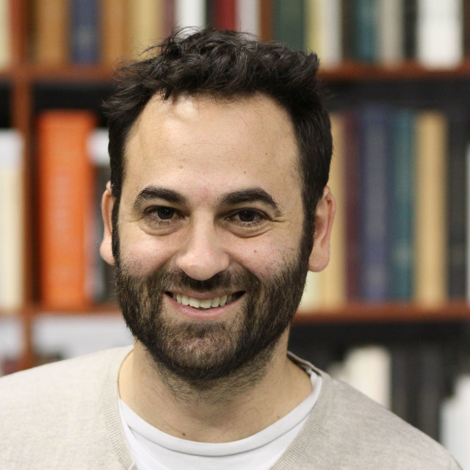

Dr. Eli Cook is a historian of American capitalism and the head of the American Studies program at Haifa University. He studied economics and history at Tel Aviv University and then completed a doctorate in American history at Harvard University. His book, published in 2017 by Harvard University Press, reviews the history of economic indexes in the United States and won two prestigious awards in the field of the history of ideas. He is now writing a book in Hebrew about the hardships of global capitalism.

