**For The Attention Of:**

**Colonel Dr. Haffner**

Defense Attaché

**Embassy of the Federal Republic of Germany, Israel**

Colonel Dr. Haffner,

It is with great pleasure that I present to you an official request, for the German Bundeswehr, to join a Multi-National de-confliction mechanism.

The purpose of the mechanism, as said above, is to coordinate and de-conflict operations in times of contingency, specifically the efforts to safely evacuate non-combatants from Lebanon.

The above mechanism is composed by 7 countries, along with Israel, and is classified "secret". The mechanism is a joint effort, in parallel to the NGC mechanism and EX-Argonaut.

We see Germany as an important piece in the mechanism and would request to explore this opportunity.

The mechanism will meet in June, in a General Officer executive format, along with action-officers and planners sessions.

In order to move forward, we would like to conduct a bi-lateral meeting with relevant planners, to discuss our contingency and operational plans, and to set common grounds for de-confliction, as soon as possible.

Yours sincerely,

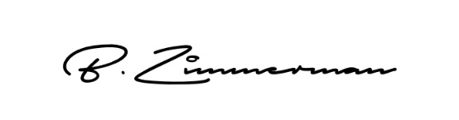



CPT (P) Benzi Zimmerman

Head, International Cooperation Desk

Israel Defense Forces Operations Directorate