צה"ל - כספות
IDF-M4U-SAFE

Miluim-Officers-O

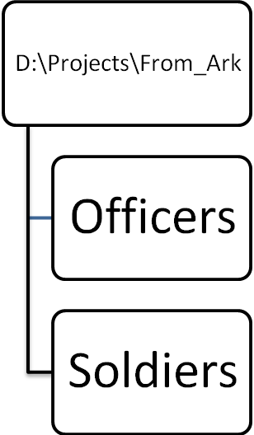
Miluim-Soldiers-O

Miluim-Soldiers-I

