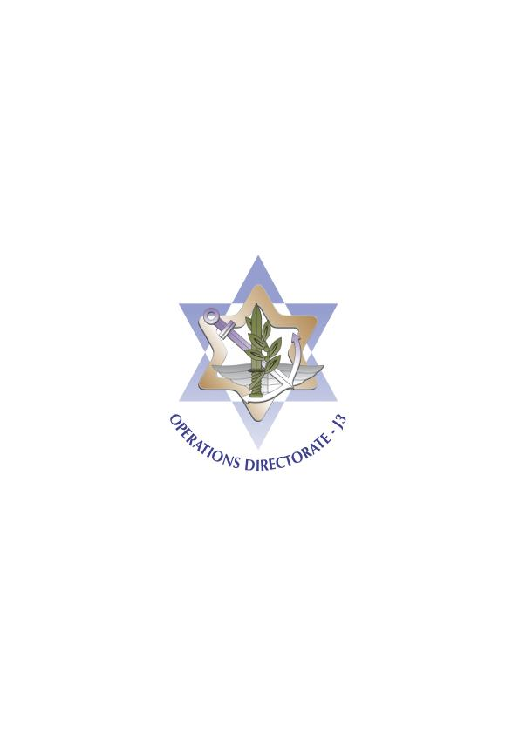 ISRAEL DEFENCE FORCES

**J3, OPERATIONS DIRECTORATE**

May 2020

**Lieutenant General (*) Michael N. Rouleau**

Commander, Canadian Joint Operations Command (CJOC)

Dear General Rouleau,

I would like to first of all extend my best wishes for you, the Canadian Armed Forces, and the entire Canadian nation - may this spring and upcoming summer bring only health and prosperity, and know that our thoughts are with you, and the entire world, as we battle with COVID-19.

I was looking forward to meeting you in person this past January, and would like to take this opportunity to share with you some thoughts.

The IDF, and the state of Israel, sees Canada as an important partner with which we have many shared interests, regional and also for joint endeavors between our forces.

As you know, the Middle East is once again going through challenging times. We are in a long lasting battle to push back the Iranian entrenchment in the region, specifically military and proxy presence in Syria, and foil attempts to transfer weapons to Lebanon. The transfer of PGMs remains a major threat to regional stability. If this trend continues, Israel will be forced to take action. The elimination of Solemani and the Iranian offensive preparations following it, emphasized the need for a comprehensive strategy. We can see now that Iraq is a new focus point for Iranian staging of aggressive and malign activities.

In this challenging region, international partners are not taken for granted. The state of Israel, and the IDF, remain committed to the safety of Canadian citizens, and especially to the peacekeeping forces in the area. Your continued presence and contribution to the stability of the region is of vast importance.

We also look forward to explore new avenues of cooperation between our forces. BG Anderson was here in November for our first Operational Simulation Summit, and we hope to work with him in this coming year. We are also closely working with CANSOFCOM and are enhancing our SOF cooperation.

I foresee a continued fruitful partnership and friendship between our forces, and again would like to voice out my hope to see you here soon.

Congratulations on your upcoming promotion!

With friendship,

**Major General Aharon Haliva,**  
Head, Operations Directorate  
**Israel Defense Forces**