- Confidential -

|  |
| --- |
|  |

|  |  |
| --- | --- |
| Customer | Israel Police  Tel Aviv  Israel |
|  |  |
| Project | GAP Analysis |

|  |  |
| --- | --- |
|  |  |
|  |  |
|  |  |
|  |  |
|  |  |
|  |  |
|  |  |
|  |  |
|  |  |
|  |  |
|  |  |

|  |  |  |  |
| --- | --- | --- | --- |
| Service Center | SAP Israel | | |
| Telephone | +972 52 255 4621 | | |
| Fax | +972 74 760 5689 | | |
|  | |  | | |  | | |
|  | |  | | | | | |
| Date of Service | | 27-30.03.2016 (on-site)  10-21.04.2016 (on-site) | | | Service Order No. | 30234298 | |
| Date of Report | | 28.04.2016 |  | | Customer Number | | 1209227 |
| Service Team | | Monica Galindro, Amit Tal, Boaz Nevat | | |  |  | |
|  | | <Watermark> | | | | | |

# Table of Contents

1 Table of Contents 2

2 Summary 4

2.1 Executive Summary 4

2.2 GAPs & Recommendations List 4

3 Gap Analysis 10

3.1 Goals 10

3.2 Methodology 10

4 SAP ERP HCM 12

4.1 Overview 12

4.2 HCM PA - Personal Administration 12

4.3 PA, TM & PY Master Data 12

5 PA – Personal Administration 15

5.1 Personnel Structure 15

5.2 Enterprise Structure 18

5.3 Actions 20

5.4 Status 21

5.5 Master Data 23

6 TM –Time Management 27

6.1 Processing Flow 27

6.2 Aspects in PY 27

7 PY - Payroll 29

7.1 Process Overview 29

7.2 Calculations & Processes 29

7.3 Officers Calculation 32

7.4 Non-Commissioned Officers Calculation 34

7.5 Calculation Run Times 36

7.6 Calculation Students & Building Workers 36

7.7 Payroll Steps Overview (Payroll Area) 36

7.8 Payroll Activities Overview (Start Payroll) 37

7.9 Reports 38

7.10 Authorizations 38

8 Suggestions and Recommendations 39

8.1 SAP ERP HCM PY – ASAP (Project Methodology) 39

8.2 SAP Solution Manager (Tool for Project Implementation) 41

8.3 Payroll Control Center (Payroll functionality) 41

8.4 SAP HANA 42

8.5 Parallel Payroll Run - Approach 43

9 Appendix 45

9.1 Delivery Teams 45

9.1.1 Service Delivery Team 45

9.2 Meetings 45

9.3 Client Contacts 46

# 

# Summary

|  |
| --- |
| This report covers the findings of the GAP Analysis between 27th to 30th of March and 10th to 21h of Aphril 2016. |

## Executive Summary

The Gap Analysis have the propose to identify the gaps related to your HCM system accordance with your actual solution and future needs. The primary goal of the service is to characterizes the differences between what the system do and what it is supposed to do with the payroll requirements of Israel Police.

The service focus in the future business process:

* Payroll

Analyzing the actual business processes:

* Organizational Management
* Personnel Administration
* Time Management
* Recruitment

During the service we found several gaps in the system and recommendations that should be taken in consideration for a successful payroll implementation. They are listed and details in the document.

For this conclusions several meetings and workshops were done:

* Meeting for Israel Police to introduce their business processes
* Detail workshop plan and preparation
* First workshops validate process and roles
* Second workshops define gaps and validates process steps.



## GAPs & Recommendations List

Gaps FOR SERVICE

The table below have the list and the short description of the Gaps that we have identified during our service.

| No. | GAP Name | Description | Type |
| --- | --- | --- | --- |
| 1 | Relative Process | New Group and a new action for relatives, similar to the remains, should exist in the system. | PA |
| 2 | Relative Process | New Group Customer-specific (status 1) - Relatives | PA |
| 3 | Retirement Process | The Employment (status 2) in Retirement Action should be chance to 2: Employee with in company – retiree | PA |
| 4 | Retirement Process | The retirement employees that should have monthly payment:  Group Employee 3 - Retired - Budgetary pensions and C - Retired - Bridging pensions (until they have 67 year old or they pass away).  Employment (status 2) Master Data should change to 2: Employee with in company – retiree. | PA |
| 5 | Master Data (e.g. IT0006, IT0009) | Pensioners and Remains information for payroll calculation is in the vendor system. This must be considerate as part of data migration scope in the project implementation. | Migration Data |
| 6 | Legal Master Data | Each employee should have all relevant PY Master Data (funds, taxes, social security, …). Today this information is in the vendor system. This must be considerate as part of data migration scope in the project implementation. | Migration Data |
| 7 | Infogroup in Actions | Include new infotypes in the main actions | PA |
| 8 | Basic Salary – IT0008 | The Pay Scale Grade should exist in standard infotype 0008 - Basic Pay | PY |
| 9 | Basic Salary – IT0008 | The Pay Scale Grade should exist in standard infotype 0008 - Basic Pay. This information already exist retrieved by vendor in IT0008, but it should be taken in consideration that unless 2 calculations | PY |
| 10 | Grant calculation in the leaving month, for Group Employee 4 - Released/Leaving | Termination Calculation for IT0053 – Company Pension, pension type 02 - Budgetary pensions  Compensation Grant Calculation IT0053 – Company Pension, pension type 03 - Funded Pensions | PY |
| 11 | Vacations days Grant | If the employee didn’t deduct all the days | PY |
| 12 | Termination Grants Calculation | Group Employees - 3 - Retired - Budgetary pensions | PY |
| 13 | Budgetary pension calculation | Group Employees - 3 - Retired - Budgetary pensions | PY |
| 14 | Pension increase Calculation | The pension increase yearly with the index (if it is positive) | PY |
| 15 | Termination Grants Calculation | Group Employees - C - Retired - Bridging pensions | PY |
| 16 | Bridging pension Calculation | Group Employee C - Retired - Bridging pensions | PY |
| 17 | Remains Payment Calculation | Group Employee 7 - Remains | PY |
| 18 | Absence Deductions Calculation | The wage type to deduct can be in hours or days, the amount calculation should be done in payroll calculation | PY |
| 19 | Deductions with Absences (Reservation of Rifhts) | If the PY team receive authorization from the employee, the deduction will be deduct from the employee when he is absence. The deduct amount should be transfer from employee bank account and paid to the entity as the other months | PY |
| 20 | Per Diem Payment | Wage types in ZL will have the number of allowance type meals to pay. There exist 4 types with different fix values. | PY |
| 21 | Overtime Payment | Wage types in ZL will have the number hours to pay in each overtime percentage of. There is 4 overtime WT’s (100%, 125%, 150% and 200%) | PY |
| 22 | Reimbursement for Military reserve service Payment | Wage types in ZL will have the number of days or hours to pay. | PY |
| 23 | Benefits & Deductions | The benefits and deductions should be read to payroll calculation, the amount for the benefits or deductions without value in IT0014 should be calculated in payroll | PY |
| 24 | Benefits & Deductions Master Data Change to IT0015 | Today the benefits and deductions are created in infotype 0014, in the future system the IT0015 should be used if it is once time payment | PY |
| 25 | Uniform Entitlements Payment or Deduction | PY calculation should read IT9027 | PY |
| 26 | Master Data for Benefits and Deductions | Phone (consumption of the mobile phone, tax impact) | PY |
| 27 | Master Data for Benefits and Deductions | Holiday (amount spent for vacations, tax impact) | PY |
| 28 | Master Data for Benefits and Deductions | Additional Work (extra police work for several organization) | PY |
| 29 | Master Data for Benefits and Deductions | Toll Road Expenses (amount spent in toll roads) | PY |
| 30 | Master Data for Benefits and Deductions | Commissioner Loan (additional payment) | PY |
| 31 | Master Data for Benefits and Deductions | Tuition Fees (additional payment) | PY |
| 32 | Master Data for Benefits and Deductions | Release Grant (incoming amount from the army) | PY |
| 33 | Master Data for Benefits and Deductions | Public transport amount, only with tax impact) | PY |
| 34 | Master Data for Benefits and Deductions | Newspaper (amount, only with tax impact) | PY |
| 35 | Master Data for Benefits and Deductions | Car amount (amount, only with tax impact) | PY |
| 36 | Master Data for Benefits and Deductions | Loss Equipment (manually deduction) | PY |
| 37 | Master Data for Benefits and Deductions | Indexation (additional payment for non-payment for a long term period) | PY |
| 38 | Master Data for Benefits and Deductions | Telephone allowance | PY |
| 39 | Master Data for Benefits and Deductions | Obligations | PY |
| 40 | Master Data for Benefits and Deductions | Dismissal pay Block (stop payment or pay only a%) | PY |
| 41 | Master Data for Benefits and Deductions | Advance payments | PY |
| 42 | Rent Payment | The amount for payment should be calculated and stored, all necessary information to calculate is in the actual system in IT9045 | PY |
| 43 | Rent Payment | PY calculation should read IT9045 | PY |
| 44 | Tuition Reimbursement for Retirees Payment | PY calculation should read IT9018 | PY |
| 45 | Annual Payments Officer and NC Officers | Vacations – June | PY |
| 46 | Annual Payments Officer and NC Officers | Seniority - September | PY |
| 47 | Annual Payments Officer and NC Officers | Education Scholarships – August | PY |
| 48 | Annual Payments Officer and NC Officers | Labor Union – October | PY |
| 49 | Garnishment and Loans | Standard Infotypes: IT0045 – Loans and IT0078 – Loans Payments and PY Calculations | PY |
| 50 | Acquisition of Rights Calculation | The employees can buy unpaid periods to increase seniority. This information should be stored in IT0552, a new subtype must be created. | PA |
| 51 | Acquisition of Rights Calculation | In the payroll the deduction must be calculated in the payroll month that is mentioned in the IT0552 record. | PY |
| 52 | Letters to Employee | For some reason the employee received more than he should, in this situations employee must be notified by letter that he owes money | Forms |
| 53 | Letters to Employee | When Payroll team receive from the court that the employee have a garnishment, employee should notified by letter when the deduction will start. | Forms |
| 54 | Payslip Password | Monthly a alphanumeric password should be generate for each employee to view the payslip in the web site. The password code should be in the payslip. | PY |
| 55 | Telephone password | Monthly a numeric password should be generate for each employee to listen to telephone messages, this password should be in the payslip. | PY |
| 56 | Telephone and Web Messages (system files) | File with the changes made daily in some infotypes, this changes will be uploaded and employees will be available to consult them by telefone or in the external web site. | PA |
| 57 | Payroll Simulation to Candidates | Candidates that can be hiring, have a beginning action “Pre-Hiring Action”, Employee Group and Subgroup – “T” – Pre-Hiring. This employees shouldn’t have monthly payment but PY team should be able to simulate they possible payment in the future | PY |
| 58 | Payroll Features | Payroll runs monthly, the payment is on the 1st of each month | PY |
| 59 | Payroll Features | Retroactive calculation | PY |
| 60 | Payroll Features | Simulation - shows the slip for representative population pre actual calculation | PY |
| 61 | Legal Discounts | Social Security, Taxes, Contribution for Pension Fund | PY |
| 62 | Promotions | Compulsory promotions according to the Rank levels | PY |
| 63 | Base Wage Calculation | Base Wage Calculation – 1ª Level | PY |
| 64 | Seniority Calculation | Seniority Calculation – 1ª Level | PY |
| 65 | Training Reward Calculation | Training Reward Calculation ­– 1ª Level | PY |
| 66 | Risk Factor Inc Calculation | Risk Factor Inc Calculation – 2º Level | PY |
| 67 | Risk Factor Group | A view in employee Master Data with the Risk Factor Group associate to Professional Code in IT9014 subtype 0002 | PA |
| 68 | Seniority Factor % | Report should calculate and display the Seniority Factor %’s in the different periods and the period factors. | PY |
| 69 | Officer Training Calculation | Officer Training Calculation - 2º Level | PY |
| 70 | Service Calculation | Service Calculation – 3º Level | PY |
| 71 | 01’, 09’ and 11’ Agreement Calculation | 01’, 09’ and 11’ Agreement Calculation – 4º, 5º and 6º Level | PY |
| 72 | 99’ Agreement Inc. Calculation OWC | 99’ Agreement Inc. Calculation Old Word Calculation only for Non-Commissioned Officers | PY |
| 73 | 99’ Agreement Inc. Calculation NWC | 99’ Agreement Inc. Calculation New Word Calculation only for Non-Commissioned Officers | PY |
| 74 | Unique Agreement Inc. Calculation OWC | Unique Agreement Inc. Calculation Old Word Calculation only for Non-Commissioned Officers | PY |
| 75 | Unique Agreement Inc. Calculation NWC | Unique Agreement Inc. Calculation New Word Calculation only for Non-Commissioned Officers | PY |
| 76 | Professional Inc Calculation OWC | Professional Inc Calculation Old Word Calculation only for Non-Commissioned Officers | PY |
| 77 | Professional Inc Calculation NWC | Professional Inc Calculation New Word Calculation only for Non-Commissioned Officers | PY |
| 78 | Service Inc Calculation NWC | Service Inc Calculation New Word Calculation only for Non-Commissioned Officers | PY |
| 79 | Incentive Increment by Profession Calculation OWC | Incentive Increment by Profession Calculation Old Word Calculation only for Non-Commissioned Officers | PY |
| 80 | Incentive Increment by Profession Calculation NWC | Incentive Increment by Profession Calculation New Word Calculation only for Non-Commissioned Officers | PY |
| 81 | Applicable education Calculation | Applicable education Inc OWC and NWC | PY |
| 82 | 01’, 09’ and 11’ agreement Calculation | 01’, 09’ and 11’ agreement Calculation OWC and NWC | PY |
| 83 | Non-Commissioned Officers (all life cycle) Payroll Calculation | 2 times calculation: OWC before March 2016 and NWC after March 2016 | PY |
| 84 | Non-Commissioned Officers change to Officers Payroll Calculation | 2 or 3 times calculation: NCO calculation - 1 or 2 calculations (OWC before March 2016 and/or NWC after March 2016 depends on the data of transition) Officers Calculation | PY |
| 85 | Employees Hiring after March 2016 | 1 payroll calculation – New Word Calculation | PY |
| 86 | Students Payroll Calculation (Hour Payment) | Employees Group 1 – Policeman and Employee Subgroup 46 - Hourly Student. | PY |
| 87 | Building Workers Calculation | Employees Group 8 – Building Workers | PY |
| 88 | High/Low Gross Salary | According to an average profiles | PY Report |
| 89 | High/Low Net Salary | According to an average profiles | PY Report |
| 90 | Wage Types | Shows all of the wage types. The average amount, the number of workers who get it, etc. | PY Report |
| 91 | Wage Types | Shows the workers who had retro payment period of time (e.g. over a year). | PY Report |
| 92 | Wage Types | 50 Highest Salaries | PY Report |
| 93 | Wage Types | Statistic report of all the workers, shows averages of each WT’s in a period of time | PY Report |
| 94 | Authorizations | PY Team should have the authorizations to the relevant transactions. | PY |

Recommendations FOR Implementation

| No. | Recommendations |
| --- | --- |
| 1 | SAP ERP HCM PY – ASAP (Project Methodology) |
| 2 | SAP Solution Manager (Tool for Project Implementation) |
| 3 | Payroll Control Center (Payroll functionality) |
| 4 | SAP HANA |
| 5 | Parallel Payroll Run |

# Gap Analysis

## Goals

The Gap analysis document propose is to describe the differences between required and actual system.

Functional gap analysis characterizes the differences between what the system do and what it is supposed to do with the payroll requirements of Israel Police.

In the document processes are described if a Gap was identified it will appear as **PY GAP** or **PA GAP**, if nothing is mention the system Fit.

**PY GAP** is what system should have for runs the payroll, **PA GAP** is what the system should have even if payroll is not implemented in the future.The Actual system already have employees master data that is used by the external contractor in the payroll. Most of the missing master data in the actual system, that only external contractor use to run the payroll, will appear in the document as a **PY GAP** ( it is payroll master data requirement).

## Methodology

**Hybrid Type Fit Gap Analysis** (methodology used in the service)

The hybrid method, starts with brainstorming workshop sessions during which both the system simulations as well as the questionnaire method is applied.

First the detailed workshop agenda is prepared in the form of brainstorming sessions. System consultants and enterprise stakeholders are very active during these sessions.

System consultants and the stakeholders with the help of presentation covers system features and simultaneously gives demonstration of the actual system in test environment. Session discussions points are captured to map with system requirements.

During the presentation, enterprise stakeholders and consultants answer questions about the actual system and future needs. Thus, the output of each session discussion and answers helps in arriving at complete list of fits and gaps.

**Hybrid Type Fit Gap Steps**

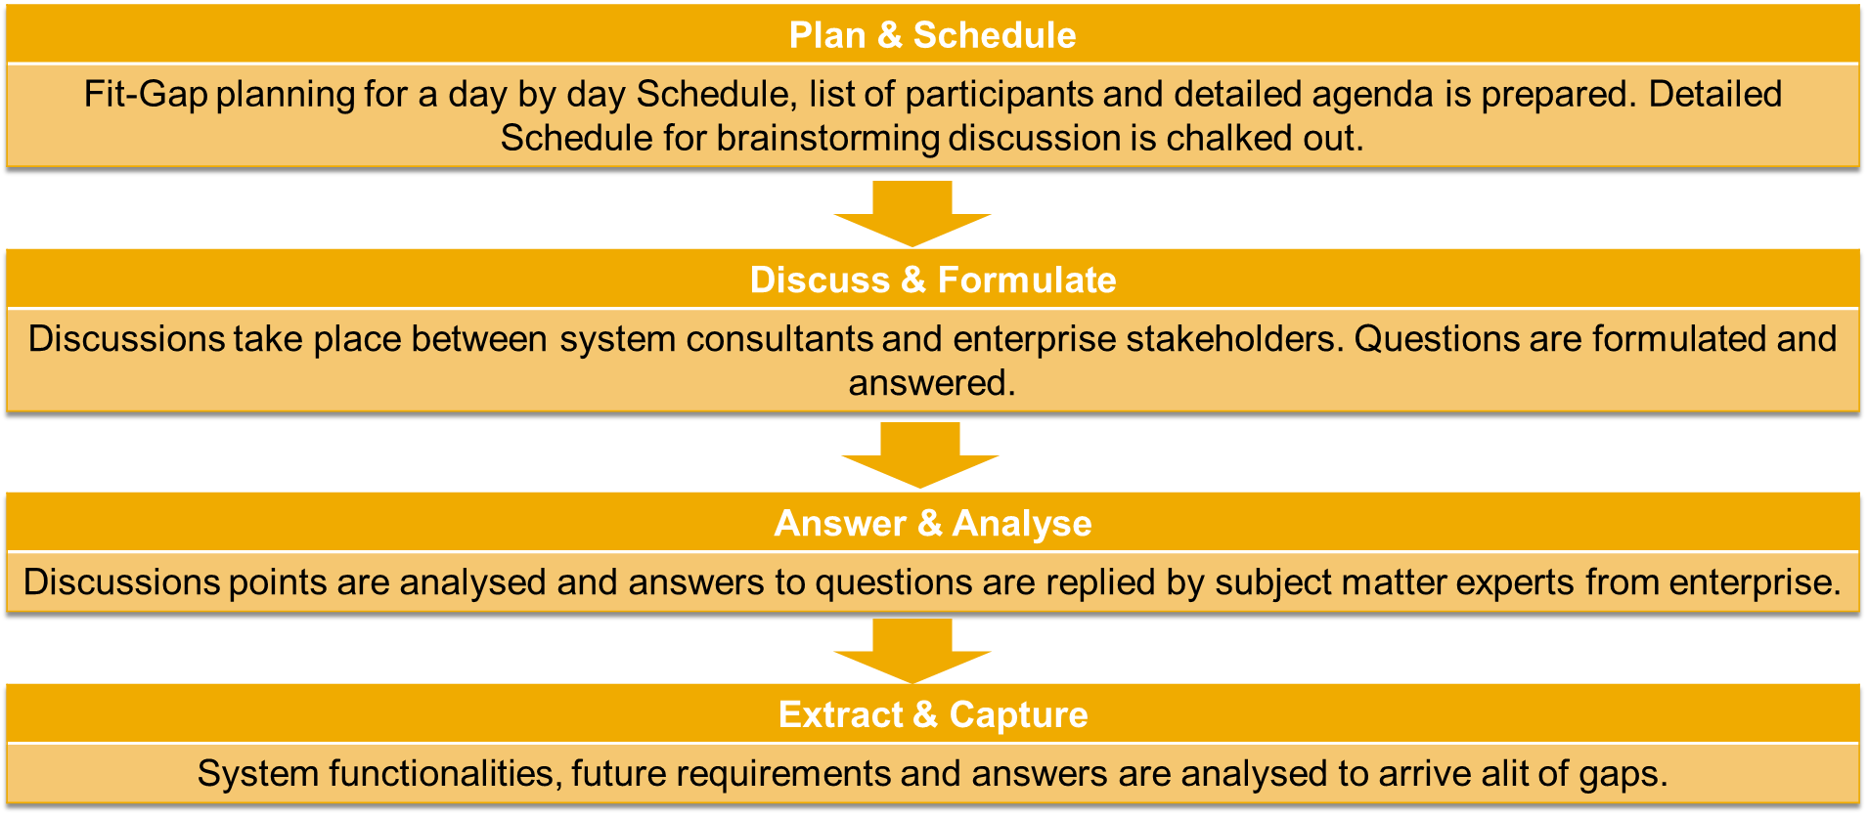

# SAP ERP HCM

## Overview

IL Police has implemented SAP HCM solutions. The next step is implementing SAP Payroll for all organization employees and retired officers.

Current situation: Payroll run by an external contractor, when data file are transferred by a bidirectional interface mainly from SAP PA , SAP Logistics and other systems.

Today Modules in Productive System:

* + OM - Organizational Management
  + PA – Personal Administration (PY impact)
  + PD – Personal Development
  + LMS – Learning Management Solution
  + ISH MED
  + Fiori
  + TM - Time Management (PY impact)
  + E-Rec – E-Recruiting (PY impact)

## HCM PA - Personal Administration

Total Employees in Israel Police – 28.279

Obligatory Service – 4.780 (Border Guard – 3.456; Police – 1.324)

National Service – 359

Permanent Officers – 23.140

76,45% men and 23,54% women (permanent officers)

Averages (permanente officers only):

* + - Age – 39 years
    - Years of service – 13,56 years
    - Academic degrees – 13,56 years
    - Religion – 87,83% Jewish and 12,17% not Jewish

## PA, TM & PY Master Data

#### 4.3.1 Standard Infotyppes

#### Infotypes are units of information in the Human Resource Management System.

Recording employee data for administrative, time recording, and payroll purposes is of primary importance for master data administration in HR. In the SAP System, the information units used to enter master data are called infotypes .

Infotypes are used to group related data fields together. They provide information with a structure, facilitate data entry, and enable you to store data for specific periods.

#### Standard Infotypes in use

#### PA – Personal Administration:

#### 0000/0302 – Actions

#### 0001 – Organizational Assignment

#### 0002 – Personal Data

#### 0006 – Addresses

#### 0007 – Planned Working Time

#### 0008 – Basic Pay (The actual pay grade - Level, Scale, Type is calculated by the vendor and later retrieved to the HR system)

#### 0009 – Bank Details

#### 0014 – Recurring Payments /Deductions

#### 0017 – Travel Privileges

#### 0021 Family Member /Dependents

#### 0022 – Education

#### 0041 – Data Specifications

#### 0050 – Time Recording Info

#### 0053 – Company Pension

#### 0105 .- Communication

#### 0167 – Health Plans

#### 0171 – General Benefits Information

#### 0182 – Date

#### 0552 – Time Specification/Employ. Period

#### 0555 – Military Service

#### TM – Time Management:

#### 0007 – Planned Working Time

#### 0050 – Time Recording Info

#### 2001 – Absences

#### 2002 – Attendances

#### 2006 – Absences Quota

#### PY - Payroll:

#### 0003 - Payroll Status

#### 0008 – Basic Pay (The actual pay grade - Level, Scale, Type is calculated by the vendor and later retrieved to the HR system)

#### 0014 – Recurring Payments /Deductions

#### 4.3.2 Client Infotyppes

#### Client Infotypes in use.

#### PA – Personal Administration:

#### 9008 – Pay Scale Type

#### 9012 – Commitment of service

#### 9016 - Contracts

#### 9022 – Courses & Trainings

#### 9027 – Uniform Points Allocation

#### 9034 – Add. Identific. Data

#### 9040 – MOD Recognition

#### 9042 - Flight Eligibility Details

#### PY - Payroll:

#### 9008 – Pay Scale Type

#### 9009 – Create Pay Scale at Recruitment

#### 9010 – Risk Factor Inc (WT amount is calculated by the vendor and later retrieved to the HR system)

#### 9014 – Professional Level

#### 9015 – Leave Details

#### 9018 – Study Payment for Retiree

#### 9045 – Rent Recognition

#### 9077 – Shoulder Rank

#### 9078 – Appointment Rank

# PA – Personal Administration

## Personnel Structure

#### Personnel Structure describes an employee’s position in a company from the individual employee’s view.

The personnel structure can be considered from two perspectives:

* administrative perspective
* organizational perspective

The **administrative personnel structure** consists of the following elements:

* Employee group

Employee groups represent a primary subdivision of personnel. An employee group defines the extent to which its employees place their labor at the disposal of the enterprise. The Personnel Administration component makes a significant differentiation between active, pensioner and early retiree employee groups. In customizing each employee group is defined with a one-digit identification.

The employee group has the following organizational functions:

* Employee groups allow you to generate data entry default values, for example, for the payroll accounting area or an employee’s basic pay.
* Employee groups serve as selection criteria for reporting.
* Employee groups constitute an authorization check unit.

The standard system contains a few specimen employee groups. You can copy the employee groups that are delivered or if necessary adjust them to your company specific needs.

* Employee subgroup

Employee subgroups subdivide employee groups. Within the employee group for active employees, for example, a distinction is made between the following employee subgroups:

* Hourly wage earners
* Monthly wage earners
* Pay scale employees
* Non-pay scale employees

In Customizing, the employee subgroup is defined by a two-character, alpha-numeric code.

All of the control features for the personnel structure are defined at the employee subgroup level. The most important control features are as follows:

* The employee subgroup grouping for a personnel calculation rule enables you to standardize or differentiate how an employee is dealt with in Payroll . For example, this grouping enables you to control whether an employee’s remuneration is calculated on a monthly or hourly basis.
* The employee subgroup grouping for the primary wage types enables you to determine which wage types are permissible for which employee subgroups.
* The employee subgroup grouping for collective agreement provision enables you to restrict the eligibility of pay scale groups to specific employee subgroups.
* The employee subgroup grouping for the work schedule enables you to determine which work schedules are permissible for which employee subgroups.
* The employee subgroup grouping for time quotas enables you to specify which attendance and absence quote types are eligible for which employee subgroups.
* The employee subgroup grouping for appraisals enables you to set up appraisal criteria dependent on the employee subgroup.
* The employee subgroup enables you to define data entry default values, for example, for the payroll accounting area or an employee’s basic pay.
* The employee subgroup is a selection criterion for evaluations.
* Employee subgroups are an authorization check unit.

You set up your company-specific personnel structure at the employee subgroup level. The standard system contains a few templates for employee subgroups. You can copy the employee subgroups that are delivered or if necessary adjust them to your company specific needs.

* Payroll area

The payroll area is an organizational unit in the Human Resources department, which can be defined for a unified payroll accounting area. Based on organizational assignment criteria, all of the employees who are accounted simultaneously in the payroll run are assigned to the same payroll area.

In Personnel Administration Customizing, the payroll area is defined by a two-character, alpha-numeric code.

As a rule, payroll is run per payroll area. Based on the payroll area, the system determines two pieces of information for payroll:

* The number of employees for whom a payroll accounting run is to be performed
* The specific payroll dates

The number of employees is determined by the infotype Organizational Assignment (0001), which is where the employee’s payroll area is stored.

The specific payroll dates are determined as follows:

* The general payroll period is stored as a period modifier for each payroll area. For example, payroll can be performed on a monthly, semi-monthly, bi-weekly, or weekly basis.
* The exact dates are stored for each valid payroll period.
* The exact dates of the current payroll period are determined by using a payroll control record, which attaches the period that is still to be accounted to the previously accounted period.
* Organizational key

The organizational key consists of a 14-character field that you can structure as you wish. Specific control and rule tables can help you do this. The organizational key is part of the authorization concept in Personnel Administration and Organizational Management. This gives you flexibility if you enhance the authorization check.

The **organizational personnel structure** consists of the following elements:

* Position
* Job
* Organizational unit

Israel Police already have the Personnel Structure defined. The existing Employee Group and Subgroup in use:

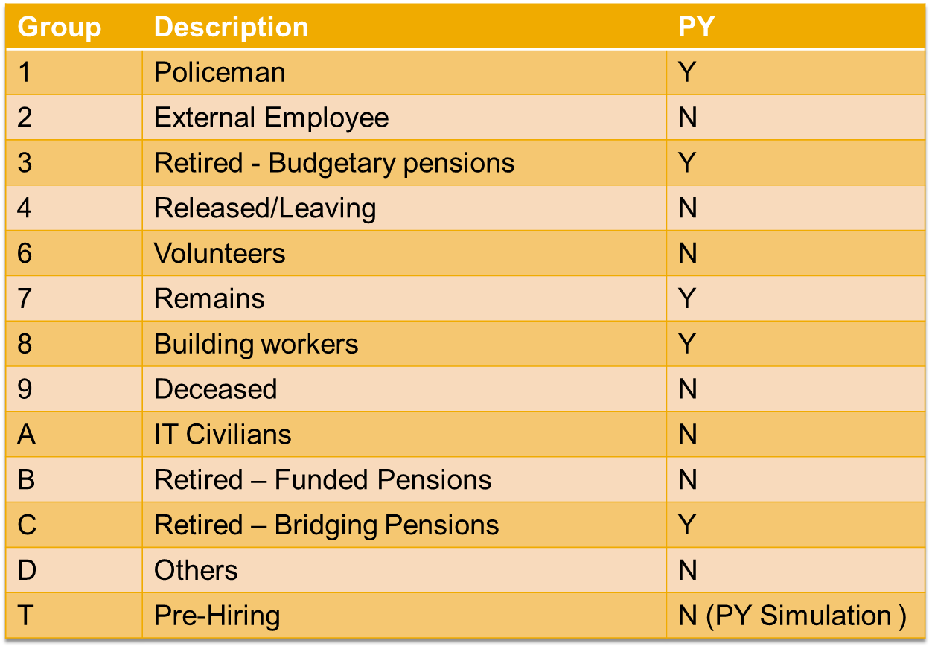

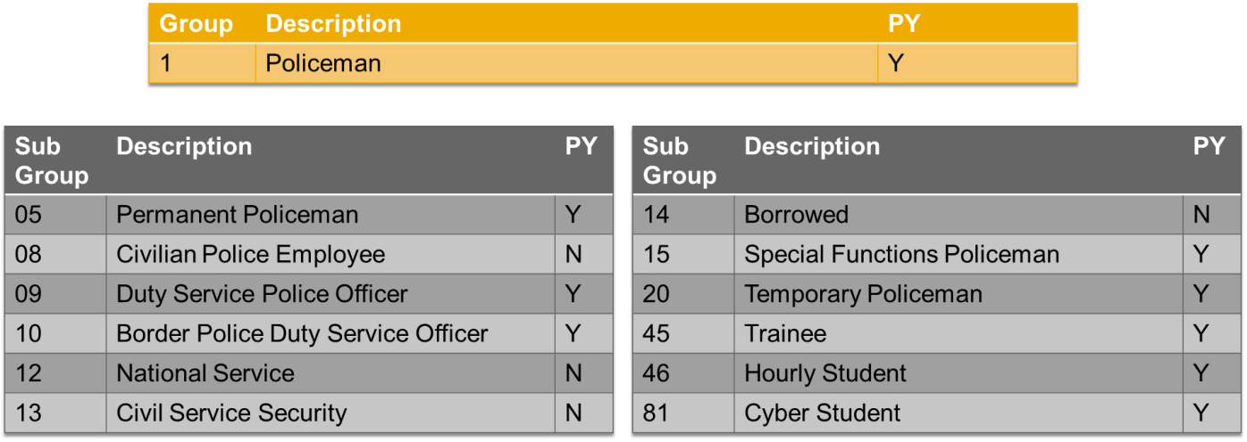

Payroll Area in used – 01 – Monthly

Organizational key isn’t being used.

## Enterprise Structure

Structure of company according to personnel administrative, time management and payroll perspectives from the point of view of your own company.

The company structure describes elements of the company and there dependencies.

The enterprise structure in Personnel Administration consists of the following:

* Company code

The company code is the smallest organizational unit of external accounting in which a complete and isolated financial accounting can be created. All events that affect the company code and the creation of all statements for a legal financial statement, for example balances, profit and loss calculation are contained within the company code organizational units.

* Personnel area

The personnel area is an organizational unit; according to a personnel administrative, time management and payroll organizational point of view, a personnel area represents a delimited enterprise area. The personnel area is only used in Personnel Administration and is unique within a client.

Personnel areas are sub-divided into personnel subareas. Organizational data and guidelines as how to assign it, are stored on a personnel area and personnel subarea level. The rules and guidelines could be of a legal, pay scale and collective agreement, or internal nature. A personnel area is assigned to a company code which has the financial accounting values that are relevant for the personnel area. A pay scale area, a pay scale type and a public holiday calendar are precisely defined for a personnel subarea.

* Personnel subarea

The personnel subarea is only used in Personnel Administration . The groupings linked to the personnel subarea determine which entries from the subsequent screen are allowed for an employee of a particular company code/personnel area.

Groupings are used for validation of master and time data. Groupings are also used to check the plausibility of data that you enter.

* Organizational key

The organizational key enables you to define the organizational assignment more exactly. The organizational key can consist of elements from the enterprise structure and personnel structure.

Israel Police already have the Enterprise Structure defined. The existing Employee Areas and subareas in use:

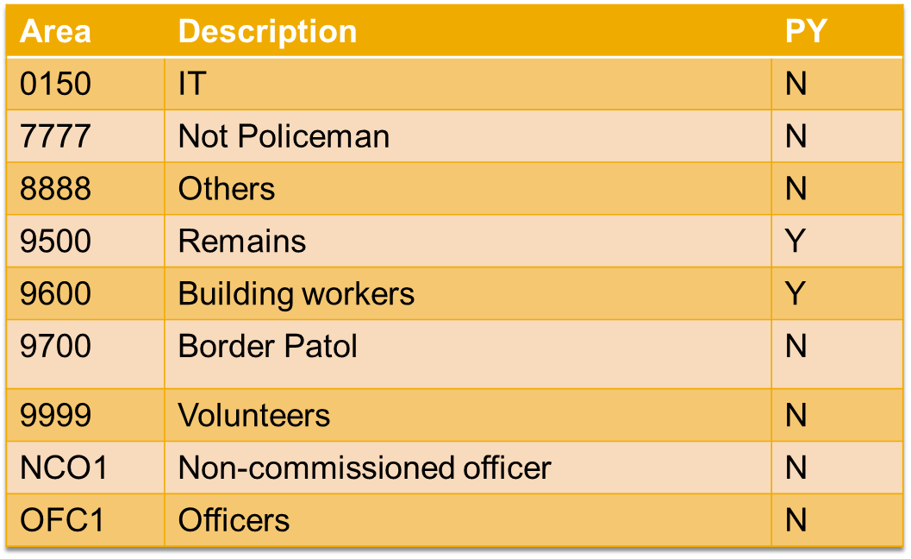

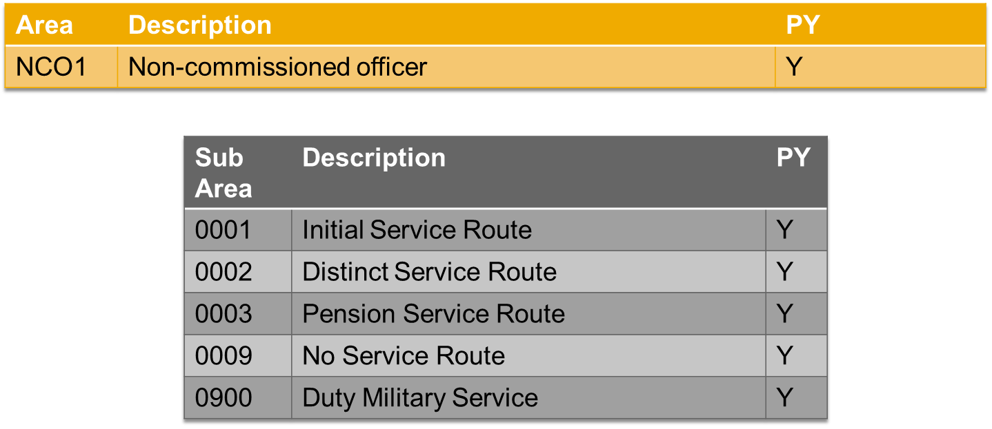

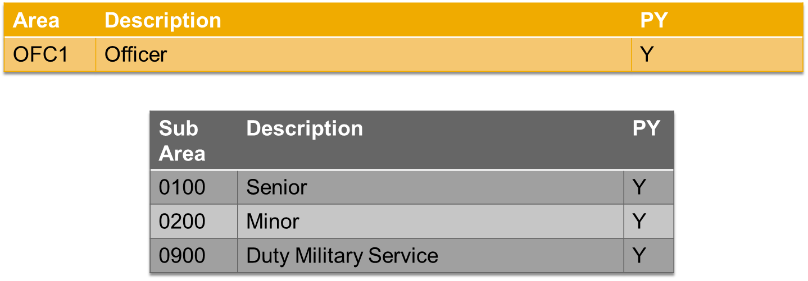

## Actions

The system simplifies the processing of complex personnel procedures, such as hiring a new employee, by using what are known as personnel actions .

You can use personnel actions to:

* Hire an employee
* Change the organizational assignment of an employee
* Change the employee’s pay
* Set an employee’s status to early retiree or pensioner
* Document when an employee leaves or re-enters the enterprise.

Personnel actions combine several related infotypes into one infotype group. Examples of personnel action types include the following:

* Hiring an employee
* Organizational reassignment
* An employee leaving the enterprise.

With the Actions infotype (0000), you can display an overview of all the important changes related to an employee, and you can thus document the most important stages that an employee passes through in your enterprise.

Israel Police existing actions:

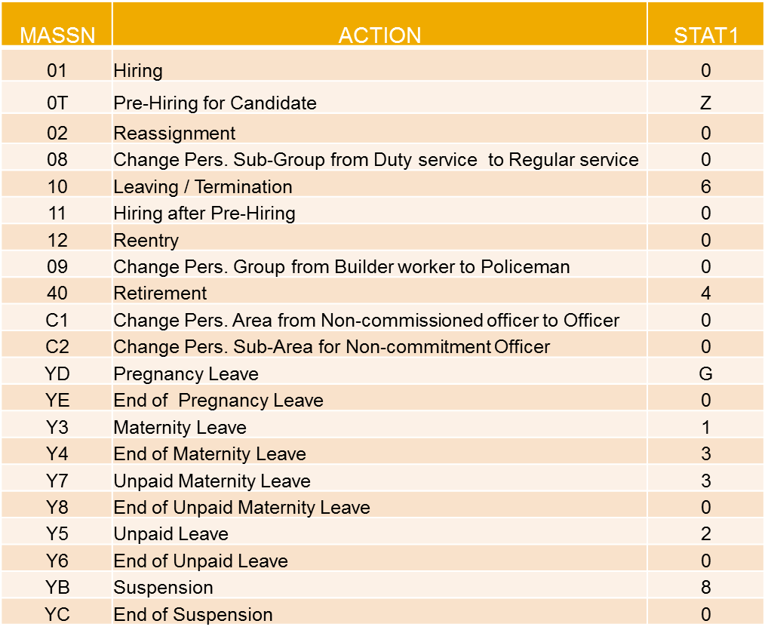

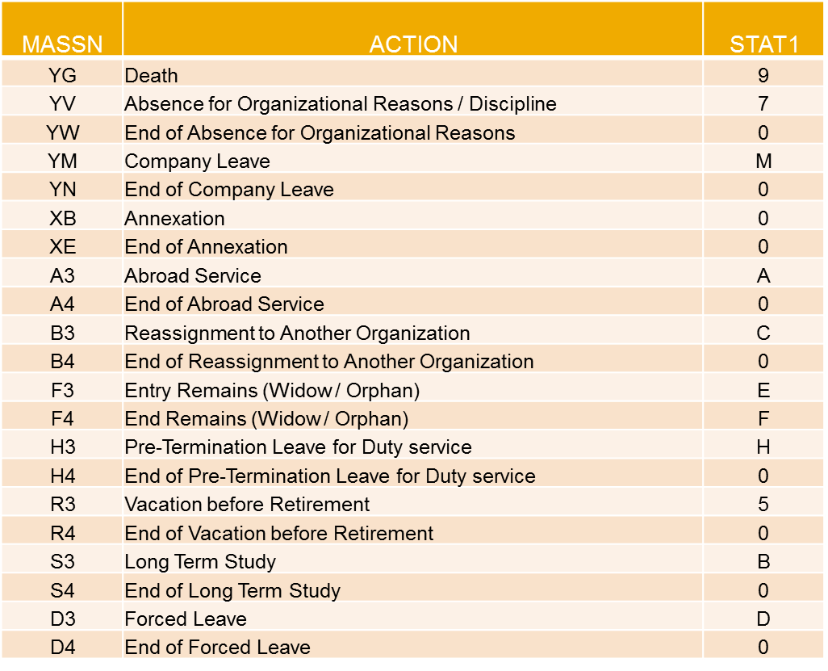

#### PA GAP: Relative Process

#### New Group and a new action for relatives, similar to the remains, should exist in the system.

## Status

Most actions create a record in the infotype of the same name Actions (0000). The deciding criteria as to whether a personnel action type should be stored in the Actions infotype (0000) is its effect on the status indicators.

In Customizing for Personnel Administration, you can assign the following three status indicators, each of which can have different values, to each personnel action type:

* Customer-specific (status 1)

Status 1 is customer-specific and is not used in the standard system.

Israel Police existing Customer-specific (status 1):

0: Active

1: Maternity Leave

2: Unpaid Leave

3: Unpaid Maternity Leave

4: Retired

5: Pre Retirement Leave

6: Released/Leaving

7: Not Working

8: Suspension

9: Death

A: Abroad

B: Long Term Education

C: Borrowed

D: Forced Leave

E: Remains

F: Inactive Remains

Z: Pre Hiring

#### PA GAP: Relative Process

New Group Customer-specific (status 1) - Relatives

* Employment (status 2)

Status 2 relates to the employee’s employment relationship. Status 2 is used in PA in the following two central places:

* + In Reporting

Status 2 is used to indicate entries into and exits from the company. This affects data selection within reporting. Employees who have left the company are, for example, identified by status 2.

* + In time-constraint validation

Data records with time constraint 1 may be deleted at the end if the value assigned to status 2 is 0, i.e. if the employee has left the company. The following infotypes constitute exceptions:

* + - Actions (0000)
    - Organizational Assignment (0001)
    - Personal Data (0002)

For these infotypes, a data record must exist at all times in the system for each employee from the point at which he or she is hired.

In Israel Police the existing Employment (status 2):

0: Employee not with company

3: Employee active in company

#### PA GAP: Retirement Process

#### The Employment (status 2) in Retirement Action should be chance to 2: Employee with in company – retiree.

#### The retirement employees that should have monthly payment:

Group Employee 3 - Retired - Budgetary pensions and C - Retired - Bridging pensions (until they have 67 year old or they pass away)

Employment (status 2) Master Data should change to 2: Employee with in company – retiree.

## Master Data

#### Master Data Requirements for PY functionalities:

#### PY GAP: Master Data (e.g. IT0006, IT0009)

#### Pensioners and Remains information for payroll calculation is in the vendor system. This must be considerate as part of data migration scope in the project implementation.

#### Some infotypes for Remains employees will have the same information of the deceased employee (e.g. IT9014).

#### PY GAP: Legal Master Data

#### Each employee should have all relevant PY Master Data (funds, taxes, social security, …). Today this information is in the vendor system. This must be considerate as part of data migration scope in the project implementation.

**PA GAP:** Infotype group in main actions

The main actions should include the new infotypes that are going to be used for PY.

#### PY GAP: Basic Salary – IT0008

#### The Pay Scale Grade should exist in standard infotype 0008 - Basic Pay. This information already exist retrieved by vendor in IT0008, but it should be had in consideration that unless 2 calculations occur every month for employees old word calculation - OWC (rules

#### Pensioners information for payroll calculation is in the vendor system. This must be considerate as part of data migration scope in the project implementation (% for Group Employee 3 – Retired – Budgetary pensions and amount for Group Employee – Retired – Bridging pensions).

#### Remains information for payroll calculation is in the vendor system. This must be considerate as part of data migration scope in the project implementation. The IT0008 should have the same Pay Scale Grade of the deceased employee.

#### Students information for payroll calculation This must be considerate as part of data migration scope in the project implementation. The IT0008 should have the associate tariff of the students.

#### Relatives information for payroll calculation This must be considerate as part of data migration scope in the project implementation. The IT0008 should have the payment wage type.

#### 5.4.1 Hiring and Hiring after Pre-Hiring Actions

#### Hiring after Pre-Hiring is used only to Employee Group and Subgroup: T – Pre-Hiring.

#### Pre-Hiring action should able payroll simulation. Is not mandatory that “T” employees have Hiring after Pre-hiring action.

#### PY custom relevant infotypes:

#### IT9008 – Create Pay Scale Type (mandatory)

#### IT9009 – Create Pay Scale at Recruitment (Initial Pay Scale Type, Area - Rank, Group and Level)

#### The actual Pay Grade - Level, Scale, Type is calculated by the vendor and later retrieved to the HR system to IT0008.

#### IT9077 – Shoulder Rank (mandatory)

#### IT9078 – Appointment Rank

#### Today the vendor receive the information from the mentioned infotypes and calculate from IT9077 and IT9078 the highest rank, this one will be used in the payroll calculation (IT9078 can’t exist without IT9077).

#### The actual pay grade – Type, Rank and level is calculated by the vendor and later retrieved to the HR system.

#### IT9014 – Professional Level Subtypes: 0002 – Generic Prof. Level, 0001 – Steps Level

#### PY GAP: Basic Salary – IT0008

#### The Pay Scale Grade should exist in standard infotype 0008 - Basic Pay. This information already exist retrieved by vendor in IT0008, but it should be taken in consideration that unless 2 calculations occur every month for employees:

#### - Old Word Calculation - OWC (rules before March 2016)

#### - New Word Calculation – NWC (rules after March 2016)

#### This calculations are explained in the PY slides.

#### 5.4.2 Leaving Action

#### PY GAP: Grant calculation in the leaving month, for Group Employee 4 - Released/Leaving:

#### Termination Grant Calculation for IT0053 – Company Pension, pension type 02 - Budgetary pensions

#### Termination Grant = Number of years in Service * Highest Gross Salary

#### Compensation Grant Calculation IT0053 – Company Pension, pension type 03 - Funded Pensions:

#### Compensation Grant = 28% * Highest Gross Salary

#### Termination and Compensation Grants are calculated base in the highest gross salary, the calculation and rules of old word - OWC (before March 2016) and new word – NWC (after March 2016) are explained in the PY slides.

#### Today the calculation depends of the pension type in IT0053 – Company Pension, in the future this infotype will be obsolete, it should be use the localization fund infotype – IT0840.

#### PY GAP: Vacations days Grant (if the employee didn’t deduct all the days) Calculation

#### Vacations days Grant = Vacation redemption (days) (WT from Time Management Calculation) * Highest Gross Salary

#### 5.4.3 Retirement Action

#### PY relevant infotypes:

#### IT9015 – Change Leave Detail - The field Part. Pension %, have the percentage that should be paid to the pensioners (today is not being used in the PY calculation).

#### IT0053 – Company Pension:

#### Pension type 02 - Budgetary pensions, the group employee will be 3 - Retired - Budgetary pensions,

#### Pension type 03 - Funded Pensions, the group employee will be C - Retired - Bridging pensions.

#### PY GAP: Termination Grants Calculation for Group Employees - 3 - Retired - Budgetary pensions

#### In the last month as a policeman several Grants must be paid:

#### - Termination Grant (max = 12 months) = Number of years in Service / 2 * Highest Gross Salary

#### - Vacation redemption (days)

#### - Sickness redemption (days) ) (WT will exist in Time Management Calculation)

#### PY GAP: Budgetary pension calculation for Group Employee 3 - Retired - Budgetary pensions

#### Pension = % IT0008 for pension WT * Highest Gross Salary (calculated in PY)

#### Today, the % is in IT9015, but isn’t being used for the Payroll. In the future the % should be migrated to IT0008

#### PY GAP: Pension increase Calculation

#### The pension increase yearly with the index (if it is positive).

#### 

#### PY GAP: Termination Grants Calculation for Group Employee C - Retired - Bridging pensions

#### In the last month as a policeman several Grants must be paid:

#### - Compensation Grant = 28% * Highest Gross Salary

#### - Vacation redemption (days)

#### - Sickness redemption (days) ) (WT will exist in Time Management Calculation)

#### - Determination Grant = Number of years in Service / 2 * Highest Gross Salary

#### PY GAP: Bridging pension calculation Group Employee C - Retired - Bridging pensions

#### Until the employees have 67 years old or until he is not death we paid the pension amount that the fund sent, after the payment will be done by the fund pension to the pensioner or to the remains.

#### Master Data for this Group Employee should be migrated to PA is in the vendor system, it should be migrated to PA.

#### 5.4.4 Remains Action

#### The remains (Widow / Orphan) are created in the system as new employees, they are linked with the wife and children's of the deceased employee.

#### PY GAP: Remains Payment Calculation Group Employee 7 - Remains

#### Remain Pension = % IT0008 for remain pension WT * Last Pension (should be extracted from the last pension paid to the deceased employee).

# **TM –Time Management**

## Processing Flow

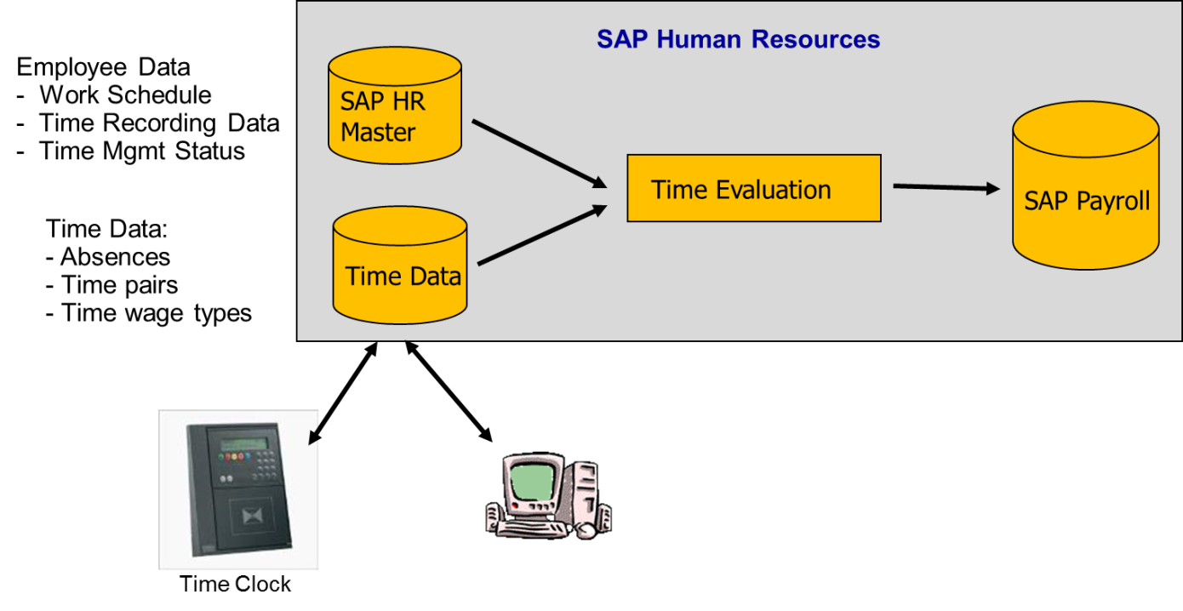

## Aspects in PY

#### The implementation of time management for the IL Police includes 150 work schedules. Most of them are identical from the payroll perspective (since the nature of the organization does not encourage incentives based on timely manner).

#### Cases of time management effect to the payroll

#### Overtime wage type for students and abazim (ZL/B2)

#### Per diems, absence hours, redemption days (ZL/B2)

#### Reimbursement for Military reserve service (Infotype 2001)

#### The WT derived from TM are determined by the time evaluation in cluster ZL/B2, for the time being, the calculation is done the last day of each month.

**Time Management Wage Types:**

#### 

* Allowance WT’s, the other ones are deduction WT’s.

The WT are calculated in the Time evaluation, they have the days or hours that goes to impact the PY, in the future system the calculations must be done.

**PY GAP:** Absence Deductions Calculation

The wage type to deduct can be in hours or days according to the table in last slide, the amount calculation should be done in payroll calculation.

**PY GAP:** Deductions with Absences

If the PY team receive authorization from the employee, the deduction will be deduct from the employee when he is absence. The deduct amount should be transfer from employee bank account and paid to the entity as the other months.

**PY GAP:** Per Diem Payment

Wage types in ZL will have the number of allowance type meals to pay. There exist 4 types with different fix values.

**PY GAP:** Overtime Payment

Wage types in ZL will have the number hours to pay in each overtime percentage of. There is 4 overtime WT’s (100%, 125%, 150% and 200%).

**PY GAP:** Reimbursement for Military reserve service Payment

Wage types in ZL will have the number of days or hours to pay.

# PY - Payroll

## Process Overview

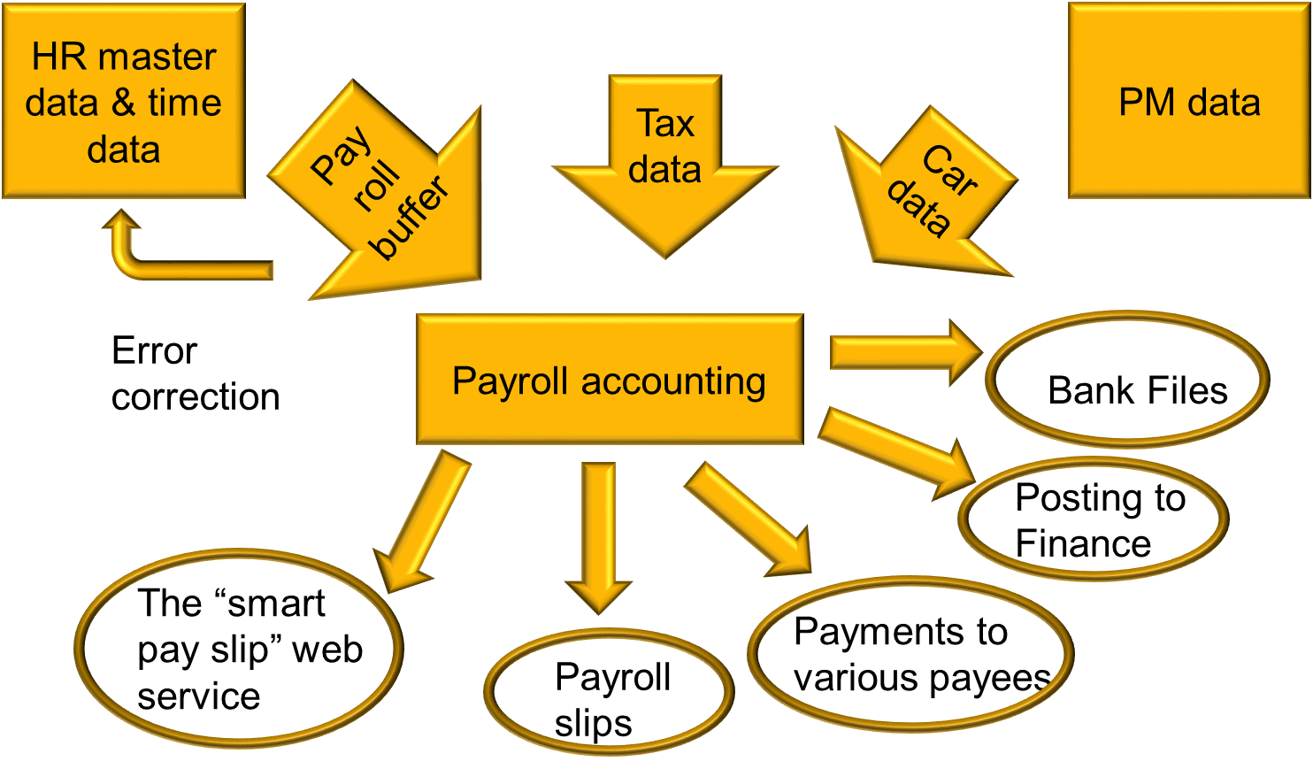

## Calculations & Processes

Benefits and Deductions that already exist in the system:

* Chief inspector grant
* Non-commissioned officer grant
* Service route grant
* Warriors grant
* Sappers grant
* Training grant
* Student grant
* Special police unit grant
* Holy places grant
* Jerusalem grant
* Service bonus
* Dental Insurance
* Flights eligibility
* Education Scholarships
* Kinder garden & Summer Camp Reimbursement
* Others

The Benefits and Deductions are created in infotype 0014 with or without amount, manually in each employee or massively in developed programs. The payment amount for the benefits and deductions without amount in IT0014 are calculated in the vendor system.

**PY GAP:** Benefits & Deductions

The benefits and deductions should be read to payroll calculation, the amount for the benefits or deductions without value in IT0014 should be calculated in payroll.

**PY GAP:** Benefits & Deductions Master Data Change to IT0015

Today the benefits and deductions are created in infotype 0014, in the future system the IT0015 should be used if it is once time payment.

**PY GAP:** Uniform Entitlements Payment or Deduction

Uniform Entitlements Payment or Deduction is already calculate monthly in the system, the amounts are stored in IT9027. Employees can have uniform allowance and deduction. The deduction can append if some rules change in the period of the Uniform Entitlements, e.g. the employee schedule of 100% reduce for 80%, the program will calculate the value that should be retrieved by the employee and store it in IT9027 subtype 0001. The payroll system must read this value to deduct it in the payment.

**PY GAP:** Master Data for Benefits and Deductions

Today there are several benefits and deductions that only exist in payroll system of the vendor. In the future system they should be include in Master Data as a payroll requirement.

* Phone (consumption of the mobile phone);
* Indexation (additional payment for non-payment for a long term period);
* Additional Work (extra police work for several organization);
* Toll Road Expenses (amount spent in toll roads);
* Obligations;
* Tuition Fees (additional payment);
* Release Grant (incoming amount from the army);
* Public transport (amount, only with tax impact);
* Newspaper (amount, only with tax impact);
* Car amount (amount, only with tax impact);
* Loss Equipment (manually deduction);
* Holiday (amount spent for vacations);
* Telephone allowance;
* Commissioner Loan (additional payment);
* Dismissal pay Block (stop payment or pay only a %);
* Advance payments;

**PY GAP:** Rent Payment

The amount for payment should be calculated and stored, all necessary information to calculate is in the actual system in IT9045. The payroll system must read the stored amount for payment.

**PY GAP:** Tuition Reimbursement for Retirees Payment

Tuition Reimbursement for Retirees calculations already exist in the system, the amounts are stored in IT9018. The payroll system must read the stored amount for payment.

**PY GAP:** Annual Payments Officer and NC Officers

* + - * + Vacations – June PY
        + Seniority - September PY
        + Education Scholarships – August PY
        + Labor union – October PY

**PY GAP:** Garnishment and Loans

Standard Infotypes: IT0045 – Loans and IT0078 – Loans Payments

**PY GAP:** Acquisition of Rights Calculation

The employees can buy unpaid periods to increase seniority. This information should be stored in IT0552, a new subtype must be created.

In the payroll the deduction must be calculated in the payroll month that is mentioned in the IT0552 record.

**PY GAP:** Letters to Employee

For some reason the employee received more than he should, in this situations employee must be notified by letter that he owes money;

When Payroll team receive from the court that the employee have a garnishment, employee should notified by letter when the deduction will start.

**PY GAP:** Payslip Password

Monthly an alphanumeric password should be generate for each employee to view the payslip in the web site. The password code should be in the payslip.

**PY GAP:** Telephone password

Monthly a numeric password should be generate for each employee to listen to telephone messages, this password should be in the payslip.

**PA GAP:** Telephone and Web Messages (system files)

File with the changes made daily in some infotypes, this changes will be uploaded and employees will be available to consult them by telephone or in the external web site.

**PY GAP:** Payroll Simulation to Candidates

Candidates that can be hiring, have a beginning action “Pre-Hiring Action”, Employee Group and Subgroup – “T” – Pre-Hiring. This employees shouldn’t have monthly payment but PY team should be able to simulate they possible payment in the future.

**PY GAP:** Payroll Features:

**-** Payroll runs monthly, the payment is on the 1st of each month. Transference goes to bank 2/3 days before.

- Retroactive calculation.

- Simulation - shows the slip for representative population pre actual calculation.

**PY GAP:** Legal Discounts

Social Security, Taxes, Contribution for Pension Fund

**PY GAP:** Promotions

Compulsory promotions according to the Rank levels

## Officers Calculation

Main factors which impact the officers’ salary calculation

* + - Police ranks
    - Academic degree
    - Police profession/occupation
    - Police Seniority
    - Risk factor & risk factor seniority
    - Training reward credit

Calculation Levels:

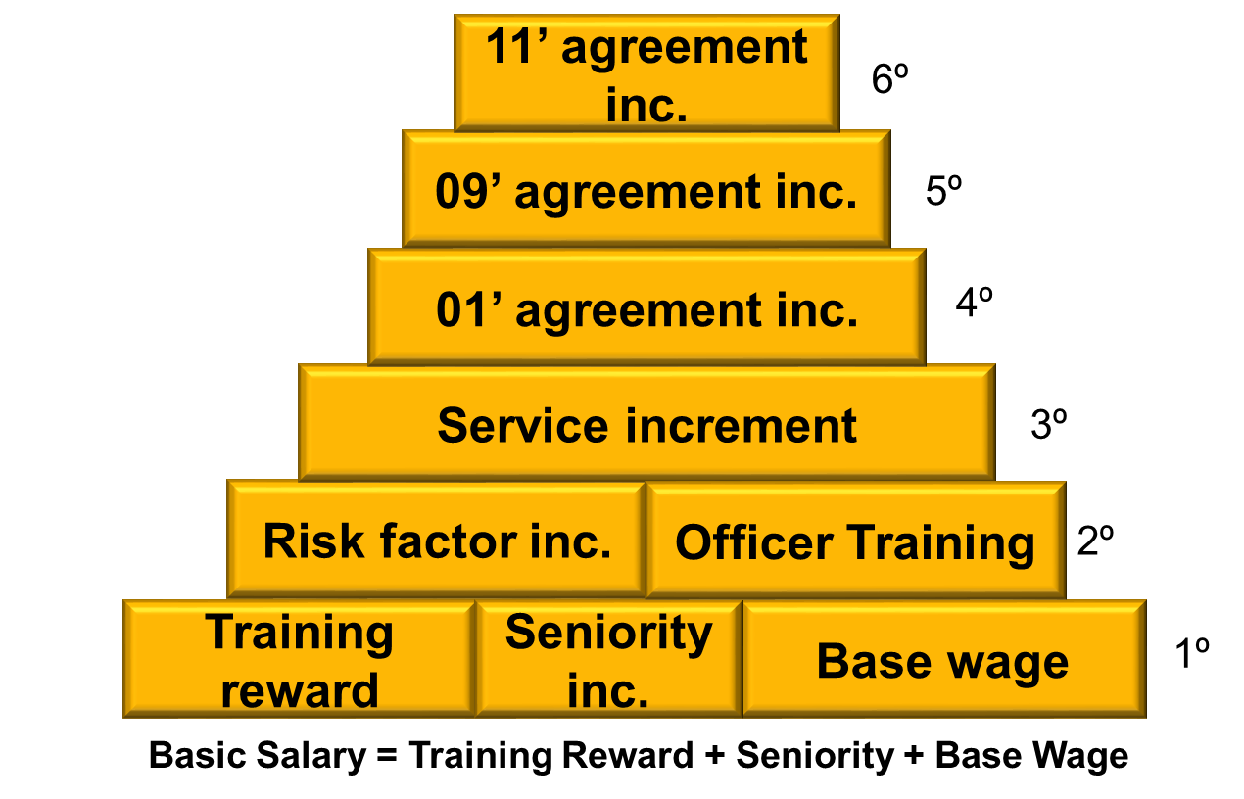

The vendor receive the information from IT9008 - Pay Scale Type, IT9009 - Pay Scale initial grade, IT9077 - Shoulder Rank and IT9078 Appointment Rank. From Shoulder Rank and Appointment Rank the highest is considerate and the Base Wage amount for payment is found in Table PSType / Rank / Level.

**PY GAP:** Base Wage Calculation (1º Level)

Calculation should be based in IT0008 – Basic Salary

Base Wage = amount in Table PSType / Rank / Level

**PY GAP:** Seniority Calculation (1º Level)

Seniority Inc = Base Wage * Seniority %

Two types of seniority must be calculated Seniority in 1ª Degree and Higher Seniority:

* Seniority in 1ª Degree = number of years from the entry date till the payroll date + additional periods in IT0552 without subtype 62 – Additional Degree Seniority – absence periods - actions periods
* Higher Seniority = period from IT0552 subtype 62 – Additional Degree Seniority

Seniority % = (1.01) (seniority in 1ª Degree + higher seniority/2)

**PY GAP:** Training Reward Calculation (1º Level)

If the employee have training reward wage type, it would be in IT0014, employees can have 1º Training Reward or 2º Training Reward, there is a fix value for each one.

**PY GAP:** Risk Factor Inc Calculation (2º Level)

Risk Factor Inc = Basic Salary (1º) * Risk Factor %

Risk Factor %= % from Pay Scale / Rank / Risk Factor Group (associate to Professional Code in IT9014 subtype 0002)

* If the Risk Factor Group is different from the associate one the Risk Factor Group is inserted in IT0014 and the Risk factor % will be calculated with this Risk Factor Group (% from Pay Scale / Rank / Risk Factor Group in IT0014).
* If the Employee decrease in the Risk Factor Group (associate to Professional Code in IT9014 subtype 0002) or Leave Service instead of Risk Factor %, Seniority Risk Factor % should be calculated for the best Risk Factor Group in a period of 10 years. The Seniority Factor % should only be calculated after 4 years of service.

Risk Factor % = Seniority Risk Factor %

**PY GAP:** Risk Factor Group

A view in employee Master Data with the Risk Factor Group associate to Professional Code in IT9014 subtype 0002 (to be decided in project implementation if it really need).

**PY GAP:** Seniority Factor %

Seniority Risk Factor % = Risk Factor % (per period - absences) * number of years (per period - absences) in the best Risk Factor Group in a period of 10 years (maximum of 90%) + 10% of the lowest Risk Factor Group or the actual one.

Seniority Service Factor % = Service Factor % (per period - absences) * number of years (per period - absences) in the best Risk Factor Group in a period of 10 years (maximum of 90%) + 10% of the lowest Risk Factor Group or the actual one.

Report should calculate and display the Seniority Factor %’s in the different periods and the period factors.

**PY GAP:** Officer Training Calculation (2º Level)

Officer Training Inc =Basic Salary (1º) * Officer Training %

Officer Taining % = % from Pay Scale / Rank / Risk Factor Group (associate to Professional code in IT9014 subtype 0002).

**PY GAP:** Service Calculation (3º Level)

Service Inc (3º) = (1º Level + 2º Level) * Service %

Service %= % from Pay Scale / Rank / Risk Factor Group / Incentive (associate to Professional Code in IT9014 subtype 0002)

* If the Employee decrease in the Risk Factor Group (associate to Professional Code in IT9014 subtype 0002) or Leave Service instead of Service %, Seniority Service Factor %should be calculated for the best Risk Factor Group in a period of 10 years. The Seniority Service Factor % should only be calculated after 4 years of service.

Service % = Seniority Service Factor %

**PY GAP:** 01’, 09’ and 11’ Agreement Calculation

01’, 09’ and 11’ Agreement Inc = % associate to Pay Scale

01’ Agreement Inc (4º) = (1º + 2º + 3º) * 01’ agreement %

09’ Agreement Inc (5º) = (1º + 2º + 3º + 4º) * 09’ agreement %

11’ Agreement Inc (6º) = (1º + 2º + 3º + 4º + 5º) * 11’ agreement %

## Non-Commissioned Officers Calculation

Main factors which impact the officers’ salary calculation:

* + - Police ranks
    - Police profession/occupations (8 professional groups).
    - Police Seniority
    - Risk factor & risk factor seniority
    - Occupation seniority.
    - Training reward credit

Calculation Levels:

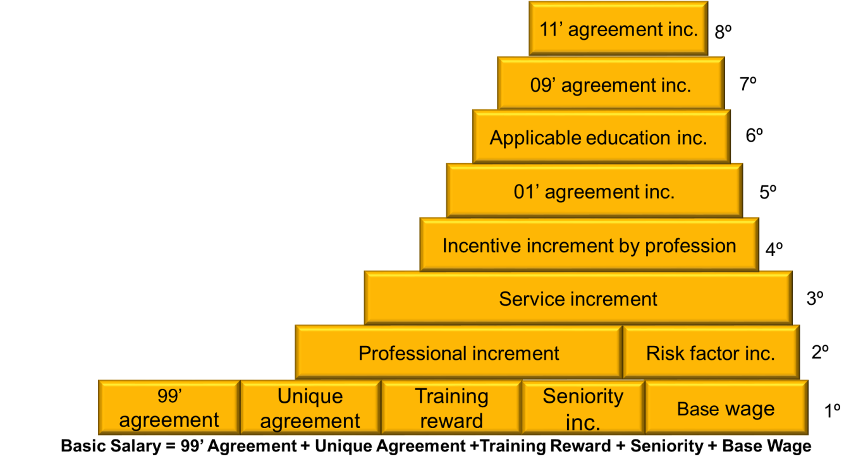

**PY GAP:** Old Calculation and New Calculation

From March 2016 Non-Commissioned Officers have a new payroll calculation, the system should calculate the Payroll the old way and in the new way, and the highest should be paid.

**PY GAP:** Base Wage Calculation (OWC - old way calculation and NWC - new way calculation) (1º Level)

Base Wage like Officers Calculation

**PY GAP:** Seniority Calculation OWC and NWC (1º Level)

Seniority like Officers Calculation

**PY GAP:** Training Reward Calculation OWC and NWC (1º Level)

Training Reward like Officers Calculation

**PY GAP:** 99’ Agreement Inc. Calculation OWC and NWC (1º Level)

99’ Agreement Inc = Base Wage * 99’ Agreement %

99’ Agreement % OWC = % From Pay Scale/ Rank

99’ Agreement % NWC = % From Pay Scale/ Rank / Risk Factor Group

**PY GAP:** Unique Agreement Inc. Calculation OWC and NWC (1º Level)

Unique Agreement Inc = Base Wage * Unique Agreement %

Unique Agreement % OWC = % From Pay Scale/ Rank / Risk Factor Group / Incentive (associate to Professional Code in IT9014)

Unique Agreement % NWC = % From Pay Scale/ Rank / Risk Factor Group / Incentive (fix value 8%)

**PY GAP:** Risk Factor Calculation OWC and NWC (2º Level)

Risk Factor like Officers Calculation

**PY GAP:** Professional Inc Calculation OWC and NWC (2º Level)

Professional Grade Inc OWC = 1º Level * Professional Grade %

Professional Grade % = % From Pay Scale/ Rank / Professional Grade (associate to Professional Code in IT9014 subtype 0001) / Incentive (associate to Professional Code in IT9014 subtype 0002)

Professional Inc NWC = Basic Salary (1º) * Professional %

Professional % = % from Professional Group / Rank / Risk Factor Group

**PY GAP:** Service Inc Calculation OWC and NWC (3º Level)

Service Inc OWC and NWC like Officers Calculation

Service Inc NWC = (1º Level + 2º Level) * Service % (define in a table)

**PY GAP:** Incentive Increment by Profession Calculation OWC and NWC

Incentive Inc by Profession (4º) OWC = (1º + 2º + 3º) * Incentive % by Profession

Incentive % by Profession = % From Professional Code in IT9014 subtype 0002

If in a period of 3 years there is the same %, the % will freeze.

If the Employee decrease in the profession % (associate to Professional Code in IT9014 subtype 0002) or Leave Service Seniority Incentive Inc by Profession % should be calculated for the profession % in a period of 10 years. The Seniority Service Factor % should only be calculated after 4 years of service.

Incentive % by Profession = Seniority Incentive % by Profession (same mechanism mention for the other calculations Seniority factor %)

Incentive by Profession (4º) NWC = % in WT0660 in IT0014

The WT0660 already exist, is calculate in a program. This program is going to get the associate % to Professional Group and Rank. For the seniority calculation the mechanism is the same that the risk factor, the program that calculate the % to WT0660 already include the rules.

**PY GAP:** Applicable education Calculation

Applicable education Inc OWC and NWC = (1º + 2º + 3º + 4º+ 5º) * Applicable education Inc

Applicable education Inc = Inserted manually WT in IT0014 ( two possible %’s WT4196 = 7% or WT4197 =15%)

**PY GAP:** 01’, 09’ and 11’ agreement Calculation

01’, 09’ and 11’ Agreement Inc = % associate to Pay Scale

01’ agreement (5º) OWC and NWC = (1º + 2º + 3º + 4º) * 01’ agreement %

09’ agreement (7º) OWC and NWC = (1º + 2º + 3º + 4º + 5º + 6º ) * 09’ agreement %

11’ agreement (8º) OWC and NWC =(1º + 2º + 3º + 4º + 5º + 6º + 7º) * 11’ agreement %

## Calculation Run Times

**PY GAP:** Non-Commissioned Officers (all life cycle) Payroll Calculation

* 2 times calculation: OWC before March 2016 and NWC after March 2016
* Pay the highest

**PY GAP:** Non-Commissioned Officers change to Officers Payroll Calculation

* 2 or 3 times calculation: NCO calculation - 1 or 2 calculations (OWC before March 2016 and/or NWC after March 2016 depends on the data of transition) Officers Calculation
* Pay the highest

**PY GAP:** Employees Hiring after March 2016 only have 1 payroll calculation

## Calculation Students & Building Workers

**PY GAP:** Students Payroll Calculation (Hour Payment)

This payroll calculation is to Employees Group 1 – Policeman and Employee Subgroup 46 - Hourly Student.

The monthly payment to students is done according to the hours they have during the month. The hours are calculated in time management evaluation, the Payroll Payment will be the amount of the total of hours.

**PY GAP:** **:** Building Workers Calculation

This payroll calculation is to Employees Group 8 – Building Workers.

The monthly payment to building workers is done according to Base Wage Type (Rank), incentive increment and two incentives wage types that are constants to all employees in this group.

This employees have overtime calculation:

Hour Amount = (Base Wage + Increment Inc) / 195h (hours per month)

## Payroll Steps Overview (Payroll Area)

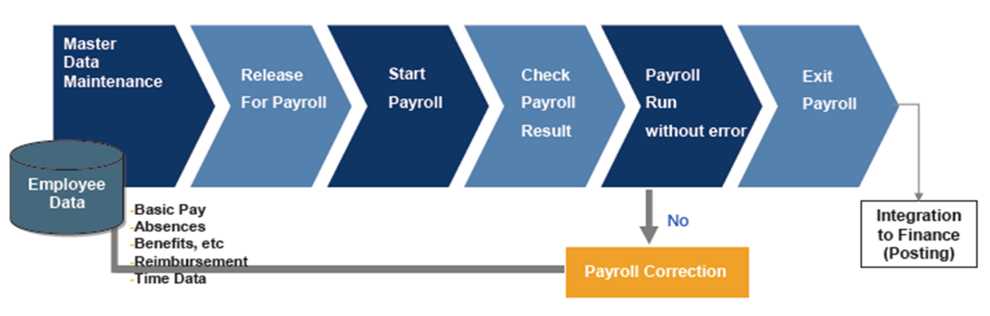

Payroll Area:

Payroll Areas are used in SAP HR to group together employees for whom payroll is run at the same time, and also to set the dates for the payroll period. Employees from different employee subgroups can belong to the same payroll area.

Control Record:

It controls the activities of Payroll. The status of the payroll can be seen in this record. The status can be change manually here.

It locks master data and time data so no changes in relevant payroll data can be made during the payroll process. Control record sets current payroll period and defines the earliest possible retroactive accounting date for each payroll areas.

Status for control record:

* + - * Master Data Maintenance
      * Release for payroll
      * Start Payroll
      * Check Payroll Result

Payroll Period:

Payroll period determines the period for which a payroll is run. The length of payroll periods can differ, e.g., it can be monthly, weekly, …

Period Parameter:

Period parameter defines specific payroll with start and end dates. If you run payroll for all employees in the same time interval, you only require one period parameter.

## Payroll Activities Overview (Start Payroll)

Consolidating operating entities within a single payroll platform with real-time HR and financials integration delivers best-in-class accuracy, compliance and workforce insight

Process Steps:

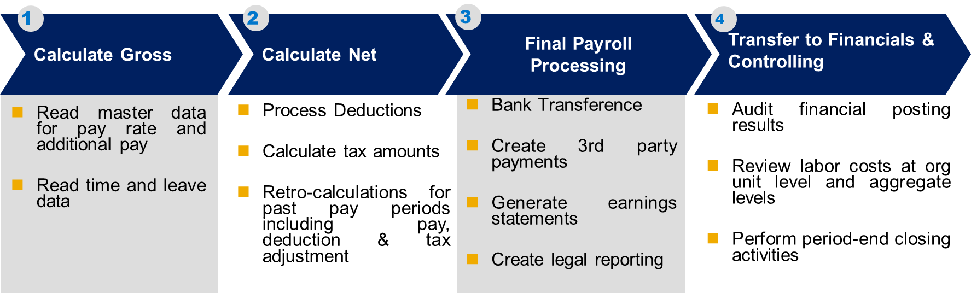

## Reports

**PY GAP:** High/Low Gross Salary

According to an average profiles

**PY GAP:** High/Low Net Salary

According to an average profiles

**PY GAP:** Wage Types

* Shows all of the wage types. The average amount, the number of worker who get it etc.
* Shows the workers who had retro payment period of time (e.g. over a year).
* 50 Highest Salaries
* Statistic report of all the workers, shows averages of each WT’s in a period of time

## Authorizations

**PY GAP:** Authorizations

PY team should have the authorizations to the relevant transactions.

# Suggestions and Recommendations

## SAP ERP HCM PY – ASAP (Project Methodology)

The ASAP Methodology for Implementation is SAP’s content-rich methodology for assisting with the implementation and/or upgrade of SAP solutions across industries and customer environments. Built on our experience in thousands of SAP projects, ASAP provides content, tools, and best practices that help consultants to deliver consistent and successful results across industries and customer environments.

Accelerated SAP (ASAP) Implementation Methodology, there is a timeline which includes five paths.

1. Project Preparation

2. Business Blueprint

3. Realization

4. Final Preparation

5. Go Live & Support

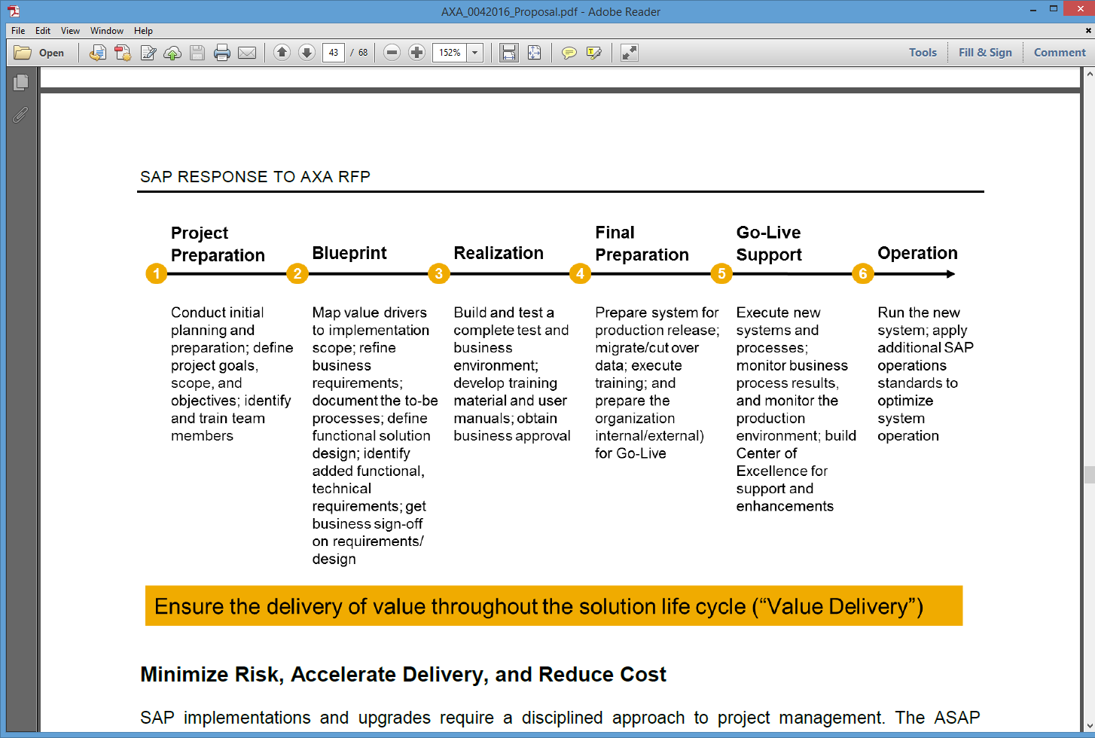

**Phase 1 : Project Preparation**

During this phase the team goes thought initial planning and preparation for SAP project. Each project has its own unique objectives, scope, and priorities. The deliverables described in this phase assist in completing the initiation and planning steps in an efficient and effective manner – like setup of project governance, project plan and project schedule are prepared at this stage.

**Phase 2- Business Blueprint**

SAP has defined a business blueprint phase to help extract pertinent information about your company that is necessary for implementation. These blueprints are in the form of questionnaires that are designed to probe for information that uncovers how your company does business. As such, they also serve to document the implementation.

Each business blueprint document essentially outlines your future business processes and business requirements.

**Phase- 3 - Realization**

With the completion of the business in phase 2, "functional" experts are now ready to begin configuring SAP.

The Realization phase is broken in to two parts.

1)  Your SAP consulting team helps you configure your baseline system, called the baseline configuration.

2) Your implementation project team fine-tunes that system to meet all your business and process requirements as part of the fine tuning configuration.

The initial configuration completed during the base line configuration is based on the information that you provided in your blueprint document. The remaining approximately20% of your configuration that was not tackled during the baseline configuration is completed during the fine tuning configuration.

Fine tuning usually deals with the exceptions that are not covered in baseline configuration. This final bit of tweaking represents the work necessary to fit your special needs.

**Configuration Testing**

With the help of your SAP consulting team, you segregate your business processes into cycles of related business flows. The cycles serve as independent units that enable you to test specific parts of the business process. You can also work through configuring the SAP implementation guide (IMG). A tool used to assist you in configuring your SAP system in a step by step manner.

**Knowledge Transfer**

As the configuration phase comes to a close, it becomes necessary for the Project team to be self-sufficient in their knowledge of the configuration of your SAP system.

Knowledge transfer to the configuration team tasked with system maintenance (that is, maintenance of the business processes after Go-live) needs to be completed at this time. In addition, the end users tasked with actually using the system for day-to-day business purposes must be trained.

**Phase 4 - Final Preparation**

Phase 4 concentrates on the last adjustments of your configuration before Go-live and more importantly, the migration of data from your old system or systems to SAP

Workload testing (including peak volume, daily load, and other forms of stress testing), and integration or functional testing are conducted to ensure the accuracy of your data and thestability of your SAP system. Because you should have begun testing back in phase 2, you do not have too far to go until Go-live.

Now is an important time to perform preventative maintenance checks to ensure optimal performance at your SAP system. At the conclusion of phase 4, take time to plan and document a Go-live strategy. Preparation for Go-live means preparing for your end-users questions as they start actively working on the new SAP system.

**Phase 5 - Go-live and Support**

The Go-live milestone is itself is easy to achieve; a smooth and uneventful Go-live is another matter altogether. Preparation is the key, including attention to what-if scenarios related not only to the individual business processes deployed but also to the functioning of technology underpinning these business processes and preparation for ongoing support, including maintenance contracts and documented processes and procedures are essential.

## SAP Solution Manager (Tool for Project Implementation)

SAP Solution Manager is a software platform that provides the integrated tools, content, and methodologies needed to implement, support, operate, and monitor SAP enterprise applications. With SAP Solution Manager, customers are better equipped to minimize risk and increase the reliability of their IT solutions.

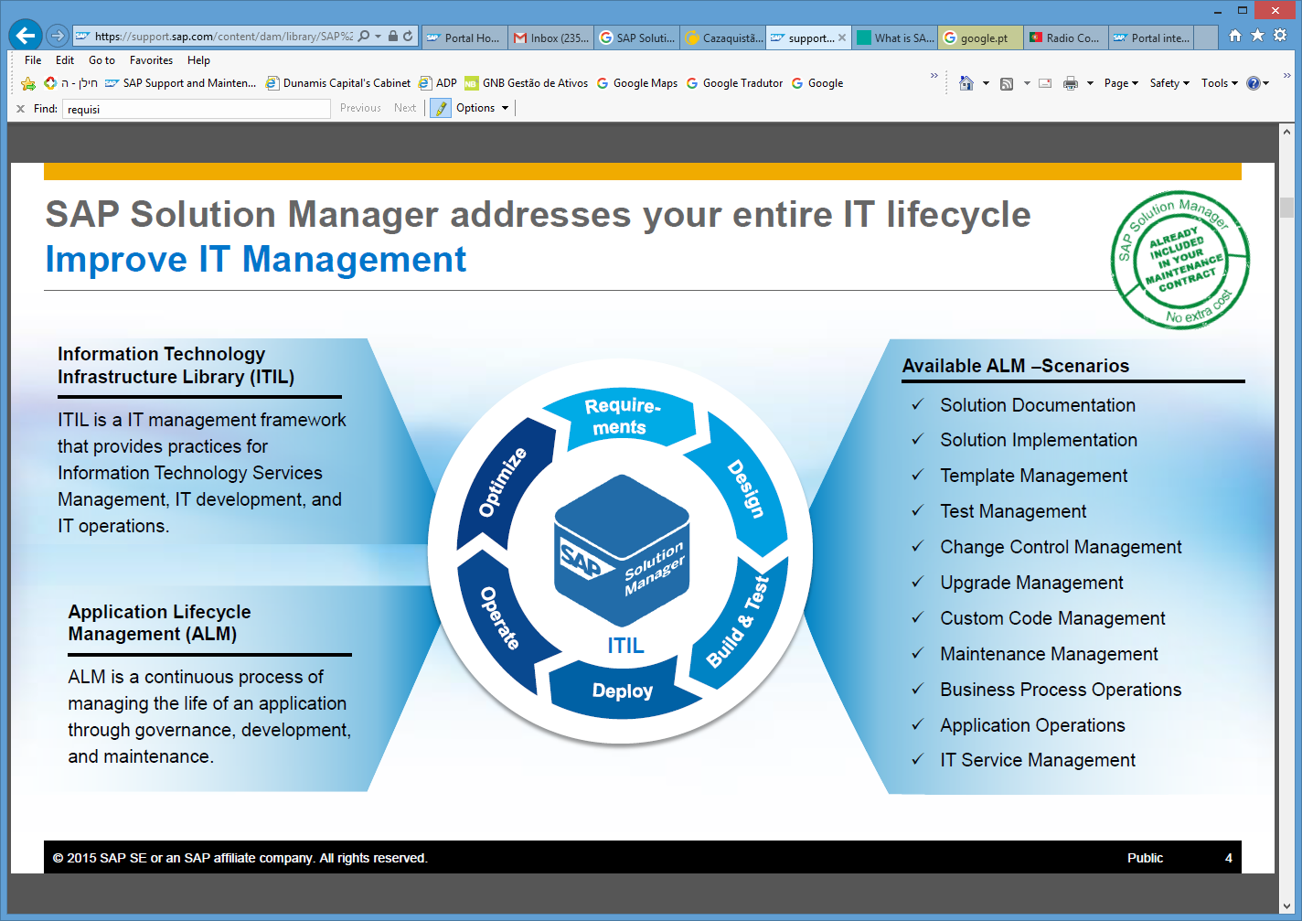

## Payroll Control Center (Payroll functionality)

Payroll needs to be accurate and efficient. It is important for payroll professionals to be able to easily identify and quickly rectify problems that can adversely affect the payroll run. Gathering and reacting to this information has been time consuming and prone to error. Many times the process of finding the information is a manual effort.

The Payroll Control Center makes the identification and resolution of payroll related issues easy.

Customers can start using the SAP Payroll Control Center when they have SAP ECC HCM on Enhancement Package 7 and they have their SAP NetWeaver on the 7.4 release. The payroll data on which the validation rules are running is stored in [the declustered tables](http://scn.sap.com/community/erp/hcm/blog/2013/12/19/how-do-sap-hcm-customers-benefit-from-declustering-payroll-and-time-management-on-sap-hana).

The new SAP Payroll control center add-on provides a fundamentally new approach in which potential issues are pointed out in real-time by the application rather than payroll administrators digging through information and trying to find issues themselves. With this functionality payroll administrators only need to focus on issue solving and this saves payroll departments a lot of valuable time.

During the preparation of the payroll there are a lot of validations on master data executed by payroll administrators. They make sure that information like tax info, missing address info or any other payroll relevant information is valid or corrected before the payroll runs.

 And after the payroll has run these payroll administrators make sure the results are correct before the actual pay-out. That means that they run analyses like:

* Gross variance deviation of 10%: this identifies employees with a 10% or more deviation in their current salary compared to their last salary;
* Zero Net: this identifies active, inactive and withdrawn employees who will receive “zero net” pay out;
* Excess Net: this identifies employees with a net pay over a specified tolerance;
* And many many more.

Currently there are a lot of different reports created for these analyses. These can now be converted in so called ‘validation rules’ that run in the SAP Payroll Control Center. Via these validation rules potential issues will be pointed out by the application. The validation rules ‘framework’ can encapsulate almost any type of master data and reconciliation analysis that is required.

The SAP Payroll Control Center is developed in the latest HTML5 technology and will be delivered as part of HR Renewal 2.0 (<http://help.sap.com/hr_renewal>). Payroll Administrators can launch the SAP Payroll Control Center via a small lane in the HR Renewal screen. Customers that do not have HR Renewal implemented can embed a link in their portal or SAP ECC HCM system.

The SAP Payroll Control Center points out which master data and other corrections need to be made before the payroll can run. These master data corrections can be made in HR Renewal applications or in SAP ECC HCM. Then the payroll can run and when the program is ready the SAP Payroll Control Center points out the potential issues that need to be evaluated and possibly corrected. This can again be done via HR Renewal or the SAP ECC HCM application.

The following graph displays the screens:

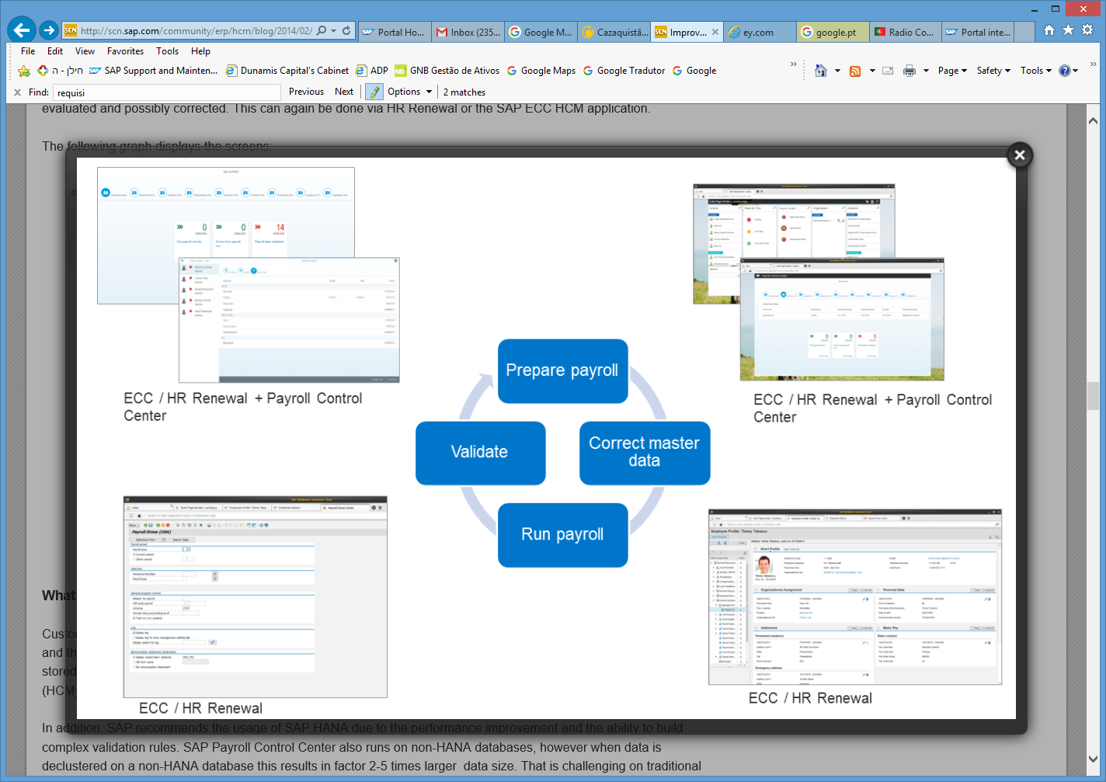

## SAP HANA

SAP recommends the usage of SAP HANA due to the performance improvement and the ability to build complex validation rules. SAP Payroll Control Center also runs on non-HANA databases, however when data is declustered on a non-HANA database this results in factor 2-5 times larger  data size. That is challenging on traditional databases and this also results in a situation in which it’s not possible to create validation rules with the complexity that most customers require.

## Parallel Payroll Run - Approach

Parallel Payroll Testing is used to determine that the results of SAP Payroll and the legacy applications are same. This testing required for two applications, i.e. Legacy + external applications and SAP Payroll + external applications – to compare one to one results on both systems.

Minimum Number of Parallel Payroll Run - 3

* The QA environment should be refreshed and loaded with latest production data for this testing.
* Run a simulation run to check whether the master data has been loaded correctly, test for roadblocks, and resolve them before the actual parallel run scheduled.
* Obtain the YTD converted data from the legacy system, do the sanity check, fix any data issues.
* SAP system should be loaded with transactional data from the legacy system for all active employees and inactive employees who had latest termination and sanity check should be performed.
* Execute different payroll frequencies (Weekly / Semi-Monthly / Monthly) using the payroll transactional data on the actual dates of pay cycles
* Verify master data and payroll YTD (Year-to-Date) conversion
* Compare the results of SAP payroll with legacy system
* Resolve the exceptions and perform root cause analysis
* Get an agreement with a project and service delivery / operations team if the exceptions are correct, and get the sign-off
* Fix the discrepancies if any with SAP payroll system
* Re-run the next parallel run
* Compare payroll results on SAP Payroll and legacy for:
  + Build-to-Gross: compute gross pay/earnings
  + Gross-to-Net: compute taxes, benefits, pensions, other earnings, and deductions.
  + Post-Payroll Activities: generate Payroll/Finance files, Operational/ Statutory and Tax reports, Tax deposits/Returns, Electronic bank transfers, and so on
* Compare the pension and benefit calculations against the legacy system
* Year-end reports should comprise the same details
* Tax withholding calculations will be done going forward
* Minimize parallel payroll exceptions between SAP Payroll and legacy system with consecutive parallel runs until the exceptions reach a predefined target or until all known differences have been identified
* The high level test approach for Parallel testing is given in the table below:

|  |  |
| --- | --- |
| **High level Test Components** | **Parallel Test Execution** |
| * Execute the simulation run to check for exceptions and resolve any system roadblocks for initial master data upload. * Obtain the YTD converted data from legacy system, do the sanity check, fix any data issues. * Transfer the legacy YTD data into SAP Cluster table. * Test master data and Payroll YTD conversion. * Live run of different payroll frequencies (Weekly / Semi-Monthly / Monthly) using the production data on the actual dates of pay cycles * Compare the results of SAP payroll with legacy * Resolve the deviations and perform root cause analysis * Get an agreement with a project and service delivery team if the deviations are correct, and get the sign-off. * Fix the deviations if any with SAP payroll system * Re-run the next parallel run. * Compare the payroll results on SAP Payroll and legacy for:   + Build-to-Gross: Compute gross pay/earnings   + Gross-to-Net: Computing taxes, benefits, Pensions, other earnings and deductions.   + Post-Payroll Activities: Generating Payroll/Finance files, Operational/Statutory and tax reports, tax deposits/returns   + Test the above results against legacy   + Test the pension and benefit calculations against legacy | Upload the initial master data and run an initial simulation run to test the data is successfully loaded.    Do all parallel payroll runs on QA environment whose configuration (H/W, software, Platform, Cluster etc.) is 100% equal to Production environment.  After Go Live on Production, the QA environment will be downgraded to 50% of Production without cluster.    Comparison of Results between Legacy and SAP Payroll:   * Manual comparison. * Automated comparison (in case of tool which is completely tested by any automated testing tools) |
| * Year End reports should be tested * Tax withholding calculations will be tested for correctness * Minimize parallel payroll exceptions between SAP Payroll and legacy with consecutive parallel runs till the exceptions reach to a targeted percentage or all known differences have identified. * Data medium exchange file will be tested and checked. | All discrepancies have to be dealt on case by case basis  Involve labor relations and business process owners to interpret deviations which cannot be resolved by external engines.  In such cases, more time need to be spent for testing resolve deviations. |

**When to perform the Parallel Payroll Testing**

1. **Unit Testing**: Individual components need to be unit tested within the logical boundary
   * Master Data
   * Payroll
   * Time Management
2. **System Integration Testing**: End-to-end business scenarios from Hire to Retire
3. **Performance and Stress Testing**: Volume testing with at least equal to or more than production load at high concurrency
4. **User Acceptance Testing**: Business executes end to end scenarios with controlled data – IT supports
5. **Parallel Payroll Testing**

# Appendix

## Delivery Teams

### Service Delivery Team

| Name | Company | Role |
| --- | --- | --- |
| Mónica Galindro | SAP | HCM Application Expert Payroll |
| Amit Tal | Julius IT | HR Senior Consultant |
| Boaz Nevat | SAP | Sales LE Account Managers |

## Meetings

| Name (1ª Visit) | Date | Time | Location |
| --- | --- | --- | --- |
| Kick-Off | 27.03.2016 | 09:00-10:00 | IL Police Jerusalem |
| Project Overview Meeting | 27.03.2016 | 10:00-11:00 | IL Police Jerusalem |
| SAP Payroll Solution Overview | 27.03.2016 | 11:15-13:00 | IL Police Jerusalem |
| SAP Payroll Solution Overview | 27.03.2016 | 13:00-15:00 | IL Police Jerusalem |
| Il Police Main Business Processes Analysis: HCM - Overview + PA/OM | 28.03.2016 | 09:00-11:30 | SAP - IL Ra'anan |
| Il Police Main Business Processes Analysis: HCM - Time Management | 28.03.2016 | 11:30-13:00 | SAP - IL Ra'anan |
| Il Police Main Business Processes Analysis: HCM - other modules | 28.03.2016 | 13:00-15:00 | SAP - IL Ra'anan |
| Differences between Payroll data and PA data | 28.03.2016 | 15:00-16:00 | SAP - IL Ra'anan |
| Il Police Main Business Processes Analysis: HCM - Today Payroll | 29.03.2016 | 09:00-10:30 | IL Police Jerusalem |
| Il Police Main Business Processes Analysis: HCM - Today Payrol | 29.03.2016 | 10:30-13:00 | IL Police Jerusalem |
| Il Police Main Business Processes Analysis: HCM - Future Payrol | 29.03.2016 | 14:00-17:00 | IL Police Jerusalem |
| Prepare/Planning 2ª vistit – GAP Analysis | 30.03.2016 | 09:00-10:30 | SAP - IL Ra'anan |

| Name (2º Visit) | Date | Time | Location |
| --- | --- | --- | --- |
| Il Police Main Business Processes Analysis: HCM - Overview + PA | 11.04.2016 | 08:30-13:00 | IL Police Tel Aviv |
| Il Police Main Business Processes Analysis: HCM - Overview + PA | 11.04.2016 | 14:00-17:30 | IL Police Tel Aviv |
| GAP Analyses Doc | 12.04.2016 | 08:30-13:00 | IL Police Tel Aviv |
| Il Police Main Business Processes Analysis: HCM - Time Management | 12.04.2016 | 14:00-17:30 | IL Police Tel Aviv |
| Il Police Main Business Processes Analysis: HCM - Payroll | 13.04.2016 | 08:30-13:00 | IL Police Jerusalem |
| Il Police Main Business Processes Analysis: HCM - Payroll | 13.04.2016 | 14:00-17:30 | IL Police Jerusalem |
| GAP Analyses Doc | 14.04.2016 | 08:30-13:00 | SAP - IL Ra'anan |
| Status Meeting | 14.04.2016 | 14:00-17:00 | SAP - IL Ra'anan |
| Il Police Main Business Processes Analysis: HCM - Payroll | 17.04.2016 | 09:00-10:30 | IL Police Jerusalem |
| Il Police Main Business Processes Analysis: HCM – Payroll Interfaces | 17.04.2016 | 14:00-17:30 | IL Police Jerusalem |
| Il Police Main Business Processes Analysis: HCM – Payroll Interfaces | 18.04.2016 | 09:00-10:30 | IL Police Jerusalem |
| Il Police Main Business Processes Analysis: HCM – Payroll Reports | 18.04.2016 | 14:00-17:30 | IL Police Jerusalem |
| GAP Analyses Doc | 19.04.2016 | 09:00-17:30 | SAP - IL Ra'anan |
| Il Police Main Business Processes Analysis Review | 20.04.2016 | 09:00-17:30 | IL Police Tel Aviv |
| GAP Analyses Doc | 21.04.2016 | 09:00-13:00 | SAP - IL Ra'anan |

## Client Contacts

| Name | Company | Role |
| --- | --- | --- |
| Ron Ayzenberg | Israeli Police | Project Manager |
| Dror Midgan |  | Consultant |
| Itzchak Leventer | Israeli Police | Payroll Department Head |
| Gay Ivgi | Israeli Police | Payroll Department officer |
| Ada Harel | Israeli Police | Retirees Department Head |
| Michal Mann | Israeli Police | Retirees Department officer |
| Oren Guanias | Israeli Police | Head of ERP HR |
| Marsela Goldman | Israeli Police | Head of Wage entitlement team |
| Yulia Yamini | Israeli Police | Head of IT ERP department |
| Ela Bar-Ilan | HPe | IT HR team leader |
| Miri Fridman | MALAM | HR TM Senior Consultant |
| Amit Tal | JULIUS | HR Senior Consultant |