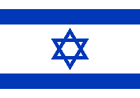

A Token of Appreciation for Fostering New Relationships

Major General Itai Veruv Commandant of the Military Colleges
Israel Defense Forces

